SOIL-STRUCTURE INTERACTION
<Copyright 1998, Computers and Structures, Inc. All Rights Reserved>
http://www.csiberkeley.com/Tech_Info/soilStructInter.htm
At A Finite Distance from A Structure the Absolute Displacements Must Approach the Free-Field Displacements
INTRODUCTION
The estimation of earthquake motions at the site of a structure is the most important phase of the design or retrofit of a structure. Because of the large number of assumptions required, experts in the field often disagree by over a factor of two as to the magnitude of motions expected at the site without the structure present. This lack of accuracy of the basic input motions, however, does not justify the introduction of additional unnecessary approximations in the dynamic analysis of the structure and its interaction with the material under the structure. Therefore, it will be assumed that the free-field motions at the location of the structure, without the structure present, can be estimated and are specified in the form of earthquake acceleration records in three directions. It is now common practice, on major engineering projects, to investigate several different sets of ground motions in order to consider both near fault and far fault events.
If a lightweight flexible structure is built on a very stiff rock foundation, a valid assumption is that the input motion at the base of the structure is the same as the free-field earthquake motion. This assumption is valid for a large number of building systems since most building type structures are approximately 90 percent voids, and, it is not unusual that the weight of the structure is excavated before the structure is built. However, if the structure is very massive and stiff, such as a concrete gravity dam, and the foundation is relatively soft, the motion at the base of the structure may be significantly different than the free-field surface motion. Even for this extreme case, however, it is apparent that the most significant interaction effects will be near the structure, and, at some finite distance from the base of the structure, the displacements will converge back to the free-field earthquake motion.
SITE RESPONSE ANALYSIS
The 1985 Mexico City and many recent earthquakes clearly illustrate the importance of local soil properties on the earthquake response of structures. These earthquakes demonstrated that the rock motions could be amplified at the base of a structure by over a factor of five. Therefore, there is a strong engineering motivation for a site-dependent dynamic response analysis for many foundations in order to determine the free-field earthquake motions. The determination of a realistic site-dependent free-field surface motion at the base of a structure can be the most important step in the earthquake resistant design of any structure.
For most horizontally layered sites a one dimensional pure shear model can be used to calculate the free-field surface displacements given the earthquake motion at the base of a soil deposit. Many special purpose computer programs exist for this purpose. SHAKE [1] is a well-known program, based on the frequency domain solution method, which iterates to estimate effective linear stiffness and damping properties in order to approximate the nonlinear behavior of the site. WAVES [2] is a new nonlinear program in which the nonlinear equations of motion are solved by a direct step-by-step integration method. If the soil material can be considered linear then the SAP2000 program, using the SOLID element, can be used to calculate either the one, two or three dimensional free-field motions at the base of a structure. In addition, a one dimensional nonlinear site analysis can be accurately conducted using the FNA option in the SAP2000 program.
KINEMATIC OR SOIL-STRUCTURE INTERACTION
The most common soil-structure interaction SSI approach, used for three dimensional soil-structure systems, is based on the "added motion" formulation [3]. This formulation is mathematically simple, theoretically correct, and is easy to automate and use within a general linear structural analysis program. In addition, the formulation is valid for free-field motions caused by earthquake waves generated from all sources. The method requires that the free-field motions at the base of the structure be calculated prior to the soil-structure interactive analysis.
In order to develop the fundamental SSI dynamic equilibrium equations consider the three dimensional soil-structure system shown in Figure 16.1.
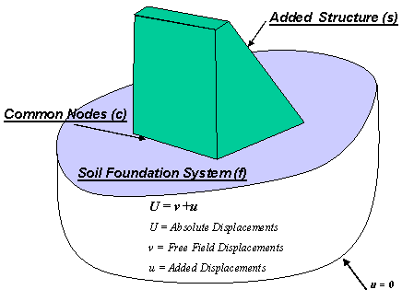
Figure 16.1. Soil-Structure Interaction Model

Consider the case where the SSI model is divided into three sets of node points. The common nodes at the interface of the structure and foundation are identified with "c"; the other nodes within the structure are "s" nodes; and the other nodes within the foundation are "f" nodes. From the direct stiffness approach in structural analysis, the dynamic force equilibrium of the system is given in terms of the absolute displacements, , by the following sub-matrix equation:
(16.1)
where the mass and the stiffness at the contact nodes are the sum of the contribution from the structure (s) and foundation (f), and are given by
(16.2)
In terms of absolute motion, there are no external forces acting on the system. However, the displacements at the boundary of the foundation must be known. In order to avoid solving this SSI problem directly, the dynamic response of the foundation without the structure is calculated. In many cases, this free-field solution can be obtained from a simple one-dimensional site model. The three dimensional free-field solution is designated by the absolute displacements and absolute accelerations . By a simple change of variables it is now possible to express the absolute displacements and accelerations in terms of displacements relative to the free-field displacements . Or,
(16.3)
Equation (16.1) can now be written as
(16.4)
If the free-field displacement is constant over the base of the structure, the term is the rigid body motion of the structure. Therefore, Equation (16.4) can be further simplified by the fact that the static rigid body motion of the structure is
(16.5)
Also, the dynamic free-field motion of the foundation requires that
(16.6)
Therefore, the right-hand side of Equation (16.4) can be written as
(16.7)
Hence, the right-hand side of the Equation (16.4) does not contain the mass of the foundation. Therefore, three dimensional dynamic equilibrium equations, for the complete soil-structure system with damping added, are of the following form for a lumped mass system:
(16.8)
where M, C and K are the mass, damping and stiffness matrices, respectively, of the soil-structure model. The added, relative displacements, u, exist for the soil-structure system and must be set to zero at the sides and bottom of the foundation. The terms and are the free-field components of the acceleration if the structure is not present. The column matrices, , are the directional masses for the added structure only.
Most structural analysis computer programs automatically apply the seismic loading to all mass degrees-of-freedom within the computer model and cannot solve the SSI problem. This lack of capability has motivated the development of the massless foundation model. This allows the correct seismic forces to be applied to the structure; however, the inertia forces within the foundation material are neglected. The results from a massless foundation analysis converge as the size of the foundation model is increased. However, the converged solutions may have avoidable errors in the mode shapes, frequencies and response of the system.
To activate the soil-structure interaction within a computer program it is only necessary to identify the foundation mass in order that the loading is not applied to that part of the structure. The program then has the required information to form both the total mass and the mass of the added structure. The SAP2000 program has this option and is capable of solving the SSI problem correctly.
RESPONSE DUE TO MULTI-SUPPORT INPUT MOTIONS
The previous SSI analysis assumes that the free-field motion at the base of the structure is constant. For large structures such as bridges and arch dams the free-field motion, at all points where the structure is in contact with the foundation, is not constant.
The approach normally used to solve this problem is to define a quasi-static displacement that is calculated from the following equation:
(16.9a)
The transformation matrix allows the corresponding quasi-static acceleration in the structure to be calculated from
(16.9b)
Equation (16.4) can be written as
(16.10)
After substitution of Equations (16.6) and (16.9), Equation (16.10) can be written as
(16.11)
The reduced structural stiffness at the contact surface is given by
(16.12)
Therefore, this approach requires a special program option to calculate the mass and stiffness matrices to be used on the right-hand side of the dynamic equilibrium equations. Note that the loads are a function of both the free-field displacements and accelerations at the soil-structure contact. Also, in order to obtain the total stresses and displacements within the structure the quasi-static solution must be added to the solution. At the present time, there is not a general-purpose structural analysis computer program that is based on this "numerically cumbersome" approach.
An alternative approach is to formulate the solution directly in terms of the absolute displacements of the structure. This involves the introduction of the following change of variables:
(16.13)
Substitution of this change of variables into Equation (16.1) yields the following dynamic equilibrium equations in terms of the absolute displacement, , of the structure:
(16.14)
After the free-field response, Equation (16.6), is removed the dynamic loading is calculated from the following equation:
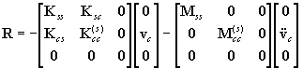(16.15a)
This equation can be further simplified by connecting the structure to the foundation with stiff massless springs that are considered as part of the structure. Therefore, the mass of the structure at the contact nodes is eliminated and Equation (16.15a) is reduced to
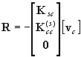(16.15b)
It is apparent that the stiffness terms in Equation (16.15b) represent the stiffness of the contact springs only. Therefore, for a typical displacement component (n = x, y or z), the forces acting at point "i" on the structure and point "j" on the foundation are given by
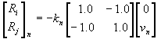(16.16)
where is the massless spring stiffness in the nth direction and is the free-field displacement. Hence, points "i" and "j" can be at the same location in space and the only loads acting are a series of time-dependent, concentrated, point loads that are equal and opposite forces between the structure and foundation. The spring stiffness must be selected approximately three orders-of-magnitude greater than the stiffness of the structure at the connecting nodes. The spring stiffness should be large enough so the fundamental periods of the system are not changed, and small enough not to cause numerical problems.
The dynamic equilibrium equations, with damping added, can be written in the following form:
(16.17)
It should be pointed out that concentrated dynamic loads generally require a large number of eigenvectors in order to capture the correct response of the system. However, if LDR vectors are used, in a mode superposition analysis, the required number of vectors is reduced significantly. The SAP2000 program has the ability to solve the multi-support, soil-structure interaction problems using this approach. At the same time, selective nonlinear behavior of the structure can be considered.
ANALYSIS OF GRAVITY DAM AND FOUNDATION
In order to illustrate the use of the soil-structure interaction option several earthquake response analyses of the Pine Flat Dam were conducted with different foundation models. The foundation properties were assumed to be the same properties as the dam. Damping was set at five percent. Ten Ritz vectors, generated from loads on the dam only, were used. However, the resulting approximate mode shapes, used in the standard mode superposition analysis, included the mass inertia effects of the foundation. The horizontal dynamic loading was the typical segment of the Loma Prieta earthquake defined in Figure 15.1a. A finite element model of the dam on a rigid foundation is shown in Figure 16.2.
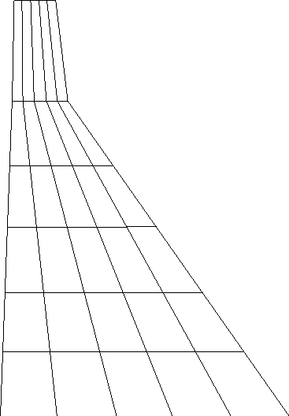
Figure 16.2. Finite Element Model of Dam only
The two different foundation models used are shown in Figure 16.3.

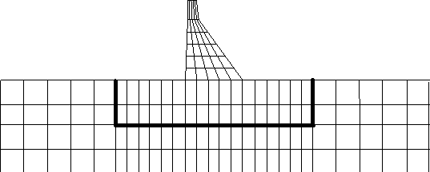

Figure 16.3. Models of Dam with Small and Large Foundation
Selective results are summarized in Table 16.1. For the purpose of comparison, it will be assumed that Ritz vector results, for the large foundation mesh, are the referenced values.
Table 16.1. Selective Results Of Dam-Foundation Analyses

 | DAM WITH NO Foundation | SMALL Foundation | LARGE Foundation
TOTAL MASS lb-sec²/in | 1,870 | 13,250 | 77,360
PERIODS seconds | 0.335 0.158 | 0.404 0.210 | 0.455 0.371
Max. Displacement inches | 0.65 | 1.28 | 1.31
Max & Min Stress ksi | -37 to +383 | -490 to +289 | -512 to +297
The differences between the results of the small and large foundation models are very close which indicates that the solution of the large foundation model may be nearly converged. It is true that the radiation damping effects in a finite foundation model are neglected. However, as the foundation model becomes larger, the energy dissipation due to normal modal damping within the massive foundation is significantly larger than the effects of radiation damping for transient earthquake type of loading.
THE MASSLESS FOUNDATION APPROXIMATION
Most general purpose programs for the earthquake analysis of structures do not have the option of identifying the foundation mass as a separate type of mass on which the earthquake forces do not act. Therefore, an approximation that has commonly been used is to neglect the mass of the foundation completely in the analysis. Table 16.2 summarizes the results for an analysis of the same dam-foundation systems using a massless foundation. As expected, these results are similar. For this case the results are conservative; however, one cannot be assured of this for all cases.
Table 16.2. Selective Results Of Dam With Massless Foundation Analyses

 | DAM WITH NO Foundation | SMALL Foundation | LARGE Foundation
TOTAL MASS lb-sec²/in | 1,870 | 1,870 | 1,870
PERIODS seconds | 0.335 0.158 | 0.400 0.195 | 0.415 0.207
Max. Displacement inches | 0.65 | 1.27 | 1.43
Max & Min Stress ksi | -37 to +383 | -480 to +289 | -550 to +330

APPROXIMATE RADIATION BOUNDARY CONDITIONS
If the foundation volume is large and the modal damping exists, it was demonstrated in the previous section that a finite foundation with fixed boundaries can produce converged results. However, the use of energy absorbing boundaries can further reduce the size of the foundation required to produce a converged solution.
In order to calculate the properties of this boundary condition consider a plane wave propagating in the x-direction. The forces, which cause wave propagation, are shown acting on a unit cube in Figure 16.4.
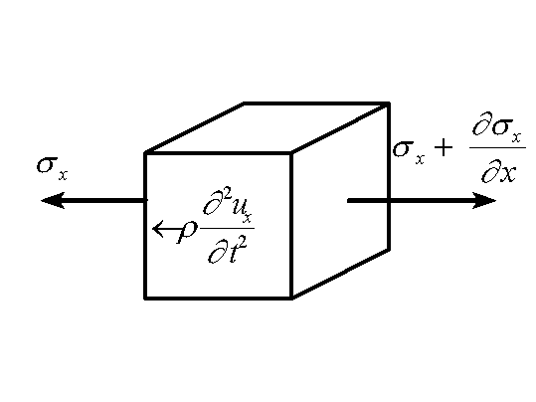
Figure 16.4. Forces Acting on Unit Cube
From Figure 16.4 the one dimensional equilibrium equation in the x-direction is
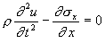(16.18)
Since 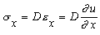the one dimensional partial differential equation is written in the following classical wave propagation form:
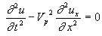(16.19)
where is the wave propagation velocity of the material and is given by
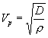(16.20)
in which is the mass density and is the bulk modulus given by
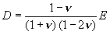(16.21)
The solution of Equation (16.13), for harmonic wave propagation in the positive x-direction, is a displacement of the following form:
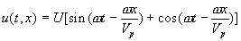(16.22)
This equation can be easily verified by substitution into Equation (16.18). The arbitrary frequency of the harmonic motion is . The velocity, , of a particle at location x is
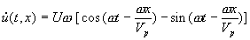(16.23)
The strain in the x-direction is
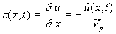(16.24)
The corresponding stress can now be expressed in the following simplified form:
(16.25)
The compression stress is identical to the force in a simple viscous damper with constant damping value equal to per unit area of the boundary. Therefore, a boundary condition can be created, at a cut boundary, which will allow the wave to pass without reflection and allow the strain energy to "radiate" away from the foundation.
Also, it can be easily shown that the shear wave "radiation" boundary condition, parallel to a free boundary, is satisfied if damping values are assigned to be per unit of boundary area. The shear wave propagation velocity is given by
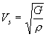(16.26)
where is the shear modulus.
The FNA method can be used to solve structures, in the time domain, with these types of boundary conditions. In later editions of this book, the accuracy of these boundary conditions approximation will be illustrated with numerical examples. Also, it will be used with a fluid boundary where only compression waves exist.
USE OF SPRINGS AT THE BASE OF A STRUCTURE
Another important structural modeling problem, which must be solved, is at the interface of the major structural elements within a structure and the foundation material. For example, the deformations at the base of a major shear wall in a building structure will significantly affect the displacement and force distribution in the upper stories of a building for both static and dynamic loads. Realistic spring stiffness can be selected from separate finite element studies or by using the classical half-space equations that are given in Table 16.3.
It is the opinion of the author that the use of appropriate site-dependent free-field earthquake motions and selection of realistic massless springs at the base of the structure are the only modeling assumptions required to include site and foundation properties in the earthquake analysis of most structural systems.
Table 16.3 also contains effective mass and damping factors that include the approximate effects of radiation damping. These values can be used directly in a computer model without any difficulty. However, considerable care should be taken in using these equations at the base of a complete structure. For example, the effective earthquake forces must not be applied to the foundation mass.
Table 16.3. Properties Of Rigid Circular Plate On Surface Of Half-Space

DIRECTION | STIFFNESS | DAMPING | MASS
Vertical | 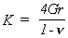
Horizontal | 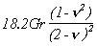
Rotation
Torsion
plate radius; shear modulus; Poisson's ratio; mass density
Source: Adapted from "Fundamentals of Earthquake Engineering, by Newmark and Rosenblueth, Prentice-Hall, 1971
SUMMARY
A large number of research papers and several books have been written on structure-foundation-soil analysis and site response due to earthquake loading. However, the majority of these publications have been restricted to the linear behavior of soil-structure systems. It is possible, with the use of the numerical methods presented in this book, to conduct accurate earthquake analysis of real soil-structure systems in the time domain, including many realistic nonlinear properties. Also, it can be demonstrated that the solution obtained is converged to the correct soil-structure interactive solution.
For major structures on soft soil one dimensional site response analyses should be conducted. Under major structural elements, such as the base of a shear wall, massless elastic springs should be used to estimate the foundation stiffness. For massive structures, such as gravity dams, a part of the foundation should be modeled by three dimensional SOLID elements in which SSI effects are included.
REFERENCES
"SHAKE - A Computer Program for the Earthquake Response for Horizontally Layered Sites", by P. Schnabel, J. Lysmer and H. Seed, EERC Report No. 72-2, University of California, Berkeley, February 1970.
J. Hart. and E. Wilson "WAVES - An Efficient Microcomputer Program for Nonlinear Site Response Analysis", National Information Center for Earthquake Engineering, Davis Hall, University of California, Berkeley, Tel. # (415) 642-5113.
R. Clough, and J. Penzien, Dynamics of Structures, Second Edition, McGraw-Hill, Inc., ISBN 0-07-011394-7, 1993.

