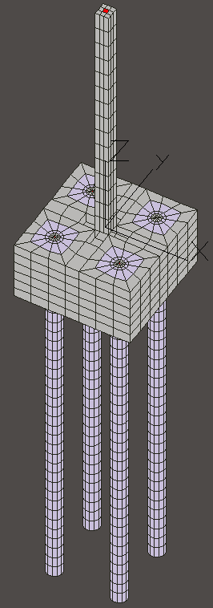 | Soil Structure Interaction: Pile Groups  Finite Element Modeling of static and dynamic behavior of pile groups with material and geometric nonlinear behavior of soil and concrete on in-house developed parellel computer software and hardware.
We here present the approach to solving a problem of Dynamic Soil- Structure Interaction based on the finite element method and parallel, off-the-shelf computer technology.

The implication of proposed methodlogy is that soon, every civil engineering academic department and civil engineering design company will have computer system similar to NorthCountry, and be able to develop various design options by means of affordable and efficient parallel finite element numerical computations.
Foundation system consisting of a group of four piles with a superstructure (bridge) is loaded by an earthquake. We modele the system by using a full 3D finite element method in time domain and include the effects of large deformations (geometic nonlinearities) and elasto-plasticity (material nonlinearities).

The problem size and computational requirements are such that we opted to use our recently developed parallel computer NorthCountry, based on the Beowulf concept.
One of our finite element models for a pile group is shown on figures below. It features four concrete piles, 30m long, each 2m in diameter, connected on top by a concrete pile cap, a 2m thick, 7m square plate. The pile cap extends into a 1m thick and 7m wide bridge pier. Superstructure (bridge) is initially modeled only as mass added to the system, while we will be adding (finite element model of) bridge structure in later stage of the project. This pile group is embedded in soil. The soil region is modeled as a solid cylinder 60m in diameter and 70m in height. The elements used for the finite element mesh are 8 node bricks. There are 25,832 brick elements, 29,484 nodes and 88,140 degrees of freedom. The size of the stiffness matrix, saved in skyline format is 584.2 MB. The number of Gauss points for the soil part of the system (a majority of which will plasticize) is in the order of 140,000, if we assume 2x2x2 integration rule for each finite element.

The size of this finite element model is such that currently only large commercial (quite expensive) computer workstation can handle memory requirements, while the processing power needed would require vector supercomputer and even then will take considerable amount of computer time to perform dynamic material and geometric nonlinear finite element analysis. In contrast to that, with our in-house developed parallel computer and Plastic Domain Decomposition (PDD) Method based parallel material and geometric nonlinear finite element program, the problem of this size will be analyzed in reasonable computer time on a local parallel computer.

The implication of being able to analyze such problems on an inexpensive computer system is that in near future it will be possible for civil engineering academic departments and/or civil engineering design companies to have similar computer systems with installed finite element software and be able to develop various design options by means of affordable and efficient parallel finite element numerical computations.
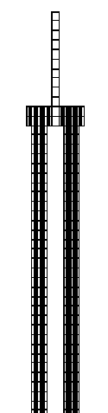Side view of a four pile group with a pile bridge pier on top.
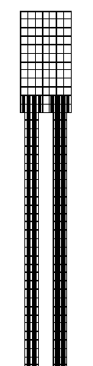
Fronr view of a four pile group with a pile cap a bridge pier on top.
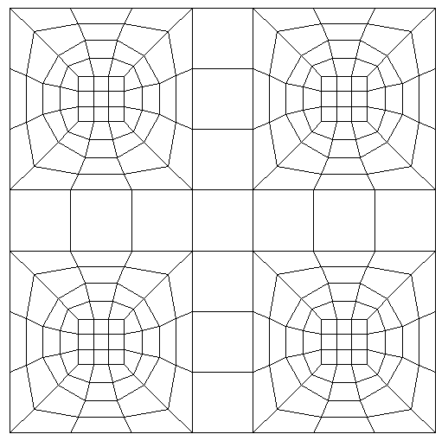Top view of a four pile group with a pile cap and a bridge pier in the middle.
Top view of the com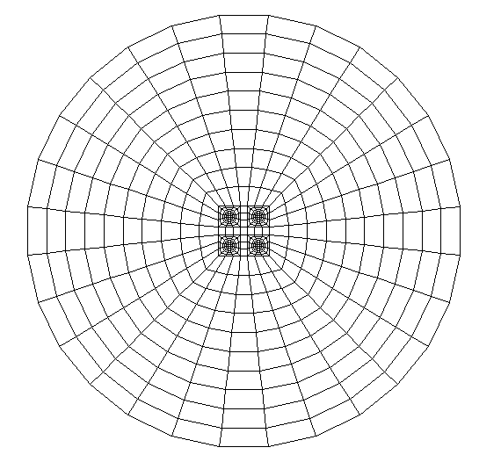plete FEM model.
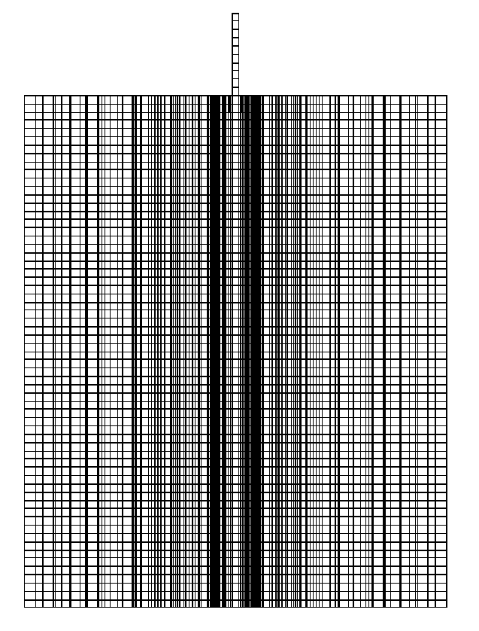Side view of the complete FEM model.
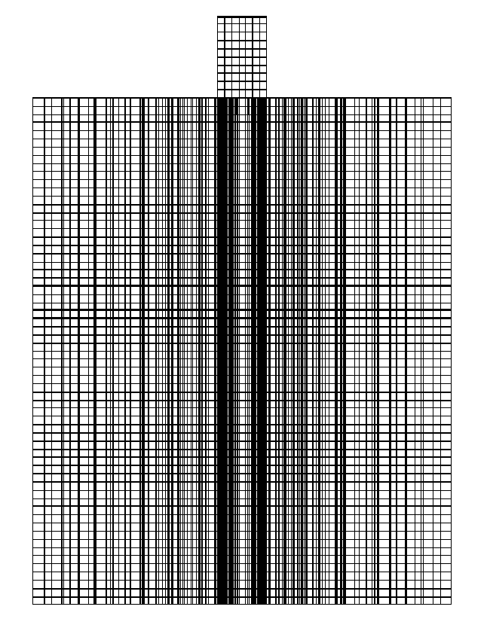Front view of the complete FEM model.
Boris Jeremic
Sept. 1998

