Physics-507
Homework Set (6)

This set is due by Monday 13th of Safar, 1435 (16th of December 2013) at 10.00 p.m.

In all homeworks, please solve fully and clearly, state assumptions, and comment wisely (when applicable).

Please circle your final answer, and identify which of the multiple choices is the correct answer.

As discussed today in class, please solve this problem set independently (without communication with other people, not even virtually)

I wish you well, wa assalam alaikum!!
Zain Yamani
Phys-507 Instructor

Question #1:
A system consists of two-pendula of equal mass and equal length oscillating in the same vertical plane. The pendula are connected by a horizontal spring that is unstretched when the masses are in the vertical positions. Consider small oscillations only.
- From symmetry arguments discuss the expected normal modes for the system). Is there anything to be said about the eigenfrequencies?
- Formally (i.e. mathematically) determine the normal frequencies and normal modes of oscillation.
- Find the general motion of the masses as a function of time if initially each of the two masses were struck (from rest at equilibrium position) in opposite directions with an impulse of magnitude I.

Question-2:
Three particles of the same mass (m) are constrained to move in a common circular path. They are connected by three, originally outstretched, ideal identical springs. [see figure]
- From symmetry arguments discuss the expected normal modes for the system). Is there anything to be said about the eigenfrequencies?
- Analytically find the frequencies and normal modes of vibration.
- Use a computer code (*) to animate the different modes of “vibration”.

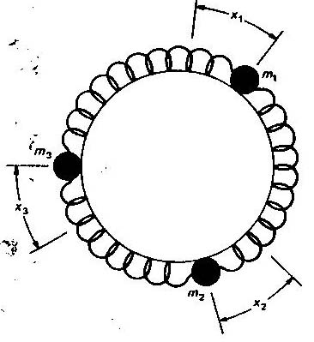

(*) feel free to use my code at: http://faculty.kfupm.edu.sa/phys/zhyamani/teaching/Coupled_Oscillations/lectures/lecture_8/four%20masses%20on%20a%20rim%20connected%20by%20springs.nb, but now there are just three masses instead of four.

