Phys-301
Set-III
[This set is due by Wedneday, the 17th Dhul-Qi’dah, 1433 at 4.00 p.m.]

Instructions:
- Please solve all problems completely and clearly.
- State your assumptions.
- If you do not understand the question(s) please call me.
- I do not mind that you discuss with your fellow classmates.
- Let’s start: بسم الله

Question-1:
A point-mass (m = 63.32 grams) is connected to a spring (stiffness k = 2500 dyne/cm) on a horizontal table. The non-stretched (i.e. equilibrium) position of the system is at x = 0. At time t = 0, the mass is stretched to x = 2 cm and let go. The system oscillates along the x-axis [neglect friction]:
- What is the period of oscillation, in seconds.
- Write down the equation of motion for the oscillating mass.
- What is the speed of the mass at x = 1 cm.
- How long does it take the mass to move from x = 0 cm to x = -1 cm.

Question 2:
Fig. 7 shows a U-tube with cross-sectional area A and partially filled with oil of density ρ. A solid cylinder, which fits the tube tightly but can slide without friction, is placed in the right arm. The system is in equilibrium. Find the weight of the cylinder in terms of g, h, A, L, and ρ.

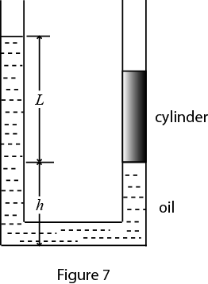

Question 3:
Describing the “acceleration” vector quantity in 3-dimensional rectangular coordinates is basically staightforward.
Describe the same quantity in spherical polar coordinates. Confirm that it reduces to the expected when motion is (just) one dimenstional.

