Phys-301
Set-II
[This set is due by Monday, the 30th of Shawwal, 1433 at 4.00 p.m.]

Instructions:
- Please solve all problems completely and clearly.
- State your assumptions.
- If you do not understand the question(s) please call me.
- I do not mind that you discuss with your fellow classmates.
- Let’s start: بسم الله

Question-1:
Estimate the magnitude of the gravitational force that the Sun exerts on Earth.

Question 2:
A 1-kg rock is suspended by a mass-less string from one end of a 1-m measuring stick. What is the weight of the measuring stick if it is balanced by a support force at the 0.25 meter mark.

Question 3:
Calculate (approximately) the ratio of the mass of the sun to the mass of the earth using only length of the year, lunar month, and the radii of the orbits of earth about the sun and the moon about earth.

Question 4:

A bucket of water [see figure] is filled to a height [H]. Find the height of a hole in the bucket [h] at which the pissing water travels the maximum range. Neglect air resistance.
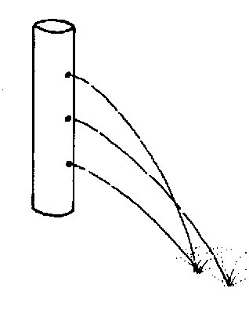

Question 5:
In the figure below, point (O) is at the center of the cube.
- Use geometry and/ or trigonometry to find the angle aÔb. [Ans. 70.5º ].
- From symmetry considerations, and using clear arguments, find the angle aÔc
- Does this remind you of some well-known molecular configuration of a hydrocarbon?

c
b
o
a

سؤال خارجي: في أي آية من أي سورة يقول الله تعالى{و قل ربي زدني علما}. ما تفسيرها، و ما هو واجبي (كفيزيائي) تجاهها؟

