Physics-301
Homework Set (1)

The main objective of this problem set is for you to review what you studied in earlier Classical Mechanics courses.

This set is due by Wednesday, 18th of Shawwal, 1433 (5th of September 2012) at 4.00 p.m.

In all homeworks, please solve fully and clearly, state assumptions, and comment wisely (when applicable).

Please circle your final answer, and identify which of the multiple choices is the correct answer.

You are welcome to “discuss” the problems with your classmates, but NO copying ← be responsible for ‘your’ solution.

I wish you well, wa assalam alaikum!!
Zain Yamani
Phys-301 Instructor
Q1.
An aluminum cylinder of density 2.70 g/cm³, a radius of 2.30 cm, and a height of 1.40 m has the mass of:

A) 13.8 kg
B) 6.28 kg
C) 25.0 kg
D) 8.50 kg
E) 45.1 kg

Q2.
If and, then =

A) (4.0+ 1.0) m
B) (−1.0) m
C) (−4.0 + 7.0) m
D) (4.0 − 7.0) m
E) (1.0) m

Q3.
An 8.0 kg block is pushed against a vertical wall by a horizontal force F as shown in Fig 7. If the coefficients of friction between the block and the wall are μ_{s} = 0.60 and μ_{k} = 0.30 then the minimum value for (F) that will prevent the block from slipping is:

A) 260 N
B) 87 N
C) 130 N
D) 78 N
E) 24 N

Q4.
To measure your weight, you stand on a spring scale on the floor of an elevator. Among the following situations, select the one that gives the highest reading on the scale:

A) The elevator remains stationary.
B) The elevator moves downward at constant speed.
C) The elevator moves upward with increasing speed.
D) The elevator moves upward with decreasing speed.
E) The elevator moves downward with increasing speed.

Q5.
A boy wishes to swim across a river from A to B. He can swim at 1.0 m/s in still water and the river is flowing at 0.50 m/s (Fig 3). At what angle θ should he be heading?

A) 70°
B) 30°
C) 60°
D) 20°
E) 45°

Q6.
A box with a weight of 50 N rests on a horizontal surface with μ_{s}= 0.40. A person pulls horizontally on it with a force of F₂=10 N and it does not move. To start it moving, a second person pulls vertically upward on the box with a force F₁ (see Fig 6). What is the smallest vertical force (F₁) for which the box starts moving?

A) 14 N
B) 35 N
C) 25 N
D) 10 N
E) 5.0 N

Q7.
A stone is thrown vertically downward from the top of a 40 m tall building with an initial speed of 1.0 m/s. After 2.0 s the stone will have traveled a distance of

A) 25 m
B) 38 m
C) 40 m
D) 15 m
E) 22 m

Q8.
A 7.0 kg block and a 3.0 kg block are connected by a string as shown in Fig 5. If the pulley is massless and the surface is frictionless, the magnitude of the acceleration of the 3.0 kg block is:

A) 3.3 m/s²
B) 9.8 m/s²
C) 6.7 m/s²
D) 2.9 m/s²
E) 4.9 m/s²

Q9.
A 2.0 kg block is released from rest the top of a ramp (point A) as shown in Fig 8. The coefficient of kinetic friction between the block and the inclined surface is 0.20. The speed by which the block hits the bottom (point B) is:

A) 6.6 m/s
B) 11 m/s
C) 0.0 m/s
D) 13 m/s
E) 2.0 m/s

Q10.
A vector in the xy plane has a magnitude of 25 m and an x component of +12 m and a positive y component. The angle it makes with the positive y axis is:

A) 64°
B) 29°
C) 26°
D) 241°
E) 61°

Q11.
Two vectors and have magnitudes of 10 m and 15 m respectively. The angle between them is 65°. The component (projection) of along is:

A) 6.3 m
B) 7.5 m
C) 4.2 m
D) 0
E) 9.1 m

Q12.
A particle starts from the origin at t = 0 and moves along the positive x-axis. A graph of the velocity of the particle as a function of time is show in Fig 1. The average velocity of the particle between t = 0.0 s and 5.0 s is:

A) 1.4 m/s
B) 3.5 m/s
C) 0 m/s
D) 1.0 m/s
E) -2.0 m/s

Q13.
A 1000 kg car moves on a level horizontal circular road of radius 50 m. The coefficient of static friction between the tires and the road is 0.50. The maximum speed with which this car can round this curve without slipping is:

A) 3.0 m/s
B) 12 m/s
C) 4.9 m/s
D) 9.8 m/s
E) 16 m/s

Q14.
A stone is tied to a 0.50 m string and rotated at a constant speed of 2.0 m/s in a vertical circle. Its acceleration at the bottom of the circle is:

A) 9.8m/s², down
B) 8.0m/s², down
C) 32 m/s², up
D) 8.0 m/s², up
E) 9.8 m/s², up

Q15.
At a traffic light, a truck traveling at 10 m/s passes a car as it starts from rest. The truck travels at a constant velocity and the car accelerates at 4.0 m/s². How much time does the car take to catch up with the truck?

A) 25 s
B) 15 s
C) 20 s
D) 5.0 s
E) 2.0 s

Q16.
The coordinate of a particle in meters is given by, where the time t is in seconds. The particle is momentarily at rest at time t equal to:

A) 0.75 s
B) 2.0 s
C) 1.3 s
D) 4.0 s
E) 0.50 s

Q17.
An elevator cab with a total mass of 2000 kg is pulled upward by a cable. If the elevator accelerates at 2.00 m/s² upward, find the tension in the cable.

A) 3.25 ×10⁴ N
B) 9.80 N
C) 0.00 N
D) 2.36 ×10⁴ N
E) 1.56 ×10⁴ N

Q18.
An arrow is shot horizontally from a point P toward X as shown in Fig 2. It hits at a point Y, 0.20 s later. If the speed of the arrow at P is v_{o}= 11 m/s, the distance PX is:

A) 1.8 m
B) 2.2 m
C) 1.0 m
D) 0.1 m
E) 0.5 m

Q19.
A 4.0 kg block is pushed upward a 30° inclined frictionless plane with a constant horizontal force F (Fig 4). If the block moves with a constant speed find the magnitude of the force F.

A) 9.8 N
B) 23 N
C) 40 N
D) 33 N
E) 0 N

Q20.
A train traveling north at 20 m/s turns and then travels south at 20 m/s. The change in its velocity is:

A) 40 m/s south
B) 20 m/s south
C) 40 m/s north
D) 20 m/s north
E) 0 m/s

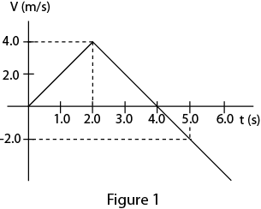 | 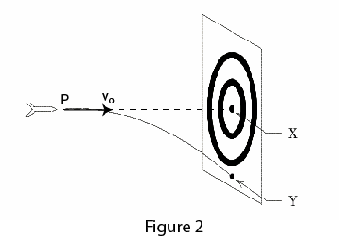
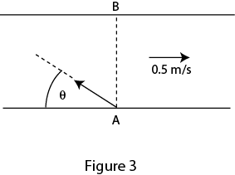 | 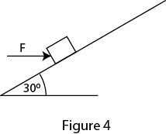
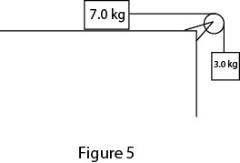 | 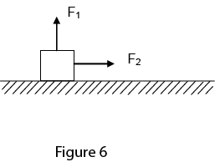
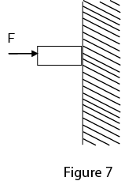 | 