HW. Questions Chapter 30 (Dr. Gondal-Phys102)
T062
Q29. A 1.7-T uniform magnetic field makes an angle of 30⁰ with the z axis. The magnetic flux through an area of 4.0-m² lying in the xy-plane is: (Ans:6.0 T.m²)
Q30. A uniform magnetic filed B is perpendicular to a loop of an area 1.5 m². The resistance of the wire forming the loop is 2.50 Ω. At what rate must the magnitude of the magnetic field B change to induce a current of 0.3 A ? (Ans: 0.5 T/s)
T061: Q#28. Each turn of a 150-turn coil, encloses an area of 0.8 m². What should be the rate of change of a magnetic field parallel to its axis in order to induce a current of 0.1 A in the coil? [The resistance of the coil is 600 Ohm] (Ans: 0.50 T/s.)
Q#30. A constant magnetic flux of 4.0×10⁻⁵ Wb is maintained through a coil for 0.5 s. What emf is induced in the coil by this flux during that period? (Ans: Zero)
T-052: Q#26. Figure 8 shows a metal rod of length 25 cm moving at a constant velocity along two parallel metal rails. If the magnetic field is 0.35 T into the page, and the induced emf is 15 mV, calculate the speed of the metal bar. (Ans: 14 cm/s.)
Q#30. A long straight wire carries a current that increases at a rate of 6×10⁴ A/s. The wire passes through the center of a circular loop of radius 5 cm, as shown in Figure 9. The induced emf in the loop is: (Ans: 0 mV)

Fig. 8, T052 Fig. 9, T052 Fig. 1, T051 Fig. 2, T051 Fig. 7, T051

T-051: Q#2. A long solenoid has 10 turns per cm and carries a 4 A current. A circular loop with cross-sectional area = 8 cm 2 has 5 turns and lies within the solenoid with its axis parallel to the axis of the solenoid. Find the magnitude of the induced emf if the current increases 0 to 4 A in 0.1 s. (Ans: 4.0×10 -4 V) T-051: Q#2. A long solenoid has 10 turns per cm and carries a 4 A current. A circular loop with cross-sectional area = 8 cm 2 has 5 turns and lies within the solenoid with its axis parallel to the axis of the solenoid. Find the magnitude of the induced emf if the current increases 0 to 4 A in 0.1 s. (A1: 4.0×10 -4 V)
Q#3. A 500 turns toroid has a radius of 5 cm. If the magnetic field inside the toroid is 0.04 T, the current passing through the toroid is. (A1: 20 A)
Q#8. A flat circular coil has 80 turns of diameter 20 cm with a total resistance of 40 . The plane of the coil is perpendicular to a uniform magnetic field. At what rate should the magnetic field change for the power dissipated in the coil to be 2 W? (A1: 3.6 T/s)
Q# 19. A metal bar is free to move over a U-shaped metal rail, as shown in the figure 1. At t=0s, the external field is 0.4 T directed out of the page and is increasing at a rate of 0.2T/s. What will be the velocity of the metal bar such that the induced emf will be zero at x = 5 cm and t = 0 ? Take L=5 cm. ( A1: 0.025 m/s, along –x direction.)

v
I
Figure 9

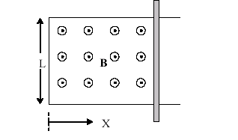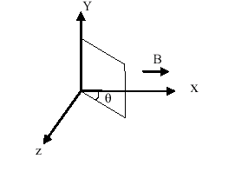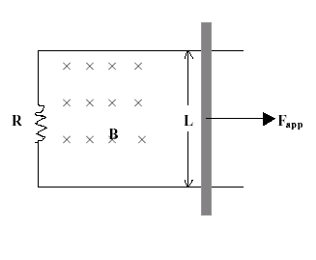
T051-Fig.1 T051-Fig.2 T042-Fig.9 T001-Fig. 7

Q#26. A square coil of side 20 cm is rotating about the y-axis. It is oriented as shown in the figure 2. The external field is B = 0.5 T along the positive x-axis. What is the change in the magnetic flux through the coil if the angle ⎝ changes from 37 o to 53 o ?. (A1: -4 mWb.)
T042: Q29: A small circular loop of area 0.50 cm**2 is placed in the plane of, and concentric with, a large circular loop of radius 2.0 m. The current in the large loop is changed uniformly from +100 A to –100 A in a time of 0.50 s. Find the emf induced in the small loop in this time interval (Assume the field is uniform through the smaller loop). (A1: 6.3*10**(-9) V.)
Q30: A long straight wire is in the plane of a circular conducting loop as shown in figure 9. The straight wire carries a constant current I in the direction shown. The circular loop starts moving to the left. The induced current in the circular loop is: (A1: counter clockwise.)
T-041 Q#1: A circular wire loop, of an area 0.10 m**2, is initially oriented so that its plane is perpendicular to a 0.40 T magnetic field. When the loop is rotated so that its plane is parallel to the field, a 25 V average potential difference is induced across the loop. The time (in seconds) required to make this rotation of the loop is (A1: 1.6*10**(-3).)
Q#2: A 2.0 m long copper wire, with resistance 5.0 Ohm, is formed into a square loop and placed perpendicular to a uniform magnetic field that is increasing at the constant rate of 10.0 mT/s, at what rate is thermal energy generated in the loop? (A1:1.3*10**(-6) W.)
T-032:Q#1: A 400-turn coil of total resistance 6.0 ohm has a cross sectional area of 30 cm**2. How rapidly should a magnetic field parallel to the coil axis change in order to induce a current of 0.3 A in the coil? (Ans: 1.5 T/s.)
Q#2: A circular wire loop of area 0.5 m**2 is perpendicular to a magnetic field of 0.8 T. If the coil is removed completely from the field in 0.1 s, the average emf induced in the loop has a magnitude (Ans: 4.0 V.)
Q#3: A long straight wire carrying a constant current I is in the plane of a circular conducting loop as shown in figure (9). If the wire is moved away from the loop toward point A, the current induced in the loop is (Ans: clockwise.)

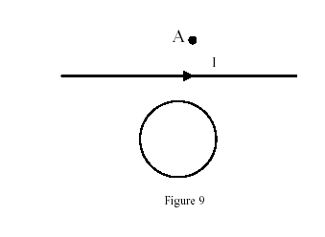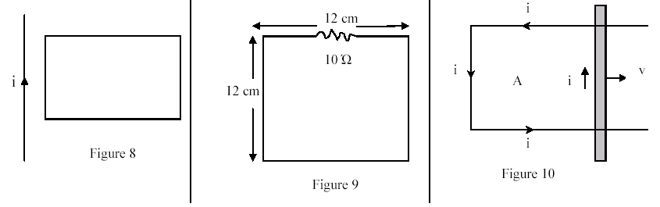

T032-Fig.9 T031-Fig.8 T031-Fig.9 T031-Fig.10

T031 Q#1: A long straight wire is in the plane of a rectangular conducting loop as shown in Figure 8. The straight wire carries an increasing current “i” in the direction The current in the rectangular is: (Ans: counter clockwise.)
Q#2: The circuit shown in figure 9 is in a uniform magnetic field that is into the page and is decreasing in the magnitude at the rate of 150 T/s. The current in the circuit is: (Ans: 0.22 A.)
Q#3: Figure 10 shows a bar moving to the right on two conducting rails. To make an induced current in the direction indicated, a constant magnetic field in region “A” should be in what direction? (Ans: Into the page.)
T011: Q#1: A single turn plane loop of wire of cross sectional area 40 cm**2 is perpendicular to a magnetic field that increases uniformly in magnitude from 0.5 T to 5.5 T in 2.0 seconds. What is the resistance of the wire if the induced current has a value of 1.0*10**(-3) A? (Ans: . 20 Ohms.)
Q#2: The magnitude of the magnetic field at 88.0 cm from the axis of an infinitely long wire is 7.30*10**(-6) T. What is the current in the wire? (Ans: 42.8 A.)
T002: Q#1: Faraday's law states that an induced emf is proportional to: (Ans: the rate of change of magnetic flux.)
Q#2: A magnet is taken towards a metallic ring in such a way that a constant current of 10**(-2) A is induced in it. The total resistance of the ring is 0.25 Ohm. In 10 seconds, the flux of the magnetic field through the ring changes by: (Ans:2.5*10**(-2) Wb.)
Q#3: Consider a circular loop of wire within which the magnetic flux, Phi, is given as a function of time, t, as Phi = a*t**2 + b, where a and b are constants. If the induced emf is measured as 48 V at t=3 s, what is the value of a? (Ans:- 8.0 V/s.)
T001: Q#1: A single turn plane loop of wire of cross sectional area cm**2 is perpendicular to a magnetic field that increases uniformly in magnitude from 0.5 T to 5.5 T in 2.0 seconds. What is the resistance of the wire if the induced current has a value of 1.0 mA. (Ans: 10 Ohms)
Q#2: Figure 7 shows a conducting bar moving with a constant speed of 5.0 m/s to the right. Assume that R = 5.0 Ohms, L = 0.20 m, and that a uniform magnetic field of 3.5 T is directed into the page. Calculate the magnitude of the applied force pulling the bar.(Neglect the mass of the bar.) (Ans: 0.49 N)
T-991 Q#1:A conducting rod of length 1.2 m is moving with a speed of 10 m/s as shown in Figure 9. If the magnetic field is 0.55 T into the page. Calculate the potential difference between the ends of the rod. (Ans: 6.6 V)
Q#2: A flat coil of wire consisting of 20 turns, each with an area of 50 cm**2, is positioned perpendicularly to a uniform magnetic field that increases its magnitude at a constant rate from 2.0 T to 6.0 T in 2.0 s. If the coil has a total resistance of 0.4 ohms, what is the magnitude of the induced current in the coil? (Ans: 0.5 A)

