Old Exam Questions Chapter 29 (Dr. Gondal Phys102)
T081
Q10.Two long straight wires penetrate the plane of the paper at two vertices of an equilateral
triangle as shown in Fig 6. They each carry 2.0 A, out of the page. The magnetic field at the third vertex (P) has magnitude (in T): A) 1.7 × 10−5
Q12. A long, coaxial cable, shown in cross-section in Fig 8, is made of two conductors that share a common central axis, labeled C. The current in the inner conductor is 2.0 A directed into the page and that in the outer conductor is 2.5 A directed out of the page. The distance from point C to B is 0.0030 m. What is the magnitude and direction of the magnetic field at point B? ( Ans: 3.3 × 10–5 T, counterclockwise)
Q13. Solenoid 2 has twice the radius and six times the number of turns per unit length as solenoid 1. Find the ratio of the magnetic field in the interior of solenoid 2 to that in the interior of solenoid 1, if the two solenoids carry the same current. (Ans: 6)

Fig.6, T081 Fig.8, T081

T072: Q23.Two long parallel straight wires, at a separation d = 20.0 cm, carry currents i1 = 3.61 mA and i2 = 3.00 mA out of the page. At what distance from the origin on the x-axis shown in Fig. 1, is the net magnetic field due to the currents equal zero? (Ans: 11 cm)
Q24. What are the strength and direction of the magnetic field at point P in Fig. 2 at the center of arcs, if the current in the loop is 5.0 A? (Ans: 79 μT into the page)
Q25: A long solid cylindrical wire, of radius R = 2.00 cm carries a uniform current of 1.9 A. Find the magnetic field strength at a distance of 1 cm from the center of the wire. (Ans: 9.5 μT)
Q27.We wish to generate a 0.10 T uniform magnetic field near the center of a 10 cm long ideal solenoid. What is the minimum number of turns needed, if the wire can carry a maximum current of 10 A? (Ans: 800)
T071
Q23. Two long straight, parallel wires are 3.0 cm apart. They carry currents I1 = 3.0 A and I2= 5.0 A in opposite directions, as shown in the figure 1. At what point, beside infinity, could the magnetic field be zero? (Ans: A)
Q24. A cylindrical wire of radius R carries current I uniformly distributed across its cross-section.
Find the magnetic field inside the wire at r < R from the axis. (Ans: B=μ₀i r/(2πR²))
Q25. A magnetic field of 0.10 T is generated near the center of a 10 cm long solenoid. How many turns are needed if the current in the wire is 10 A? (Ans: 796)
Q27. What is the magnetic field at the center of the loop in the figure 2. (Ans: 2.1⋅10⁻⁴ T into the page)

Fig 1, T072 Fig 2, T072 Fig 1, T071 Fig 2, T071
T062 Q24. The figure 1 shows four wires carrying equal currents and four Amperian loops. Rank the loops according to the magnitude of along each, greatest first. (Ans: c, b and d tie, then a )

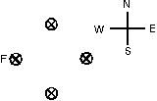
a
c
d
b
Enclosed all wire
Enclosed one wire
Enclosed two wire
Enclosed three wire
A
Fig. 1, T062 Fig. 2, T062
Q25. Four long straight wires carry equal currents into the page as shown in the figure 2 . The direction of the net magnetic force exerted on wire A by the other three wires is: (Ans: East)
Q26. A very long wire carries a current I = 0.5 A directed along the negative x-axis. Part of the wire is bent into a circular section of radius R = 2.5 cm as shown in the figure. What is magnetic field at point C? (Ans: 16.6 μT, into the page)

y
I
.
C
R
I
x
I
a
b
Fig. 3, T062 Fig. 4, T062

Q27. An ideal solenoid that is 100 cm long has a diameter of 5.0 cm and a winding of 1000 turns and carries a current of 5.0 A. Calculate the magnetic field inside the solenoid. (Ans: 6.3 mT )
Q28. The following figure shows a hollow cylindrical conductor of inner radius a = 3.0 mm and outer radius b = 5.0 mm carries a current of 2.0 A parallel to its axis. The current is uniformly distributed over the cross section of the conductor. Find the magnitude of the magnetic field at a point that is 2.0 mm from the axis of the conductor. (Ans: Zero)

T-051: Q#2. A long solenoid has 10 turns per cm and carries a 4 A current. A circular loop with cross-sectional area = 8 cm 2 has 5 turns and lies within the solenoid with its axis parallel to the axis of the solenoid. Find the magnitude of the induced emf if the current increases 0 to 4 A in 0.1 s. (A: 4.0×10 ⁻⁴ V).
Q#3. A 500 turns toroid has a radius of 5 cm. If the magnetic field inside the toroid is 0.04 T, the current
passing through the toroid is (A: 20 A).
Q#14. The figure 1 shows three arrangements of circular loops, centered on vertical axes and carrying identical currents in the directions indicated. Rank the arrangements according to the magnitudes of the magnetic fields at the midpoints between the loops on the central axes, maximum to minimum.(A: 1, 3, 2)
Q#16. In the figure 2 shown, R2 = 3×R1 = 9 cm. The current i = 10A. Calculate the magnitude magnetic field at point p.(A: 7.0×10 -5 Tesla.)
Q#30. The figure 3 shows three parallel wires carrying currents I1 = 2 A, I2 = 6 A, and I3. The spacing between adjacent wires is 1 cm. Calculate the value of I3 such that the magnitude of the net force per unit length at the third wire is 0.25 × 10 -3 N/m.(A: 2.5 A).

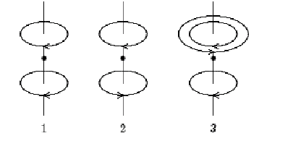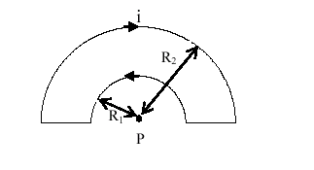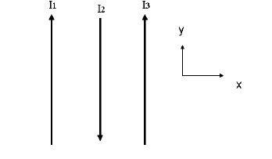
Fig. 1-T051 Fig. 2-T051 Fig. 3-T051
T-042: Q#22: Five long, straight, insulated wires are closely bound together to form a small cable of diameter 1.0 cm. Currents carried by the wires are I1=20A, I2=-6A, I3=12A, I4=-7A, and I5=18A (negative currents are opposite in direction to the positive). Find the magnitude of the magnetic field at a distance 10 cm from the cable. (A1 74 micro-T.)
Q#23: A copper wire is of total length 1.0 m. You want to make N-turn circular current loop, using the entire wire, that generates a 1.0 mT magnetic field at the center of the coil when the current is 1.0 A. What will be the diameter of your coil? (A1 0.02 m.)

Figure 10

Y
X
r₂
r₁
1
3
2
0.5 m
0.5 m
Figure 8

Q#24: An electron is moving along the axis of a solenoid carrying a current. Which of the following is a correct statement about the magnetic force acting on the electron? (A1 No force acts )
Q#25 :Figure 10 shows two concentric, circular wire loops, of radii r1=15 cm and r2=30 cm, are located in the xy plane. The inner loop carries a current of 8.0 A in the clockwise direction, and the outer loop carries a current of 10.0 A in the counter clockwise direction. Find the net magnetic field at the center. (A1: 12.6*10**(-6)T,directed into the page.)
Q#26 : How strong is the magnetic field at a distance of 10.0 cm from a long straight wire, of radius 3.0 cm carrying a current of 5.0 A? (A1: 1.0*10**(-5) T.)

Q# 27 : Two long parallel wires, a distance d apart, carry currents of I and 5*I in the same direction. Locate the point r, from I, at which their magnetic fields cancel each other. (A1: r=d/6.)
Q# 28 : Three long parallel wires are arranged as shown in figure 8. Wires 1 and 3 each carries a current of 5.0 A in the directions shown. If the net magnetic force on wire 3 is zero, what is the magnitude and direction of the current in wire 2? (A1: 2.5 A, downwards. )
T-041 Q#1: Two long wires are parallel to the z-axis as shown in figure 2.Find the resultant magnetic field at the origin, given that the wires carry equal current I and moves in the same direction. [Take I= 1.0 A and a=0.5 m](Ans:Zero.)
Q#2: A solenoid has length L=2.0 m and diameter d=4.0 cm, and it arries a current I=6.0 A. It consists of seven closed packed ayers, each with 90 turns along length L. What is B at its enter? (Ans: 2.4*10**(-3) Tesla.)
Q#3: Two infinite parallel wires are separated by 2.5 cm and carry current 10 A and 12 A in the same direction. What is the force per unit length on each wire? (Ans:1.0*10**(-3) N/m, attraction.)
Q#4: Part of a long, flexible, current-carrying wire is made into a circular loop, while the rest of it lies in a straight line as shown in figure 3. What is the magnetic field strength at point C, the center of the loop? [Take I= 1.0 A and a=0.5 m] (Ans: 1.7*10**(-6) T, out of the page.)
Q#5: Figure 4 shows four circular loops concentric with a wire whose current is directed out of the page. The current is uniform across the cross section of the wire. Rank the loops according to the magnitude of the enclosed current, greatest first [loops a and b inside the wires, c and d are outside] (Ans: d = c > b > a.)
Q#6: A proton is moving along the axis of a solenoid carrying a current. Which of the following statement is CORRECT about the magnetic force acting on the proton? (Ans: No force acts.)
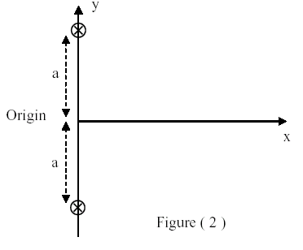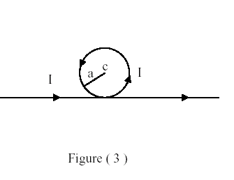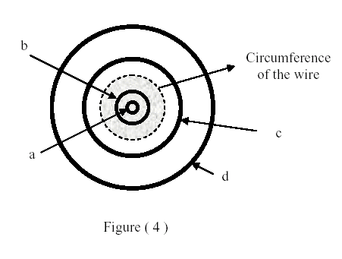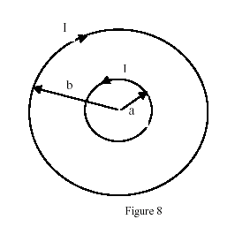
T041-Figure 2 T041-Figure 3 T041-Figure 4 T032-Figure 8
T-032:Q#1: Figure (8) shows two concentric circular loops of radii a and b and both carry a current I. Find the resultant magnetic field at the center of the two loops if a = 10 cm, b = 20 cm and I = 20 A. (Ans: 63 micro-T, out of the page.)
Q#2: Two long parallel wires, D and B, are separated by 2.0 cm. The current in D is THREE times the current in B. If the magnitude of the force on 2.0 m length of one of the wires is equal to 60 micro-N, find the current in B. (Ans: 1.0 A.)
Q#3: The radius R of a long current-carrying wire is 2.3 cm. If the magnetic field at r1 = 2.0 cm is equal to THREE times the magnetic field at r2, r2 > R, calculate the distance r2. (Ans: 7.9 cm.)
Q#4: A hollow cylindrical conductor of inner radius 3.0 mm and outer radius 5.0 mm carries a current of 80 A parallel to its axis. The current is uniformly distributed over the cross section of the conductor. Find the magnitude of the magnetic field at a point that is 2.0 mm from the axis of the conductor. (Ans: zero.)
T-031: Q#1: Two parallel wires, carrying equal currents of 10 A, attract each other with a force F. If both currents are doubled, and the distance between them reduced by 50%, the new force will be: (Ans: 8*F.)
Q#2: Four long straight wires carry equal currents into page as shown in Figure 6. The magnetic force exerted on wire “A” is: (Ans: East.)
Q#3: Consider two solenoids, A and B, having the same current. Solenoid B has twice the radius and six times the number of turns per unit length as solenoid A. The ratio of the magnetic field in the interior of solenoid B to that in the interior of solenoid A is: (Ans:6.)
Q#4: The segment of wire is formed into the shape as shown in Figure 7 and carries a current I = 6 A. When R = 6.28 cm, what is the magnetic field at the point P? (Ans: 3.0*10**(-5) T into the page.)

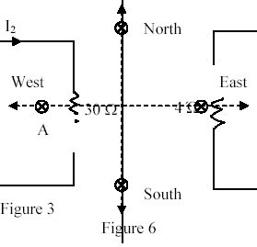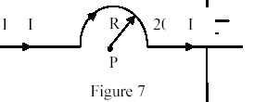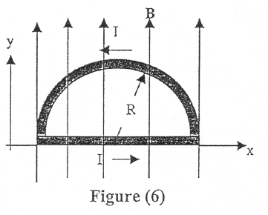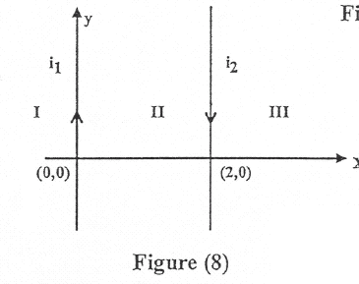
T031-Figure 6 T031-Figure 7 T011-Figure 6 T011-Figure 8
T011: Q#1: Figure (8) shows two wires carrying anti-parallel currents. If i2 is greater than i1, the point at which the resultant magnetic field of the two wires will be zero is located in the region (regions): (Ans: . II and III.)
Q#2: A 2.0 Tesla uniform magnetic field makes an angle of 60 degrees with the xy-plane. The magnetic flux through an area of 3 m**2 portion of the xy-plane is: (Ans: 3.0 Wb.)
Q#3: A wire bent into a semicircle of radius R = 2.0 m forms a closed circuit and carries a current of 1.5 A. The circuit lies in the xy-plane, and a uniform magnetic field B = 3.0 T is present along the y axis, as shown in figure (6). Find the magnitude of the magnetic force on the curved portion of the wire. (Ans: 18 N.)
Q#4: A current of 2.5 A passes in a solenoid of length L = 50 cm. It produces a magnetic field of 2.3*10**(-3) T at its center. The number of turns in the solenoid is: (Ans: 366.)
Q#5: Consider an infinitely long straight wire carrying a current I. If the magnetic field at r1 = 2.5 am inside the wire and at r2 = 10 am outside the wire are equal, then the radius of the wire is: (Ans: 4.0 mm.)
Q#6: Three long parallel wires, shown in figure (9), are in the xy-plane. Each wire carries a current of 3.0 A. The separation between the adjacent wires is d = 8.0 cm. What is the magnitude of the net force per meter exerted on the central wire by the other two wires? (Ans: . 9.2*10**(-5) N/m.)
Q#7: The magnitude of the magnetic field at 88.0 cm from the axis of an infinitely long wire is 7.30*10**(-6) T. What is the current in the wire? (Ans: 42.8 A.)
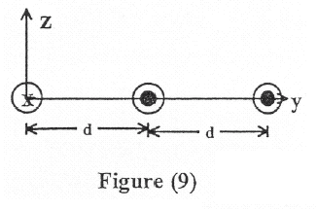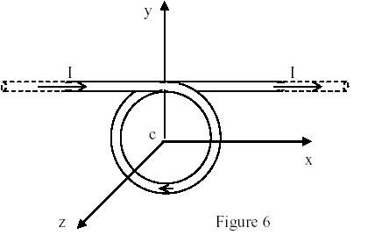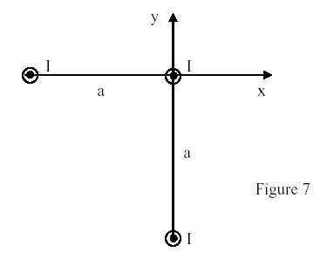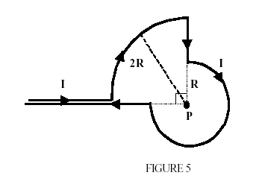
T011-Figure 9 T002-Figure 6 T002-Figure 7 T001-Figure 5
T002: Q#1: A conductor consists of a circular loop of radius R = 0.10 m and two straight, long sections, as in Figure (6). The wire lies in the plane of the paper (xy-plane) and carries a current of I = 5.3 A. Determine the magnetic field, in Tesla, at the center of the loop. (k is a unit vector in +z-direction) (Ans: -4.4*10**(-5) k.)
Q#2: A long solid cylindrical conductor of radius R= 4.0 mm carries a current I parallel to its axis. The current density in the wire is 2*10**4 A/m**2. Determine the magnitude of the magnetic field at a point that is 5.0 mm from the axis of the conductor. (Ans: 40 micro-T.)
Q#3: A solenoid is 3.0 m long and has a circumference of 9.4*10**(-2) m. It carries a current of 12.0 A. The magnetic field inside the solenoid is 25.0*10**(-3) T. The length of the wire forming the solenoid is: (Ans: 467 m.)
Q#4: Suppose that the identical currents I in figure (7) are all out of the page. The magnitude of the force per unit length on the wire at the origin is: [take I = 10.0 A, and a = 1.0*10**(-4) m.] (Ans: 0.28 N/m.)
T-001 Q#1: A segment of wire is formed into the shape shown in Figure 5 and carries a current I = 1.0 A. What is the magnitude of the resulting magnetic field at the point P if R = 10 cm? (Ans: 5.5 micro-T into the page)
Q#2: A 500 turns solenoid is 30 cm long, has a radius of 0.5 cm and carries a current of 2.0 A. The magnitude of the magnetic field at the center of the solenoid is: (Ans: 4.2*10**(-3) T)
Q#3: Two long wires parallel to the x-axis carry currents I1 and I2 as shown in Figure 6. If I1 = 5 A, what is the magnitude and direction of I2 if the net magnetic field at the origin is 0.35 micro-T and directed out the page. (Ans: 1 A to the left)
Q#4: What must be the radius R of a long current-carrying wire if the magnetic field at r1 = 2.0 cm (inside the wire) is equal to three times the magnetic field at r2 = 8.0 cm (outside the wire). (Ans: 2.3 cm)
Q#5: A uniform magnetic field B = (2.0 i + 4.0 j + 5.0 k) T intersects a circular surface of radius 2 cm lying in the yz plane. What is the magnetic flux through this surface? (Ans: 2.5*10**(-3) T*m**2)
T-991 Q#1: What is the magnitude of the magnetic field at point P due to the current carrying wire shown in Figure 7, if I = 2.0 A, a = 20 cm and b = 2a? (Ans: 0.8 micro-T)
Q#2: Figure 8 shows a cross section of three long parallel wires each carrying a current of 15 A. The currents in the wires A and C are out of the paper, while that in wire B is into the paper. If the distance a = 5.0 mm, what is the magnitude of the force per unit length on wire C? (Ans: 4.5 milli-N/m)
Q#3: A long cylindrical wire has a radius R = 2.0 cm and carries a current I = 40 A that is uniformly distributed through the cross-section of the wire. What is the magnitude of the magnetic field at a point which is 1.5 cm from the axis of the wire? (Ans: 3*10**(-4) T)
Q#4: Consider a circular loop of radius R = 20 cm lying in the x-y plane. There is throughout the region a uniform magnetic field given by B = (5.0i + 4.0j + 3.0k) T. Calculate the magnetic flux though the loop. (Ans: 0.38 T*m**2)
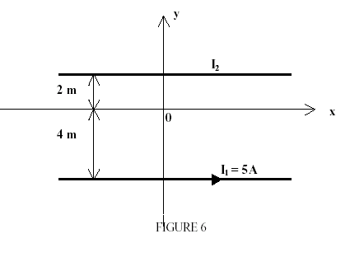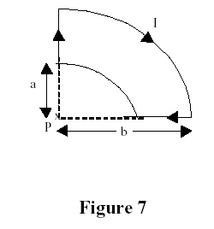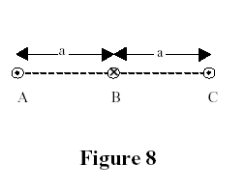
T001-Figure 6 T991-Figure 7 T991-Figure 8

