Old Exams. Questions Chapter 28 (Dr. Gondal-Phys102)
T071: Q19. A loop of wire carrying a current of 3.0 A is in the shape of a right triangle with two equal sides, each 16 cm long. A 0.8T uniform magnetic field is parallel to the hypotenuse. The total magnetic force on the two equal sides has a magnitude of: (Ans: 0)
Q20. A potential difference of 600 V is applied to accelerate an electron from rest. This accelerated electron enters a uniform magnetic field and completes one revolution in 9 nano seconds. Determine the radius of the electron orbit? (Ans: 0.021 m)
Q21. An electron with a velocity of v = (4.0×10⁴ i + 3.0×10⁶ j) m/s enters a region of magnetic field B = (0.40 i) T. The magnetic force on the electron is: (A 1.9×10⁻¹³ k N)
Q22. A 300 turn square loop, having a side length of 6 cm, carries a current of 15 A. The loop is placed in an external magnetic field of magnitude 3.0 T. Determine the magnitude of the maximum torque exerted on the loop. (A: 49 N.m)
T062: Q18.The following figure shows a loop of wire carrying a current of 2.0 Ampere is in the shape of a right triangle with two equal sides, each 15 cm long. A 0.7 T uniform magnetic field is parallel to the hypotenuse as shown in the figure. The resultant magnetic force on the two equal sides has a magnitude of: (Zero)
Q19. An electron moving perpendicular to a 50 µT magnetic field goes through a circular trajectory. What is the time required to complete one revolution? (7.15 x 10⁻⁷ s )
Q20. An electron has a velocity: v = (5 x 10⁶ – 3 x 10⁶ ) m/s and moves through a uniform magnetic field: B = ( 0.5 + 0.3 ) T. Find the magnetic force (in Newtons) on the electron. (- 4.8 x 10⁻¹³ ).
Q21: The following Fig. 1 shows a straight horizontal length of copper wire of mass m = 50 g and length L = 1.0 m lies in a uniform magnetic field B = 0.5 T directed out of the page. What is the magnitude and direction of the current in the wire to balance the gravitational force? (Ans: 0.98 A, to the left)

L = 1.0 m
x
y
z
I
+ x
+ y
+ z
p
v

Fig. 1, T062 Fig. 2, T062 Fig. 3, T062
Q22. A 100 turns coil, lies in xz-plane, has an area of 2.0 m² and carries a current I = 0.3 A in the direction indicated in the Fig. 2. The coil lies in a magnetic field directed along the x-axis and has a magnitude of 1.5 T. What is magnitude and direction of the torque on the coil? (Ans: 90 N.m along the positive z axis)
Q23.The Fig. 3 shows a proton moving at a constant speed of 300 m/s along the negative x-axis through uniform electric and magnetic fields. The electric field is directed along the positive y-direction and has a magnitude of 900 N/C. What is the magnitude and direction of the magnetic field?

T-051: Q#5. An electric field of magnitude 400 V/m is normal to a magnetic field of magnitude 0.25 T. If an electron moving through these two fields experiences no force, what is the speed of the electron? (Ans: 1.60 km/s.)
Q#17. In the figure 1, an electron of speed 2.0×10 5 m/s moves along positive x axis in a uniform magnetic field of 0.2 T pointing into the page –z direction. The magnetic force on the electron is: (Ans: 6.4 × 10 ⁻¹⁵ N, -y axis.)
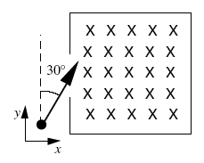
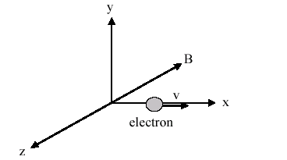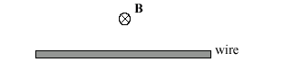
Figure 7

Fig. 1, T051 Fig. 2 T051 Fig. 7, T042
Q#23. In a uniform magnetic field, a particle of charge 1.5 µC and mass 2.0 µg completes 5 revolutions in one second. What is the magnitude of the magnetic field? (Ans: 42 mT.)
Q#25. A straight wire of linear mass density 100 g/m is located perpendicular to a magnetic field of 0.5 T as shown in the figure 2. What current in the wire is needed to balance the gravitational force on the wire?( Ans: 2.0 A to the right)
T-042: Q#17 An electron enters a region that contains a magnetic field directed into the page as shown in figure 7. The velocity of the electron makes an angle of 30 degrees with the +y axis. What is the direction of the magnetic force on the electron when it enters the field? (A1: at an angle of 30 degrees below the positive x axis and in the plane of the page.)
Q#19: An electron is accelerated from rest through a potential difference of 500 Volts, then injected into a uniform magnetic field. Once in the magnetic field, it completes one revolution in 4.0 nano-s. What is the radius of the orbit? (A1 8.4 mm)
Q#20 A charged particle is projected with velocity v into a region where there exists a uniform electric field of strength E perpendicular to a uniform magnetic field of strength B. If the velocity of the charged particle is to remain constant, the minimum velocity must be (A1 of magnitude E/B and perpendicular to both E and B.)
Q#21: A circular coil of 160 turns has a radius of 1.90 cm and carries a current I. If the maximum torque that the coil can experience in a uniform 35.0 mT magnetic field is 0.08 N*m, what is the value of I. (A1 12.6 A.)
T-041 Q#1: In figure 5, an electron moves toward the west at speed of 1.0*10**7 m/s in a downward (normal into the page) uniform magnetic field of 3.0*10**(-4) T. The magnetic force on the electron is (Ans: 4.8*10**(-16), north.)
Q#3: An electron is accelerated by a potential difference of 2.0 kV. Then it passes normally through a region of magnetic field, where it moves in a circular path with radius 0.2 m. What is the magnitude of the magnetic field? (Ans: 7.5*10**(-4) T.)
Q#4: The plane of area 4.0 cm**2 rectangular loop of wire is parallel to a 2.0 T magnetic field. The loop carries a current of 6.0 A. Calculate the magnitude of the torque acts on the loop. (Ans:4.8*10**(-3) N*m.)
Q#5: A charged particle is placed in a region of space and it experiences a force only when it is in motion. It can be conclude that the region encloses (Ans: A magnetic field only.)
Q#6 An electric field and a magnetic field normal to each other. The electric field is 4.0 kV/m and the magnetic field strength is 2.0 mT. They are act on a moving electron to produce no force, calculate the electron speed. (Ans: 2.0*10**6 m/s.)
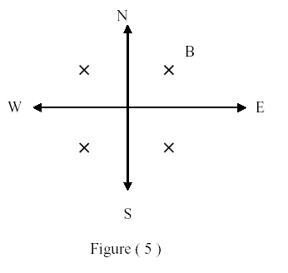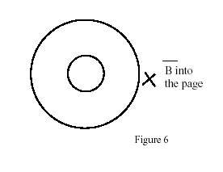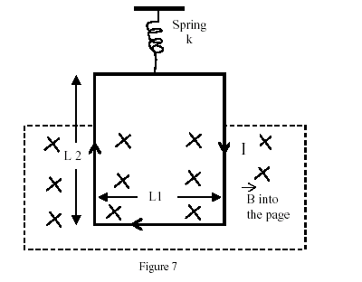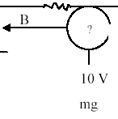

T041-Figure 5 T032-Figure 6 T032-Figure 7 T031-Figure 5

T-032:Q#1: Figure 6 shows the circular paths of an electron and a proton that travel at the same speed in a uniform magnetic field B, which points into the page. (a) Which particle follows the bigger circle, and (b) does that particle travel clockwise or counterclockwise? (Ans: (a) proton (b) counterclockwise)
Q#2: In figure 7, a rectangular loop, L1 = 2.0 cm by L2 = 3.0 cm, carrying a current I = 0.1 A, is suspended from a spring of spring constant, k = 8.0*10**(-2) N/m. The loop is placed into a uniform magnetic field, which points into the page, and the spring is observed to stretch 1.0 cm. What is the magnitude of the magnetic field? [Neglect the mass of the loop] (Ans:0.4 T.)
Q#3: At a point in a uniform magnetic field the acceleration of an electron is 5.0*10**14 m/s**2 and its speed is 7.0*10**6 m/s. If the magnitude of the magnetic field is 1.0 mT, what is the angle between the electron’s velocity and the magnetic field? (Ans:24 degrees.)
Q#4:A proton moves with constant velocity, v = (8.0*10**5 m/s) i, through crossed electric and magnetic fields. If the magnetic field is B = (2.5 mT) j, what is the electric field? [i, j and k are the unit vectors in the positive x, y and z directions, respectively]. (Ans: (-2.0 kV/m) k.)
Q#5: Which one of the following statements is FALSE (NOT TRUE). A uniform magnetic field (Ans: changes the kinetic energy of a charge.)
T-031: Q#1: An electron that has velocity v = 3.2*10**7 i m/s traveling parallel to a uniform magnetic field of strength 2.60*10**(-3) Tesla. The force on the electron is: [i is the unit vectors in the directions of x] (Ans:zero.)
Q#2: A straight horizontal length of copper wire is located in a place where the magnetic field of the earth B = 0.5*10**(-4)T (see figure 5). What minimum current in the wire is needed to balance the gravitational force on the wire? [The linear density of the wire is 60.0 gram/m] (Ans:1.2*10**4 A into the page.)
Q#3: The path of a charged particle in a magnetic field, when its direction of motion is not at right angle to the magnetic field, will be a: (Ans: helix.)
Q#4: An electron moving at right angle to a uniform magnetic field completes a circular orbit in 10**(-8) s. What is the magnitude of the magnetic field. (Ans: 3.6*10**(-3) T.)
T-011: Q#1: An electric field of 1.5*10**3 V/m and a magnetic field of 0.50 T act on a moving electron to produce no net force. Calculate the minimum speed of the moving electron. (Ans:. Zero.)
Q#3: A proton that has velocity v=( 3.0*10**6 i- 2.0*10**6 j ) m/s moves in a magnetic field B = (0.50 i) T. Find the force on the proton. (i, j and k are the rectangular unit vectors.) (Ans: -1.6*10**(-13) kN.)
Q#6: What uniform magnetic field, applied perpendicular to a beam of electrons moving at 1.4*10**6 m/s is required to make the electrons travel in a circular orbit of radius 0.40 m? (Ans: 7.0*10**(-5) T.)
Q#7: What is the initial direction of the deflection of an electron, moving in the y direction as it enters the magnetic field shown in figure (7)? [The magnetic field is in the xy-plane and makes an angle of 45 degrees with the x axis]. (Ans: y direction.).

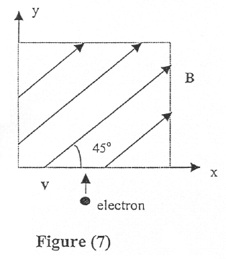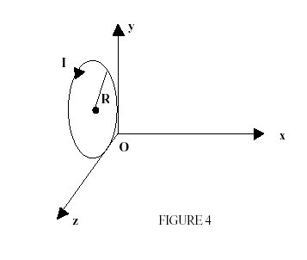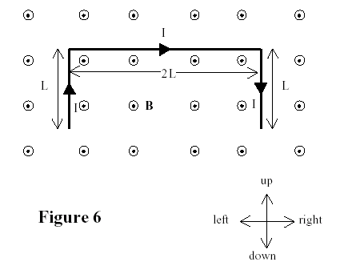
T011-Figure 7 T992-Figure 4 T991-Figure 6
T-002:Q#1: An electron is projected into a uniform magnetic field B = (0.8 k) T. Find the magnitude of the magnetic force, on the electron when the velocity is: v = (5.0*10**5 i + 3.0*10**5 j) m/sec. (i, j and k are the unit vectors in the x, y and z directions, respectively). (Ans:7.5*10**(-14) N.)
Q#2: In figure (4), a loop of wire carrying a current, I, of 2.0 A is in the shape of a right triangle with two equal sides, each 15 cm long. A 0.7 T uniform magnetic field is in the plane of the triangle and is perpendicular to the hypotenuse. The resultant magnetic force on the two equal sides is: (Ans: 0.30 N, into the page.)
Q#3: A magnetic field CANNOT: (Ans: cannot change the kinetic energy of a charge.)
Q#4: Electrons are accelerated from rest through a potential difference of 500 V. They are then deflected by a magnetic field of 0.2 T that is perpendicular to their velocity. The radius of the electrons trajectory is: (Ans: 0.38 milli-m.)
T-992: Q#1: An electron enters a region of magnetic field B = (0.40 i) T with a velocity v = (3.0*10**4 i + 2.0*10**5 j) m/s. (i, j and k are the unit vectors in x, y and z directions, respectively). The magnetic force that the electron experiences is: (Ans: ( 1.3*10**(-14) k) N)
Q#2: An electron moving perpendicular to a 50 micro-T magnetic field, goes through a circular trajectory. What is the time required to complete one revolution? (Ans: 715 nano-seconds)
Q#3: A current of 17 mA is maintained in a circular loop of 2 m circumference which is parallel to the y-z plane (see Figure 4). A magnetic field B = (- 0.8 k) T is applied. Calculate the torque exerted on the loop by the magnetic field. (i, j and k are the unit vectors in x, y and z directions, respectively). (Ans:( 4.33*10**(-3) j) N*m)
T-991: Q#1: An electron is projected into a uniform magnetic field B = (1.4i + 2.1j) T. Find the force on the electron when the velocity is v = (3.7*10**5 j) m/sec (i, j and k are the unit vectors in the x, y and z directions, respectively). (Ans: (8.3*10**(-14) k) N)
Q#2: An electron moving in a circular path perpendicular to a uniform magnetic field takes 1.0 nano-second to complete one revolution. Determine the magnitude of the magnetic field. (Ans: 36 milli-T)
Q#3: A wire of total length 4L and carrying a current I is placed in a uniform magnetic field B that is directed out of the page as shown in Figure 6. Determine the net magnetic force on the wire. (Ans: 2ILB down)
Q#4: A square loop, of side a = 5 cm and 200 turns, carries a current of 10 A. The loop is placed in an external magnetic field of 2.0 T. Determine the magnitude of the maximum torque exerted on the loop. (Ans: 10 N*m)

