Old Exam Questions Chapter 27 (Dr. Gondal-Phys102)
T071
Q13. A single loop circuit contains two external resistors and two emf sources as shown in the figure 1. Assume the emf sources are ideal, what is the power dissipation across resistor R1. (Ans: 0.9 W)
Q14. A capacitor of capacitance 5.0x10-6 F is discharging through a 4.0 M Ω resistor. At what time will the energy stored in the capacitor be half of its initial value? (Ans: 7 s)
Q15. Four resistors are connected as shown in the figure 2. What is the current through R1, when a potential difference of 30.0 Volts is applied between points a and b? (Ans: 1.75 A)
Q16. If Va – Vb = 3.2 V, what is Vd – Vc shown in Figure 3 ? (Ans: -9.6 V)
Q17. The figure below shows 3 identical light bulbs connected to a battery. What happens to the power of light bulb 1 when the switch S is closed in Figure 4? (Ans: The power increases)

Fig#
Fig. 3, T071 Fig.2, T071 Fig. 1, T071
Fig. 4, T071
T062
Q13. A 6-V battery supplies a total of 48 W to three identical light bulbs connected in parallel. The resistance of each bulb is: (Ans: 2.25 Ω)
Q14.In the following figure 1, find the current in 3 Ω resistor and the resistance R for the given currents. (Ans: 8 A, 9 Ω)
Q15. Two resistors r and R are connected in series across 100 V line. If r = 30 kΩ and the voltage across it is found to be 60 V, find the resistance of R. (Ans: 20 kΩ)
Q16. A 30.0 kΩ resistor and a capacitor are connected in series and a 15.0 V potential difference is suddenly applied across them. The potential difference across the capacitor rises to 5.00 V in 1.50 µs. Find the capacitance of capacitor(Ans: 123 pF)
Q17. Four resistors , each of 20-Ω, are connected in parallel and the combination is connected to a 20 V emf device. The current in any one of the resistors is: (Ans: 1.0 A)
T052: Q#6. In the figure 1 shown, each resistance is 1 Ω. Calculate the emf of the battery if the current I is 4 A.[ 7 V ]
Q#7. In the figure 2 shown, the potential difference between point 1 and 2, (V2-V1), is -40 V, and the current is
equal to 4.0 A, then, the value of the resistance R is [ 3 Ω]
Q#20. A 2.0 volt battery has an internal resistance r = 0.2 Ω is used to operate a lamp of resistance R = 2.3 Ω. What is the percentage of the power delivered to the lamp relative to that of the battery? [ 92 %].
Q#24. An uncharged capacitor is connected as in the circuit shown in Fig. 3. When the switch is closed, the charge on the capacitor reaches half its maximum value in 20 ms. If R=500 Ω and the voltage of the battery is 10 V
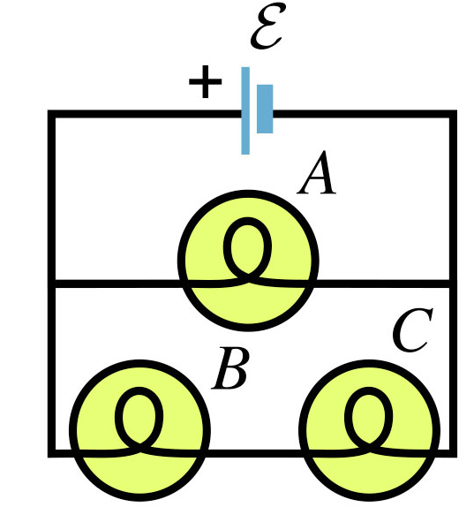
then the capacitance of the capacitor is: [58 micro-F ]
T042-Fig. 6

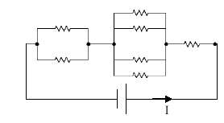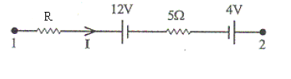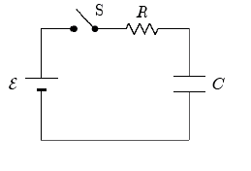
T052 Fig.1 T052 Fig.2 T052 Fig.3

T042: Q#11: Three resistors are connected as shown in figure 3. The potential difference between points A and B is 26 V. How much current flows through the 4-Ohm resistor? (A1 2.0 A )
Q#12: In the circuit shown in figure 4, I=0.65A and R=15 Ohms. What is the value of the emf of the battery? (A1 39 V)
Q#13: A 5.0-micro-F capacitor is fully charged by connecting it to a 12-V battery. After disconnecting the battery, it was allowed for capacitor to discharge through a simple RC circuit, with a time constant of 4.0 s. What is the charge on the capacitor after one time constant has elapsed? (A1 2.2*10**(-5) C)
Q#14: In the circuit shown in figure 5, what is the current in the 8.00-Ohm resistor? (A1 2.25 A to the left)
Q#15: A number of 240-Ohms resistors are connected in parallel to a 120-V source. If the maximum current allowed in the circuit is 9 A, determine the largest number of resistors, which can be used in this circuit without exceeding the maximum current. (A1 18.)
Q#16: In figure 6, three identical light bulbs are connected to a battery. Which one of the following statements is CORRECT? (A1 The largest current passes through A.)
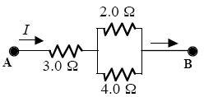
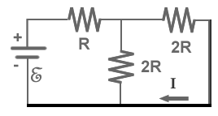
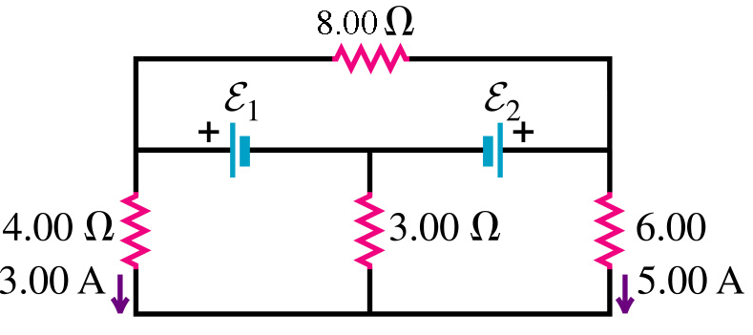
T042-Fig. 3

T042 Fig.4

T042-Fig. 5

T-041 Q#1: The current in single-loop circuit is 5.0 A. When an additional resistance of 2.0 Ohm is added in series, the current drops to 4.0 A. What was the resistance in the original circuit? (Ans: 8.0 Ohm)
Q#2: Three wires are joined together at a junction. A 0.40-A current flows toward the junction from one wire and a 0.3-A current flows away from the junction in the second wire. The current in the third wire is (Ans: 0.10-A, away from the junction).
HWQ#3: An electrical source with internal resistance r = 2.0 Ohm is used to operate a lamp of resistance R = 18 Ohm. What fraction of the total power is delivered to the lamp? (Ans: 0.9)
Q#4: In the circuit shown in figure 1, calculate potential difference VB-VA. The points A, B and C are three junctions. [Take the current I=2.0 A] (Ans: 8.0 V.)
HWQ#5: A capacitor of capacitance C is discharging through a resistor of resistance R. In terms of RC, when will the energy stored in the capacitor reduces to one fifth of its initial value? (Ans: 0.80 RC.)
T-032: Q#1: A 6-V battery supplies a total of 48 W to two identical light bulbs connected in parallel. The resistance (in ohm) of each bulb is (Ans: 1.5)
Q#2: A capacitor, initially uncharged in a single-loop RC circuit, is charged to 85% of its final potential difference in 2.4 s. What is its time constant in seconds? (Ans:1.3)
Q#3: Find the potential difference (VB-VA) between points B and A of the circuit shown in figure (4) (Ans:- 10 volts)
HWQ#4: Find the value of R1 in the circuit of figure (5) (Ans:6.0 ohms.)

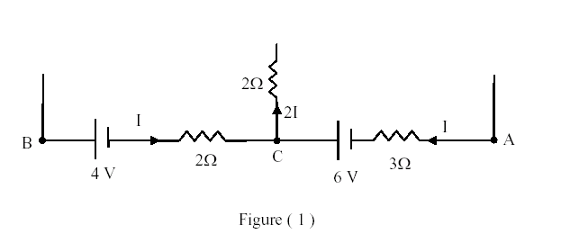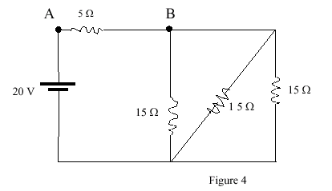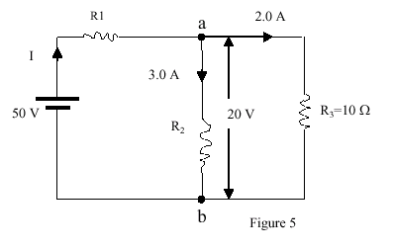

T031: Q#1 In figure 2, a battery of emf of 12-Volt and internal resistance of r = 3.0 Ohm is connected to a bulb of resistance R. If the bulb will light at a steady current of 0.1 A, what should the value of R be? (117 Ohm)
Q#2: A resistor R = 30*10**6 Ohm is connected in series with a capacitor C = 3.0 micro-F and a 21-Volt battery for long time. The battery was removed, then R and C are connected in a loop. What is the energy stored in the capacitor C after one minute? (Ans: 174 micro-J.)
HWQ#4: In figure 3, if R = 10 Ohm find the current in R. (Ans:- 0.2 A)
Q#3: What is the power dissipated in 4.0 Ohm resistor in Figure 4. (Ans: 9.0 W.)
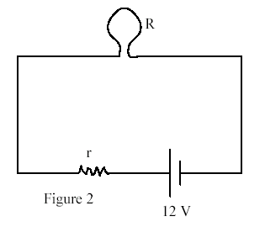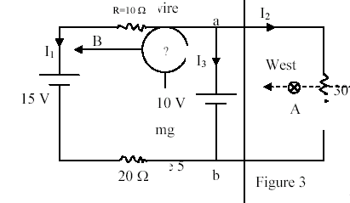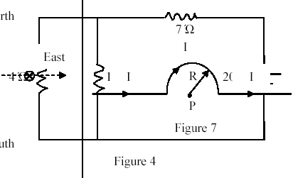
T-011 HW Q#1: In the circuit shown in figure (4), the capacitor is initially uncharged. At t = 0, switch S is closed. If T denotes the time constant, then the current passing through the 3.0 Ohm resistor at t = T/100 is: (Ans: 0.5 A.)
Q#2: Three resistors, of resistance 2.0 Ohm, 4.0 Ohm and 6.0 Ohm, are connected to a 24 Volt battery as shown in figure (2). The power dissipated in the 2.0 Ohm resistor is: (Ans: 4 W.)
Q#3: If the current I in figure (5) is equal to 4.0 A, then the potential difference between point 1 and 2, i.e. (V2 -V1), is: (Ans: 40 Volts.)
Q#4: The current in the 8.0 Ohm resistor shown in the circuit of figure (3) is: (Ans: 3.0 A.)
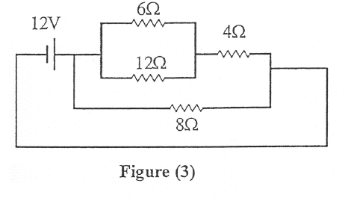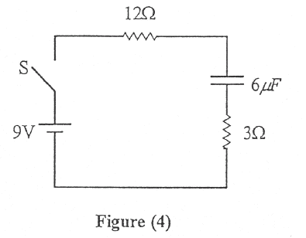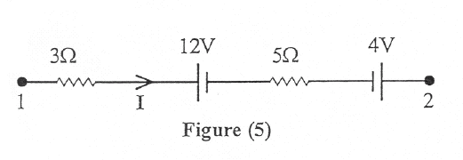
T002: Q#1: The capacitor in figure (1) is initially charged to 50 V and then the switch is closed. What charge flows out of the capacitor during the first minute after the switch was closed? (Ans: 4.8 mC.)
HW Q#2: In figure (2), if Vc-Vd=6.0 Volts, what is the emf of the battery? (Ans:10.8 Volts)
Q#3: The sum of the currents entering a junction equals the sum of the currents leaving that junction is a consequence of: (Ans: conservation of charge)
HW Q#4: Find the values of the currents in figure (3). (Ans: I1 = 2 A, I2 = 2 A, I3 = -4 A.)

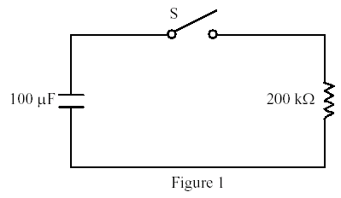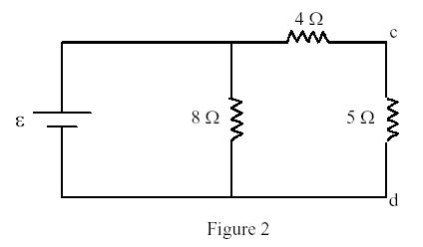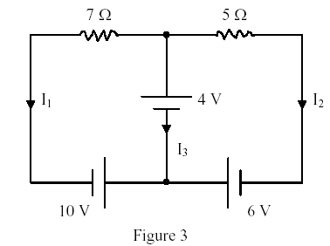
T-001 Q#1: Calculate the voltage E of the battery shown in Figure 1. (Ans: 20 V)
Q#2: The light bulbs in the circuit of Figure 2 are identical. When the switch S is closed, then: (Ans: nothing changes to the intensity of the light bulbs)
HW Q#3: The circuit in Figure 3 has been connected for a long time. Find the potential difference Vb - Va. (Ans: 8 V)
Q#4: A 4.00 micro-F capacitor is charged to 24.0 V. Find the charge on the capacitor 4.00 milli-seconds after it is connected across a 200-Ohm resistor. (Ans: 0.647 micro-C)

