Old-Examination Questions Chapter 26 (Dr. Gondal-Phys102)
T071: No Questions on Ch-26
T062-Q18.: If a wire is stretched uniformly to n-times its original length, it's resistance changes by a factor of: (n²)
Q19.: The potential difference across the ends of a wire is doubled in magnitude. If Ohm’s law is obeyed, which one of the following statements concerning the resistance of the wire is true? (The resistance is not changed)
Q20.: A 40-W and a 60-W light bulbs are designed for use with the same voltage. What is the ratio of the resistance of the 60-W bulb to the resistance of the 40-W bulb? (Ans: 0.67 )
T061: Q#19. A 100 W bulb is designed to operate with a line voltage of 120-V. If the line voltage decreases and the bulb consumes only 90 W, find the final voltage in the line. Assuming the resistance of the bulb is constant. (Ans: 114 V )
Q#20. A heater of unknown resistance is plugged into a 120-V line. The charge passing through it in one hour is 4800 C. What is the resistance of the heater? (Ans: 90 Ω)
T051: Q#18. If 1200 C of charge flows through a 10-ohm resistor in 4 minutes, what is the value of the voltage across the resistor?(C) 50 V.
Q#19. Two wires are made from different materials and carry the same uniform current. The current density in both is the same only if:((D) their radii are the same.
Q#20. In a simple circuit a voltage of 5 V is applied across a 10 Ohm resistance. The energy dissipated in the resistor in 2 minutes is: (E) 300 J.
T042: Q#19: A 500 W electric heater is designed to operate from a 120-V power supply. The line voltage decreases and the heater takes only 459 W. Find the voltage drop in the line voltage (Assuming the resistance is (A1 5 Volts.)
Q#20: What diameter must a copper wire have if its resistance is to be the same as that of an equal length of an aluminum wire with 3.26 mm diameter? [Resistivity of aluminum = 2.75*10**(-8) Ohm.m; Resistivity of copper = 1.69*10**(-8) Ohm.m; (A1 2.6 mm.)
T-041: Q#1 The resistivity of nichrome wire is 1.0*10**(-6) Ohm.m. Calculate the length of wire needed for a 1200 watt electric heater that is connected across a 120 V potential difference. [The wire’s radius is 0.40 mm] (Ans:6.0 m.)
Q#2: A heating coil is immersed in a 0.2 kg of cold water. The coil is connected to a 12 V supply and a current of 5 A flows for 140 seconds. Calculate the temperature increase of the water. [Specific heat of water is 4200 J/(kg*K)] (Ans: 10 K.)
HWQ#3: Figure 7 shows three cylindrical copper conductors along with their face areas and length. Rank them according to the current through them, greatest first, when the same potential difference V is placed across their lengths. (Ans: 1,3 and 2. )

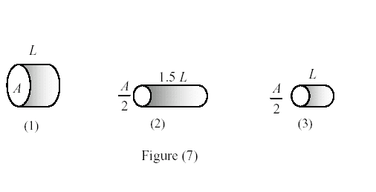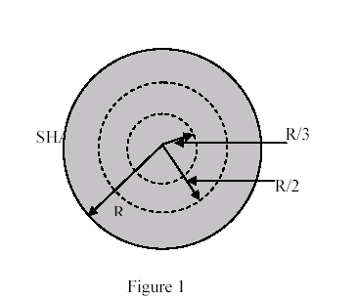
Figure 1-Final-T-031

T-032: Q#1: A 20% increase in the resistance of a copper wire was noticed when its temperature was raised above room temperature. Find the final temperature of the wire if the temperature coefficient of resistivity for copper is 4.0*10** (-3) /K. [Assume the room temperature = 290 K] (Ans: 340 K. )
Q#2: A potential difference of 9.0 V is applied across the length of a cylindrical conductor with radius 2.0 mm. Calculate the current density if the conductor has a resistance of 90 ohms. (Ans: 8.0*10**3 A/m**2.)
Q#3: A current of 5.0 A exists in a 10 ohms resistor for 5.0 min. How many electrons pass through any cross section of the resistor in this time? (Ans: 9.4*10**21)
Q#5: A 6-V battery supplies a total of 48 W to two identical light bulbs connected in parallel. The resistance (in ohm) of each bulb is (Ans: 1.5 )
T-012: HWQ#1: A copper wire "1" has a length L1 and diameter d1. Another copper wire "2" has a length L2 and diameter d2. At constant temperature, the second conductor has smaller resistance if: (Ans: d2 > d1 and L2 < L1.)
Q#2: If 4.7*10**(16) electrons pass a particular point in a wire every minute, what is the current in the wire? (Ans: 1.3*10**(-4) A.)
Q#3: An electric device, which heats water by immersing a resistance wire in the water, generates 153 J of heat per second when an electric potential difference of 12 V is placed across its ends. What is the resistance of the heater wire? (Ans: 0.94 Ohms)
T-992: Q1# In one hour, how many electrons pass between the terminals of a 12-V car battery when a 96 watts headlight is used? (Ans: 1.8*10**23 electrons.).
HWQ#2: A resistance operated at 110 Volts has a power output of 100 Watt. What is the percentage increase of the power if the voltage increase to 121 Volts. (Assume that the resistance stays constant.) (Ans: 21% ).
Final-T041: Q#1: The current in single-loop circuit is 5.0 A. When an additional resistance of 2.0 Ohm is added in series, the current drops to 4.0 A. What was the resistance in the original circuit? (Ans: 8.0 Ohm.)
HWQ#2: Three wires are joined together at a junction. A 0.40-A current flows toward the junction from one wire and a 0.3-A current flows away from the junction in the second wire. The current in third wire is (Ans: 0.10-A, away from the junction.)
Q#3: An electrical source with internal resistance r = 2.0 Ohm is used to operate a lamp of resistance R = 18 Ohm. What fraction of the total power is delivered to the lamp? (Ans: 0.9.)
Final-T032: Q#1 A 20% increase in the resistance of a copper wire was noticed when its temperature was raised above room temperature. Find the final temperature of the wire if the temperature coefficient of resistively for copper is 4.0*10** (-3) /K. [Assume the room temperature = 290 K] (Ans: 340 K.)
HWQ#2: A potential difference of 9.0 V is applied across the length of a cylindrical conductor with radius 2.0 mm. Calculate the current density if the conductor has a resistance of 90 ohms. (Ans: 8.0*10**3 A/m**2)
Q#3: A current of 5.0 A exists in a 10 ohms resistor for 5.0 min. How many electrons pass through any cross section of the resistor in this time? (Ans: 9.4*10**21)
Q#3: A 6-V battery supplies a total of 48 W to two identical light bulbs connected in parallel. The resistance (in ohm) of each bulb is (Ans:1.5 )
Final-T031: HWQ#1: A cylindrical wire of radius R = 2.0 mm has a uniform current density J = 2.0*10**(5) A/m**2. What is the current through the portion of the wire between radial distances R/3 and R/2? (see figure 1) (Ans: 0.35 A)
Q#2: A heater element of resistance 10**3 Ohm is constructed to operate at 110 V. How much thermal energy is produced in one hour by the heater? (Ans: 4.4*10**4 J.)
Final-T011: Q#1: A hair dryer of resistance 80 ohms is plugged into a 120-V line. The charge passing through it in one hour is: (Ans. 2400 coulombs)
Final-T002: Q#1: An electric device, which heats water by immersing a resistance wire in the water, generates 153 J of heat per second when an electric potential difference of 12 V Q0 placed across its ends. What is the resistance of the heater wire? (Ans: 0.94 Ohms)
Final-T001: Q#1: An electric device, which heats water by immersing a resistance wire in the water, generates 300 J of heat per second when an electric potential difference of 12 V is placed across its ends. What is the resistance of the heater wire? (Ans: 0.48 Ohms)
Final-992: Q#1: An electric device, which heats water by immersing a resistance wire in the water, generates 300 J of heat per second when an electric potential difference of 12 V is placed across its ends. What is the resistance of the heater wire? (Ans: 0.48 Ohms)
Final-991: HWQ#1:At 40 degrees-C the resistance of a gold wire is 80 Ohms. What is the resistance of the same wire at 60 degrees-C? (Alpha(gold) = 3.4*10**(-3) /C-degrees). (Ans: 85 Ohms)

