Old Exam. Questions Chapter 25 (Dr. Gondal, Phys102)

T071: Q1. The three capacitors in the figure 1 have an equivalent capacitance of 2.77 μF. What is C2? (Ans: 7 μF).
Q2. When the potential difference across a 5 μF capacitor is increased by 2 V, the energy stored increases by 10 %. What was the original potential difference? (Ans: 40 V).
Q3. What is the charge on C3 in the figure 2? (Ans: 16 μC).
Q4. A parallel-plate capacitor is completely filled with a dielectric of dielectric constant 6, has a capacitance of 50 pF. If the plate separation is 0.1 mm, find the plate area. (Ans: 0.94 cm²)
Fig. 1, T071 Fig. 2, T071

T062: Q14. How much energy is stored in the combination of capacitors shown figure (5)?(Ans: 0.03 mJ)
Q15. Consider three identical capacitors. Their equivalent capacitance when connected in parallel is C_{p}, and their equivalent capacitance when connected in series is C_{s}. Which of the following statements is CORRECT? (C_{p}=9C_{s})
Q16. Two parallel-plate capacitors are connected in series to a battery as shown in figure (6). A dielectric is inserted in capacitor C₁. (The charge on C₂ increases)
Q17.: Figure (7) shows three capacitors connected to a battery of voltage V = 6 Volts. The charges on the capacitors are known to be Q₁ = 24 µC for C₁ and Q₂ = 96 µC for C₂. What are the values of the capacitances C₁ and C₂? (Ans: C1=8 μF, C2= 16 µF).
T061:Q#15. A parallel plate capacitor has square shaped plates with an area = 4.1×10⁻³ m² and 1.6×10⁻³ m separation. What charge will appear on the plates of such capacitor if a potential difference of 80 V is applied? (Ans: 1.8×10⁻⁹ C)
Q#16. An air filled parallel-plate capacitor has a capacitance of 3.0x10⁻¹² F. The plate separation is then doubled and a wax dielectric is inserted, completely filling the space between the plates. As a result the, capacitance becomes 7.5×10⁻¹² F . The dielectric constant of the wax is: (Ans: 5 )
Q#17. A battery having potential difference V = 12 V and four capacitors, each having a capacitance of 12Fμ, are connected as shown in the figure 1. What is the charge on C2? (Ans: 72 C μ)
Q#18. Consider the combination of capacitors as shown in the Figure 2. The energy stored in the 8.0 Fμ capacitor is 0.40 J. The energy stored in the 5.0 Fμ capacitor is: (Ans: 0.25 J)

T052:Q#1: Each of the four capacitors shown in figure 5 is 500 μF. The voltmeter reads 1000V. The magnitude of the charge, on each capacitor plate is: (Ans: 0.5 C )
Q#3: A parallel-plate capacitor has a plate area of 0.2 m² and a plate separation of 0.1mm. The electric field between the plates is 2.0 × 10⁶ V/m. The energy stored in the capacitor is: (Ans: 0.35 mJ)
Q#6: An air-filled parallel-plate capacitor has a capacitance of 1 pF. The plate separation is then doubled and a wax dielectric is inserted, completely filling the space between the plates. As a result, the capacitance becomes 2 pF. The dielectric constant of the wax is: (Ans: 4.0 )
Q#17: Capacitors A and B have the same capacitance. Capacitor A is charged so that it stores 4 J of energy and capacitor B is uncharged. The capacitors are then connected in parallel. The total stored energy in the capacitors is now: (Ans: 2 J )
T051:Q#14. A parallel-plate capacitor has an area of 16 cm 2 . The plates are separated by 0.5 mm and are connected across a 60 V battery. Find the magnitude of the charge on each plate. (Ans: 1.7 nC)

T051:Q#14. A parallel-plate capacitor has an area of 16 cm 2 . The plates are separated by 0.5 mm and are connected across a 60 V battery. Find the magnitude of the charge on each plate. (D) 1.7 nC.
Q#15. Consider the arrangement of capacitors shown in the figure 1. Find the energy stored in the 5 µF capacitor. (E) 0.56 mJ.
Figure 8

C1

C2

C3

V=20V

Figure 10

C₂, q₂
+ +
- -
C₁, q₁
+ +
- -

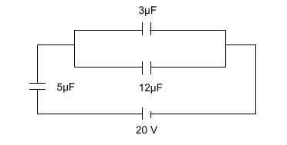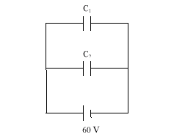 Figure 1, T051
Fig. 1, T051 Fig. 2, T051
Q#16. A dielectric materials is inserted completely between the plates of a capacitor. If the potential difference is kept constant, and the charge was increased by 60%, determine the dielectric constant of the material. (A) 1.6
Q#17. Two capacitors, C1= 2 ∝F and C2 = 6 ∝F, are connected in parallel with a 60 V battery, as shown in Figure 2. The battery is removed and plates of opposite sign are connected. Find the final potential difference for each capacitor. (B) 30 V, 30 V.
T042:Q#16: Consider two separate capacitors: c1=30 micro-F carries a charge of q1=6.0*10**2 micro-C and c2=50 micro-F, carries a charge of q2=1.0*10**3 micro-C. If the opposite polarity terminals of the two capacitors are connected together as shown in figure 10, find the new voltage across c1. (A1: 5.0 Volts.)
Q#17: A 25 micro-F parallel plates capacitor is constructed using Pyrex glass as a dielectric. If the thickness of the Pyrex glass sheet is doubled, calculate the new capacitance of the capacitor. (Dielectric constant of Pyrex Glass = 5.6) (A1 12.5 micro-F.)
Q#18: Three capacitors C1=5 micro-F, C2=10 micro-F and C3= 3 micro-F are connected to a 20 V battery as shown in Figure 8. Find the stored electric energy in C2. (A1 2.2*10**(-4) J.)

T-041-Q#1 A parallel-plate capacitor (with plates A and B) has circular shape of radius 6.0 cm separated by 2.0 mm. Find the total charges on both plates (A and B) when a 12 V battery is connected. (Ans: zero)
HWQ#2 The three capacitors in figure 5 have an equivalent capacitance of 12.4 micro-F, find the capacitance of C1. (Ans: 6.0 micro-F)
HWQ#3:In figure 6, a capacitor of capacitance C = 9.0 micro-F is charged to a potential difference Vo = 10.0 volts. The charging battery is disconnected and the capacitor is connected to uncharged capacitor of unknown capacitance Cx. The potential difference across the combination is reduced to V = 3.0 volts. Find the value of Cx. (Ans: 21 micro-F)
Q#4 A parallel-plate capacitor has plates of area A and separation d and is charged by a battery of a potential difference V. If the charging battery is disconnected, then the work required, by external agent, to separate the plates of the capacitor to infinite distance is: [Take A = 2.0 m**2, V = 12 Volts, d = 3.0 cm] (Ans: 42 nano-J. )
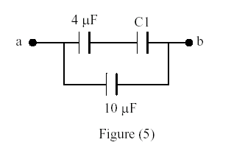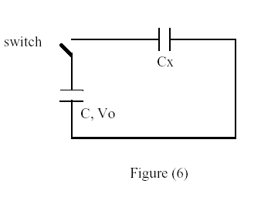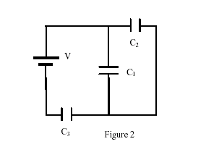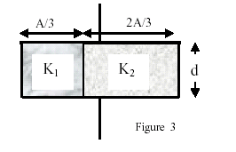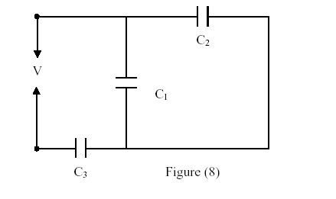

Fig. 5 T041 Fig. 6 T041 Fig. 2 T032-final Fig. 3 Final-032 Figure8- Term-031
Final. Exam 032: HWQ#1: In figure (2), find the charge stored by the capacitor C3 if the potential difference across the battery is 10.0 V. Use the values C1 = C2 = 2.0 micro-F and C3 = 4.00 micro-F.(Ans: A1 20 micro-C.)
HWQ#2: Two concentric spherical shells of radii 10 cm and 5.0 cm are charged to a potential difference of 20 V. How much energy is stored in this spherical capacitor? (Ans: 2.2*10**(-9) J.)
Q#3: A parallel-plate air-filled capacitor, of area 25 cm**2 and plate separation of 1.0 mm, is charged to a potential difference of 600 V. Find the energy density between the plates. (Ans: 1.6 J/m**3.)
HWQ#4: A parallel-plate capacitor has an area A and a separation d. Find its capacitance if it is filled with two dielectrics as shown in figure 3. [Co is the capacitance of the air-filled parallel-plate capacitor. K1 = 3 and K2 = 1.5 are the dielectric constants] (Ans: 2*Co. 6*Co.).
T031: Q#1: Find the equivalent capacitance of three capacitors connected in series. Assume the three capacitors are: C1 = 2.00 micro-F, C2 = 4.00 micro-F and C3 = 8.00 micro-F. (A: 1.14 micro-F.)
HWQ#2: In figure (8), find the total charge stored by the three capacitors if the potential difference “V” is 10.0 volts. Assume C1 = 10.0 micro-F, C2 = 5.00 micro-F and C3 = 4.00 micro-F(Ans: 31.6 micro-C.)
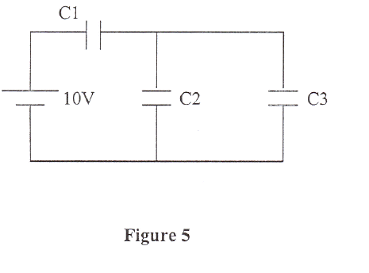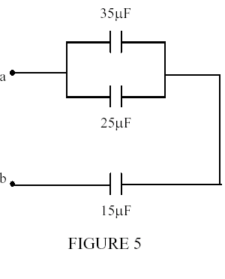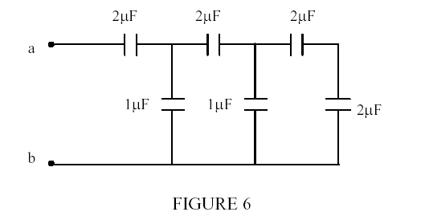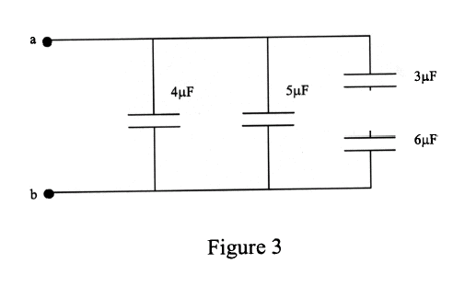
------Fig.-5-Term-011-------Fig.-5-Term-002-------------Fig.-6-Term-002-----------Fig. -3-Term-992-------
HW Q#3: An air filled parallel-plate capacitor has a capacitance of 1.00*10**(-12) F. The plate separation is then doubled and a wax dielectric is inserted, completely filling the space between the plates. As a result the, capacitance becomes 2.00*10**(-12) F. The dielectric constant of the wax is: (Ans: 4.00.)
Q#4: Two capacitors, C1 and C2, are connected in series and a potential difference is applied to the combination. If the capacitor that is equivalent to the combination has the same potential difference, then the charge on the equivalent capacitors is the same as: (Ans: The charge on C1 or C2.)
T-012: Q#1 A parallel-plate capacitor has a plate area of 0.2 m**2 and a plate separation of 0.1 mm. If the charge on each plate has a magnitude of 4.0*10**(-6) C the electric field between the plates is approximately: (Ans: 2.3*10**6 V/m.)
Q#2:A 2 micro-F and a 1 micro-F capacitor are connected in series and a potential difference is applied across the combination. The 2 micro-F capacitor has: (Ans: half the potential difference of the 1 micro-F capacitor.)
HWQ#3: Capacitors A and B are identical. Capacitor A is charged so it stores 4 J of energy and capacitor B is uncharged. The capacitors are then connected in parallel. The total stored energy in the capacitors is now: (Ans: 2 Joules.)
T-011 Q#1:A 2.5 micro F capacitor, C1, is charged to a potential difference V1 = 10 V using a 10 V battery. The battery is then removed and the capacitor is connected to an uncharged capacitor, C2, with capacitance of 10 micro F. What is the potential difference across C1 and C2, respectively? (Ans: 6 V, 6 V.)
Q#2: Consider an isolated capacitor of capacitance Co and charge Which of the following statements is true when a dielectric slab is inserted between the plates of the capacitor? (Ans: The capacitance goes to zero.)
HWQ#3: Consider the circuit shown in figure (5). If C1 = 1 micro F, C2 = 6 micro F and C3 = 3 micro F, what is the charge on C3? (Ans: 5 micro C ).
T-002:HWQ#1: If Vab is equal to 50 V, find the charge stored and the potential difference across the 25 micro-F capacitor shown in Figure 5 (Ans:250 micro-C and 10 V.)
HWQ#2: The equivalent capacitance between points a and b in the combination of capacitors in figure 6 is: (Ans: 1.0*10**(-6) F.)
HWQ#3: A parallel-plate capacitor, of capacitance 1.0*10**(-9) F, is charged by a battery to a potential difference of 12.0 volts. The charging battery is then disconnected and oil with dielectric constant = 4.0 fills the inside space between the plates. The resulting potential difference, in volts, between the plates is(Ans:3.)

T-001: Q#1: An isolated capacitor, Cl = 20.0 micro-F has a potential difference of 26.0 V. When an uncharged capacitor C2, of unknown value, is connected across Cl, the potential difference becomes 16.0 V for both. What is the value of C2? (Ans:12.5*10**(-6) F.)
Q#2: A parallel plate capacitor of capacitance C has a charge of magnitude' q when connected to a battery of potential difference v. After being fully charged, the capacitor is disconnected from the battery and the separation between the plates is doubled. Which one of the following statements is TRUE? (Ans: The voltage across the plates doubles.)
T-992- HWQ#1: Consider the combination of capacitors in Fig. (3) .The energy stored in the 5 micro-F capacitor is 0.20 J. The energy stored in 4 micro-F capacitor is: (Ans: 0.16 J.)
Q#2: An isolated capacitor, Cl = 20.0 micro-F has a potential difference of 26.0 V. When an uncharged capacitor C2, of unknown value, is connected across Cl, the potential difference becomes 16.0 V for both. What is the value of C2? (Ans: 12.5*10**(-6) F.)

