Old-Exam. Questions-Ch. 24 (Dr. Gondal-Phys102)

T072: Q10. What is the external work required to bring four 3.0×10-9 C positive point charges from infinity and place them at the corner of a square of side 0.12 m (Ans: +3.7 μJ)
Q11. A point charge q1 = + 2.4 μC is held stationary at the origin. A second point charge q2 = - 4.3 μC moves from x1= 0.15 m, y1= 0 to a point x2 = 0.25 m, y2 = 0.25 m. How much is work done by the electric force on q2 ? (Ans: 0.36 J)
Q12. An electron is accelerated from a speed of 3×106 m/s to 8×106 m/s. Calculate the potential through which electron has to pass to gain this acceleration? (Ans: 157 V)
Q13. The electric potential in a certain region is described by V(x,y, z) = 2xy- 4x2 + 6 y. Find the magnitude of the net electric field at x = -1 and y = 1? (Ans: 11 N/C)
Q14. A conducting sphere with a radius of 10 cm, has a surface charge density of 4 ×10⁻⁶ C/m2. The electric potential, at r = 5 cm from the center of the sphere is ( assume V= 0 at infinity): (Ans: 4.5×10⁴ V)

T062: Q8. Calculate the ratio of the speed of a proton to that of an electron, both accelerated through the same potential difference. (Ans: 0.023)
Q10.: Two charged spherical conductors having radii 4.0 cm and 6.0 cm are connected by a long conducting wire. A total charge of 20 μC is placed on this combination of two spheres. Find the charges on each sphere (smaller first). (8 μC and 12 μC)
Q11.: Figure (3) shows three charges located at the corners of a triangle. How much energy would be needed to remove the 4 μC charge to infinity? [Assume V = 0 at infinity.] (8.2J)
Q12: Three concentric spherical shells A, B and C, of radii a, b and c (a<b<c), have charges q, -q and q respectively. The potential of C is: Vc=kq/c:
T061:
Q#10. A 5-cm radius conducting sphere has a surface charge density of 2 ×10⁻⁶ C/m² on its surface. The electric potential, at r = 2.5 cm from the center of the sphere is: [Assume V = 0 at infinity.] (Ans:1.1 × 10⁴ V )
Q#11. The diagram in Fig. 1 shows four pairs of, identical, large parallel conducting plates. The value of the electric potential is given for each plate. Rank the pairs according to the magnitude of the electric field between the plates, least to greatest.
( Ans: 2,4, 1, 3)
Q#12. An electron starts from rest at a point 10 cm from a positively charged conducting plate, with a surface charge density σ = +1 × 10⁻⁹ C/m². The electron is attracted to the plate until it collides with the plate. With what speed will the electron collide with plate? (Ans: 2.0 × 10⁶ m/s
Q#13. A point charge of 5.0 × 10⁻⁹ C is transferred, by an external agent, from infinity to the surface of a ball of radius 5.0 cm. If the ball has the charge density 5.0 × 10⁻⁴ C/m², then the amount of work done, by the external agent, in the process is: [Assume V = 0 at infinity.] (Ans: 1.4×10⁻² J )

☞ T051: Q#10. A proton moves in a uniform electric field of 2.5×10 7 N/C from point A to point B by traveling a distance of 1.5 m. Find the work done and the potential difference between point a and b.(A) 6×10 -12 J; 3.75 ×10 ⁷ V.)
Q#11. The electric potential at point in an XY plane is given by V = 3X ² – 4Y ^{2 .}what are the magnitude and direction of the electric field at a point (4m, 2m) ? (A) E = 29 N/C and 146 counterclockwise from + x-axix.
Q#12. What is the net potential at point P due to four point charges arranged in th configuration as shown in the Figure. Here q = 36 nC, d = 0.5 m, A) Vp = 324 V.
Q
q
-q
-q
-q
q
q
30º
30º
r
Figure 4

Y
A
O
p
p
e
3 m
4 m
3 m

X
Figure 7

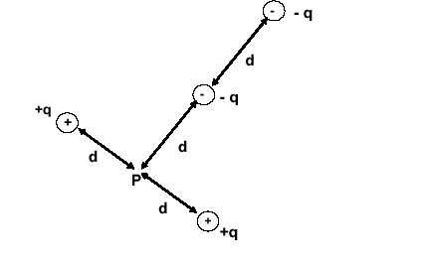

☞ T042:Q11. Two oppositely charged parallel plates, 0.02 m apart, produce a uniform electric field between the plates. The potential energy U(J) of an electron in the field varies with displacement x(m) from one of the plates as shown in figure 5. What is the magnitude of the force on the electron? (A1 7.5*10**(-15) N.).
Q#12 A point charge Q, at the center of a circle, is surrounded by six charges each of magnitude q at a distance r as shown in figure 4. How much work is done by an external agent to remove the charge Q from the center to infinity? [Consider the electrostatic potential at infinity = 0 ] (A1 zero.)
Q#13 Two protons, P, are fixed 6.0 m apart, as shown in figure 7. An electron, e, is released from point A. Find its speed at point O, midway between the protons. (A1 11.6 m/s.)
Q#14 Figure 6 shows three points X, Y and Z forming an equilateral triangle of side S in a uniform electric field of strength E. A unit positive test charge is moved from X to Y, then from Y to Z, and from Z back to X. Which one of the following correctly gives the work done by an external agent in moving the charge along the various parts of the path? (A1 0, -E*S*Sin(60 degrees) , + E*S*Sin(60 degrees).)
Q#15 Over a certain region of space, the electric potential is give by: V(x,y) = x**2 +y**2 +2*x*y. Find the angle that the electric field vector makes with Z-axis at the point P(1.0,2.0,0.0) (A1 90 degrees.)
☞ T041 Q#1: In figure 3, two large horizontal metal plates are separated by 4 mm. The lower plate is at a potential of -6.0 V. What potential should be applied to the upper plate to create an electric field of strength 4000 V/m UPWARDS in the space between the plates? (Ans:A1 -22 V.)
Q#2: In figure 4, the point charge Q1 causes an electric potential of 60 V and an electric field strength of 30 V/m at P, and the the point charge Q2, separately, causes an electric potential of 120 V and electric field strength of 40 V/m at P. Which of the following gives possible values of potential and field strength at P due to the joint action of Q1 and Q2? (Ans: 180 V, 50 V/m).
Q#3: In the xy plane, a charge q1 = 3.0 micro-C located at (3.0 cm, 0.0) and another charge q2 = -4.0 micro-C located at (0.0 cm, 4.0 cm). How much work must be done, by an external agent, to bring these charges to their fixed positions starting from infinite separation. [Consider V = 0 at infinity] (Ans:A1 -2.2 J)
Q#4: If an isolated metal sphere of radius r = 10 cm has a net charge of 4.0 micro-C. What is the potential on the surface of the sphere? [Consider V = 0 at infinity] (Ans: A1 3.6*10**5 V.)
Q#5: It is required 1.0 mJ of work to move two identical positive charges +q from infinite separation so that they are separated by a distance a. How much work is required to move four identical positive charges +q from infinite separation so that they are arranged at the corner of a square with edge length a? [Consider V = 0 at infinity] (Ans: A1 5.4 mJ)

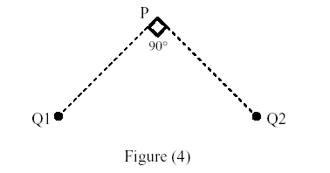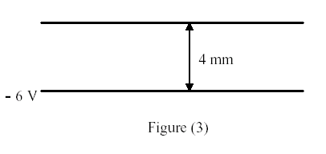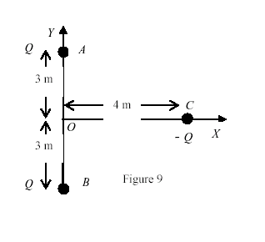
X
E
Y
S
Z
Figure 6

☞ T032: Q#1: Find the electrostatic potential at x = 0 for the following distribution of charges:-2q at x= 10 cm and -2q at x= -10 cm. [Take q = 1.0*10**(-9) C, and the electrostatic potential at infinity = 0 (Ans: -360 V.)
Q#2: Three point charges are initially infinitely far apart. Two of the point charges are identical and have charge Q. If zero net work is required to assemble the three charges at the corners of an equilateral triangle of side d, then the value of the third charge is (Ans: - Q/2.)
Q#3: Consider two concentric conducting shells of radii (a) and (b), b > a. The smaller (inner) shell has a positive charge (q) and the larger (outer) shell has a charge (Q). If the potential of the inner shell is zero, what is the value of Q? (Ans: Q = -b*q/a.)
Q#4: In figure 9, two equal positive charges, each of magnitude 5.0*10**(-5) C, are fixed at point A and B separated by a distance of 6 m. An equal and opposite charge moves towards them along the line CO. At point C, 4.0 m from O, the kinetic energy of the moving charge is 4.0 J. What is the kinetic energy of this charge when it passes point O? (Ans:10.0 J.)
Q#5: The potential of a charge distribution is given by: V(x,y) = A [y*(x**2)- x*(y**2)], where A is in appropriate units. The electric field will be zero at the point: (Ans: x = 0, and y = 0.)
T031:Q#1: The electric potential at points in the xy–plane is given by: V = (x**3 - 2*x*y) Volts, where x and y are in meters. The magnitude of the electric field at the point with the coordinates x = 1 m and y = 2 m is: (Ans: Sqrt(5) V/m.)
Q#2: In figure (7), what is the net potential at point P due to the four point charges if V = 0 at infinity ? [take d = 2 cm, q = 1.0 micro-C]. (Ans: 9.0*10**5 V.)
Q#3: Which one of the following statements is true? (Ans: The electric field lines are perpendicular to the equipotential surfaces.)
Q#4: Two balls with charges 5.0 micro-C and 10 micro-C are at a distance of 1.0 m from each other. In order to reduce the distance between them to 0.5 m the amount of work to be performed is: (Ans: 0.45 J.)

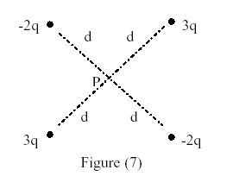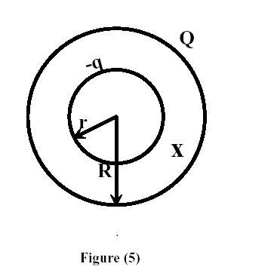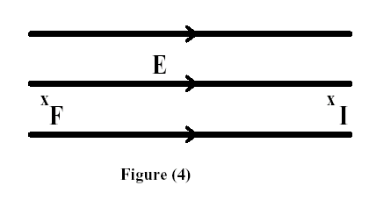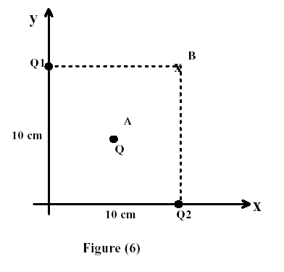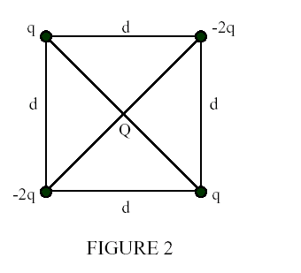
Figure 6-T012 Figure 2-T002

☞ T012: Q#1: What is the external work required to bring four 2.0*10**(-9) C point charges from infinity and to place them at the corner of a square of side 0.14 m (Ans: 1.4*10**(-6) Joule.)
Q#2: In figure (4), an electron moves from point 'I' to point 'F' in a uniform electric field directed as shown in the figure. (Ans: The electric field does positive work on the electron.)
Q#3: In figure (5), a hollow sphere, of radius r that carries a negative charge -q, is put inside another hollow sphere, of radius R that carries a positive charge Q. At a distance x from the common center, such that r < x < R, the electric
potential is: (Ans: k*[(Q/R)-(q/x)].)
Q#4: In figure (6), Q1 = 2.0*10**(-6) C and Q2 = - 2.0*10**(-6) C. What is the external work needed to move a charge Q = - 4.0*10**(-6) C at constant speed from point A at the center of the square to point B at the corner?
(Ans: Zero.)
☞ T011: Q#3: Consider a metallic sphere carrying a charge of 4.0*10**(-8) C and having a potential of 400 v. Find the diameter of the sphere. (Ans:6.0 m.)
Q#9: Two equal charges, each of 0.12 C, are separated by a distance of 1.8 m. What is the work done, by an external agent, to bring a charge of 0.15 C from infinity to the midpoint between the two charges? (Ans: 3.6*10**8 J.)
Q#12: What is the electric potential energy of an electron at a distance r = 2.40*10**(-10) m from the nucleus of a hydrogen atom? (the nucleus consists of a single proton) (Ans: -6.0 eV.).
☞ T002:Q#1: A particle [m = 8.0*10**(-9) kg, q = +6.0*10**(-9) C] has a speed of 80 m/s at point A and moves to point B where the potential is 2.0*10**3 V greater than at point A. What is the particle's kinetic energy at point B? (Assume that only electric forces act on the particle during its motion.) (Ans:14*10**(-6) J.)
Q#2: In figure 2, four charges are fixed at the corners of a square whose sides are of length d. The work done by an external agent to bring a fifth charge, Q, from infinity to the center of the square is:
(Ans: - 2.8*k*q*Q/d.)
Q#3: A charge q is located at the center of a circle with a large radius R, see figure 4. Another charge Q is located on the circumference of the circle at the x-axis. What is the work, in Joules, needed to move Q from its location to point F, on the x-axis, along the circumference? (Ans: Zero.)
☞ T001:Q#1: Two point charges Q1 and Q2 are positioned as shown in Figure (2) .If Q1 = 2.0*10**(-9) C, Q2 = -2.0*10**(-9) C, a = 3.0 m, and b = 4.0 m, what is the electric potential difference, VA- VB? (Ans: 4.8 V)
Q#2: A particle [m = 8.0*10**(-9) kg, q = +6.0*10**(-9) C] has a speed of 80 m/s at point A and moves to point B where the potential is 2.0*10**3 V greater than at point A. What is the particle's kinetic energy at point B? (Assume that only electric forces act on the particle during its motion.) (Ans: 14*10** (-6) J.)
Q#3: A 2 meters conducting rod is fixed perpendicularly to a uniform 200 Nlc electric field. The potential difference between its ends is: (Ans: Zero.)
Q#4: Two conducting spheres are very far apart. The smaller sphere carries a total charge of 6 micro-C. The larger sphere has a radius twice that of the smaller sphere and is neutral (Q = 0) .After the two spheres are connected by a thin conducting wire, the charges on the smaller and the larger spheres, respectively are: (Ans: 2 micro-C and 4 micro-C.)

1.5*10⁻¹⁶
0
0
x(m)
U(J)
0.02
Figure 5

Figure 5, T042

