Old-Exam-Questions-Ch. 23 (Dr. Gondal-Phys102)

071
Q5. When a piece of paper is held with its face perpendicular to a uniform electric field the flux through it is 30.0 N·m /C. When the paper is turned at certain angle with respect to the field the flux through it is 24.6 N·m²/C. What is the angle? (Ans: 35º)
Q6. An infinitely long uniformly charged rod is coaxial with an infinitely long uniformly charged cylindrical shell of radius 5.0 cm. The linear density of the rod is + 15 ⋅ 10⁻⁹ C/m and that of the cylindrical shell is – 20 ⋅ 10⁻⁹ C/m. What is the magnitude of the electric field at a distance of 10 cm from the axis? (Ans: 900 N/C)
Q7. A particle, of mass 1.0 g and charge 1.0 ⋅ 10⁻⁶ C, is held stationary between two parallel non-conducting sheets that carry equal but opposite surface charge densities. What is the magnitude of the surface charge density? (Ans: 8.7 ⋅ 10⁻⁸ C)
Q8. An insulating spherical shell of radius 15 cm has a total charge of 10 μC uniformly distributed on its surface. Calculate the electric field intensity at a distance of 14 cm from the center of the shell. (Ans: 0)
T062: Q5. A uniform electric field intersects a surface of area A. The flux through the area is: (Ans: Zero if the surface lies in the xy plane)
Q6. A point charge of 12 μC is placed at the center of a spherical shell of radius 12 cm. Find the ratio of the total electric flux through the entire surface of the shell to that of a concentric spherical surface of radius 6.0 cm. (Ans:1)
Q7. An insulating sphere of radius R = 10 mm has a uniform charge density ρ = 6.00 x 10⁻³ C/m³. Calculate the electric flux through a concentric spherical surface with radius 5.00 mm. (Ans: 355 N.m²/C)
Q8. The electric field, at a distance of 40 cm, from a very long uniform wire of charge is 840 N/C. How much charge is contained in a 2.0 cm long of the wire? (Ans: 0.37).
T061: Q#6. When a piece of paper is held with its face perpendicular to a uniform electric field the flux through it is 25.0 N·m²/C. When the paper is turned 25.0º with respect to the field the flux through it is: (Ans: 22.7 N·m²/C )
Q#7. Charge Q is distributed uniformly throughout a spherical insulating shell. The net electric flux in N·m²/C through the inner surface of the shell is: (Ans: 0 )
Q#8. A long wire, of linear charge density λ_{l} , runs along the cylindrical axis, of a cylindrical conducting shell, which carries a net linear charge density of λ_{c}. The charge per unit length on the inner and outer surfaces of the shell, respectively are: [Note: linear charge density charge per unit length] ≡ (Ans: −λ_{l} and λ_{c} + λ_{l} )
Q#9. Two large insulating parallel plates carry uniformly-distributed surface charge densities of equal magnitude, one positive and the other negative, as shown in Fig. 1. Rank the points 1 through 5 according to the magnitude of the electric field at the points, least to greatest. (Ans: 1, 4, and 5 tie, then 2 and 3 tie )
Fig. 1, T061 Fig. 4, T052
T052: Q#7. A long solid non-conducting cylinder (radius = 12 cm) has a uniform charge density (5.0 nC/m³) distributed throughout its volume. Determine the magnitude of the electric field 5.0 cm from the axis of the cylinder. (Ans: 14 N/C ).
Q#8. A large insulating solid sphere has a charge density of 5 nC/m³. Calculate the electric field inside the sphere at a distance of 10 cm from its center. (Ans: 18.8 N/C )
Q#14. Three large insulating sheets of charge with the given charge densities are shown in figure 4. The magnitudes of electric field at points A and B are respectively (Ans: σ_{o} / 2ε_{o} , σ_{o} / 2ε_{o})
Q#15. A conducting spherical shell with a net charge q_{o} has an outer radius R. A point charge q_{o} is placed at a distance R/3 from the center of the shell. What is the surface charge density on the outer surface of the shell? (Ans: 2q_{o} / 4π R²)
Q#20. Consider a long wire of linear charge density λ. Now imagine a closed cylindrical Gaussian surface of radius r and length L with the wire as the axis. What is the electric flux through the cylinder surface? (Ans: λL/ε_{o}) 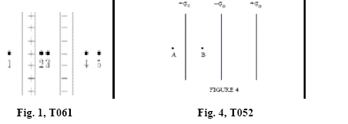

T051: Q#6. A point charge is at the center (0,0) of a conducting sphere which has a radius of 0.3 m. Another point charge of 2 µC is located at r =0.40 m. If the net flux through the surface of the sphere is 360 Nm 2 /C, calculate the value of the charge inside the sphere. (A) 3.2 nC.
Q#7. An insulating sphere with radius =0.22 m has charge distributed uniformly through its volume. What must be the total charge on the sphere if the electric field at 0.11 m from the center of sphere is 950 N/C ? (A) 10 nC.
Q#9. A square shaped charged plate having a side length 1.5 m. The electric field near its surface is 10 5 N/C and directed normally into the plate. What is the total charge at the surface of the plate? (A) -4 µC.
T042: Q#6 A very long uniform line of charge having a linear charge density of 6.8 micro-C/m lies along x-axis. A second line of charge has a linear charge density of -3.40 micro-C/m and is parallel to x-axis at y = 0.5 m. What is the net electric field at point where y= 0.25 m on y-axis? (A1 7.3*10**5 N/C along +y-axis.)
Q#8: The net electric flux passing through a closed surface is -4.00*10**2 N*m**2/C. What is net electric charge contained inside the surface if the surface is a cylinder of height 3.52 cm and radius 1.12 cm. (A1 -3.54*10**(-9) C.)
Q#9: A positive point charge q sits at the center of a hollow spherical shell. The shell, with radius R and negligible thickness, has net charge -2q. The electric field strength outside the spherical shell (at r>R) will be: (A1 k*q/r**2 radially inwards.)
Q#10: A charged, isolated, large non-conducting plate is placed on the XY-plane. At 1.5 m from the plate, on Z-axis, the electric field measured was 10**4 N/C and directed into the plate. What is the charge density on the plate? (A1 -1.8*10**(-7) C/m**2.)
T041: Q#1: An imaginary closed spherical surface S of radius R is centered on the origin. A positive charge is originally at the origin, and the flux through the surface is “Phi”. The positive charge is slowly moved from the origin to a point 2*R away from the origin. In doing so the flux through S. ( Ans: decreases to zero.)
Q#3: Figure 1 shows three situations in which a Gaussian cube sits in an electric field. The arrows and the values indicates the directions(in N*m**2/C)of the flux through the six sides of each cube. In which situations does the cube enclose, a positive net charge, a negative net charges and zero net charge? respectively.(Ans: 2,3 and 1.)
Q#4: In figure 2, the magnitude of the electric field at point A, due to an infinite line charge density of 9.0*10**(-6) C/m, is 7.2*10**4 N/C. If the point A is at a distance R from the line charge, what is R? (Ans: 2.3 m.)
Q#5: A non conducting sphere, of radius 4.0 m, has a charge density of 2.0 micro-C/m**3. What is the electric field at a distance 1.7 m from the center? (Ans: 1.3*10**5 N/C)
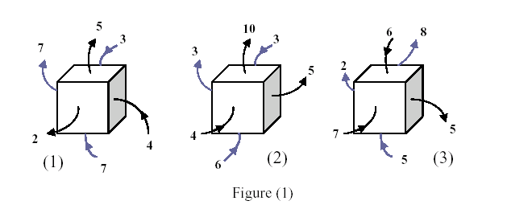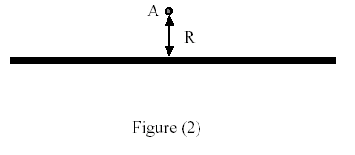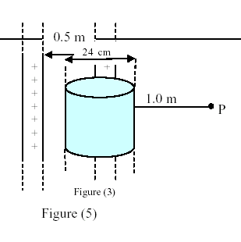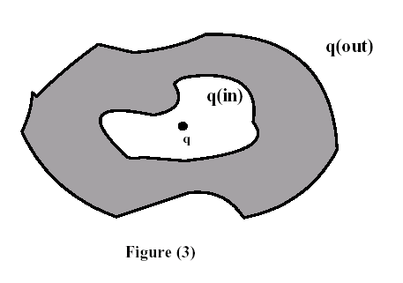
T032: Q#1:: A point charge, q1 = -2.0*10**(-6) C, is placed inside a cube of side 5.0 cm, and another point charge q2 = 3.0*10**(-6) C is placed outside the cube. Find the net electric flux through the surfaces of the cube. (Ans: -2.3*10**5 N m**2/C)
Q#2 Figure 7 shows portions of two large, parallel, nonconducting sheets, A and B. The surface charge densities are: sigma 1 = -4.5 micro-C/m**2 and sigma 2 = -6.5 micro-C/m**2. Find the electric field at any point between the two sheets. (Ans: 1.1*10**5 N/C towards B.)
Q#3: A hollow metallic sphere, of radius 2.0 cm, is filled with a non-conducting material which carries a charge of 5.0 pico-C distributed uniformly throughout its volume. What is the magnitude of the electric field 1.5 cm from the center of the sphere? (Ans: 84 N/C.)
Q#4: A total charge of 5.00*10**(-6) C is uniformly distributed inside an irregularly shaped insulator. The volume of the insulator is 3.0 m**3. Now, imagine a cube of volume 0.50 m**3 inside the insulator. What is the total electric flux through the surfaces of the cube? (Ans: 9.4*10**4 N*m**2/C.)
Q#5: A 40 N/C uniform electric field points perpendicularly toward a large neutral conducting sheet, as shown in figure 8. The surface charge densities (in C/m**2) on the right, sigma-R and left, sigma-L, respectively are (Ans: - 3.5*10**(-10); +3.5*10**(-10).)
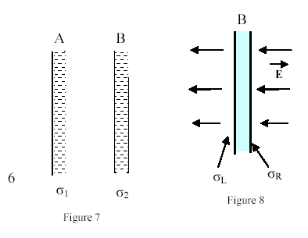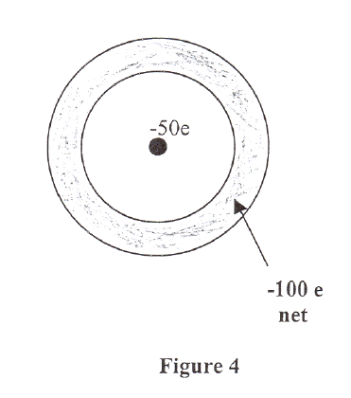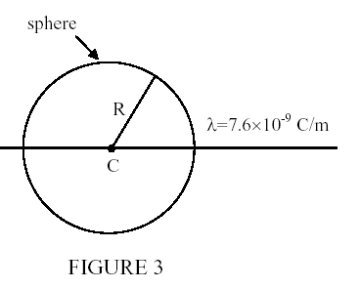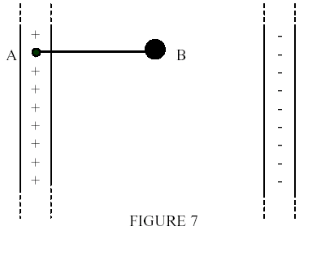

Q#4: At which point can the electric field due to the two charges shown in figure 6 be zero? (Ans: point E.)
T031: Q#1: For the two infinite dielectric sheets, see figure (5), find the magnitude of the electric field at a point P. Consider that each sheet has a positive surface charge density of 10**2 C/m**2. (Ans: 1.1*10**13 N/C.)
Q#2: A point charge of +4.0 micro-C lies at the center of a hollow spherical conducting shell that has a net charge of -13.0 micro-C. If the inner radius of the shell is 2.0 cm and the outer radius is 3.0 cm, then the ratio between the charge density on the inner surface to the charge density on the outer surface is: (Ans:1 : 1.)
Q#3 A cube, as in figure (6), has an edge length of 3.00 m in a region of a uniform electric field given by the equation: E = (- 5.00 j + 6.00 k) N/C, where i, j, and k are the unit vectors in the directions of x, y, and z respectively. Find the electric flux through the top face (shaded). (Ans: - 45 N*m**2/C.)
T012: Q#1: A point charge of 2.0 micro-C is placed at the center of a cube 50 cm on edge. What is the flux through the bottom surface? (Ans:3.8*10**4 N*m**2/C.)
Q#2: An electron is shot directly toward the center of a large metal plate that has excess negative charge with surface charge density 2.0*10**(-6) C/m**2. If the initial kinetic energy of the electron is 200 eV and if the electron is to stop just as it reaches the plate, how far from the plate must it be shot? (Ans: 0.9 mm.)
Q#3: An isolated conductor of arbitrary shape has a net charge of -15*10**(-6) C. Inside the conductor is a cavity within which is a point charge q=-5.0*10**(-6) C. What is the charge on the cavity-wall, q(in), and what is the charge on the outer surface of the conductor, q(out)? [See figure (3)].(Ans: q(in) = 5.0*10**(-6) C; q(out) = -20*10**(-6) C.)
T011: Q#2: A point charge of -50e lies at the center of a hollow spherical metal shell that has a net charge of -100e, as seen in figure(4). Calculate the charge on the (a) shell's inner surface, and (b) on its outer surface. [e is the magnitude of the charge on the electron.] (Ans: (a) Zero (b) -150e.)
T002: Q#1:, Two uniformly charged, concentric and hollow, spheres have radii r and 1.5*r. The charge of the inner sphere is q/2 and that on the outer sphere is 3*q/2. Find the electric field at a distance 2.0*r from the center of the spheres. (Ans: 0.5*k*q/(r**2).)
Q#2: An infinitely long line has a charge density of 7.6 nano-C/m. Calculate the electric flux through a spherical surface of radius R = 7.7 cm whose center, C, lies on the line charge as shown in Figure 3. (Ans: 132 (N*m**2)/C)..
Q#3: Fig. 7 shows two parallel plates, infinite and non-conducting, with surface charge densities of 8.9*10**(-4)C/m**2 and –8.9*10**(-4)C/m**2. B, a ball with negligible mass, carries a positive charge of 6.0*10**(-8) C and is attached to point A with a non-conducting string of length 10 cm. At equilibrium, the tension in the string is: (Ans:6.0 N.)
T001: Q#1: An isolated conducting spherical shell has an inner radius of 4.0 cm and outer radius of 5.0 cm. A charge 8.0*10**(-6) C is put on the shell. What is the ratio of the charge on the inner surface of the shell to the charge on the outer surface? (Ans: Zero.)
Q#2: A solid insulating sphere has a charge of 20 micro-C uniformly distributed throughout its volume. The magnitude of the electric fields inside the sphere at r = 2 cm and outside the sphere at r = 10 cm, measured from the center of the sphere, are equal. F'ind the volume charge density of the sphere . (Ans: 24 milli-C/m**3.)
Q#3: A total charge of 5.00*10**(-6) C is uniformly distributed inside an irregular insulator. The volume of the insulator is 2.50 m**3. Now, imagine a cube of volume 0.50 m**3 inside the insulator. What is the total electric flux through the surface of the cube? (Ans: 1.13*10**5 N*m**2/C.)

