Old Examination Questions Chapter 22 (Dr. Gondal-Phys102)

T072
Q1.Two charges are arranged as shown in the figure below. If d=7.2 cm, what is the resultant electric field at P A) 1.23 x 10⁴ N/C making an angle of 45o with + x-axis.
Fig 81.1 Fig 81.2 Fig.81.3

Q2.In the figure 2, charge Q = - 3.7 nC. For what value of charge q1 will charge q2 be instatic equilibrium?A) 15 nC
Q3.In the figure3, a uniform electric field E = -18 j N/C exists between two plates that are 4 cm apart. A proton is fired from the lower plate with a velocity 8×103 j m/s. Find the distance from that plate at which the instantaneous velocity of the proton is zero.(ignore gravity) -39 nC
T071
Q17. Two charges Q1 and Q2 of equal magnitudes and opposite signs are positioned as shown in the figure 1. Which of the shown arrows represents correctly the electric field at point P. (Ans: A)
Q19. A uniform electric field has a magnitude of 2.0 × 10⁴ N/C and points to the right. An electron is released from rest in this electric field. How far will the electron travel in two nanoseconds after its release? (Ans: 7.0 mm to the left)
Q20. Four equal negative point charges are located at the corners of a square centered at the origin, their positions in the xy plane are (1, 1), (-1, 1), (-1, -1), (1, -1). The direction of the electric field at (1, 0) is: (Ans: along the negative x axis)
Fig. 1, T071 Fig. 1, T062

T061: Q#3. Three electric charges Q_{A}= Q_{B} = q, and Q_{C} = -2q are located at the points A (x = + a, y = 0), B (x = -a, y = 0), and C (x = 0, y = +2a), respectively. What is the electric field at the origin? (Ans: k q/2a² toward Q_{C})
Q#4. A proton with a speed of 3.0×10⁵ m/s moves in uniform electric field of 1.9×10³ N/C. The field is acting to decelerate the proton. How far does the proton travel before it is brought to rest? (Ans: 0.25 m )
Q#14. A particle, of mass and charge q, is placed at rest at point A in a uniform electric field mE, as shown in the figure 1. If the particle is released, then the kinetic energy it attains after moving a distance y is: (Ans: qEy)
T052: Q#4. A charged particle with a mass of 2x10⁻⁴ kg is held suspended (stationary) by a downward electric field of 300 N/C. The charge on the particle is: (Ans: – 6.5 x 10⁻⁶ C )
Q#9. In figure 2, two charges q₁ = –5.0 μC, q₂ = 10 μC, are fixed on the x-axis. At what distance, measured from q₁, the electric field will be zero? (Ans: 2.4 m to the left of q₁)
Q#12. Two small identical conducting spheres, initially uncharged are separated by a distance of 1.0 m. Find the number of electrons that must be transferred from one sphere to the other in order to produce an attractive force of 2x10⁴ N between the spheres. (Ans: 9.3 x 10¹⁵)

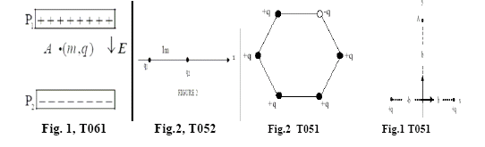

T051
Q#3. What is the electric field on the y-axis at a distance b from the origin due to two identical positive point charges, each of charge q, located on the x-axis one at a distance b and the other a distance –b from the origin? (A) k q/(b*2√2) in the negative y-direction.
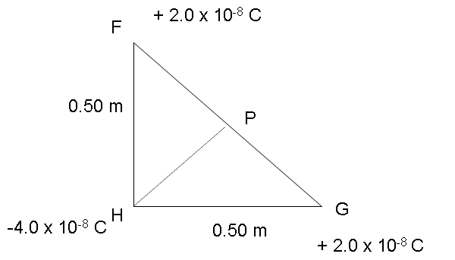
Figure 2

(m,q)

E
θ
Figure 9

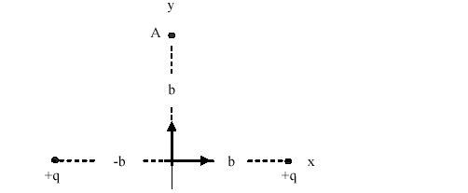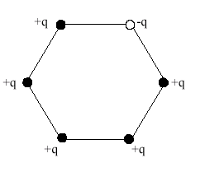

Fig. Q#3 T051 Fig. Q#4 T051 Fig. 9, T042 Fig. 2 T042
Q#4. Six point charges are placed on the corners of a regular hexagon as shown in the figure. Five of them have a charge of +1.0 µC and the sixth has a charge of – 1.0 µC. If the distance from the center of the hexagon to its corner is 1 cm, what is the electric field at the center? (A) 1.8 x 10⁸ N/C.
Q#3 Three charges +2.00*10**(-8) C, +2.00*10**(-8) C, and -4.00*10**(-8) C are respectively arranged at the corners F, G, and H of a right-angle triangle as shown in figure 2. Find the magnitude and direction of the resultant electric field at point P due to the three charges. [ A1 2.88*10**3 N/C towards H.]
Q#4 In figure 9, a small ball of mass m=2.0 g is hanging from a fixed point by a non-conducting string of length 1.00 m. The ball carries a charge q=25.0*10**(-9) C. The mass of the string is negligible. An electric field E with magnitude E=2.0*10**5 N/C, in the positive x-direction, causes the ball to be in an equilibrium position with an angle Theta. Find the angle Theta. [Take g = 9.80 m/s**2]. [A1 14.3 degrees.]
+
- Plate
- Plate
+ Plate
e
p
Figure 3

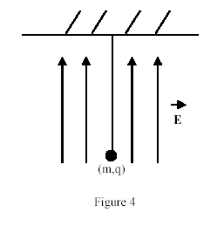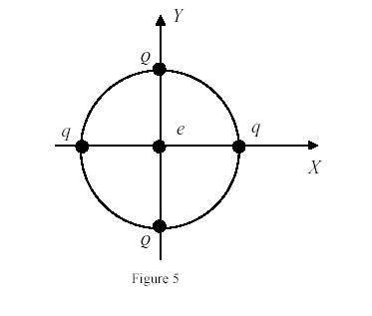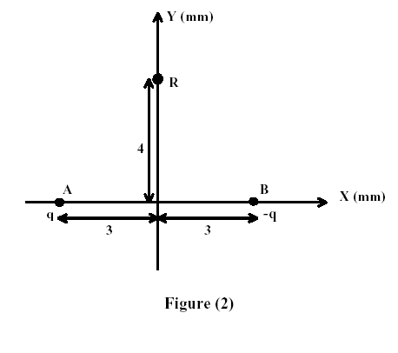

Fig. 3, T042 Fig. 4, T032 Fig. 5, T032 Fig. 9, T042

Q#5 A uniform electric field is set up between two large charged plates, see Figure 3. An electron is released from the negatively charged plate, and at the same time, a proton is released from the positively charged plate. They cross each other at a distance of 5.00*10(-6) m from the positively charged plate. If only the field due to the charged plates is considered, find the distance between the two plates. [Take the ratio mass of the electron : mass of the proton = 1 : 1833] [A1 9.19 mm.]

T041
Q#1: The electric field produced by a +3.0 C charge at a point 1000 m to the left of the charge is (Ans: A1 2.7*10**4 N/C toward the left)
T 032
HWQ#1:In figure 4, a 0.3 g metallic ball hangs from an insulating string in a vertical electric field of 4000 N/C directed upward as shown. If the tension in the string is 0.005 N, then the charge on the ball is: (Ans: -0.52 micro-C )
Q#2: In figure 5, four charges are placed on the circumference of a circle of diameter 2 m. If an electron is placed at the center of the circle, then the electron will [Take Q = 60 micro-C, q = 20 micro-C] (Ans: stay at the center.)
Q#3: A particle of mass 5.0 g and charge 40 mC moves in a region of space where the electric field is uniform and given by E = -5.5 i (N/C). If the velocity of the particle at t = 0 is given by v = 50 j (m/s), find the speed of the particle at t = 2 s. [i, and j are the unit vectors in the directions of x, and y respectively]. (Ans: 101 m/s. )
HWQ#4: At which point can the electric field due to the two charges shown in figure 6 be zero? (Ans: point E.)
T031
HWQ#1: A particle, of mass m and charge q, is released from rest at point A in a uniform electric field, see figure (2). The kinetic energy, due to the electric field, it attains after moving a distance y is: (Ans: q*E*y.)

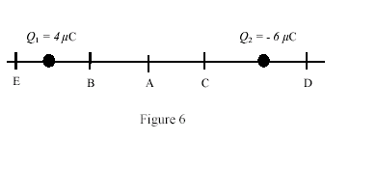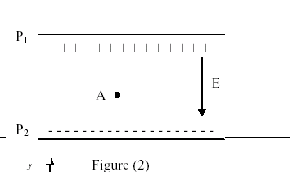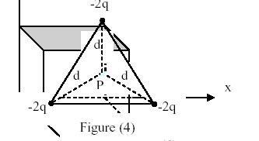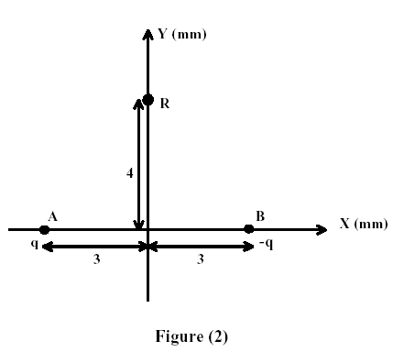

Fig. 6, T032 Fig.2, T031 Fig.4, T031 Fig. 2, T012
HWQ#4: In figure (4), what is the magnitude of the electric field at point P, center of the equilateral triangle? [take d = 2 m, q = 10**(-9) C] (Ans: A1 Zero.)
T012
HWQ#1: In figure (2), find the magnitude of the electric field at the point R: (0,4) mm due to two-point charges q (1 micro-C) and - q placed at points A: (-3, 0) mm and B: (3, 0) mm, respectively.(Ans: 4.3*10**8 N/C.)
T002
Q#1: A point charge of 4.0 nano-C is located at a point having coordinates (30.0 cm, 40.0 cm). At what point will the electric field be 72 N/C and pointing in the negative y-direction? (Ans: (30.0, -30.7) cm)
Q#3: A charged particle has a mass of 2.0*10**(-4) kg. If it is held stationary by a downward 300 N/C electric field, the charge of the particle is: (Ans: - 6.5*10**(-6) C)
T001
HWQ#1: Four electric charges are arranged so that the total electric field at the origin is zero. Which configuration in figure (1) would achieve this? (Ans: Configuration 1.)
Q#2: An electron, traveling with initial velocity 10**5 i m/s, enters a region of a uniform electric field given by E = 4.0*10**3 i N/C. Determine the time it takes for the electron to come to rest momentarily.(i is a unit vector in the positive x-direction) (Ans: 1.4*10**(-10) s.)
T 992
Q#3: An electron, traveling with initial velocity 10**5 i m/s, enters a region of a uniform electric field given by E = 4.0*10**3 i N/C. Determine the time it takes for the electron to come to rest momentarily.
Final- T 032
Q#1: The electric field 20 mm from a certain point charge has a magnitude |E|. The magnitude of the electric field 10 mm from the point charge is : (Ans: 4.0*|E|.)

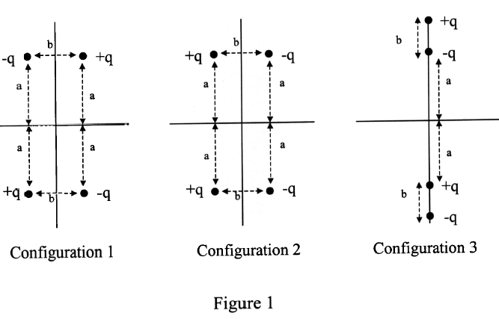
Fig. 1, T001

