Old-Exam-Questions-Ch.#19 (Dr. Gondal-Phys102)
T081: Q12.A gas expands from a volume of 2.00 m³ to a volume of 6.00 m³ along two different paths as shown in Fig 2. The heat added to the gas along path IAF equals 1.68 × 10⁶ J. Find the heat added during path IF. (Ans: 1.48 × 10⁶ J)
Q13: Fig. 3. shows a cycle undergone by 1.0 mol of a monatomic ideal gas. What is the heat added to the gas during the whole cycle? (Ans: 520 J)
Q14. What is the change in the internal energy of a 1.00 mole of a monatomic ideal gas that goes from point 1 (T1= 455K and pressure P1 = 1.00 atm) to point 2 (T2 = 300 K and pressure P2 = 1.00 atm.)? (Ans: -1930 J)
Q15. The mass of an oxygen molecule is 16 times that of a hydrogen molecule. At room temperature, the ratio of the rms speed of an oxygen molecule to that of a hydrogen molecule is: (Ans: ¼)
Q16. A 0.825 mol of an ideal gas undergoes an isothermal process. The initial volume is 0.20 m³ and the final volume is 0.30 m³. If the heat added to the gas is 1000 J, find the temperature of the gas. (Ans: 360 K)
T072: Q15. An ideal monatomic gas expands from state A to state B along the straight line path shown. Below in Fig. 1. Calculate the heat absorbed by the gas in the process. (Ans: +962 J)
Q16. An ideal gas is initially at a pressure of 1.40 atm and has a volume of 3.50 L. It expands isothermally to a final pressure of 0.600 atm. What is the work done in the process? (Ans: + 420 J)
Q17. One mole of an ideal monatomic gas is taken through an adiabatic process, as shown in the Fig. 2. Calculate the work done in this process. (Ans: 7.8 kJ)
T071
Q13. A gas initially at a temperature of 0 ºC and a pressure of 100 kPa is compressed isothermally from 30 L to 20 L. What is the work required? (1.2 kJ)
Q19. An ideal monatomic gas, undergoes an adiabatic expansion to one-third of its initial pressure. Find the ratio of the final volume to the initial volume. (Ans: 1.9)
Q20. A gas undergoes the cyclic process shown in the figure1. The net heat absorbed during the complete cycle is 1000 J. Find the work done by the gas for the process c to a. (Ans: -1000 J)
T062
Q14. One mole of an ideal monatomic gas, initially at 300 K, expands adiabatically to twice of its initial volume. The work done in this process is: (Ans: 1.4 J)
Q15. One mole of a monatomic ideal gas absorbs heat at constant pressure and its temperature rises from 40 °C to 90 °C. The heat absorbed in the process is (Ans: 1.0 kJ)
Q16. Two moles of an ideal monatomic gas are compressed adiabatically from A to B and then further compressed isothermally from B to C as shown in the figure 1. Calculate the net heat transfer in the process from A to C. (Ans: -6.7 kJ)
Fig. 1, T071 Figure 1, T062
T061: Q14. One mole of a diatomic ideal gas is initially at a temperature of 127 oC and has a volume of 0.090 m3. The gas is compressed adiabatically to a volume of 0.045 m3. What is the final temperature? (Ans: 528 K) Q15. Q 2. 6 moles of an ideal gas are kept at a constant temperature of 60 .0 oC while the pressure of the gas is increased from 1.00 atm to 4.00 atm. Find the heat involved during this process. (Ans: -23 kJ) Q16. A sample of one mole of an ideal gas is taken through the cyclic process ABCA as shown in the Figure 1. What is the net energy added to the gas as heat during the cycle? (Ans: 12 kJ).

T052: Q#2. One mole of an ideal gas is cooled at constant pressure process from 100 oC to 40 oC. Calculate the work done during the process. (Ans: –500 J) Q#10. A sample of argon gas ( MAr = 40 g/mole) is at four times the absolute temperature of hydrogen gas (MH = 2 g/mole). The ratio of the rms speed of the argon atoms to that of hydrogen molecules is: (Ans: 0.45 ) Q#20. A monatomic ideal gas is compressed adiabatically from an initial pressure of 1 atm and volume of 800 cm3 to a volume of 400 cm3. If the initial temperature of the gas is 20 oC, what is the final temperature of the gas? (Take γ=1.67) (Ans: 466 K.)
T051: Q#13. A sample of an ideal gas is compressed by a piston from 10 m3 to 5 m3 and simultaneously cooled from 540 K to 270 K. As a result there is: (Ans: No change in pressure. Q#14. An ideal gas expands at constant pressure of 120 kPa from (a) to (b) as shown in the Figure 1. It is then compressed isothermally to point (c) where the volume is is 40 L. Find the net work done during these two processes ( Ans: 1060 J ) Q#15. Two moles of ideal gas are at 20 oC and a pressure of 200 kPa. If the gas is heated to 40 oC, and its pressure is reduced by 30%, what is the new volume? (Ans: 37 L) Q#16. In the Figure 2 below, paths 1 and 3 are isotherms and paths 2 and 4 are adiabatic. Which path results in the highest heat transferred to the gas? (Ans: Path 1)
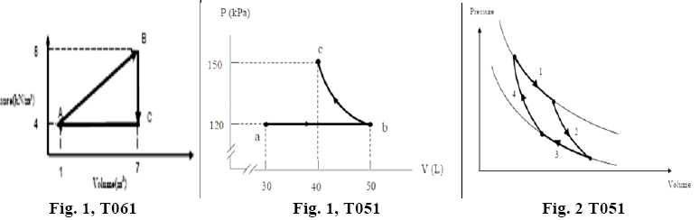

T042: Q14 : An ideal monatomic gas originally in state A is taken reversibly to state B along the straight line path shown in figure 4. What is the change in the internal energy of the gas for this process? (A1:30 kJ.)
Q15 : A system of monatomic ideal gas expands to twice its original volume, doing 300 J of work in the process. The heat added to the gas will be largest if the process is . A1: done at constant pressure.
Q16 One mole of a monatomic ideal gas is initially at a temperature of 300 K and with a volume of 0.080 m**3. The gas is compressed adiabatically to a volume of 0.040 m**3. What is the final temperature? ( A1 : 476 K)
Q#17 Five moles of an ideal gas are kept at a constant temperature of 53.0 degrees Celsius while the pressure of the gas is increased from 1.00 atm to 3.00 atm. Find the work done in the process. ( A1 14.9 kJ of work done on the gas.)
Q#18 Two moles of a monatomic ideal gas with an RMS speed of 254 m/s are contained in a tank that has a volume of 0.15 m**3. If the molar mass of the gas is 0.39 kg/mole, what is the pressure of the gas? A1 1.1*10**5 Pa.

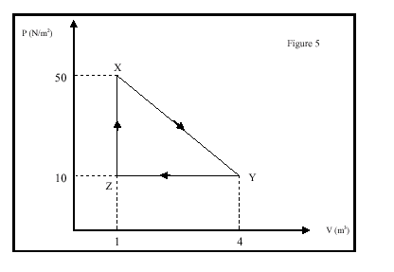
Figure 4

Fig.4, T042 Fig. 5, T041
T041: 1) A mass of an ideal gas of volume V at pressure P undergoes the cyclic process shown in figure 5. At which points is the gas coolest and hottest?(A1: Coolest at Z and hottest at X).
2) A system of an ideal gas undergoes the cyclic process shown in figure 5. Calculate the work done by the system along the path XY. (A1: 90 J.
3) The temperature of two moles of helium gas is raised from zero degrees Celsius to 100 degrees Celsius at constant pressure. Calculate the work done by the gas? (Ans: 1.66 kJ.)
4) A cylinder of volume 2.5 L contains 0.25 moles of helium [M = 4.0 grams/mole] at 2.0 atmospheric pressure. What is 41 the internal energy of the gas? (A1: 0.76 kJ.
5) A cylinder with a frictionless piston contains 0.2 kg of water at 100 degrees Celsius. What is the change in internal energy of water when it is converted to steam at 100 degrees Celsius at constant pressure of 1 atm. [Density of steam = 0.6 kg/m**3, water = 10**3 kg/m**3] (A1: 418 kJ. )
T032: 1) One mole of oxygen molecule (M = 32 g/mol) occupies a cubic vessel of side length 10 cm at a temperature of 27 degree-C. Calculate the pressure of the gas on the walls. (A1: 2.49*10**6 Pa.
2) The equation of state of a certain gas is given as P*V**2 = K, where P is the pressure, V is the volume and K is a constant. Find the work done by the gas if its volume increases from Vi = 2.0 m**3 to a final volume Vf = 4.0 m**3. (Ans: K/4. ) .
4) A diatomic ideal gas undergoes a constant pressure process in which its internal energy increases by 540 J. Find the heat added to the gas and the work done by the gas. (A1: Q = 756 J, W = 216 J. )
5) The air in an automobile engine at 20 degree-C is compressed adiabatically from an initial pressure of 1 atm and a volume of 200 cm**3 to a final volume of 20 cm**3. Find the final temperature if the air behaves like an ideal gas. [Take gamma = 1.4] (A1: 463 degree-C )
T031:Q1) Two moles of nitrogen are in a 3-liter container at a pressure of 5.0*10**6 Pa. Find the average translational kinetic energy of a molecule. A1: 1.9*10**(-20) J.
2) Two moles of helium (monatomic) gas are heated from 100 degrees Celsius to 250 degrees Celsius. How much heat is transferred to the gas if the process is done at constant pressure? (A1: 6.23 kJ)
3) An ideal diatomic gas, initially at a pressure Pi = 1.0 atm and volume Vi, is allowed to expand isothermally until it’s volume doubles. The gas is then compressed adiabatically until it reaches its original volume. The final pressure of the gas will be:( A1: 1.3 atm)
4) Five moles, of an ideal monatomic gas, expand at constant pressure of 1.0*10**2 Pascal from a volume of 1.0 m**3 to to a volume of 3.0 m**3. What is the change in the internal energy of the system? (A1: 300 J).
T012: Q:1) Two moles of a monatomic ideal gas at a temperature of 300 K and pressure of 0.20 atm is compressed isothermally (constant temperature) to a pressure of 0.80 atm. Find the work done by the gas. (A1: -6900 J )
2) An ideal gas undergoes an isothermal process starting with a pressure of 2*10**5 Pa and a volume of 6 cm3. Which of the following might be the pressure and volume of the final state? (A1: 6*10**5 Pa and 2 cm**3 )
3) Two moles of a monatomic ideal gas is compressed at a constant pressure of 1.5 atm from a volume of 70 liters to 35 liters. Calculate the change in internal energy of the gas. A1: - 1.3*10**4 J )
4) In an adiabatic process, the temperature of one mole of an ideal monatomic gas is decreased from 500 K to 400 K. What is the work done during the process in calories? (A1: 300 )
T0111) Two identical containers, one has 2.0 moles of type 1 molecules, of mass m1, at 20 degrees Celsius. The other has 2.0 moles of type 2 molecules, of mass m2 = 2*m1, at 20 degrees Celsius. The ratio between the average translational kinetic energy of type 2 to that of type 1 is: A1: . 8)
2) One mole of an ideal gas is taken through the cyclic process ABCA as shown in Fig. (2). What is the net heat transfer
during the cycle? (A1: 2.0*10*3 J.)
Q#3: A diatomic ideal gas, at a pressure of 1.0 atm, expands isotropically from a volume of 2.0 Liters to a volume of 5.0 Liters. Calculate the change in internal energy of the gas during the process. (A1. -3.1*10**2 J.)

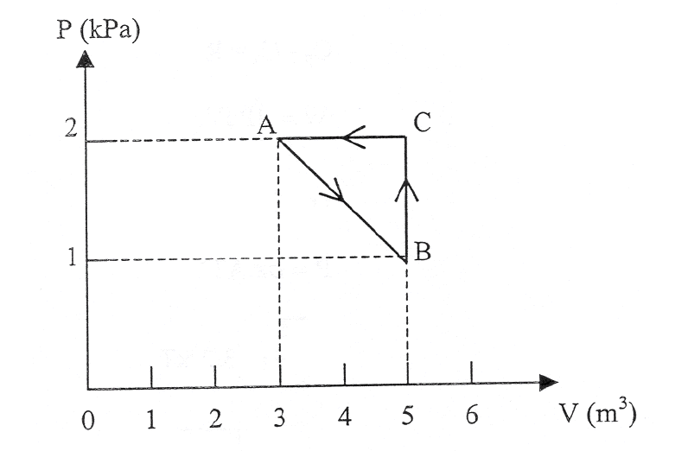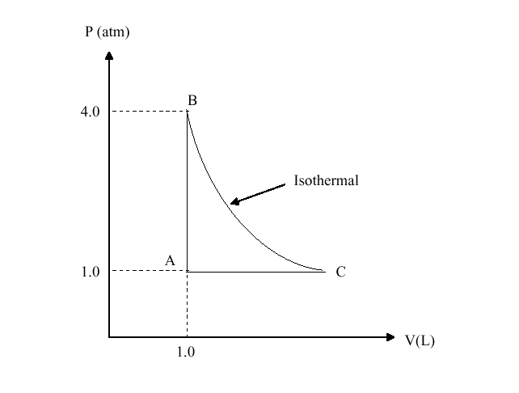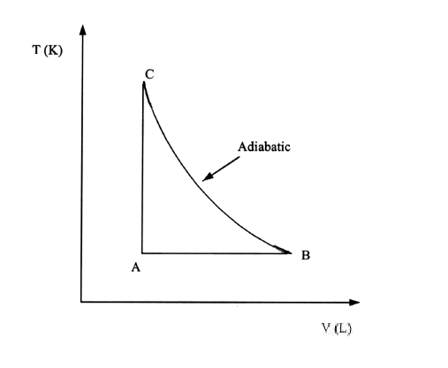
Fig. 2, T011 Fig. 2, T002 Fig. 1, T001
T002Q1) 5 moles of hydrogen gas occupy a balloon that is inflated to a volume of 0.3 m**3 and at 1.0 atmospheric pressure. What is the root-mean square velocity of the molecules inside the balloon? [The mass of hydrogen atom is 1.66*10**(-27) kg].( A1: 4.3*10**3 m/s.)
Q2) Helium gas is heated at constant pressure from 32 degrees Fahrenheit to 212 degrees Fahrenheit. If the gas does 20.0 Joules of work during the process, what is the number of moles? (A1: 0.024 moles)
Q3) Two moles of helium (monatomic) gas are heated from 100 degrees Celsius to 250 degrees Celsius. How much heat is transferred to the gas if the process is isobaric? (A1: 6.23 kJ ).
Q4) An ideal diatomic gas, initially at a pressure Pi = 1.0 atm and volume Vi, is allowed to expand isothermally until its volume doubles. The gas is then compressed adiabatically until it reaches its original volume. The final pressure of the gas will be: (A1: 1.3 atm)
HWQ5) One mole of an ideal gas undergoes the thermodynamic process shown in figure (2). If the process BC is an isothermal, how much work is done by the gas in this isothermal process? (A1: 0.56*10**3 J ).
T 001: Q1) One mole of an ideal gas has a temperature of 25 degree Celsius. If the volume is held constant and the pressure is doubled, the final temperature will be: (A1: 323 degree Celsius)
Q2) A lead bullet, travelling at 200 m/s, strikes a tree and comes to rest. If half the heat produced is retained by the bullet. The temperature of the bullet will be change by: (Specific heat of lead = 0.125*10**3 J/(kg*Celsius degree) (Assume that all the kinetic energy is converted to heat energy.) (A1: 80 Celsius degree.)
Q3) Five moles of an ideal gas expands isothermally at 100 degree Celsius to five times its initial volume. Find the heat flow into the system. (A1: 2.5*10**4 J )
Q4) Two kilograms of water, at 100 degree Celsius, occupy a volume of 2.0*10**-3 m**3. When this amount of water is boiled, at atmospheric pressure, it becomes 3.3 m**3 of steam. Find the change in the internal energy. (A1: 4.2*10**6 J.)
Q5) Two moles of helium (monatomic) gas are heated from 100 degree Celsius to 250 degree Celsius. How much heat is transferred to the gas if the process is isobaric? (A1: 6.23*10**3 J)
Q6) An ideal monatomic gas goes through the process in T-V diagram of figure (1) .At Point A, the temperature is 400 K, and the volume is 2 liters. If the volume at point B is 10 liters, what is the temperature at point C be? (A1: 1.17*10**3 K.)
T 992Q1) Consider an isothermal compression of 0.1 moles of an ideal gas at a temperature of 0 degree-C. The initial pressure of the gas is 1 atm and the final volume is 1/5 the initial volume. Find the thermal energy transfer for this process. (A1: 365 J lost by the gas.)
Q2) A cylinder contains 4 moles of a diatomic ideal gas (Cv = 5R/2) at a temperature of 27 degrees-C and a pressure of 1.5 atm. The gas is heated under constant pressure until its temperature reaches 127 degrees-C. How much work is done by the gas in this process? (A1: 794 calories)
Q3) Consider 100 g of helium (He) gas at 77 K. How much heat energy must be supplied to the gas to increase its temperature to 24 degrees-C, if the process is iso-volumetric? (M(He) = 4 g/mole and He is a monatomic gas.) (A1: 69 kJ).
T991Q1) Nitrogen gas (m = 1.00 kg) is confined in a cylinder with a movable piston at a pressure of 1 atm. A quantity of heat 25 kcal is added to the gas in an isobaric process, and its internal energy increases by 8 kcal. What is the change in the volume of the gas? (A1: 0.7 m**3)
Q2) An ideal gas is taken through the cyclic process shown in Figure 1. How much heat is added or removed from the gas ? (A1: 200 kJ)
Q3) An ideal gas (gamma = 1.40) expands slowly and adiabatically. If the final temperature is one third the initial temperature, by what factor does the volume change? (A1: 15.6)
Q4) Two moles of helium (monatomic) gas are heated from 100 degrees Celsius to 250 degrees Celsius. How much heat is
transferred to the gas if the process is isobaric? (A1: 6.23 kJ)
Q5) Oxygen gas at 20 degrees Celsius is confined in a cube. What is the translational average kinetic energy per molecule?
(A1: 6.1*10**-21 J

