Old Exam. Questions Ch. 9-Dr. Gondal (Phys. 101)

T082
Q#9: Sphere A has mass m and is moving with velocity v. It makes a head-on elastic collision with a stationary sphere B of mass 2m. After the collision their speeds vA and vB are, respectively: (Ans: −v/3, 2v/3 )
Q#10: A 3.0-kg and a 2.0-kg carts approach each other on a horizontal air track. They collide and stick together. After the collision their total kinetic energy is 0.40 x10² J. The initial speed of their center of mass was: ( A) 4.0 m/s
Q#11: A projectile has a range R. At its highest point the projectile explodes into two equal parts. One part falls vertically down. How far from the firing point will the other part land? (A) 3R/2
Q#12: A 1.0-kg ball moving with a speed of 2.0 m/s perpendicular to a wall rebounds from the wall (opposite to its original direction) with a speed of 2.0 m/s .The change in the momentum of the ball is: (A) 4.0 N · s away from the wall

T081
Q9.: A ball of mass 60 g traveling horizontally at 14 m/s hits a vertical wall and bounces back with a speed of 12 m/s. If the duration of impact is 2.0 ms, what is the magnitude of the force of the wall on the ball? (Ans: 780 N)
Q10.: An object of mass 5 kg is moving on a frictionless table toward the North. It explodes into two pieces, m₁ moving at a speed of 3 m/s, 45⁰ East of North, and m₂ moving at a speed of 5 m/s, 45⁰ West of North. Find m₁ and m₂ in kilograms. (Ans: m₁ = 3.1 m₂ = 1.9)
Q11.Two identical red and blue cars are moving along the same track in opposite directions. The red car has 5 times the momentum of the blue car. They undergo a perfectly inelastic collision. The speed after the collision is (Ans: twice the initial speed of the blue car)
Q12. Figure 4 shows the momentum versus time graph of a particle moving along the x-axis. The force on the particle is maximum in the time interval (Ans: 2 to 3 s)

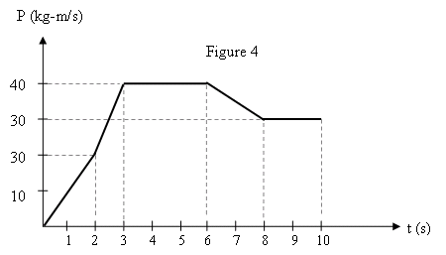

Fig. 4, T081

T072
Q#9: A sulfur dioxide molecule SO₂ consists of a Sulfur atom (M = 32 u) located at the origin with two Oxygen atoms each of mass (m = 16 u) bound to it as in Fig 4. The angle between the two bonds is 120°. If each bond is 0.1432 nm long, what is the location of the center of mass of the molecule (x,y)? (Ans: (0.0358, 0) nm)
Q10. A 10.0 kg toy car is moving along the x axis. The only force F_{x} acting on the car is shown in Fig. 5 as a function of time (t). At time t = 0 s the car has a speed of 4.0 m/s. What is its speed at time t = 6.0 s? (Ans: 8.0 m/s )
Q11. An object of mass M moving on a frictionless frozen lake with speed V explodes into two equal pieces, one moving at 6.0 m/s due north, and the other at 8.0 m/s due west. Determine V. (Ans: 5.0 m/s)
Q12. A 4.0 kg block with a velocity of 2i m/s makes an elastic collision with a 2.0 kg block moving with a velocity of ( 2i+j ) m/s. What is the total kinetic energy of the two blocks after the collision? (Ans: 13 J)

T071
Q8. Two velocities of the three-particle system are shown in the Fig. 1. If the velocity of the center of mass is zero, find the velocity v of the 4.0 kg mass. (Ans: (5i-3j) m/s)
Q9. A 4.0 kg object moving with velocity (9.0) i m/s explodes into two pieces, one with mass 1.0 kg and velocity (6.0 j) m/s and the other with mass 3.0 kg and velocity v . Determine v. (Ans: (12i-2.0 j) m/s )
Q10. A 5 kg object moving along the x axis is subjected to a force F_{x} in the positive x direction. A graph of F_{x} as a function of time t is shown in Fig. 2. Find the magnitude of the change in the velocity of the object during the time the force is being applied. (Ans: 0.8 m/s)
Q11. A block of mass m = 500 g moving on a frictionless track at an initial speed of 3.20 m/s undergoes an elastic collision with an initially stationary block of mass M. After collision, the first block moves opposite to its original direction at 0.500 m/s. The mass M is: (Ans: 685 g)
Q12. Two bodies , A and B each of mass 2.0 kg moving with velocities v_{A} = (2.0i+5.0 j) m/s and v_{B} = (1.0i-5.0j) m/s collide and stick together after collision. After the collision, the velocity of the composite object is: (Ans: 1.5 i m/s )
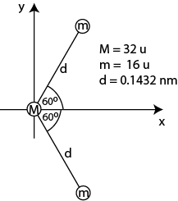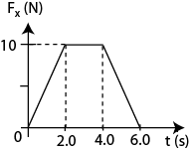
Fig. 4, T072 Fig. 5, T072 Fig. 1, T071 Fig. 2, T071 Fig. 3, T062

T062: Q9. An impulsive force Fx as a function of time (in ms) is shown in the Fig. 3 as applied to an object (m = 5.0 kg) at rest. What will be its final speed? A) 2.0 m/s.
Q10. Each object in Fig. 4 has a mass of 2.0 kg. The mass m₁ is at rest, m₂ has a speed of 3.0 m/s in the direction of +ve x-axis and m₃ has a speed of 6.0 m/s in the direction of +ve y-axis. The momentum of the center of mass of the system is: (Ans: 6i+12j)
Q11. A 0.20 kg steel ball, travels along the x-axis at 10 m/s, undergoes an elastic collision with a 0.50 kg steel ball traveling along the y-axis at 4.0 m/s. The total kinetic energy of the two balls after collision is: (Ans: 14 J.)
Q12. If the masses of m₁ and m₃ in Fig. 5 are 1.0 kg each and m₂ is 2.0 kg, what are the coordinates of the center of mass? (Ans: (1.00, 0.50) m )

T061; Q10. A small object with linear momentum 5.0 kg·m/s makes a head-on collision with a large object at rest. The small object bounces straight back with a momentum of magnitude 4.0 kg·m/s. What is the magnitude of the change in momentum of the large object? (Ans: 9.0 kg·m/s )
Q11. A 1500 kg car traveling at 90.0 km/h east collides with a 3000 kg car traveling at 60.0 km/h south. The two cars stick together after the collision (see Fig 2). What is the speed of the cars after collision? A) 13.9 m/s
Q12. A 3.0 kg mass is positioned at (0, 8.0) m, and a 1.0 kg mass is positioned at (12, 0) m. What are the coordinates of a 4.0 kg mass which will result in the center of mass of the system of three masses being located at the origin (0, 0)? (Ans: (-3.0, -6.0) m )

T052: Q#9: The location of two thin flat objects of masses m₁= 4.0 kg and m₂ = 2.0 kg are shown in Fig. 3, where the units are in m. The x and y coordinates of the center of mass of this system are: (Ans:1.0 m, 0.33m).
Q#10: The impulse which will change the velocity of a 2.0-kg object from v₁ =+30jm/ s to v₂== −30 i m/s is : (-60i-60j)N.s.
Q#11: A 2.00 kg pistol is loaded with a bullet of mass 3.00 g. The pistol fires the bullet at a speed of 400 m/s. The recoil speed of the pistol when the bullet was fired is: (Ans: 0.600 m/s)

Q#12: Sphere A has mass 3m and is moving with velocity v in the positive the x direction. Sphere B has a mass m and is moving with velocity v in the negative x direction. The two spheres make a head-on elastic collision. After the collision the velocity of A (v_{A}) is: (Ans:zero)

T051: Q9: Sphere A has a mass M and is moving with speed 10 m/s. It makes a head-on elastic collision with a stationary sphere B of mass 3M. After the collision the speed of B is: (Ans: 5.0 m/s )
Q10: The two pieces of uniform sheets made of the same metal are placed in the x-y plane as shown in the Figure 2. The center of mass (x_{com}, y_{com}) of this arrangement is(Ans: (-0.75, 0.75) cm)
Q#11: A 0.50 kg ball moving at 2.0 m/s perpendicular to a wall rebounds from the wall at 1.4 m/s. The impulse on the ball is: (Ans: 1.7 N · s away from wall)
Q#12: An object of 12.0 kg at rest explodes into two pieces of masses 4.00 kg and 8.00 kg. The velocity of the 8.00 kg mass is 6.00 m/s in the +ve x-direction. The change in the kinetic is: (Ans: 432 J)
T042: Q8: Four masses, m1 = 1.0 kg, m2 = 2.0 kg, m3 = 3.0 kg and m4 = 4.0 kg are placed at the corners of a square of side a = 1.0 m, as shown in Fig 3. The x and y coordinates of their center of mass are: (Ans (0.5 m, 0.7 m)
Q9: A 1.0 kg ball strikes a vertical wall at an angle of 30 degrees with a speed of 3.0 m/s and bounces off at the same angle with the same speed, as shown in Fig 4. The change in momentum of the ball is : (Ans 3 kg*m/s to the left)
Q10: A 6.0 kg body moving with velocity v breaks up (explodes) into two equal masses. One mass travels east at 3.0 m/s and the other mass travels north at 2.0 m/s. The speed v of the 6.0 kg mass is: (Ans 1.8 m/s)
Q11: In an inelastic collision between two objects with no external forces, (Ans: momentum is conserved but kinetic energy is not conserved)
Q12: A 1.0 kg ball falling vertically hits a floor with a velocity of 3.0 m/s and bounces vertically up with a velocity of 2.0 m/s . If the ball is in contact with the floor for 0.10 s, the average force on the floor by the ball is: (Ans 50 N down)
Q13 A 2.0 kg block with a speed of 4.0 m/s undergoes a head on ELASTIC collision with a 4.0 kg block initially at rest. After the collision, the 4.0 kg block has 14.2 J of kinetic energy . The speed of the 2.0 kg block after the collision is: (Ans 1.3 m/s)

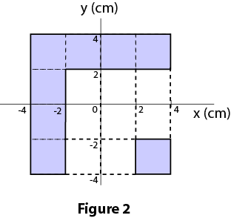

Fig. 4, T062 Fig. 5, T062 Fig. 2, T061 Fig. 3, T052 Fig. 2, T051

T041: Q7 A 1.0 kg particle is moving with a velocity of 16 m/s along the positive x direction while a 3.0 kg particle is moving with a velocity of 4.0 m/s along the positive y direction. Find the magnitude of their center of mass velocity. (Ans 5.0 m/s )
Q8 A 10 kg bomb initially at rest explodes, breaking into two pieces of masses 4.0 kg and 6.0 kg. The 4.0 kg piece fly off along the +x axis with a speed 30 m/s. Find the velocity of the 6.0 kg piece. (Ans 20 m/s along the -x axis )
Q9 A 0.5 kg ball having velocity (10 i + 10 j) m/s collides and bounces off a wall with a velocity of (-5.0 i + 10 j) m/s. Find the average force on the ball if the collision time is 0.01 s. (Ans (-750 i) N )
Q10 A circular hole of radius 5.0 cm is cut from a uniform square of metal sheet having sides 20 cm as shown in Fig 2. Which point could be the center of mass of this sheet? (Ans Point B )
Q11 A 2.0 kg block is given a single impulsive force in the positive x-direction as shown in Fig 3. If the velocity of the block at t=0 was -2.0 m/s, find its velocity at t=5.0 s. ( Ans 3.0 m/s )
Q12 As shown in Fig 4, a ball of mass M is hanging from a rope to make a pendulum. A 10 g bullet strikes the ball with a speed v=308 m/s. The center of mass of the ball + bullet rises a vertical distance of h=12 cm. Assuming that the bullet remains embedded, calculate the mass M of the ball. (Ans 2.0 kg)
Q13 A ball of mass m1= 0.2 kg and speed= v1 makes an elastic head-on collision with another ball of mass m2 initially at rest. After collision, m1 continues to move in the original direction but with speed = (1/3)v1. What is the value of m2? (Ans 0.1 kg ).

T032: Q8 A 10 gram bullet is shot in the +x-direction with a speed of Vo = 500 m/s into a stationary block of wood that has a mass of 5.0 kg (see Fig 3). The bullet embeds itself in the block. What distance (d) will the block slide on a surface having a coefficient of kinetic friction equal to 0.5? (Ans 10 cm)
Q9 A 10 kg bomb at rest explodes, breaking into three pieces of masses 2.0 kg, 2.0 kg, and 6.0 kg. The two 2.0 kg pieces fly off perpendicular to each other, one along the +x-axis and the other along the +y-axis, with the same speed 30 m/s. Find the speed of the 6.0 kg piece. (Ans 14 m/s )
Q10 Three particles are placed in the xy-plane. A 4.0 kg particle is located at (3.0, 4.0) m and a 6.0 kg particle is located at (-2.0, -6.0) m. Find the location of a 2.0 kg particle so that the center of mass of this three-particle system is located at Q0 the origin. ( Ans (0, 10))
Q11 A ball having a mass of 35 grams strikes a wall with a velocity of 8 m/s perpendicular to the wall and rebounds in the opposite direction with only 50 % of its initial kinetic energy. What is the magnitude of the impulse that acts on the ball while it is in contact with the wall during collision? (Ans 0.48 kg*m/s )

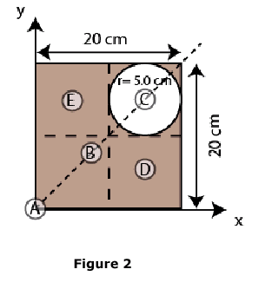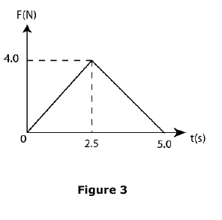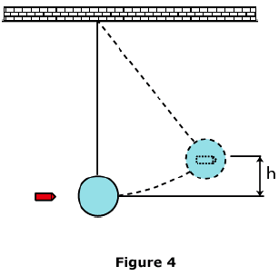

Fig. 3, T042 Fig. 4, T042 Fig. 2, T041 Fig.3, T041 Fig.4-T041
Q12 Fig 4 shows a plot of the force versus time (in millisecond) during the collision of a ball with a wall. Find the magnitude of the impulse delivered to the ball by the wall. (Ans 20 kg*m/s )
Q13: Body A with mass m moves along an x axis with kinetic energy of 9.0 J before having an elastic collision with body B with the same mass m , which is initially at rest. What is the final kinetic energy of B? (Ans 9.0 J)
T031: Q7 Three particles are placed in the xy plane. A 40-g particle is located at(4,3) m, and a 50-g particle is located at (-2,-2) m. Where must a 20-g particle be placed so that the center of mass of the three-particle system is at the origin (0,0)? (Ans (-3, -1) m )
Q8 A 2000-kg truck traveling at a speed of 6.0 m/s makes a 90 deg turn in a time of 4.0 s and emerges from this turn with a speed of 4.0 m/s. What is the magnitude of the average resultant force on the truck during this turn? (Ans 3.6 kN )
Q9 An 8.0 kg object moving at 4.0 m/s in the positive x direction makes a one-dimensional collision with a 2.0 kg object moving at 3.0 m/s in the opposite direction. The final velocity of the 8.0 kg object is 2.0 m/s in the positive x direction. What is the total kinetic energy of the two objects after the collision? (Ans 41 J )
Q10 A 4.0 kg mass has a velocity of (4.0 i) m/s, when it explodes into two 2.0 kg masses. After the explosion, one of the masses has a velocity of 3.0 m/s making an angle of 60 degrees with the +x axis. What is the magnitude of the velocity of the other mass after the explosion? (Ans 7.0 m/s)
Q11 A 3.0 kg steel ball strikes a wall with a speed of 10 m/s at an angle of 60 degrees with the surface. It bounces off with the same speed and angle (see Fig. 4). If the ball is in contact with the wall for 0.20 s, what is the average force exerted on the ball by the wall? ( Ans (-260 i) N)
Q12 A 3.0 kg object with an initial velocity of (5 i) m/s collides with and sticks to a 2.0 kg object moving with an initial velocity of (-3 j) m/s. Find the final velocity of the composite body. ( Ans ( 3.0 i - 1.2 j) m/s).

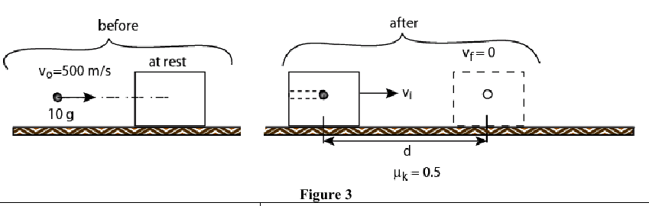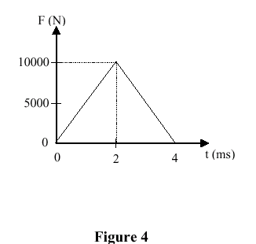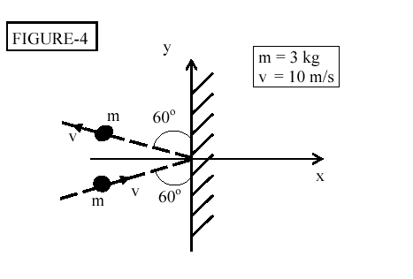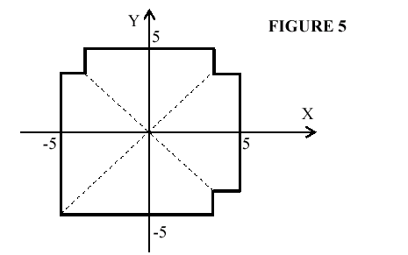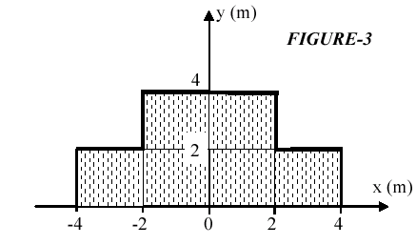
Fig.3-T032 Fig. 4-T032 Fig. 4 T031 Fig. 5-T022 Fig. 3-T021
T022
Q8 Fig. 5 shows a uniform square sheet from which three identical corners are removed. What is the location of its center of mass? ( A1 in the third quadrant).
Q9 Car A (mass 1000 kg) travels east with a constant velocity of 80 km/h. Car B (mass 1500 kg) has an unknown velocity. If the center of mass of these two cars is moving with a velocity of 24 km/h due north, find the velocity of car B. (Take i and j along east and north respectively). (Ans (-53i + 40j) km/h )
Q10 A 80-kg hunter gets a rope around a 120-kg polar bear. They are stationary, 10 m apart, on frictionless level ice. When the hunter pulls the polar bear to him, the polar bear will move: ( Ans 4.0 m)
Q11 Initially a 2-kg disk is moving north at 3 m/s on a horizontal smooth ice surface. Then a 4-N force in the east direction acts on the disk for 1.5 s. What is the final velocity of the disk? (Take i and j along east and north respectively). (Ans (3i + 3j) m/s)
Q12 A 2.0-kg and a 3.0-kg carts approach each other on a horizontal air track in such a way that their center of mass has a speed of 2.0 m/s. They collide and stick together. After the collision their total kinetic energy in joules is: (Ans 10)
Q13 Sphere A of mass 200 g is moving with VAi = +6.0 m/s. It makes a head-on collision with sphere B of mass 400 g at rest. After collision sphere B moves with VBf = +3.0 m/s. What is the velocity of sphere A after collision? (Ans 0 m/s )

T021
Q# 7. A 3.0 kg particle is moving along the +x direction at 30 m/s toward a stationary 7.0 kg particle. What is the velocity of the center of mass of the two particles? (Ans: 9.0 m/s )
Q#8. A 3.0 kg object, initially at rest explodes into three pieces of equal mass. Two pieces move perpendicular to each other, each with a speed of 10 m/s. What is the speed of the third piece? (Ans 14 m/s)
Q# 9. A uniform plate is shaped as in Fig(3). Find the coordinates of the center of mass of the plate? (A1 (0,1.67) m)
Q11.A 0.2 kg ball drops vertically onto a floor, hitting with a speed of 30 m/s. The ball rebounds up with a speed of 20 m/s. The ball is in contact with the floor for 0.01 s. The magnitude of the average force of the floor on the ball during this time is: (Ans 1000 N )
Q12.A particle (A) has a mass m and is moving with a velocity v. It makes a head-on elastic collision with a particle (B) of mass 2m at rest. After the collision, their velocities (vA, and vB) are: (Ans -v/3, 2v/3 )
Q 13. Block A(mass = 2.0 kg, velocity = 50 m/s) and block B(mass = 5 kg, velocity= -20 m/s)are moving towards each other along the x axis. They collide and stick together after collision. The kinetic energy lost during the collision is: (Ans 3500 J)

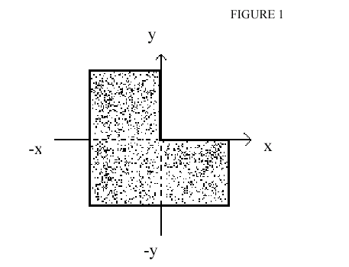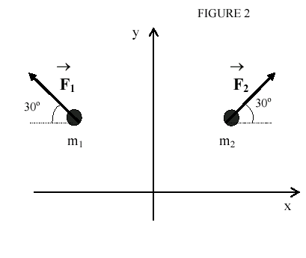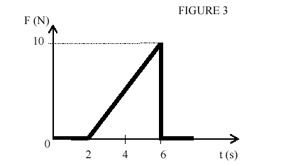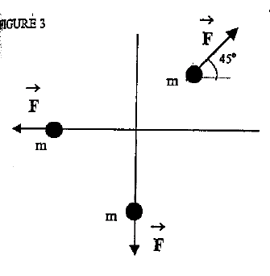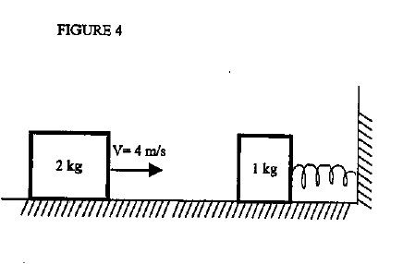
Fig. 1-T012 Fig.2-T012 Fig.3-T012 Fig. 3, T011 Fig. 4, T011
T012
Q7 A uniform plate of the shape shown in Fig. 1. The center of mass of this plate is located in: (Ans Quadrant 3)
Q8 A 4.0 kg object moving on a frictionless surface with speed v explodes into two objects of masses 1.0 kg and 9 3.0 kg. The 1.0 kg object moves north at 5.0 m/s and the 3.0 kg object moves east at 3.0 m/s. What is v? (Ans2.6 m/s)
Q9 Two particles m1 and m2,5.0-kg each, are initially at rest. External forces F1 and F2, 12 N each, are acting on these particles as shown in Fig.2. The acceleration of the center of mass of the two particles system is (A1 1.2 j m/s**2 )
Q10 A 5-kg object is acted upon by a single force in the x-direction as shown in Fig.3. Find the change of momentum delivered to the object in 6 s. (Ans 20 N.s)
Q12 Cart A of mass 3.0 kg and cart B of mass 2.0 kg approach each other on a horizontal air track in such a way that their center of mass has a speed of 4.0 m/s. They collide and stick together. After the collision the kinetic energy of the two carts system is: (Ans 40 J.)
T011
Q7: A 2.0-kg particle is moving to the right at 9.0 m/s 9 toward a 5.0-kg particle, which is moving at 2.0 m/s in the opposite direction. Find the velocity of the center of mass. (Ans 1.1 m/s to the right)
Q8 A 1.0-kg object at rest explodes, breaking into three pieces of masses 0.20, 0.20, and 0.60 kg. 9. The Two pieces, having equal mass, fly off perpendicular to each other, one along the positive x-axis and the other along the positive y-axis with the same speed of 30 m/s. Find the speed of the third (0.60-kg) piece. (Ans 14 m/s )
Q9 What is the magnitude of the acceleration of the center of mass of the system shown in Fig. 3. Each particle has a mass of 1.00 kg and pulled by a force of 2.0 N in the direction indicated in Fig.3. ( Ans 0.28 m/s**2)
Q10 Two 2.0-kg bodies, A and B, collide. Before collision the velocity of body A is (10i + 20j) m/s and after the collision body A moves with velocity (-5.0i + 10j) m/s. Find the magnitude of the impulse delivered to body B. (Ans 36 kg.m/s)
Q11 A 20-g bullet is fired into a 100-g wooden block initially at rest on a horizontal frictionless surface. If the initial speed of the bullet is 10 m/s and it comes out of the block with a speed of 5.0 m/s, find the speed of the block immediately after the collision. (Ans 1.0 m/s )
Q12 A 1.0-kg block at rest on a horizontal frictionless surface is connected to a spring (k = 200 N/m) whose other end is fixed (Fig. 4). A 2.0-kg block moving at 4.0 m/s collides with the 1.0-kg block. If the two blocks stick together after the one-dimensional collision, what maximum compression of the spring does occur when the blocks momentarily stop? ( Ans 0.33 m )

