Old Exam. Question Ch. 8 (Dr. Gondal Phys. 101)
T082
Q5. A projectile of mass m = 0.200 kg is fired at an angle of 60.0 degrees above the horizontal with a speed of 20.0 m/s. Find the work done on the projectile by the gravitational force during its flight from its firing point to the highest point on its trajectory. (A: –30.0 J)
Q6. A 0.500-kg block is pushed against a horizontal spring fixed at one end (the block is NOT attached to the spring), compressing the spring 10.0 cm. The spring has a spring constant of 1.00 x 10² N/m. The block lies on a horizontal floor having a coefficient of kinetic friction μ_{k} = 0.200. Find the total distance traveled by the block after being released from rest. (A: 51.0 cm)
Q7.A simple pendulum consists of a 2.00 kg mass attached to a 1.00 m long light string. It is given an initial speed of 0.500 m/s at A where the pendulum makes an angle θ with the vertical as shown in Fig.1. If its speed at the lowest point B is 1.70 m/s, find the value of the angle θ. (A: 30.1 degrees)
Q8. A ball of mass m, attached at one end of a massless string of length L, rotates in a vertical circle fast enough to prevent the string from going loose at the top of the circle. Neglecting air resistance, during this motion, which ONE of the following statements is WRONG: (A: Change in mechanical energy is not zero.)
T081
Q5.: A 2-kg object is dropped vertically from rest. After falling a distance of 50 m, it has a speed of 25 m/s. Calculate the work done by the air resistance on the object during this fall.( Ans:  355 J)
Q6.: A spring with spring constant k = 106 N/m is attached to the top of a frictionless 30⁰ incline as shown in Figure 2. The distance between the lower end of the incline and the relaxed end of the spring is 1 m. A 1-kg block is pushed against the spring until the spring is compressed by 0.2 m and released from rest. Find the speed of the block when it reaches the lower end of the incline. (ignore the size of the block). (Ans: 4.0 m/s)
Q7. A projectile is fired from a height of 25 m with a speed of 20 m/s as shown in Figure 3. Find its speed when it hits the ground. Ignore air resistance. (Ans: 30 m/s)
Q8.: As an object moves from point A to point B, only two forces act on it: one force is conservative and does 10 J of work, the other is non conservative and does –20 J of work. What happens to the energy of the object between points A and B? (Ans: Kinetic energy decreases, mechanical energy decreases.)

T072
Q2.: A ball slides without friction around a loop-the-loop (see Fig 2). A ball is released, from rest, at a height h from the left side of the loop of radius R. What is the ratio (h/R) so that the ball has a speed v=√Rg at the highest point of the loop? (g = acceleration due to gravity) (Ans:5/2)
Q4. A worker does 500 J of work in moving a 20 kg box a distance D on a rough horizontal floor. The box starts from rest and its final velocity after moving the distance D is 4.0 m/s. Find the work done by the friction between the box and the floor in moving the distance D.( Ans: –340 J)
Q5. A 2.0 kg block is released from rest 60 m above the ground. Take the gravitational potential energy of the block to be zero at the ground. At what height above the ground is the kinetic energy of the block equal to half its gravitational potential energy? (Ignore air resistance).( Ans: 40 m)
Q6. A 2.2 kg block starts from rest on a rough inclined plane that makes an angle of 30° above the horizontal. The coefficient of kinetic friction is 0.25. As the block moves 3.0 m down the plane, the change in the mechanical energy of the block is: (Ans: –14 J)
Q7. A 0.50 kg block attached to an ideal spring with a spring constant of 80 N/m oscillates on a horizontal frictionless surface. The speed of the block is 0.50 m/s, when the spring is stretched by 4.0 cm. The maximum speed the block can have is: (Ans: 0.71 m/s)
Q8.A block (mass = 0.100 kg) is pushed against a vertical spring compressing the spring a distance of h = 8.00 cm (see Fig 3). The block is not attached to the spring. When released from rest, the block rises to a maximum height of H = 0.600 m. Calculate the spring constant.

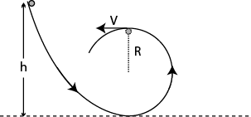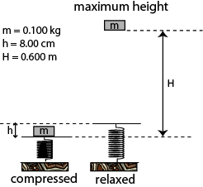

Fig. 2, T072 Fig. 3, T072
T071
Q5. A 10.0 kg block is released from rest 100 m above the ground. When it has fallen 50 m, its kinetic energy is: (Ans: 4900 J )
Q6. A 4.0 kg block is initially moving to the right on a horizontal frictionless surface at a speed of 5.0 m/s. It then compresses a horizontal spring of spring constant 200 N/m. At the instant when the kinetic energy of the block is equal to the potential energy of the spring, the mechanical energy of the block-spring system is: (Ans: 50 J)
Q7. A 5.0 kg block starts up a 30° incline with 198 J of kinetic energy. The block slides up the incline and stops after traveling 4.0 m. The work done by the force of friction between the block and the incline is: (Ans: -100 J)
T062
Q4: A 200 kg box is pulled along a horizontal surface by an engine. The coefficient of friction between the box and the surface is 0.400. The power the engine delivers to move the box at constant speed of 5.00 m/s is: (Ans: 3920 W)
Q5. A 2.0 kg object is connected to one end of an unstretched spring which is attached to the ceiling by the other end and then the object is allowed to drop. The spring constant of the spring is 196 N/m. How far does it drop before coming to rest momentarily? (Ans: 0.20 m)
Q6. A 2.0 kg block is thrown upward from the ground. At what height above the ground will the gravitational potential energy of the Earth-block system have increased by 490 J? (Ans: 25 m)
Q7. An ideal spring (compressed by 7.00 cm and initially at rest,) fires a 15.0 g block horizontally across a frictionless table top. The spring has a spring constant of 20.0 N/m. The speed of the block as it leaves the spring is: (Ans:2.56 m/s )
Q8 : A small object of mass m on the end of a massless rod of length L is held vertically, initially. The rod is pivoted at the other end O. The object is then released from rest and allowed to A small object of mass m on the end of a massless rod of length L is held vertically, initially. The rod is pivoted at the other end O. The object is then released from rest and allowed to swing down in a circular path as shown in Fig. 2. What is the speed (v) of the object at the lowest point of its swing? (Assume no friction at the pivot) (Ans: 4gL)
T061: Q5. A 2.2 kg block starts from rest on a rough inclined plane that makes an angle of 25° with the horizontal. The coefficient of kinetic friction is 0.25. As the block slides 2.0 m down the plane, the mechanical energy of the Earth-block system changes by: (Ans: −9.8 J)
Q6. An ideal spring with a 20 N/m spring constant is compressed by a 10 N force. The potential energy stored in the spring is: (Ans: 2.5 J)
Q7. An object of mass m, attached to a light cord of length L, is held horizontally from a fixed support as shown in Fig 1. The object is then released from rest. What is the tension force in the cord when the object is at the lowest point of its swing? (Ans: 3 mg)
Q8. A block of mass 2.0 kg is initially moving to the right on a horizontal frictionless surface at a speed 5.0 m/s. It then compresses a spring of spring constant 100 N/m. At the instant when the kinetic energy of the block is equal to the potential energy of the spring, the spring is compressed a distance of: (Ans: 0.50 m )
T052: Q#5: A 4.0 kg block starts up a 30° incline with 128 J of kinetic energy. How far will it slide up the incline if the coefficient of kinetic friction between the block and the incline is 0.50? (Ans: 3.5 m)
Q#7: A block is released from rest at a height h = 6.0 m along a frictionless loop-the-loop with a diameter of 3.0 m (see Fig 1). The speed at the top of the loop is: (Ans: 7.7 m/s)
Q#8: 2.0-kg block slides on a rough horizontal table top (see Fig 2). Just before it hits a horizontal ideal spring its speed is 5.0 m/s. It hits the spring and compresses it 10.0 cm before coming momentarily to rest. If the spring constant is 1200 N/m, the work done by friction is: (Ans: -19 J)
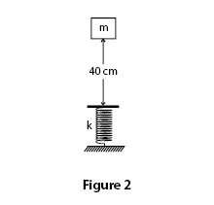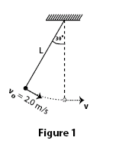
Fig. 2, T072 T062, Fig. 2 T061, Fig. 1 T042-Fig.2 T042-Fig. 1
T051: Q#8. A 0.75-kg block slides on a rough horizontal table top. Just before it hits a horizontal ideal spring its speed is 3.5 m/s. It compresses the spring 5.7 cm before coming to rest. If the spring constant is 2600 N/m, the coefficient of kinetic friction between the block and the table is: (Ans: 0.88)
T042: Q4 A 3.00 kg block is dropped from a height of 40 cm onto a spring of spring constant k (see Fig 2). If the maximum distance the spring is compressed = 0.130 m, find k. (Ans: 1840 N/m)
Q5: A 6.0 kg box starts up a 30 degrees incline with 158 J of kinetic energy. How far will it slide up the incline if the coefficient of kinetic friction between box and incline is 0.40 ? (Ans: 3.2 m)
Q6 : Fig 1 shows a pendulum of length L = 1.0 m. Its ball has speed of vo=2.0 m/s when the cord makes an angle of 30 degrees with the vertical. What is the speed (V) of the ball when it passes the lowest position? (Ans: 2.6 m/s)
T041: Q5 A projectile is fired from the top of a 40 m high building with a speed of 20 m/s. What will be its speed when it strikes the ground? (Ans: 34 m/s.)
Q6 A 75 kg parachutist releases himself off a tower that is 85 m high. Assume that he starts from rest and reaches the ground with a speed of 5.0 m/s. How much work was done by the no conservative forces on him? (Ans: -6.2* 10**4 J)

Q4 A 3.0 kg block is released from a compressed spring (k=120 N/m). It travels over a horizontal surface (mu =0.20) for a distance of 2.0 m before coming to rest, Fig 1. How far was the spring compressed before being released ? (Ans: 0.44 m.)
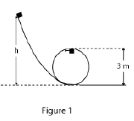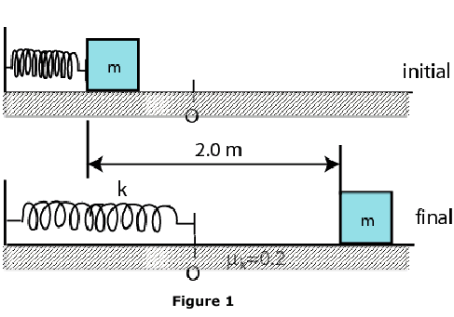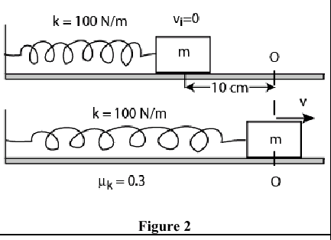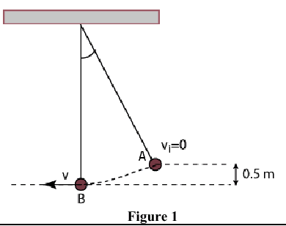
T052 Fig.1 T052- Fig. 2 Fig. 1 T041 Fig. 2 T032 Fig. 1 T032
T032: Q1 You are supposed to pull a 2000 kg equipment across a horizontal frozen lake by means of a horizontal rope. The coefficient of kinetic friction is 0.05. The amount of work you will do by pulling the equipment 100 m at constant velocity is: (Ans: 98 kJ)
Q4 A 2.0 kg block starts from rest on a rough inclined plane that makes an angle of 30 degrees with the horizontal. The coefficient of kinetic friction is 0.20. As the block moves 2.0 m down the plane, the change in gravitational potential energy of the block is: (Ans: - 19.6 J)
Q5 A projectile of mass 0.20 kg is fired with an initial speed of 20 m/s at an angle of 60 degrees above the horizontal. The kinetic energy of the projectile at its highest point is: (Ans: 10 J)
Q6 The simple pendulum shown in Fig 1 is released from rest at point (A) which is 0.5 m above its lowest point (B). The speed of the ball at (B) is: A1 3.1 m/s
Q7 A 0.50 kg block attached to a spring with a spring constant of 100 N/m moves on a horizontal surface having a coefficient of kinetic friction 0.3 (see Fig 2). The spring is initially compressed by 10 cm from the outstretched position O and then released from rest. The speed of the block when it passes through the point O is: (Ans: 1.2 m/s)
T031: Q5 A simple pendulum consists of a 2.0 kg mass attached to a string of length R=1.5 m. It is pulled up until the string is horizontal, and then released from rest (see Fig 3). Its speed (v) at the lowest point is (Ans: 5.4 m/s)
Q6 A block of mass m=3.0 kg is kept at rest after it has compressed a horizontal massless spring (k=500 N/m) by 0.15 m, as shown in Fig. 2. When the block is released, it travels a distance S on a horizontal rough surface (mu=0.4) before stopping. Calculate the distance S. ( Ans: 0.48 m).
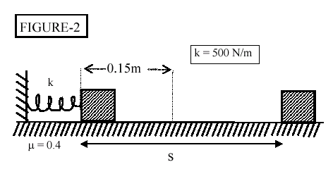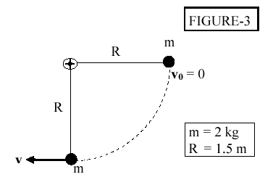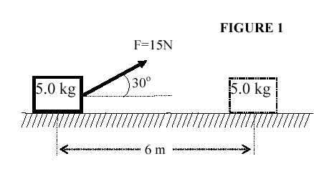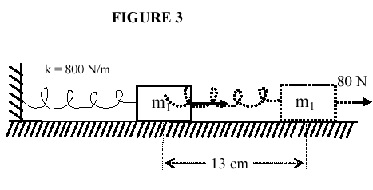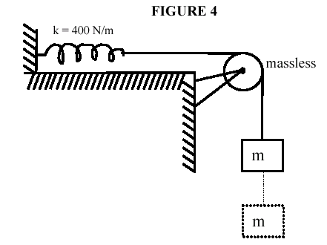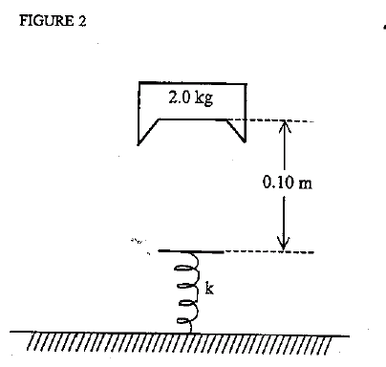

Fig. 2 T031 Fig. 3 T031 Fig. 1 T011 Fig. 3 T022 Fig. 4 T022 Fig. 2 T011
T022: Q1 A 5.0-kg object is pulled along a rough horizontal surface at constant speed by a 15 N force acting 30 degrees above the horizontal (see Fig.1). How much work is done by the friction force as the object moves 6.0 m? (Ans: -78 J)
Q4 A 12-kg block is resting on a horizontal frictionless surface. The block is attached to an un stretched spring (k= 800 N/m) (see Fig.3). A force F = 80 N parallel to the surface is applied to the block. What is the speed of the block when it is displaced by 13 cm from its initial position? (Ans: 0.78 m/s)
Q5 A block of mass m = 10 kg is connected to un stretched spring (k=400 N/m) (see Fig. 4). The block is released from rest. If the pulley is mass less and frictionless, what is the maximum extension of the spring? (Ans: 49 cm)
Q6 A 0.6-kg ball is suspended from the ceiling at the end of a 2.0-m string. As this ball swings, it has a speed of 4.0 m/s at the lowest point of its path. What maximum angle does the string make with the vertical as the ball swings? (Ans: 54 degrees).
Q7 When applied to a single object, a force is conservative if: (Ans: its work done for motion in closed paths is equal to zero.)
T021: Q#4 A 2.0 kg block is pulled at a constant speed of 1.1 m/s across a horizontal rough surface by an applied force of 12 N directed 30 degrees above the horizontal. At what rate is the frictional force doing work on the block? (Ans: -11.4 W)
Q#5. An object moves from point A to point B. Only two forces act on it: one force is non conservative and does - 40 J of work, and the other force is conservative and does +60 J of work. Between points A and B, K is the kinetic energy of object, and E is its mechanical energy. Which of the following statements is correct? (Ans: K increases, E decreases. )
Q#6. A 10 kg object is dropped vertically from rest. After falling a distance of 50 m, it has a speed of 26 m/s. How much work is done by the air resistance on the object during this descent? (Ans: -1500 J.)
T012: Q4 As a particle moves from point A to point B only two forces act on it: one force is non-conservative and does work = -30 J, the other force is conservative and does +50 J work. The change of the kinetic energy of the particle is: (Ans: 20 J)
Q5 A 2.2-kg block starts from rest on a rough inclined plane that makes an angle of 25 degrees with the horizontal. The coefficient of kinetic friction is 0.25. As the block goes 2.0 m down the plane, find the change in the mechanical energy of the block. (Ans: –9.8 J)
Q6 A 2-kg block is initially moving to the right on a horizontal frictionless surface at a speed of 10 m/s. It collides with a spring whose spring constant is 100 N/m and is brought to rest momentarily by compressing the spring. Find the compression of the spring. (Ans: 1.4 m)
T011:Q4 We would like to raise a heavy object (at a constant speed) to a certain height h. We attach a rope to the object. It is preferable to pull it along a frictionless inclined plane rather than pulling it vertically upward because: (Ans: it reduces the force required ).
Q5 A 2.0-kg block is dropped from a height of 0.10 m onto a spring of spring constant k (Fig. 2). The spring is compressed a maximum distance of 0.05 m (the block comes to rest momentarily). Find the value of k. (Ans: 2350 N/m) .
Q6 A single conservative force is acting on a 10-kg body. If the work done on the body by this force is 50 J, find the change in its potential energy. (Ans: -50.0 J)

