Old Exam. Question Chapter 7 (Dr. Gondal Phys. 101)
082
Q1. An object moves in a circle at constant speed. The work done by the centripetal force is zero because: (Ans: the centripetal force is perpendicular to the velocity.)
Q2. A 4.0-kg cart starts up an incline with a speed of 3.0 m/s and comes to rest 2.0 m up the incline. The net work done on the cart is: (Ans: –18 J)
Q3. A block of mass 1.6 kg, resting on a horizontal frictionless surface, is attached to a horizontal spring fixed at one end. The spring, having a spring constant of 1.0 x 10³ N/m, is compressed to x = -2.0 cm (x = 0.0 is the equilibrium position) and the block is released from rest. The speed of the block as it passes through the position x = - 1.0 cm is: (A) 0.43 m/s
Q4. A 3.0-kg mass has an initial velocity v_{o} = (6.0 i – 2.0 j) m/s. A single force F is applied for 5.0 s which changes its velocity to v = (8.0 i + 4.0 j) m/s. Find the average power delivered by the force in this interval. (Ans: 12 W)
081
Q1.: Figure 1 shows the acceleration of a 2 kg particle as a single force acts on it along the x-axis, from x = 0 to x = 6 m. Find the work done by the force on the particle. (Ans: 48 J)
Q2.: A 0.2-kg stone tied to a string is rotated in a horizontal circle of radius 0.5 m. The speed of the stone is kept constant at 1.0 m/s. Find the work done by the tension of the string on the stone in one rotation.( Ans:0.0 J)
Q3.: A 60-kg boy runs from the 1st floor to the 2nd floor, using the stairs, in 12 s. The stairs are made up of 30 steps, each 10 cm high. Calculate the average power required by the boy.(Ans: 147 W)
Q4.: A 2-kg block slides across a horizontal frictionless floor with a speed of 2.0 m/s. It then runs into and compresses a spring of spring constant k = 800 N/m. The block comes momentarily to rest after compressing the spring a distance d. Find the distance d. (Ans:10 cm)
072
Q1.Fig 1 shows a simple pendulum, consisting of a ball of mass M = 0.50 kg, attached to one end of a massless string of length L = 1.5 m. The other end is fixed. If the ball is initially released from rest with the string horizontal, then its speed at the lowest point is: ( Ans: 5.4 m/s)
Q3. A person pushes horizontally a 10 kg box at a constant velocity 1.5 m/s. The coefficient of kinetic friction between the box and the horizontal floor is 0.30. What is the rate of work that the person does in pushing the box? (Ans: 44W)

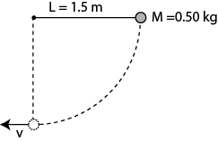
Fig. 1, T072

071
Q1. An 800 kg car is traveling at velocity 12 i m/s. When the brakes are applied, the car changes its velocity to 12 j m/s in 4.0 s. What is the change in kinetic energy of the car in this time period? (Ans: 0 J )
Q2. An ideal spring is hung vertically from the ceiling. When a 2.0 kg mass hangs at rest from it, the spring is extended 6.0 cm from its relaxed length. A downward external force is now applied to the mass to extend the spring an additional 10 cm. While the spring is being extended by the external force, the work done by the spring is: (Ans: −3.6 J )
Q3. A single force acts on a 5.0 kg object in such a way that the position of the object as a function of time is given by x=10.0 t -5.0 t² with x is in meters and t is in seconds. Find the work done on the object from t = 0 to t = 4.0 s. (Ans: 2000 J)
Q4. A 2000 kg elevator moves 20 m upward in 4.9 sec at a constant speed. At what average rate does the force from the cable do the work on the elevator? (Ans: 80000 W)
062: Q1. A 10.0 kg box slides with a constant speed a distance of 5.00 m downward along a rough slope that makes an angle of 30.0° with the horizontal. The work done by the force of gravity is: (Ans: 245 J)
Q2. A block is attached to the end of an ideal spring and moved from coordinate x_{i} to coordinate x_{f} . The relaxed position is at x = 0. For which values of x_{i} and x_{f} that are given below, the work done by spring is positive? (Ans: x_{i} = -4 cm and x_{f} = -2 cm)
Q3. Fig. 1 gives the only force F_{x} that can act on a particle. If the particle has a kinetic energy of 10 J at x = 0, find the kinetic energy of the particle when it is at x = 8.0 m. (Ans: 30 J)
061: Q1. A 16 kg crate falls from rest from a height of 1.0 m onto a spring scale with a spring constant of 2.74 × 10³ N/m. Find the maximum distance the spring is compressed. (Ans: 40 cm)
Q2. A 4.0 kg cart starts up an incline with a speed of 3.0 m/s and comes to rest 2.0 m up the incline. The net work done on the cart is: (Ans: -18 J )
Q3. A net horizontal force of 50 N is acting on a 2.0 kg crate that starts from rest on a horizontal frictionless surface. At the instant the object has traveled 2.0 m, the rate at which this net force doing work is: (Ans: 500 W)
Q4. At time t = 0 a single force F acts on a 2.0 kg particle and changes its velocity from at t = 0 to vi. During this time the work done by v_{i} = (4.0i -3.0 j) m/s to v_{f} = (4.0i +3.0 j) m/s at t = 3.0 s. During this time the work done by F on the particle is: (Ans: 0)
052: Q#2: An object of mass 1.0 kg is whirled in a horizontal circle of radius 0.50 m at a constant speed of 2.0 m/s. The work done on the object during one revolution is: (Ans: Zero-J).
Q#3: A boy holds a 40-N weight at arm's length for 10 s. His arm is 1.5 m above the ground. The work done by the force of the boy on the weight while he is holding it is : ( Ans: Zero-J )
Q#4: A 40-N force is the only force applied on a 2.0-kg crate which is originally at rest. At the instant the object has traveled 2.5 m, the rate at which the force is doing work is: (Ans: 400 W )
Q#6: A ball of mass 2.0-kg is kicked with an initial speed of (5 m/s)i +(5 m/s)j . The ratio of the potential energy (relative to ground level) to the kinetic energy of the projectile at its highest point is: (Ans: 1.0)
051: Q#1. A 0.50 kg block slides down a frictionless 30° incline, starting from rest. The work done by the net force on this block after sliding for 4.0 s is: (Ans:96 J)
Q#2. A person lifts a 0.40 kg cup of water 0.64 m vertically up at constant velocity of 1.2 m/s. The work done on the cup of water by him is: (Ans: 2.5 J)
Q#3. A man pushes a 50 kg crate a distance of 5.0 m upward along a frictionless slope that makes an angle of 30° with the horizontal. His force is parallel to the slope. The acceleration of the crate is 1.5 m/s 2 and is directed up the slope. The work done by the man is: (Ans:1600 J)
Q#4. A 20 N force acts horizontally on a 2.0 kg box initially (t = 0) resting on a frictionless floor. The rate at which this force is doing work at t = 2.0 s is: (Ans: 400 W)
Q#6: A varying force Fx acts on a particle of mass m = 2.0 kg as shown in Figure 1. Find the speed of the particle at x = 8.0 m, if the kinetic energy at x = 0 is 9.0 J. (Ans: 7.0 m/s)
Q#7. A 0.50 kg block is attached to an ideal spring with a spring constant of 80 N/m rests on a horizontal frictionless surface. The spring is stretched 4.0 cm longer than its equilibrium length and then released. The speed of the block when it passes through the equilibrium point is(Ans: 0.51 m/s).

042: Q#1 A helicopter lifts an 80 kg man vertically from the ground by means of a cable. The upward acceleration of the man is 2.0 m/s**2. Find the rate at which the work is being done on the man by the tension of the cable when the speed of the man is 1.5 m/s. (Ans: 1.4*10**3 W)
Q#2 A force F = (3.00 i +7.00 j) N acts on a 2.00 kg object that moves from an initial position r1=(3.00i - 2.00j) m to a final position r2 = (5.00 i + 4.00 j) m in 4.00 s . What is the average power due to the force during that time interval? (Ans: 12.0 W )
Q#3 A 5.0-kg block is moving horizontally at 6.0 m/s. In order to change its speed to 10.0 m/s, the net work done on the block must be : (Ans: 160 J )
Q#4 A 3.00 kg block is dropped from a height of 40 cm onto a spring of spring constant k (see Fig 2). If the maximum distance the spring is compressed = 0.130 m, find k. (Ans:1840 N/m)

T041: Q#1: A particle moves in the x-y plane from the point (0,1) m to point (3,5) m while being acted upon by a constant force F = 4i + 2j +4k (N). The work done on the particle by this force is: (Ans: 20 J)
Q#3: A car accelerates from zero to 30 m/s in 1.5 s. Assuming the same average power is delivered by the car, how long does it take to accelerate it from zero to 60 m/s. (Ignore friction). (Ans: 6.0 s)
T032: Q#2: A particle moves from Xi = 0 to Xf = 5.0 m while being acted upon by a single force F = 3*X**2 directed along the X axis. Find the change in the kinetic energy during this motion. (Ans: 125 J)
Q#3: Which of the following five quantities DOES NOT HAVE THE UNIT OF ENERGY? Here m is a mass, g is the acceleration due to gravity, h and d are distances, F is a force, v is a speed, a is an acceleration, P is power, and t is time.( Ans:m*a)

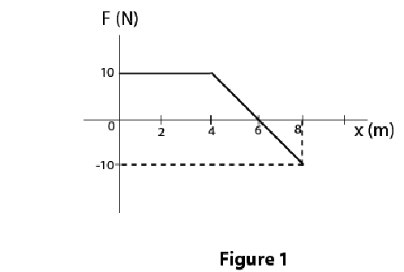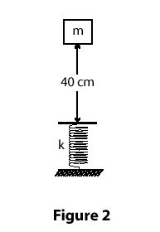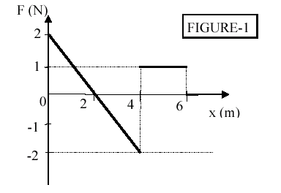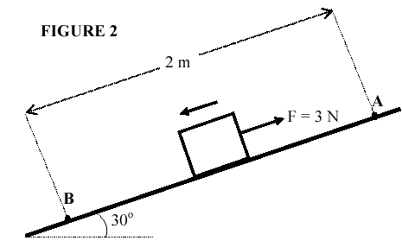

Fig. 1, T062 Fig. 1, T052 Fig. 2, T042 Fig. 1, T031 Fig. 2 T022

T031: Q#1: Two balls, with masses m and 2m, are dropped to the ground from the roof of a building. (Assume no air resistance.) Just before hitting the ground, the heavier ball has: (Ans: two times as much kinetic energy as the lighter one).
Q#2: An object is pushed by a variable force, plotted in Fig 1, as a function of position, x. How much work has the force done on the object when it has moved from x=0 to x=+6 m? (Ans: 2 J)
Q#3: A helicopter lifts a 72 kg man 15 m vertically by means of a cable. The acceleration of the man is 1.20 m/s**2. How much work is done on the man by the tension of the cable? ( Ans: 12 kJ)
T022: Q#2: A 2.0-kg block slides 2.0 m down a frictionless incline from point A to point B. A force (magnitude F =3.0 N) acts on the block between A and B, as shown in Fig.2. If the kinetic energy of the block at A is 10 J, what is its kinetic energy at B? (Ans: 24 J) .
Q#3 A 2.0-kg object moves along the +x-axis with a speed of 5 m/s under the influence of a force F= (3i+4j) N. What is the power delivered by this force? (Ans: 15 W.)

T021: Q#1: As a 2.0 kg object moves along the x axis, the only force acting on it is given by F = (4 X) N where X is measured in m. What is the work done by this force as the object moves from X = 1.0 m to X = 3.0 m? (Ans: 16 J )
Q#2. In Fig(1), a block (M = 2.0 kg) slides on a frictionless horizontal surface towards a spring with a spring constant k = 2000 N/m. The speed of the block just before it hits the spring is 6.0 m/s. How fast is the block moving at the instant the spring has been compressed 15 cm? (Ans: 3.7 m/s )
Q#3: In Fig(2), a 2.0 kg block slides down a 30 deg frictionless incline from point A to point B. A force (magnitude F = 3.0 N) acts on the block between A and B. Points A and B are 2.0 m apart. If the kinetic energy of the block at A is 10 J, what is the kinetic energy of the block at B? (Ans: 24 J)
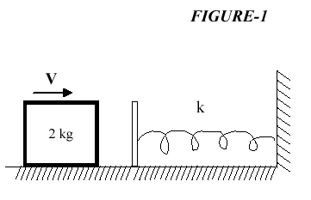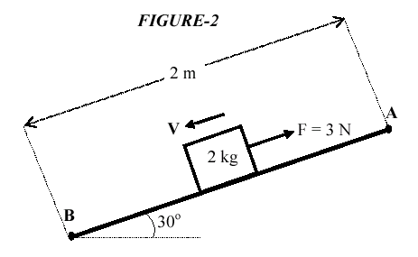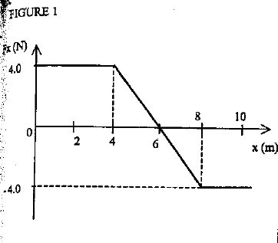

Fig. 1 T021 Fig. 2 T021 Fig. 1 T011
T012: Q#1: A force F = (4.0 i + 3.0 j ) N acts on a particle as it moves in the x-y plane from the point (0,10 m) to (10 m,0).Calculate the work done on the particle by this force. A1 10 J
Q#2 : A 1500 kg car accelerates uniformly from rest to 10 m/s in 3.0 s. The average power delivered by the engine of the car in the first 3.0 s is: (Ans: 25 kW)
Q#3: The amount of work required to stop a moving object (mass = M, speed =V, kinetic energy = K) is equal to: (Ans: K.)
T011: Q#1 A 2.0-kg object moving along the x-axis has velocity of 5.0 m/s at x = 2.0 m. If the only force acting on this object is shown in Fig.1, what is the speed of the object at x = 10 m? (Ans: 5.0 m/s )
Q#2 An object is constrained by a cord to move in a circular path of radius 0.5 m on a horizontal frictionless surface. The cord will break if its tension exceeds 16 N. The maximum kinetic energy the object can have is: (Ans: 4.0 J)

