Old Exam. Question Chapter 6 (Dr. Gondal Phys. 101)
T082 Q#18: A 5 kg block is placed on top of a 10 kg block which is lying on a frictionless horizontal surface, as shown in Fig. 4. A horizontal force F of 60 N is applied to the 10 kg block. Find the static frictional force on 5 kg block from the 10 kg block such that the 5 kg block does not slip. A) 20 N to the right
Q19. A crate is sliding down an incline that is 35◦ above the horizontal. If the coefficient of kinetic friction is 0.4 the acceleration of the crate is: A) 2.4 m/s2
Q20. An automobile moves on a level horizontal road in a circle of radius 30 m. The coefficient of static friction between tires and road is 0.5 . The maximum speed with which this car can travel round this curve without sliding is: A) 12 m/s

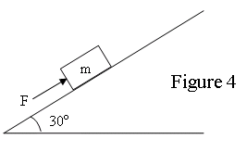
Fig. 4, T082 Fg. 4, T081
T081 : Q19.: A 1.0 kg block, attached to the end of a string of length 2.0 m, swings in a vertical circle. When the block is at its highest point, its speed is 5.0 m/s. What is the magnitude of the tension in the string at that point? A) 2.7 N
Q20: A block of mass m = 10 kg is pushed up a rough 30º inclined plane by a force F parallel to the incline as shown in Figure 4. The coefficient of kinetic friction between the block and the plane is 0.4. Find the magnitude of the force F when the block is moving up at constant velocity. (Ans: 83 N)
T072: Q15.A constant horizontal force of 36 N is acting on a block of mass 4.0 kg, another block of mass 2.0 kg sits on the 4.0 kg block. The 4.0 kg block moves on a frictionless horizontal floor. Find the magnitude of the frictional force maintaining the 2.0 kg block in its position above the 4.0 kg block during the motion.(Ans: 12 N)
Q18.In Fig. 4, a boy is dragging a box (mass =8.0 kg) attached to a string. The box is moving horizontally with an acceleration a = 2.0 m/s². If the frictional force is 12 N, calculate the applied force F at an angle θ=60° (Ans: 56 N)
Q19.At what angle should the circular roadway of 50 m radius, be banked to allow cars to round the curve without slipping at 12 m/s? (Ignore friction)(Ans: 16°)
Q20. A 1000 kg airplane moves in straight horizontal flight at constant speed. The force of air resistance is 1800 N. The net force on the plane is: (Ans: zero)
T071: Q17.: A 5.0 kg block is moving with constant velocity down a rough incline plane. The coefficients of static and kinetic friction between the block and the incline are 0.25 and 0.20, respectively. What is the inclination angle of the incline plane? (Ans: 11°)
Q18. A car rounds a flat curved road (radius = 92 m) at a speed of 26 m/s and is on the verge of sliding at this speed. What is the coefficient of static friction between the tires of the car and the road? (Ans: 0.75)
Q19.: A box of mass 40.0 kg is pushed across a rough flat floor at the constant speed of 1.50 m/s. When the force is removed, the box slides a further distance of 1.20 m before coming to rest. Calculate the friction force acting on the box when it slides.(Ans: 37.5 N)
Q20.A 10.0 kg box is pushed up an incline (θ= 30.0°) by a horizontal force of 298 N. The box then moves at a constant velocity as shown in Fig. 7. What is the frictional force on the box? ( Ans: 209 N)

T062
Q16. : A car takes a round turn on a flat circular track at a speed of 8.00 m/s. The coefficient of static friction between its tires and the track is 0.300. If the car is at the verge of slipping out of the track at this speed, the radius of the track is: (Ans: 21.8 m)
Q17: A box of mass M is placed on a 30° inclined plane. The box is sliding with an acceleration equals g/2 (g is the free fall acceleration). What is the magnitude of the force of friction between the box and the plane? (Ans: zero)
T061: Q17. A box with a weight of 50 N rests on a horizontal surface with μ_{s}= 0.40. A person pulls horizontally on it with a force of F₂=10 N and it does not move. To start it moving, a second person pulls vertically upward on the box with a force F₁ (see Fig 6). What is the smallest vertical force (F₁) for which the box starts moving? (Ans: 25 N )

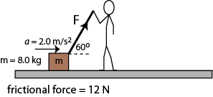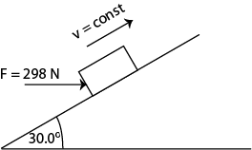
Fig. 4, T072 Fig. 7, T071 Fig. 6, T061 Fig. 7, T061 Fig. 8, T061

Q18. : An 8.0 kg block is pushed against a vertical wall by a horizontal force F as shown in Fig 7. If the coefficients of friction between the block and the wall are μ_{s} = 0.60 and μ_{k} = 0.30 then the minimum value for (F) that will prevent the block from slipping is: (Ans: 130 N)
Q#19: A 2.0 kg block is released from rest the top of a ramp (point A) as shown in Fig 8. The coefficient of kinetic friction between the block and the inclined surface is 0.20. The speed by which the block hits the bottom (point B) is: (Ans: 6.6 m/s)
Q20. A 1000 kg car moves on a level horizontal circular road of radius 50 m. The coefficient of static friction between the tires and the road is 0.50. The maximum speed with which this car can round this curve without slipping is: (Ans: 16 m/s )

T052
Q#17. A block rests on a rough incline and has coefficients of friction µ_{k}= 0.20 and µ_{s}= 0.30. If the incline angle increases, at what angle does the block start moving? (Ans: 16.7°)
Q#18. A car is moving in a horizontal circular track of radius R=50.0 m. The coefficient of static friction between the car wheels and the track is µ_{s}= 0.250. What would be the car speed at which the car starts sliding out side the track? (Ans: 11.1 m/s)
Q#19. A 5.0-kg block is at rest on a rough horizontal surface. The coefficient of static friction between the block and the surface is µs= 0.4. If a horizontal force of 15.0 N is acted on the block, what would be the magnitude of the friction force? (Ans: 15.0 N)
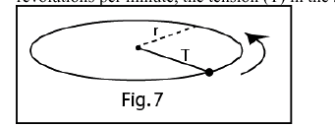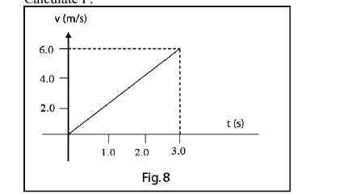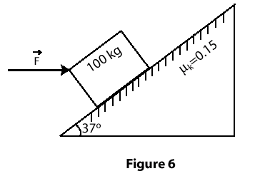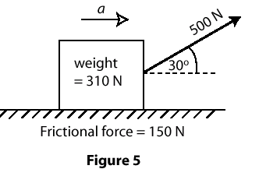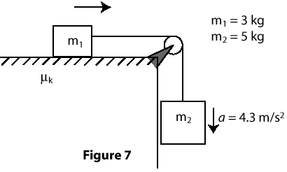
Fig. 7, T051 Fig. 8, T051 Fig. 5, T042 Fig. 6, T042 Fig. 7, T042

T051
Q#17. A 0.20-kg stone is attached to a string and whirled in a circle of radius r = 0.60 m on a horizontal frictionless surface as shown in Fig. 7. If the stone makes 150 revolutions per minute, the tension (T) in the string is (Ans: 30 N
Q#18. A block of mass M slides on a horizontal surface. Which of the following would increase the magnitude of the frictional force on the block? (Ans: Increasing M)
Q#19. A box of mass m is sliding down a rough inclined plane (which makes an angle of 30° with the horizontal and has a coefficient of kinetic friction = µk) at a constant acceleration g/4 (where g = 9.8 m/s 2 ). Find µk . (Ans: 0.29)
Q#20. A 5.0 kg block is sliding on a rough horizontal plane (µk=0.10) under the effect of a horizontal force F. Fig. 8 shows the velocity (v) of the block as a function of time (t). Calculate F. (Ans: 15 N)

T042
Q#15 A worker drags a crate across a factory floor by pulling on a rope tied to the crate as shown in Fig.5. The worker exerts a force of 500 N on the rope, which is inclined at 30 degrees to the horizontal, and the floor exerts a frictional force of 150 N. Calculate the magnitude of the acceleration of the crate if its weight is 310 N. ( Ans: 8.9 m/s**2)
Q#16 In Fig. 6 a 100 kg block is pushed at a constant speed up the rough 37 degrees ramp by a horizontal force F. The coefficient of kinetic friction between block and surface is 0.15. What is the magnitude of force F? (Ans: 998 N )
Q#17 A block (m1= 3.0 kg) on a rough horizontal plane is connected to a second block (m2=5.0 kg) by a cord over a massless pulley. Calculate the coefficient of kinetic friction between the block m1 and the table if the acceleration of the descending block m2 is 4.3 m/s**2 (see Fig 7.( (Ans: 0.50 )
Q#18 A car is rounding a flat curve of radius R=220 m with speed v= 94 km/h. What is the magnitude of the force exerted by the seat on the passenger whose mass m is 85 kg. ( Ans: 263 N)

T041
Q18: A box with a weight of 50 N rests on a rough horizontal surface (mus = 0.4). Two forces F1 (=10 N) and F2 act on the box as shown in Fig 5. What is the smallest vertical force F2 for which the box just starts sliding horizontally? (Ans:25 N)
Q19: A 400-N block is pushed along a rough horizontal surface (muk = 0.25) by an applied force F as shown in Fig 6. The block moves at constant velocity. The magnitude of F is : (Ans: 101 N)
Q20: One end of a 1.0-m long string is fixed, the other end is attached to a 2.0-kg stone. The stone swings in a vertical circle, passing the lowest point at 4.0 m/s (see Fig 7). The tension force (T) of the string at this point is: (Ans: 52 N)
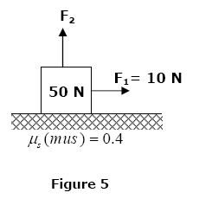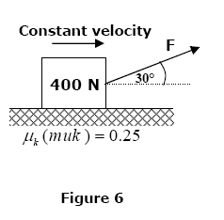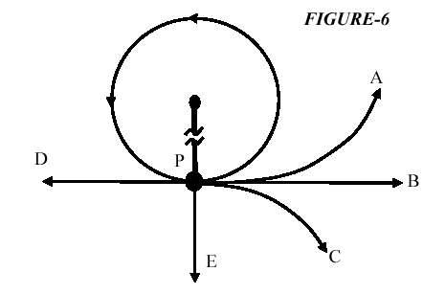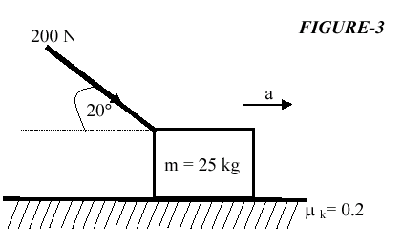
Fig. 5 T041 Fig. 6 T041 Fig. 6 T031 Fig. 3 T022

T032
Q18 A 2.0 kg block is initially at rest on a horizontal surface. A 15 N horizontal force and a vertical force P are applied to the block as shown Fig 4. If the coefficient of static friction for the block and the surface 0.60, what is the magnitude of force P that makes the block start moving? ( Ans: 5.4 N )
Q19 A 0.50 kg ball tied to the end of a string 100 cm in length swings in a vertical circle with a constant speed of 9.2 m/s. What is the tension in the string when the ball is at the bottom of the circle? (Ans: 47 N)
Q20 A bicyclist travels in a 50 m radius-circular horizontal road. Find his maximum speed without slipping if the coefficient of static friction between the bicycle and the road is 0.25. (Ans: 11 m/s )
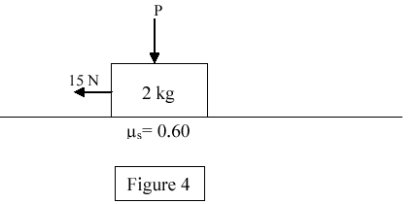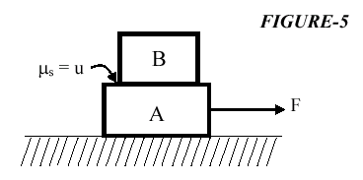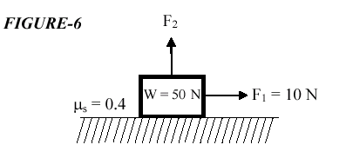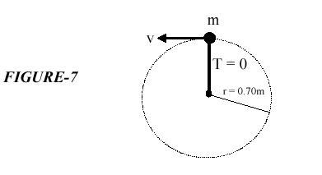
Fig. 4, T032 Fig. 5 T022 Fig. 6 T022 Fig. 7 T022
T031
Q18 A stone, of mass m, is attached to a strong string and rotates in a vertical circle of radius R. At the bottom of the path the tension in the string is 3 times the weight of the stone. The speed of the stone at this point is given by (Ans: Sqrt(2gR).
Q19 A block attached to a string, rotates counter-clockwise in a circle on a smooth horizontal surface. The string breaks at point P (Fig. 6). What path will the block follow? ( Ans: path B )
Q20: A box slides down a 30 degree incline with an acceleration = 3.2 m/s**2. Find the coefficient of kinetic friction between the box and the incline. (Ans: 0.20)

T022
Q14: A 25-kg box is pushed across a rough horizontal floor with a force of 200 N, directed 20 degrees below the horizontal (Fig.3). The coefficient of kinetic friction between the box and the floor is 0.2. The acceleration of the box is: (Ans: 5.0 m/s**2)
Q15: A 700-kg elevator accelerates downward at 3.8 m/s**2. The tension force of the cable on the elevator is: ( Ans: 4.2 kN, up)
Q18 Block A, with mass mA, is initially at rest on a frictionless horizontal floor. Block B, with mass mB, is initially at rest on the top surface of A (Fig.5). The coefficient of static friction between the two blocks is (u). Block A is pulled with a force such that it begins to slide out from under B when its acceleration reaches: ( Ans: u . g )
Q19 A box with a weight of 50 N rests on a horizontal surface. A person pulls horizontally on it with a force of F1=10 N and it does not move. To start it moving, a second person pulls vertically upward on the box (Fig. 6) with a force F2. If the coefficient of static friction is 0.4, what is the smallest F2 for which the box moves? (Ans: 25 N)
Q20 The iron ball shown in Fig. 7 is being swung in a vertical circle at the end of a 0.70-m string. What is the speed the ball can have at top of the circle for the tension in the string to be zero at that point? (Ans: 2.6 m/s )
T021
Q14 A student is standing on a scale in an elevator. The apparent weight of the student is greatest when the elevator: (Ans: accelerates upward.)
Q15 A roller-coaster car has a mass of 500 kg when fully loaded with passengers. The car passes over a hill of radius 15 m (Fig 4). At the top of the hill, the car has a speed of 8 m/s. What is the force of the track on the car at the top of the hill? (Ans: 2800 N up)
Q16 A 1.8 kg block is released from rest at the top of a rough 30 degrees inclined plane. As the block slides down the incline, its acceleration is 3.0 m/s**2 down the incline. Determine the magnitude of the force of friction acting on the block. (Ans:3.4 N)
Q17 A 3.0 kg block is pushed across a horizontal surface by a force F=20 N making an angle of 30 degrees with the horizontal (Fig 5). If the coefficient of kinetic friction between the block and the surface is 0.3, what is the magnitude of the acceleration of the block? (Ans: 1.8 m/s**2 )
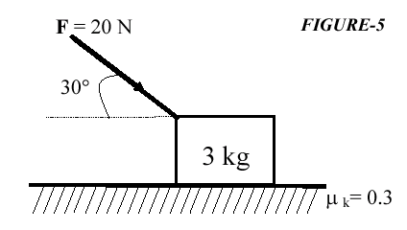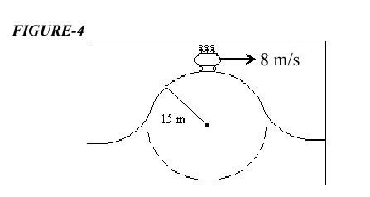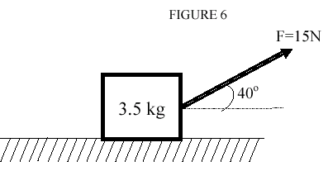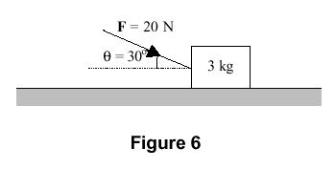

Fig. 5 T021 Fig. 4 T021 Fig. 6 T012 Fig. 6 T991

T012
Q18 A 3.5-kg block is pulled at constant velocity along a horizontal floor by a force F = 15 N that makes an angle of 40 degrees with the horizontal ( Fig.6). Find the magnitude of the force of friction between the block and the floor . (Ans: 11 N)
Q19 Find the minimum coefficient of static friction between the tires of a car and a level road if the car is to make a circular turn of radius 90 m at a speed of 60 km/h. (A1) 0.315.
Q20 One end of a 1.0-m string is fixed, the other end is attached to a 1.0-kg stone. The stone swings in a vertical circle, and has a speed of 5.0 m/s at the top of the circle. The tension in the string at this point is approximately: (Ans: 15 N)

T011
Q17: A person pulls a 50-kg box horizontally with a constant horizontal force of 200 N. If the coefficient of kinetic friction muk is 0.2 and the coefficient of static friction mus is 0.3. Find the acceleration of the box. (A1) 2 m/s**2.
Q18 A block of mass M = 10kg is pushed up along a 30 degree inclined plane with a force F parallel to the inclined plane. If the velocity of the block is constant and the coefficient of kinetic friction muk is 0.2, find the magnitude of the force. (Ans: 66 N)
Q19 An object moving at constant speed in a circular path (A1) has an acceleration of constant magnitude
Q22 One end of a 1.0-m string is fixed, the other end is attached to a 2.0-kg stone. The stone swings in a vertical circle, and has a speed of 4.0 m/s at the top of the circle. The tension in the string at this point is approximately: (Ans: 12 N)

T992
Q17 A ball of mass 100 g is connected to a string that can withstand a maximum tension of 50 N before it breaks. The ball rotates in a circle of radius 20 cm on a horizontal frictionless plane. The maximum speed the ball can have before the string breaks is: (Ans: 10 m/s)
Q18 A racing car, moving on a horizontal circular track of radius 500 m, accelerates at a uniform rate from 0.0 m/s to a speed of 35 m/s in 11 s. Find the magnitude of the total acceleration of the car when its speed is 30 m/s. [Ans: 3.7 m/s**2.]

T991
Q15: A 3.0 kg block is pushed across a horizontal surface by a force F = 20 N as shown in figure 6. If the coefficient of kinetic friction between the block and the surface is 0.30, and Theta = 30 deg, what is the magnitude of the acceleration of the block? (Ans: 1.8 m/s**2)
Q17: Two masses M and 3M are connected by a light cord as shown in figure 7. The coefficient of kinetic friction between the surface and the 3M block is 0.20, and the coefficient of kinetic friction between the surface and the M block is 0.30. If F = 14 N and M = 1.0 kg, what is the magnitude of the acceleration of either block? (Ans: 1.3 m/s**2)
Q18: An object (attached to the end of a string) swings in a vertical circle of radius R = 1.2 m (see figure 8). At an instant when theta = 30 deg, the speed of the object is 5.0 m/s. Find the magnitude of the total acceleration of the object. (Ans: 22.5 m/s**2)
Q19: On a rainy day the coefficient of friction between the tires of a car and a level circular track is reduced to half its usual value. The ratio of the maximum safe speed on a rainy day for rounding the circular track to its usual value (when it is not raining) is (Ans: 0.71)
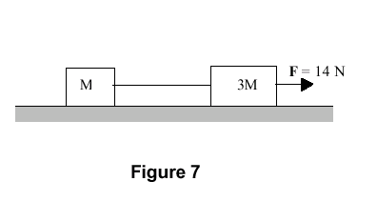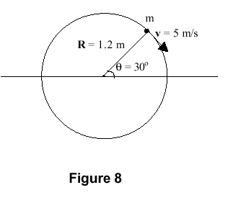
Fig. 7 T991 Fig. 8 T991

