Old Exam. Question Ch. 5 (Dr. Gondal Phys. 101)
T082
Q15: You stand on a spring scale on the floor of an elevator. The scale shows the highest reading when the elevator: (Ans: moves downward with decreasing speed)
Q16. A 70 N block A and a 35 N block B are connected by a string, as shown in Fig 3. If the pulley is massless and the surface is frictionless, the magnitude of the acceleration of the 35 N block is: A) 3.3 m/s2
Q17. When a 25.0 kg crate is pushed across a frictionless horizontal floor with a force of 200 N, directed 20◦ below the horizontal, the magnitude of the normal force of the floor on the crate is: A) 313 N
T081
Q15. Two masses m₁ = 10 kg and m₂ = 20 kg are connected by a light string and pulled across a frictionless surface by a horizontal force F = 30 N as shown in Figure 2. Find the tension in the string. (Ans: 10 N)
Q16. A 5.0-kg block and a 10-kg block are connected by a light string as shown in Figure 3. If the pulley is massless and the surface is frictionless, the magnitude of the acceleration of the 5.0 kg block is (Ans: 6.5 m/s²
Q17. A 70 kg man stands in an elevator that is moving downward at constant acceleration of 2.0 m/s². The force exerted by the man on the elevator floor is (Ans: 546 N down)

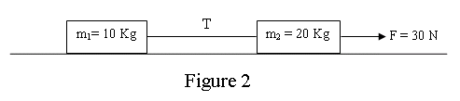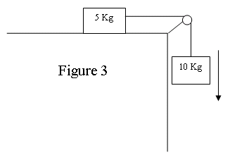

Fig. 3, T082 Fig. 2, T081 Fig. 3, T081
T072-Q13.Two blocks of mass m₁= 24.0 kg and m₂, respectively, are connected by a light string that passes over a massless pulley as shown in Fig. 2. If the tension in the string is T = 294 N. Find the value of m₂. (Ignore friction) (Ans: 40.0 kg)
Q14.Two horizontal forces of equal magnitudes are acting on a box sliding on a smooth horizontal table. The direction of one force is the north direction; the other is in the west direction. What is the direction of the acceleration of the box?(Ans:45° west of north)
Q16.: A 5.0 kg block is lowered with a downward acceleration of 2.8m/s² by means of a rope. The force of the block on the rope is:(Ans:35 N, down)
Q17.:Two students are dragging a box (m=100 kg) across a horizontal frozen lake. The first student pulls with force F₁=50.0 N, while the second pulls with force F₂. The box is moving in the x-direction with acceleration a (see Fig. 3). Assuming that friction is negligible, what is F₂?
T071 :Q13. A constant force F of magnitude 20 N is applied to block A of mass m = 4.0 kg, which pushes block B as shown in Fig. 5. The block slides over a frictionless flat surface with an acceleration of 2.0 m/s². What is the net force on block B? (Ans:12 N)
Q14. Only two forces act upon a 5.0 kg box. One of the forces is . If the box moves at a constant velocity of , what is the magnitude of the second force?( Ans: 10. N)
Q15. An elevator of mass 480 kg is designed to carry a maximum load of 3000 N. What is the tension in the elevator cable at maximum load when the elevator moves down accelerating at 9.8 m/s²? (Ans: 0)
Q16.: A car of mass 1000 kg is initially at rest. It moves along a straight road for 20 s and then comes to rest again. The velocity – time graph for the movement is given in Fig.6. The magnitude of the net force that acts on the car while it is slowing down to stop from t = 15 s to t = 20 s is: (Ans: 2000N)

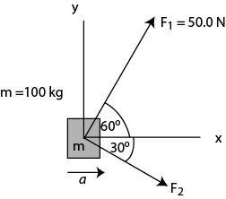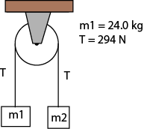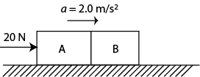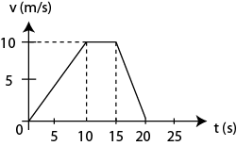
Fig. 3, T072 Fig. 2, T072 Fig. 5, T071 Fig. 6, T071

T062: Q15.: Two blocks of masses m₁ = 4.00 kg and m₂ = 2.00 kg are connected by a string passing over a massless and frictionless pulley and placed on a frictionless horizontal table as shown in Fig. 3. A force of F = 10.0 N at an angle of 60.0° with the horizontal is applied to m₁. The magnitude of acceleration of the system is: (Ans: 2.43 m/s² )
Fig. 3, T062 Fig. 4, T062 Fig. 5, T062 Fig. 6, T062 Fig. 4, T061
Q#18. Two boxes A and B (m_{A} = 3.0 kg and m_{B} =1.0 kg) are in contact on a horizontal frictionless surface and move along the x-axis (see Fig. 4). A horizontal force ˆ10.0FiN=􀁇is applied on Box A. The net force acting on A is 1F􀁇 and on B is 2F􀁇. Which one of the following statements is correct? A) 12ˆˆ7.5 and 2.5FiNFiN==􀁇􀁇 
Q19. Two boxes, one of mass m = 5.00 kg and the other with an unknown mass M are connected with a string passing over a massless frictionless pulley and are placed on frictionless planes as shown in Fig. 5.What must be the mass M, if it goes down the plane with an acceleration of a = 2.45 m/s²? (Ans: 19.1 kg )
Q#20: A 2.00-kg mass is hanging from the ceiling of an elevator accelerating upward at a = 2.50 m/s² (see Fig. 6). What is the tension T in the string? (Ans: 24.6 N)
T061
Q13. A 4.0 kg block is pushed upward a 30° inclined frictionless plane with a constant horizontal force F (Fig 4). If the block moves with a constant speed find the magnitude of the force F. ( A: 23 N )
Q14. An elevator cab with a total mass of 2000 kg is pulled upward by a cable. If the elevator accelerates at 2.00 m/s² upward, find the tension in the cable. (Ans: 2.36 ×10⁴ N)
Q16. A 7.0 kg block and a 3.0 kg block are connected by a string as shown in Fig 5. If the pulley is massless and the surface is frictionless, the magnitude of the acceleration of the 3.0 kg block is: (Ans: 2.9 m/s² )
T052
Q#13. A 5.0-kg mass is suspended by a string from the ceiling of an elevator that is moving downward with constant acceleration of 2.8 m/s 2 . The tension in the string is: (Ans: 35 N)
Q#14. A 3.0-kg block slides on a frictionless 37° incline plane. A vertical force of 15 N is applied to the block (see Fig 4). The acceleration of the block is: (Ans: 2.9 m/s 2 down the incline)
Q#15. Two blocks of mass m1 = 5.0 kg and m2 = 10. kg are connected by a massless rod and slide on a frictionless 30° incline as shown in Fig 5. The tension in the rod is: (Ans: zero)
Q#16. A 2.3-N weight is suspended by a string from a ceiling and held at an angle θ from the vertical by 4.0-N horizontal force F as shown in Fig 6. The tension in the string is: (Ans: 4.6 N)
Q#20. Three equal mass blocks each of mass =2.0 kg can move together over a horizontal frictionless surface. Two forces, F₁ = 40 i N and F₂ = -10 i N are applied on the three masses system as shown in the Fig 7. The net force on the middle mass is: (Ans: 10i N)
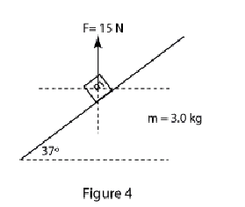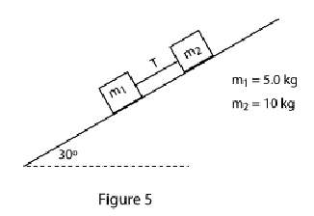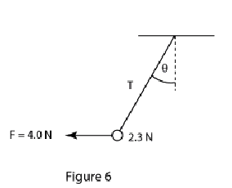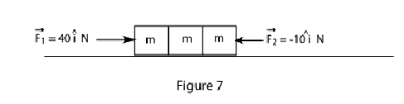
Fig. 5, T061 Fig. 4, T052 Fig. 5, T052 Fig. 6, T052 Fig. 7, T052
T051
Q#14. A block of mass m1=5.7 kg on a frictionless 30° inclined plane is connected by a cord over a massless, frictionless pulley to a second block of mass m2=3.5 kg hanging vertically as shown in Fig 4. The acceleration of m2 is:(Ans: 0.69 m/s downward)
Q#15. Fig.5 shows a block A of mass 6.0 kg and block B of 8.0 kg connected by a rigid rod of negligible mass. Force ()ˆ 16 a F Ni =G acts on block A; force ()ˆ 30 b F Ni =-G acts on block B. The tension (T) in the rod is: (Neglect friction) (Ans: 22 N)
Q#16. A 5.0-kg mass is held at an angle è from the vertical by a horizontal force F=15 N as shown in Fig 6. The tension (T) in the string supporting the mass (in Newton) is: (Ans: 51)
Q#17. A 0.20-kg stone is attached to a string and whirled in a circle of radius r = 0.60 m on a horizontal frictionless surface as shown in Fig. 7. If the stone makes 150 revolutions per minute, the tension (T) in the string is: (Ans: 30 N)

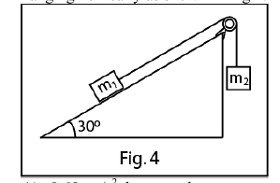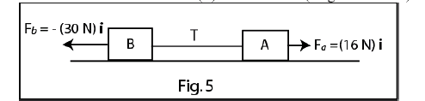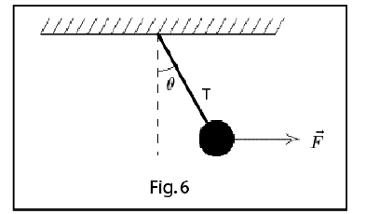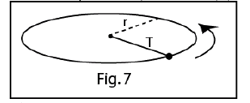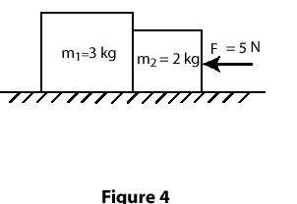
Fig. 4, T051 Fig. 5, T051 Fig. 6, T051 Fig. 7, T051 Fig. 4, T042
T042
Q14 Two blocks are in contact on a frictionless table . A horizontal force is applied to block (m2), as shown in Fig. 4. If m1=3.0 kg, m2=2.0 kg, and F=5.0 N, find the magnitude of the force between the two blocks. ( Ans: 3.0 N)
Q15 A worker drags a crate across a factory floor by pulling on a rope tied to the crate as shown in Fig.5. The worker exerts a force of 500 N on the rope, which is inclined at 30 degrees to the horizontal, and the floor exerts a frictional force of 150 N. Calculate the magnitude of the acceleration of the crate if its weight is 310 N. (Ans: 8.9 m/s**2)
T041: Q14: A 2.0 kg box slides down a frictionless vertical wall while you push on it with a force F at a 30 degrees angle with the vertical (see Fig 3). What is the magnitude of the normal force of the wall on the box if it is to slide down at a constant speed? (A1) 11.3 N
Q15 The weight of an astronaut on Earth is 800 N. What is his weight on planet Mars, where g = 3.76 m/s**2? ( A1) 307 N
Q16: A 20.0 kg block is resting on a frictionless horizontal table. A horizontal string pulls the block. If the tension in the string is 20.0 N, what is the speed of the block after moving 2.0 m? (A1) 2.0 m/s .
Q17: Two masses m1 (= 2.0 kg) and m2 (= 3.0 kg) are connected as shown in Fig 4. Find the tension T2 if the tension T1 = 50.0 N. ( A1) 30.0 N
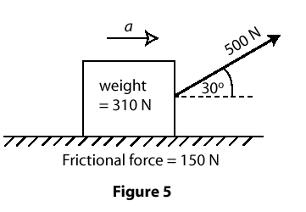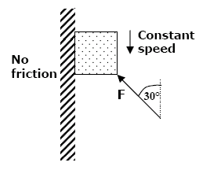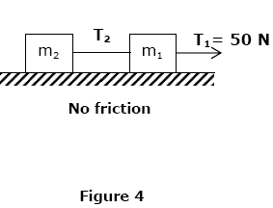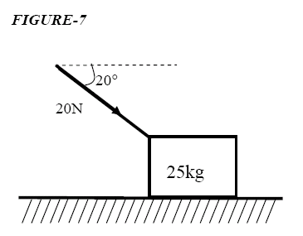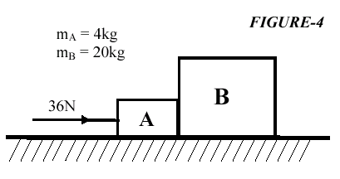
Fig. 5, T042 Fig. 3 T041 Fig. 4 T041 Fig. 7 T031 Fig. 4 T031
T032
Q13 A 2.0 kg mass has a velocity of (2.0 i + 2.0 j) m/s at one instant. Four seconds later its velocity is (2.0 i + 14 j) m/s. Assuming that the object is under the influence of a single constant force, find this force. ( Ans (6.0 j) N)
Q14 An object is hung from a spring balance attached to the ceiling of an elevator. The balance reads 70 N when the elevator is at rest. What is the reading of the spring balance when the elevator is moving upwards with an acceleration of 4.9 m/(s**2)? (Ans: 105 N)
Q15 A 3.0 kg block is placed on top of a 9.0 kg block as shown in Fig 2. A horizontal force F = 20 i N is applied to the 9.0 kg block, which slides on the frictionless surface AB. Assuming that the 3.0 kg block does not slip, find the frictional force exerted by the 9.0 kg block on the 3.0 kg block. (Ans: 5.0 i N)
Q16Two blocks, of equal mass = M, rest on frictionless surfaces, as shown in Fig 3. Assuming the pulleys to be light and frictionless, calculate the time required for block A to move 0.5 m down the plane, starting from rest. (Ans: 0.64 s)
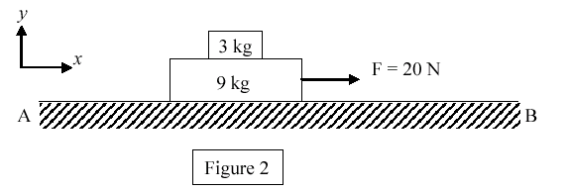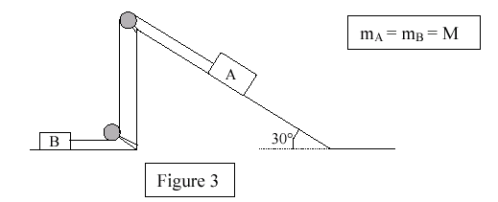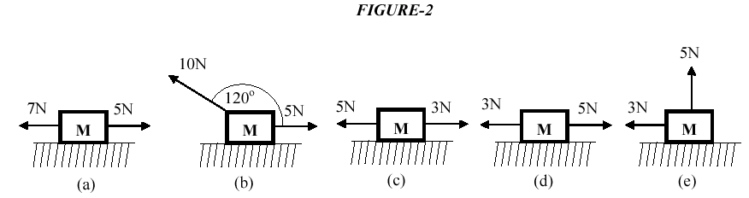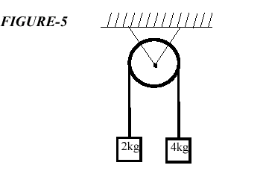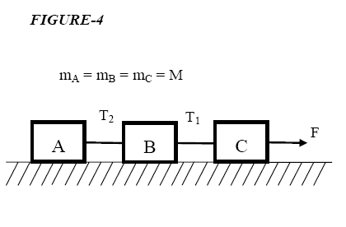
T032, Fig. 2 T032, Fig. 3 Fig. 2 T031 Fig. 5 T031 Fig. 4 T022
T031: Q14: As shown in Fig. 7, a 25-kg box is pushed across a frictionless horizontal floor with a force of 20 N, directed at an angle of 20 degrees below the horizontal. The magnitude of the acceleration of the box is: (A1) 0.75 m/s**2 .
Q15: An object of mass M = 10 kg moving on frictionless horizontal surface is subjected to two applied forces as shown in Fig. 2. In which situation is the object accelerating to the right? ( A1) (d) .
Q16: Two blocks A (MA = 4 kg)and B (MB = 20 kg) are in contact with each other and are placed on a horizontal frictionless surface. A 36-N constant force is applied to A as shown in Fig. 4. The magnitude of the force exerted on A by B is ( A1) 30 N .
Q17: Two masses m1 = 2kg, m2 = 4 kg are connected by a light string Q0 that passes over a frictionless and massless pulley (see Fig. 5). Find the magnitude of the acceleration of the masses. (A1) 3.27 m/s**2
T022: Q15 A 700-kg elevator accelerates downward at 3.8 m/s**2. The tension force of the cable on the elevator is: ( A1) 4.2 kN, up
Q16 When a 40-N force, parallel to the incline and directed up the incline, is applied to a crate on a frictionless incline that is 30 degrees above the horizontal, the acceleration of the crate is 2.0 m/s**2, down the incline. The mass of the crate is: ( A1) 14 kg .
Q17 Three blocks (A,B,C), each having mass M, are connected by strings as shown in Fig.4. Block C is pulled to the right by a force F that causes the entire system to accelerate. Neglecting friction, the tension T1 between blocks B and C is: (A1) 2F/3 .
T021: Q18 In Fig (6), F=40 N and M=2 kg. What is the magnitude of the acceleration of the suspended object M ? (All surfaces are frictionless) (A1) 2.5 m/s**2
Q19 The horizontal surface on which the objects (Fig 7) slide is frictionless. If the magnitude of the force of the small block on the large block is 5.2 N, determine F. (A1) 7.8 N .
Q20 Three blocks are placed on a table as shown in Fig (8). The table exerts a normal force: (A1) only on block C.
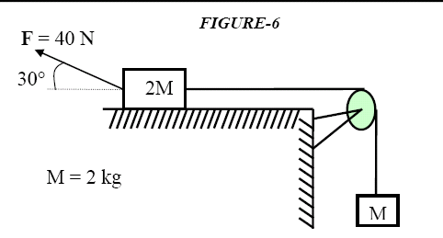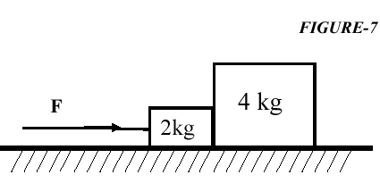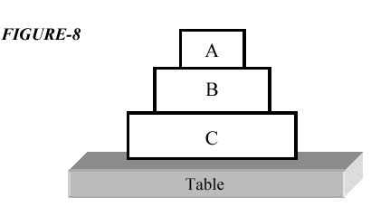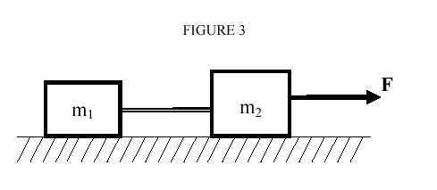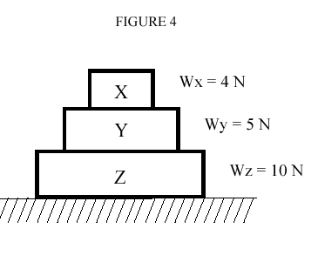
Fig. 6 T021 Fig. 7 T021 Fig. 8 T021 Fig. 3 T012 Fig. 4 T012
T012: Q13 A constant force, F, acts on a 19-kg particle. The particle, initially at rest, moves a distance of 22 m in 3.8 s. Find the magnitude of the force F. (A1) 58 N .
Q14 In Fig.3, m1 = 22 kg and m2 = 37 kg. The masses are connected by a light, horizontal cord and are being pulled across a smooth level surface by a horizontal force F = 46 N. Find the tension in the cord. (A1) 17 N .
Q15 Three books (X, Y, and Z) rest on a table as shown in Fig. 4. The weight of each book is also indicated in the Figure. The magnitude of the force of book Z on book Y is: (A1) 9.0 N.
Q16 Two blocks weighing 25 kg and 35 kg respectively, are connected by a string that passes over a mass less pulley as shown in Fig. 5. The tension in the string is: (A1) 286 N .
Q17 A 90-kg man stands in an elevator that is moving up at a constant speed of 5.0 m/s. The magnitude of the force exerted by him on the floor is: (A1) 882 N.
T011: Q14 A 16-kg block and an 8-kg block is connected by a string as shown in Fig.3.If the pulley is mass-less and the surface is frictionless, the magnitude of the acceleration of the 8-kg block is: ( A1) g/3 .
Q15 A 70-kg man stands on a spring scale in an elevator that has a downward acceleration of 2.8 m/s**2. The 5 Q0 scale will read: (A1) 490 N.

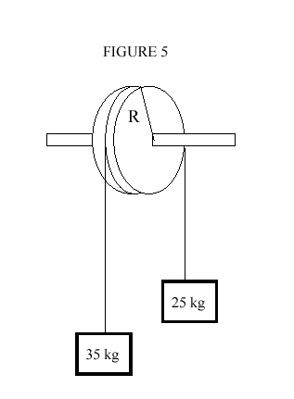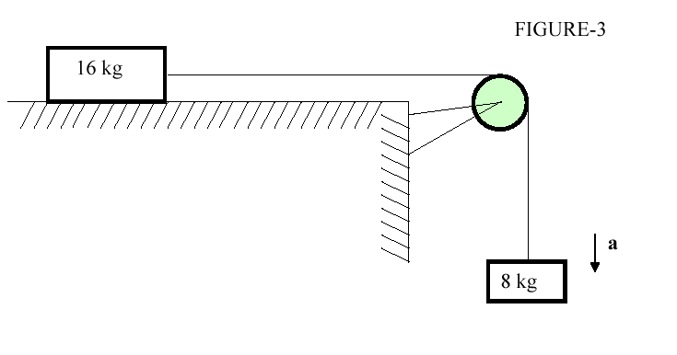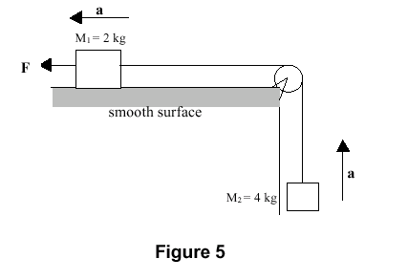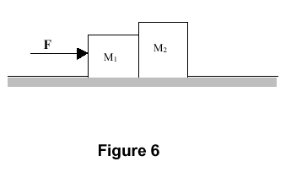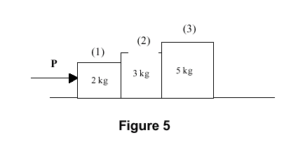
Fig. 5 T012 Fig. 3 T011 Fig. 5 T992 Fig. 6 T992 Fig. 5 T991

Q20. A motorcycle and 60.0 kg rider accelerate at 3.00 m/s**2 5 up an inclined plane 10.0 degrees above the horizontal. Find the magnitude of the net force acting on the rider. (A1) 180 N .
Q21 A monkey hangs vertically from a rope in a descending elevator that decelerates at 2.4 m/s**2.If the tension in the rope is 400 N, find the mass of the monkey. (A1) 33 kg.
T992: Q13: A block of mass m = 4.0 kg is pushed up a smooth 30 deg inclined plane, by a constant force of magnitude 40 N and parallel to the incline. Find the magnitude of the acceleration of the block. (A1) 5.1 m/s**2
Q14 :In the system shown in Figure 5, a horizontal force (F) acts on M1(=2.0 kg). If the acceleration of the system has a value of a = 3.5 m/s**2, find the value of (F). (Ignore force of friction). (A1) 60.2 N.
Q15: Two blocks of masses M1 = 2.0 kg and M2 = 4.0 kg are in contact with each other and move on a frictionless horizontal surface under the action of a horizontal force F = 60 N (see Figure 6). Find the magnitude of the force that M1 exerts on M2 . (A1) 40 N.
T991: Q14 :In figure 5, if P = 6.0 N, what is the magnitude of the force exerted by block (2) on block (1)? Assume the surface is frictionless. (A1) 4.8 N
Q16: A 2.0 kg object has a velocity of (4 i) m/s at t=0. A constant resultant force of (2 i + 4 j) N then acts on the object for 3.0 s. What is the magnitude of the velocity of the object at the end of the 3 s interval? (A1) 9.2 m/s

