Old-Exam-Questions-Ch.-4 (Dr. Gondal-Phys101)
T082
Q10. The airport terminal in Dammam has a 100 m “moving sidewalk” that moves at a constant speed of 1.00 m/s. A boy boards the moving sidewalk and walks on it with a speed of 2.00 m/s to make a round trip. How long does it take this boy to make the round trip on the moving sidewalk? (Ans: 133 s)
Q11. Fig. 2 shows a circular path taken by a particle. If the instantaneous velocity of the particle is
v = - (4.0 m/s) i + (4.0 m/s) j, through which quadrant is the particle moving at that instant if it is traveling counterclockwise? (Ans: First quadrant)
Q12. A particle leaves the origin with an initial velocity v = (3.00 i+ 4.00 j) m/s and has a constant acceleration a = (-1.00 i - 0.400 j) m/s2. What is its position vector when it reaches its maximum x coordinate? (Ans: 4.50 i + 10.2 j) m
Q13. A plane, diving with constant speed at an angle of 37.0 degrees with the vertical, releases a package at a height of 950 m. The package hits the ground 6.00 s after release. Find the speed of the plane. (Ans: 161 m/s)
Q14. : A meter stick is rotating about one end and completes 500 revolutions every minute. Find the speed and acceleration of its tip (the other end). (Ans: 52.4 m/s; 2.74 x 10³ m/s2)
T081: Q10.: A ball, thrown vertically down, hits a horizontal floor with a speed of 10 m/s and bounces back with the same speed. The change in its velocity is (Ans: 20 m/s up)
Q11.: A ball is thrown horizontally with a speed of 10 m/s from a height of 490 m above ground. Find the horizontal distance traveled by the ball when it hits the ground. (Ans: 100 m)
Q12.: Rain is falling vertically at a constant speed of 7 m/s relative to an observer on the ground. At what angle to the vertical do the rain drops appear to be falling as viewed by the driver of a car traveling on a straight horizontal road at a speed of 20 m/s? (Ans: 70.7º)
Q13.: At t = 0, a particle is moving in the xy-plane with a velocity of m/s and a constant acceleration of m/s². Find the velocity of the particle at t = 3 s. (A ns: m/s)
T072: Q9: A projectile is fired over a flat horizontal land. It takes 10 s to reach its range of 100 m. What is the speed of the projectile at the highest point of its trajectory?(Ans: 10 m/s.)
Q10.: A particle is moving counterclockwise in x-y plane in a uniform circular motion. The circle is centered at the origin and has a radius of 2.0 m. When the velocity of the particle is , then its acceleration is (Ans: )
Q11.: A river is flowing 0.20 m/s east. A boat in this river has a speed of 0.40 m/s directed 60° south of east relative to the earth. Find the velocity of the boat relative to the river.( Ans: 0.35 m/s, south)
Q12.: A particle has its position vector defined by . At what time is its speed equal to zero? (Ans: 1.0 s)
T071: Q10.A certain airplane has a speed of 80.6 m/s and is diving at an angle of 30.0° below the horizontal when it releases an object. The horizontal distance from the point of release was 300. m as shown in Fig.4. How high was the point of release of the object? (Ans: 264 m)
Q11.: An object is moving on a circular path of radius π meters at a constant speed of 4.0 m/s. The time required for one revolution is: (Ans: (π²/2) s)
Q12.: Ship A travels 40 km/h in a direction of 30° West of North and ship B travels 60° East of North at 30 km/h. What is the magnitude of the velocity of ship A relative to ship B?( Ans: 50 km/h)

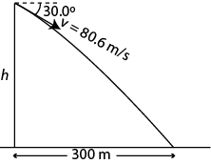

Fig. 4, T071

T062: Q10. The position of a particle is given as r= (4.00t-t²)i+t³j where r is in meters and t is in seconds. The particle’s acceleration at t = 0 s is: (Ans: -2.0i m/s)
Q11.: A projectile is fired horizontally at a speed of 15 m/s from the top of a tower. It lands on the ground at a horizontal distance of 45 m. The height of the tower is: (A: 44 m )
Q12.: If the moon makes a complete circle around the earth in 29 days (= 2.5 × 10⁶ s) and the distance between the center of earth and the center of the moon is 3.8 x10⁸ m, then the magnitude of centripetal acceleration on the moon is: (Ans: 2.4 x 10⁻³ m/s² )
Q13.: Two boats A and B leave seaport at the same time. Boat A travels at a speed of 10.0 m/s in the +x direction and boat B heads at an angle of 60.0º with the x-axis at a speed of 10.0 m/s. The velocity of A relative to B is (Ans: (5.00i-8.66 j)m/s )
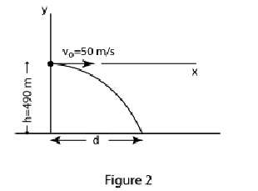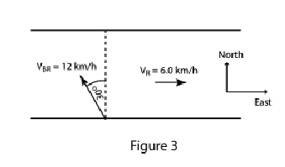

Fig. 2, T061 Fig. 3, T061 Fig. 2, T052 Fig. 3, T052

T061
Q9. A train traveling north at 20 m/s turns and then travels south at 20 m/s. The change in its velocity is: (Ans: 40 m/s south)
Q10: An arrow is shot horizontally from a point P toward X as shown in Fig 2, T061. It hits at a point Y, 0.20 s later. If the speed of the arrow at P is v_{o}= 11 m/s, the distance PX is: (Ans: 2.2 m)
Q11. A boy wishes to swim across a river from A to B. He can swim at 1.0 m/s in still water and the river is flowing at 0.50 m/s (Fig 3, T061). At what angle θ should he be heading?
(Ans: 60° )
Q12. A stone is tied to a 0.50 m string and rotated at a constant speed of 2.0 m/s in a vertical circle. Its acceleration at the bottom of the circle is: (Ans: 8.0 m/s², up )

T052
Q#9. The plane shown in Fig 2, is in a level flight at a height of 490 m and a speed of 50 m/s when a package was released. The horizontal distance between the release point and the point where the package strikes the ground is: Ans: D) 500 m
Q#10. An object moves with a constant acceleration a= -8.0 i+ 7.0 j m/s^{2.} At t=0 the velocity vo is 40i m/s. The velocity at time t = 5.0 s is: (Ans: 35 / j ms
Q#11:. An object is moving on a circular path of radius 3.0 meters at a constant speed. The time required for one revolution is 4.7 s. The acceleration of the object is: (Ans: 5.36 m/s 2
Q#12:. Fig 3 shows a boat is sailing at 12 km/h 30° W of N relative to a river that is flowing East (E) at 6.0 km/h relative to ground. As observed from the ground, the boat is sailing: (A: due N)
Q#13. A 5.0-kg mass is suspended by a string from the ceiling of an elevator that is moving downward with constant acceleration of 2.8 m/s 2 . The tension in the string is: (Ans: 35 N)

T051
Q#9 : A ball is thrown with a velocity v₀= 3.0 i + 5.0 j m/s from the ground. Its velocity just before it strikes the ground is: (Ans: v= 3.0 i - 5.0 j m/s )
Q#10. A ball is kicked from the ground with an initial speed of 20 m/s at an angle of 45°. A player 60 m away starts running to catch the ball at that instant (see Fig 2). What must be his average speed (v) if he has to catch the ball just before it hits the ground? (Ans: 6.6 m/s)
Q#11. The position of a particle as a function of time is given by r= 3.0 ti + 2.0 t²j . Find the angle between the velocity and acceleration of the particle at t =5.0 s. ( Ans: 8.5°)
Q#12. Car A is moving towards East with speed 15.0 m/s and car B is moving towards West with speed 25.0 m/s, both relative to the ground. Find the velocity of car B relative to car A.( Ans: 40.0 m/s towards West)
Q#13. Two forces F 1 & 2 F are acting on a 3.0 kg box in the x-y plane. Fig. 3 shows only F 1 and the acceleration a of the box. Find F 2 (Ans: 72 i + 24 j N )

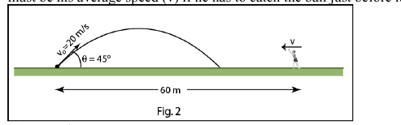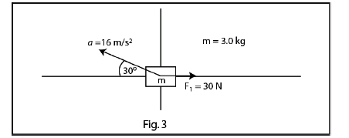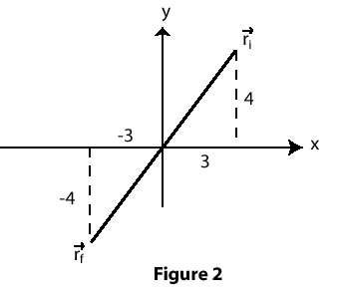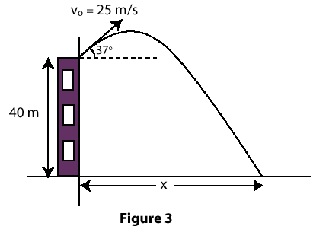
Fig. 3, T052 Fig. 2, T051 Fig. 2 T042 Fig. 3 T042

T042
Q10# The position of a particle is initially r_{i} = (3.0 m)i + (4.0 m)j, and 10 s later it is r_{f} = -(3.0 m)i - (4.0 m)j (see Fig 2). What is its average velocity during this time interval ? A1 (-0.6i - 0.8j) m/s
Q11# A ball is kicked from the roof of a building with an initial velocity of 25 m/s at an angle of 37 degrees to the horizontal(see Fig 3). How far from the base of the building will the ball land? (The height of the building is 40 m(A1 95 m A2 66 m
Q12# A satellite is placed in a circular orbit 8.0*10**3 km from the center of the earth. If it takes the satellite 2.0 hours to complete one revolution, what is its centripetal acceleration? A1 6.1 m/s**2 towards the center of the earth
Q13# A boat is sailing due North at a speed of 4.0 m/s with respect to the water of a river. If the water is moving due East at a speed of 3.0 m/s relative to the ground, what is the velocity of the boat relative to the ground? A1 5.0 m/s making an angle 37 degrees east of north
T041: Q10: Car A travels with velocity (30 j) m/s (relative to the ground) and car B travels with speed of 50 m/s in a direction making an angle of 37 degrees with +x axis (relative to the ground) (see Fig 9). What is the velocity of car A relative to car B ? (A1): (-40i) m/s .
Q11: A projectile is thrown from a height H with a speed of 10.0 m/s at an angle of 30 degrees below horizontal as shown in Fig 10. Find H , if the horizontal distance x = 20.0 m . (A1): 37.7 m .
Q12: A stone is tied to the end of a string and is rotated with constant speed around a horizontal circle of radius 1.0 m. If the magnitude of its acceleration is 225 m/s**2, What is the period (T) of the motion? (A1): 0.42 s.
Q13:At t=0, a particle leaves the origin with a velocity of vo = (4i + 2j) m/s. After 20.0 s its velocity is v = (20i - 4j) m/s. Find its acceleration (assumed constant). (A1): (0.8i - 0.3j) m/s**2.
T031: Q9 At t=0, a particle moving in the xy plane with a constant acceleration of a=(2i + 4j) m/s**2 has a velocity Vo=(-4j) m/s at the origin. Find the speed of the particle at t=3 s. (A1): 10 m/s.
Q10: A ball is projected from the ground into the air with velocity Vo. At a height of 10.0 m the velocity is observed to be V = 8.5 i + 9.1 j in m/s. Find Vo. ( A1): (8.5 i + 16.7 j) m/s .
Q11: Rain is falling vertically at constant speed of 6.0 m/s. At what angle from the vertical do the rain appear to be falling as viewed by the driver of a car traveling on a straight, level road with a speed of 8.0 m/s? (A1): 53 degrees.
Q12: The speed of a particle moving in uniform circular motion is doubled while the radius of the path of the particle is increased by a factor of 4. The new centripetal force needed will be : (A1): the same as before.
Q13: A ball is thrown horizontally with speed Vo from the edge of a cliff 35 m high. The ball strikes the ground at a point 80 m from the base of the cliff. Find Vo. (A1): 30 m/s.
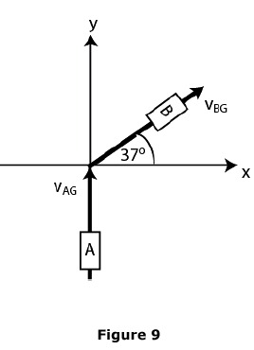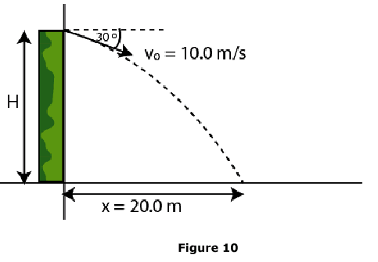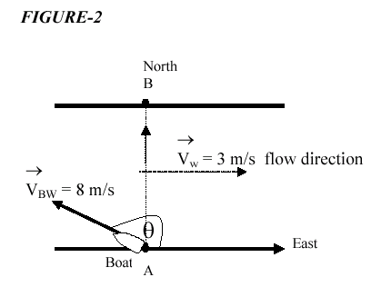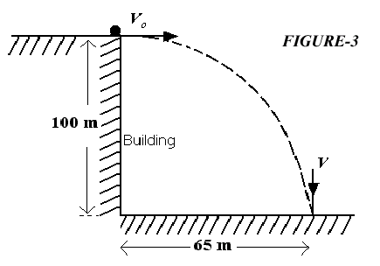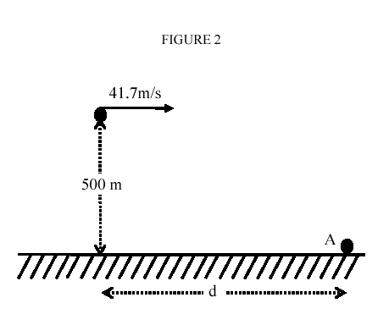

Fig. 9 T041 Fig. 10 T041 Fig. 2 T022 Fig. 3 T021 Fig. 2 T012
T022: Q10: At t=0, a particle leaves the origin with a velocity of 9.0 m/s in the positive y direction and moves in the xy plane with a constant acceleration a = (2.0 i-4.0 j) m/s**2. At the instant the x-coordinate of the particle is 16 m, what is the velocity of the particle? (A1): v = (8i - 7j) m/s.
Q11: A ball is hit at ground level. After 3.0 s the ball is observed to reach its maximum height above the ground level at a horizontal distance of 30 m from where it been hit. What is the initial speed of ball? (A1): 31 m/s.
Q12: A wheel has a 15 m radius and completes five turns about its axis every minute at constant rate. What is the magnitude of the acceleration of a point on the rim of the wheel? (A1): 4.1 m/s**2 .
Q13: A wide river has a uniform flow speed of 3.0 m/s toward the east. A boat with a speed of 8.0 m/s relative to the water leaves point (A) and heads in such a way that it crosses to a point (B) (see Fig.2). In what direction relative to east must the boat be pointed? ( A1): 112 degrees.
T021: Q10: A particle starts from the origin at t=0 with a velocity of (8j) m/s and moves in the xy plane with constant acceleration of (4i - 2j) m/s**2. At the instant the x coordinate of the particle is 32 m, what is the value of its y coordinate? ( A1): 16 m.
Q11: A ball is thrown horizontally from the top of a building 100 m high. The ball strikes the ground at a point 65 m horizontally away from the base of the building (Fig 3). What is the speed of the ball just before it strikes the ground? (A1): 47 m/s.
Q12: A particle moves at a constant speed in a circular path with a radius of 2.0 cm. If the particle makes 4 revolutions each second, what is the magnitude of its acceleration? (A1): 13 m/s**2 .
T012: Q9: Car A is moving with a speed of 30 km/h along the positive x-axis and car B is moving with a speed of 40 km/h along the positive y-axis. What is the velocity of car B with respect to car A? (A1): (-30i + 40j) km/h.
Q10: A ball leaves the ground with a speed of 50 m/s at an angle of 60 degrees with the horizontal. Find its speed at its highest point. (A1): 25 m/s.
Q11: A stone is thrown from the ground into the air with an initial velocity V = (5.0i + 9.0j) m/s. To what maximum height will the stone rise? (A1): 4.1 m.
Q12: The airplane shown in Fig. 2 is in level flight at an altitude of 500 m and a speed of 41.7 m/s. At what distance d should it release a bomb to hit the target at point A? (A1) 421 m.
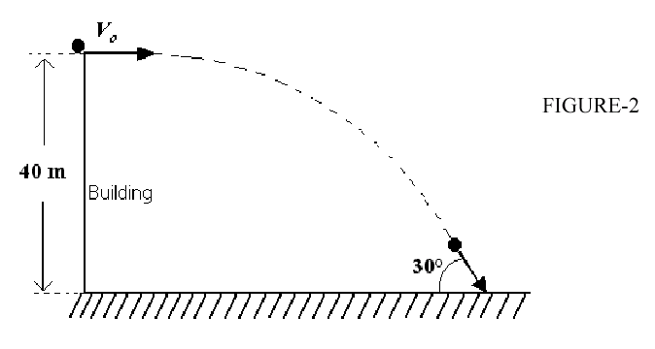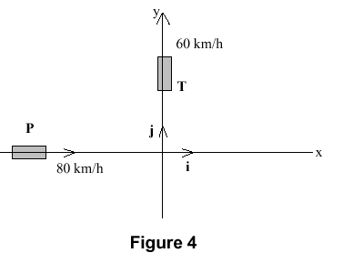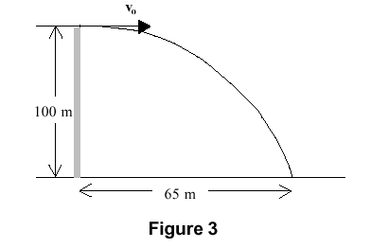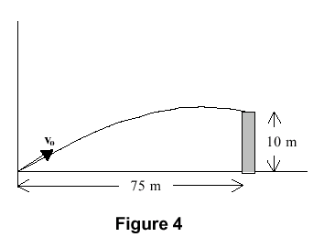
Fig. 2 T011 Fig. 4 T992 Fig. 3 T991 Fig. 4 T991
T011: Q10: A plane traveling north at 200 m/s turns and then travels south at 200 m/s. The change in its velocity is: ( A1): 400 m/s South.
Q11: A stone is thrown horizontally from the top of a 40m high hill. It strikes the ground at an angle of 30 degrees as shown in Fig.2. With what speed was it thrown? (A1): 49 m/s.
Q12: A particle starts from the origin at t = 0 with a velocity of 8.0j m/s and moves in the XY plane with a constant acceleration of (4.0i +2.0j)m/s**2. At the instant the X coordinate of the particle is 32 m, find its y coordinate. (A1): 48 m.
Q13: A river has a steady flow of 0.30 m/s. A student swims downstream a distance of 1.2 km and returns to the starting point. If the student can swim at a constant speed of v in still water and the downstream portion of the swim takes him 20 minutes, the time required for the entire swim is: (A1): 70 minutes.
T992: Q8:A particle leaves the origin at t=0 with a velocity V0 = (8.0 i) m/s. The constant acceleration of the particle is a = ( -2.0 i + 3.0 j) m/s**2. Find the y-coordinate of the particle when it reaches its maximum positive x-coordinate. (A1): 16 m
Q9: A stone is thrown horizontally from the top of a building, of height 75 m, with an initial speed of 15 m/s. Find the speed of the stone 2.0 s after it is thrown.
(A1): 25 m/s
Q10: A particle rotates in a horizontal circle of radius 3.5 m. At a given instant, its total acceleration is 2.1 m/s**2 in a direction that makes an angle of 60 deg to the radial direction (see Figure 3). Determine the speed of the particle, v, at this instant.: (A1): 1.9 m/s
Q11: Two roads intersect as shown in Figure 4. At this instant, a police car (P) is approaching the intersection along the x-axis at 80 km/h while a truck (T) is moving along the y-axis at 60 km/h. What is the velocity of the police car relative to truck? (A1): (80 i - 60 j) km/h
Q12: An ice-boat sails across the surface of a frozen lake with constant acceleration produced by the wind. At a given instant, the velocity of the boat is v = (6.3 i -8.4 j) m/s. Three seconds later, because of change of wind direction, the boat comes instantaneously to rest. Find the average acceleration of the boat during this 3.0 s interval. (A1): (-2.1 i + 2.8 j) m/s**2.
T991: Q10: A particle moves in the x-y plane with a constant acceleration given by a = (-4 j) m/s**2. At t=0 its position is (10 i) m and its velocity is (-2 i + 8 j) m/s. What is the distance from the origin to the particle at t=2 s? (A1): 10 m
Q11: A ball is thrown horizontally from the top of a building 100 m high. The ball strikes the ground at a point 65 m from the base of the building (see figure 3). What is the speed of the ball just before it strikes the ground? (A1): 47 m/s
Q12: A rock is projected from ground level as shown in figure 4. Four seconds later the rock is observed to strike the top of a 10-m tall fence that is a horizontal distance of 75 m from the point of projection. Determine the speed (v0) with which the rock was projected. : (A1): 29 m/s
Q13: A 140-m wide river flows with a uniform speed of 4.0 m/s toward the east. Starting from a point on the north bank it takes 20 s for a boat to cross the river with constant speed to a point directly across on the south bank. What is the speed of the boat relative to the water?
(A1): 8.1 m/s)

