Old Exam Questions Ch. 3 (Dr. Gondal Phys101)

T082 Q7. Vector A has a magnitude of 40.0 cm and is directed 60.0 degrees above the negative x-axis. Vector B has magnitude of 20.0 cm and is directed along the positive x-axis. Find the resultant vector (i and j are unit vectors along positive x and y axes, respectively). (Ans: 34.6 j cm)
Q8. Consider two vectors A = (3 i + 4 j) cm and B = (- 4 i + 3 j) cm. Find the angle between these two vectors. (Ans: 90 degrees)
Q9. If vector A is added to vector B, the result is (6 i + 1j) m. If A is subtracted from B, the result is (- 4 i + 7 j) m. Find the magnitude of B. (Ans. 4 m.)

T081 Q7. A boat travels a distance of 27.0 km 20.0º North of East. It then travels 53.0 km in a direction 30.0º East of North. What is the total distance traveled by the boat in the East direction? ( Ans: 51.9 km)
Q8. Consider two vectors and with magnitudes 5 cm and 8 cm, respectively. Vector is along the positive x-axis and vector is along the positive y-axis. Find · (+). (Ans: 25 cm²)
Q9. Consider the following three vectors, , and . Find the magnitude of the vector = – + . (Ans: 17.7)

T072: Q5.Vectors , , and are related through equations and . If , what is the magnitude of vector ? (Ans: 15)
Q6. Three vectors , and are related through . If vector and , then vector is: (Ans: )
Q7. A vector of magnitude 20 is added to a vector of magnitude 25. The magnitude of the vector can be: (Ans: 12)
Q8. Vectors and are defined as , and . Find the component (projection) of vector along the direction of vector .( Ans: 0.20)

T071: In Fig. 3, the unknown vector is given by: (Ans: )
Q8. Two vectors are given by: , . The angle that the vector makes with the positive x-axis is: (A: 135°)
Q9.: A man walks 5.0 km due North, then 13 km 22.6° South of East, and then 12 km due West. The man is finally at: (Ans: where he started)

T062: Q7. A and B are two perpendicular vectors: A=3.0 i and B=2.0 j The magnitude of is: A-2B (Ans: 5.0)
Q8. The angle between vector A=3.00 i+ 4.00j and the negative y-axis is: ( A: 143° )
Q9. Three vectors are given as: A=-3.0i; B= -5.0 k and C=2.0 j. The value of A. (BXC) is: (Ans -30 )

T061: Q6. A vector in the xy plane has a magnitude of 25 m and an x component of +12 m and a positive y component. The angle it makes with the positive y axis is: (Ans: 29°)
Q7. If A=(2.0 i-3.0j)m and B=(1.0i- 2.0j)m , then A-2B= (Ans: (1.0j) m)
Q8. Two vectors and A and B have magnitudes of 10 m and 15 m respectively. The angle between them is 65°. The component (projection) of B  along A  is: (Ans: 6.3 m)

T052: Q#6. If A= i+j and B= i- j then: (Ans: the angle between A and B must be 90°)
Q#7:. Let A=2.0i+ 3.0 k and B=2.0 i+ k .The vector D=( A-B)xA is: (Ans: -8.0 j )
Q#8. In Fig 1, A(12m , 60°) and B=(8m ,300°). Then x component of (A-B) is: (Ans: 2 m)

T051: Q#6:. Three vectors A, B , and C are such that: C =A+B , B=5i and C=5j . Find the angle between A and B ( Ans: 135°)
Q#7:. A man walks 4.65 km West, then 12.7 km in the direction 30° West of North and finally 11.0 km due East. The man is now at (Ans: 11.0 km due North)
Q#8. If vector A has the magnitude of 3.0 m and makes an angle 30° with the +x-axis, then the vector 2B =-A is: (Ans: 5.2 i –3.0j)

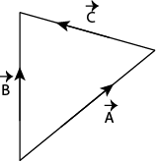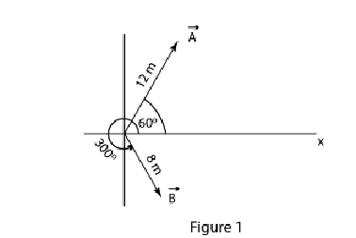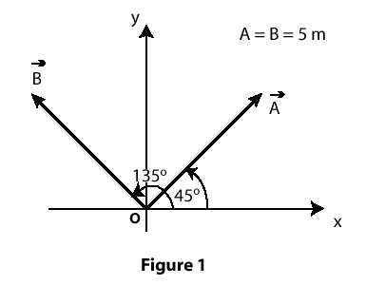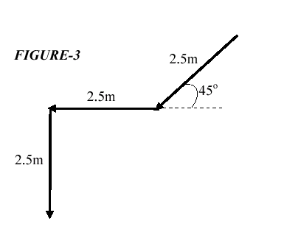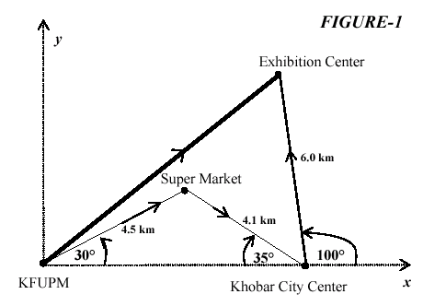
Fig. 3, T071 Fig. 1, T052 Fig. 1, T042 Fig. 3, T031 Fig. 1, T022

T042: Q#7: Two vectors A and B are shown in Fig 1. Each vector has a magnitude of 5.0 m. Find the magnitude of the resultant vector R = A + B and the angle (theta) between R and the positive x-axis (counter clockwise.( Ans: magnitude = 7.1 m, theta = 90 degrees)
Q8# Vector A has components Ax = 4.0, Ay = -3.0 . Vector B has components Bx = 8.0, By = 6.0. Find the angle between the two vectors. (Ans: 74 degrees )
Q9# Three vectors are A =1.00i + 2.00 j -3.00 k , B = 3.00 k and C = 6.00 i - 7.00 j. Find 2C.(A X B) . (Ans: 114 )
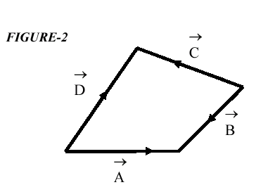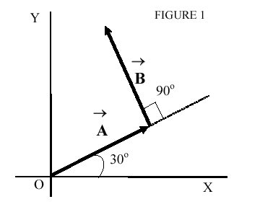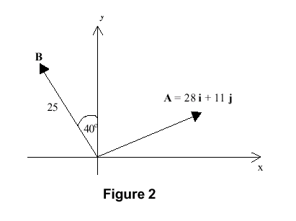
Fig. 2 T021 Fig. 1 T012 Fig. 2 T991

T041: Q#7: Two vectors are given as: A = -3.0 i + 5.0 j + 4.0 k and B = 4.0 i + 5.0 j + 3.0 k, where i,j and k are the unit vectors in the positive x, y and z directions. Find the angle between the vectors A and B. (Ans: 60 degrees)
Q#8: In the cross product F = v x B, take v = 2.0 i, F = 6.0 j and the x-component of vector B equals zero.What then is B in unit-vector notation. (Ans: -3.0 k)
Q#9: Two displacement vectors A and B have equal magnitudes of 10 m. Vector A is along the +y axis and vector B makes 45 degrees counterclockwise with +x axis. Find the vector C such that B + C = 2A . (Ans: C = -7 i + 13 j

T031: Q#6:The angle between the two vectors A = 2 i + 4 j and B = 4 i - 2 j is: (Ans: 90 degrees )
Q#7:As shown in Fig. 3, a block moves down on a 45-degree inclined plane of 2.5 m length, then horizontally for another 2.5 m, and then falls down vertically a height of 2.5 m. Find the magnitude and direction of the resultant displacement vector of the block. (Ans: 6.0 m and 45 degrees below horizontal axis )
Q#8:Given the vectors A = 3 j + 6 k , B = 15 i + 21 k. Find the magnitude of vector C that satisfies equation 2A + 3C - B = 0. (Ans: 6.16 )

T022: Q#1: Which of the following is NOT a unit vector? (A1) (1/2) (i + j) ; (A2) vector a / |a| ; (A3): j x i ; (A4): (1/sqrt(3)) (i + j + k) : (A5): 0.6 j + 0.8 k
Q#2: What is the angle between the two vectors A = (i - 2j + 2k) and B = (-2i +j +2k) ? (Ans: 90 degrees )
Q#3:A student makes the journey from KFUPM to a Super Market and then to Khobar City Center and finally to Exhibition Center. The magnitude and the direction of each of these displacements are indicated in Fig. 1. Give the resultant displacement from KFUPM to the Exhibition Center in unit vector notation. (Ans: 6.2 i+5.8 j) km

T021: Q#7:Fig (2) shows four vectors A, B, C, D. Which of the following statements is correct: (A1): C = D + B - A (A2) C = A + B + D (A3): C =-D - B + A; (A4): C = A - B + D; ( A5): C =-A - B - D
Q#8: Unit vectors i,j,k have magnitudes of unity and are directed in the positive directions of the x,y,z axes. The value of k.(k x i) is: (Ans: 0 .)
Q#9: If we have two vectors A = (a i - 2 j) and B = (2 i + 3 j) such that A.B = 4, find the value of a. (Ans: 5 )

T012: Q#6: The two vectors A and B shown in Fig. 1 have equal magnitudes of 10.0 m. Find the magnitude of the resultant, R, of these vectors and the angle theta it makes with the positive x-axis. (Ans: R = 14.1 m, THETA = 75 degrees) .
Q#7 A vector in the xy-plane has a magnitude of 25.0 and an x-component of 12.0. The angle that it makes with the positive x-axis is: ( Ans: 61.3 degrees) .
Q#8: The unit vectors in the positive directions of the x, y, and z axes are labeled i, j, and k. The value of [i.(j x k)] is: ( Ans: +1)

T011: Q#7 Vector A=(5.0i + 3.0j)m, and vector B is 6m in length and making 120 degrees angle with +ve x-axis. Find A-B. (Ans: (8.0 i - 2.2j )m )
Q#8 If a=(3.0i + 4.0j)m and b=(5.0i -2.0j)m, find the angle between the two vectors. (A1) 75 degrees
Q#9 For the following three vectors; A=2i+3j+4k, B=4i+4j and C= 2i+2k, find A.(BxA). (Ans: 0.)

T992 Q#6: Starting from the origin, a boy walks 3.5 mSouth, then 10 m at 30 degrees North of East, and finally 10 m West. Find the resultant displacement vector. Take East along the positive x-axis and North along the positive y-axis. (Ans: (-1.34 i - 1.5 j) m.

T991 Q#7: If vector A = 28 i + 11 j and vector B (magnitude of B = 25) as shown in figure 2, what is the magnitude of the sum of these two vectors? (Ans: 32)
Q#8: Vector A = -6 i + 14 j. Find vector B, whose magnitude is twice that of A and is opposite in direction to A. (Ans: 12 i - 28 j)
Q#9): If vector A = 6 i - 7 j and vector B = -12 i + 10 j, what angle does vector C = 2*A - B make with +x-axis measured counterclockwise. (Ans: 315 deg.)

