Old Exam . Questions Ch.2 (Dr. Gondal-Phys101)
Q3. A hot air balloon carrying a 10.0 kg block is descending vertically at a constant speed of 10.0 m/s. When the balloon is 100 m above the ground, the block is released. How long does it take the block to reach the ground? (Neglect air resistance) (3.61 s )

Q 4 Figure 1 shows the velocity-time graph of a particle moving along the x-axis. What is the average acceleration of the particle during the time interval t = 1.0 s to t = 8.0 s? A) (– 2.1 m/s2)

Q5. Which of the graphs shown in Figure 2 represents an object moving with a negative constant velocity?
Q6. A car moving along the positive x-axis with constant acceleration covered the distance between two points 60 m apart in 6.0 s. Its velocity as it passes the second point was 15 m/s. What was its velocity at the first point? A) 5.0 m/s

T082Q3.Two cars A and B travel on a straight line. The displacement of car A is given by x_{A} (t) =2.60 t+1.20 t2, where t is in seconds and xA in m. The displacement of car B is given by x_{B} (t) =2.80 t2- 0.20 t3. At what time the two cars will have the same acceleration? (A 2.67 s)
Q4. A ball is thrown from ground straight upward with a velocity of 26 m/s. How long does it take the ball to strike the ground? (Ans: 5.3 s)
Q5.Two automobiles, 150 kilometers apart, are traveling toward each other. One automobile is moving at 60km/h and the other is moving at 40 km/h. In how many hours will they meet? (A: 1.5)
Q6. The graph shown in Fig.1 represents the straight-line motion of a car. Find its acceleration at t = 6 s. ( A) –3.00 m/s2
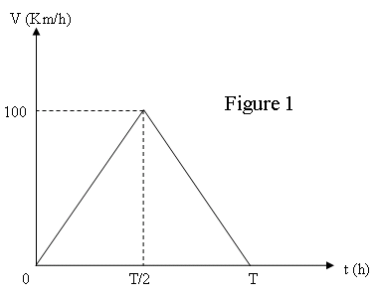
Fig.1 T082 Fig. 1, T081
T081 Q3.The velocity-time graph of a train traveling in a straight line from station A to station B, 10 km away, is shown in Figure 1. The train starts from A at t = 0 and arrives at B at t = T hours later. Find the acceleration of the train during the first half of the trip. (Ans: 1000 km/h²)
Q4.: A person throws down a stone into a well with an initial speed of 10 m/s. It takes the stone 3 s to reach the surface of the water in the well. What is the distance traveled by the stone to reach the surface of the water? (Ans: 74.1 m)
Q5: The displacement of a car is given by x = 5t² – 20t + 10, where x is in meters and t is in seconds. The car was initially moving towards the East. At what time does it change direction and move towards the West? (Ans: 2 s)
Q6.: A man leaves his home driving his car for one hour at an average speed of 90 km/h before running out of gas. He then gets out of his car and walks a distance of 10 km in 3 hours before reaching a gas station. The average speed of the man during the whole trip between his home and the gas station is (A) 25 km/h
T072 Q2.The position of an object is given as a function of time by , where x is in meters and t is in seconds. Its average acceleration during the interval from t = 1.0 s to t = 2.0 s is:(Ans: −19 m/s²)
Q3.: A car starts from rest and undergoes a constant acceleration. It travels 5.0 m in the time interval from t = 0 to t = 1.0 s. Find the displacement of the car during the time interval from t = 1.0 s to t = 2.0 s.( Ans: 15 m)
Q4. Fig. 1 represents the velocity of a car (v) moving on a straight line as a function of time (t). Find the acceleration of the car at 6.0 s. (A ns: -3.0 m/s²)
T071 : Q3.Fig 1 shows the position-time graph of an object. What is the average velocity of the object between t=0.0 s and t= 5.0 s? (Ans: 2.0 m/s)
Q4. Fig 2 shows a velocity-time graph of a runner. If the runner starts from the origin, find his position at t = 4.0 s.( Ans: 45 m)
Q5.An object is thrown vertically upward with an initial speed of 25 m/s from the ground. What is the height of the object 1.0 s before it touches ground?(Ans:20 m)
Q6.: A car starts from rest and accelerates at a rate of 2.0 m/s² in a straight line until it reaches a speed of 20 m/s. The car then slows down at a constant rate of 1.0 m/s² until it stops. How much time elapses (total time) from start to stop? (Ans: 30 s)

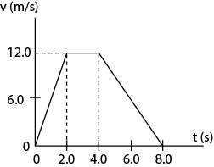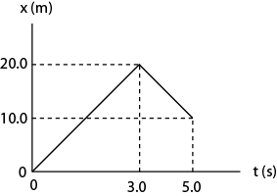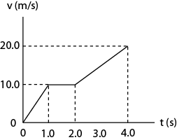
Fig. T072 Fig. 1, T071 Fig. 2, T071
T062Q3: A car travels along a straight line at a constant velocity of 18 m/s for 2.0 s and then accelerate at − 6.0 m/s² for a period of 3.0 s. The average velocity of the car during the whole 5.0 s is: (Ans: 13 m/s )
Q4. The velocity as a function of time for a particle moving along the x-axis is shown in Fig.1. The motion clearly has two different parts: the first part is from t = 0 to t = 2.0 s, and the second part is from t = 2.0 s to t = 6.0 s. Which one of the following statements is correct? (Ans: At t = 4.0 s the acceleration is -5.0 m/s² )
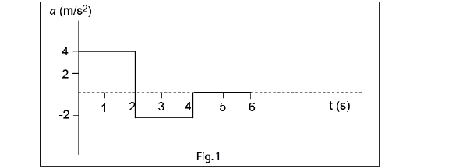
Fig. 1, T062 Fig. 1, T061 Fig. 1, T051
Q5. A particle moves along the x axis. Its position is given by the equation x = 2.0 + 3.0 t – t³ with x in meters and t in seconds. The average acceleration from t = 0 to t = 2.0 s is: (Ans: −6.0 m/s² )
Q6. An arrow is shot straight up with an initial speed of 98 m/s. If friction is neglected, how high the arrow can reach? (Ans: 490 m)
T061Q2. A stone is thrown vertically downward from the top of a 40 m tall building with an initial speed of 1.0 m/s. After 2.0 s the stone will have traveled a distance of (Ans: 22 m)
Q3. A particle starts from the origin at t = 0 and moves along the positive x-axis. A graph of the velocity of the particle as a function of time is show in Fig 1. The average velocity of the particle between t = 0.0 s and 5.0 s is: (Ans: 1.4 m/s )
Q4. At a traffic light, a truck traveling at 10 m/s passes a car as it starts from rest. The truck travels at a constant velocity and the car accelerates at 4.0 m/s². How much time does the car take to catch up with the truck? (Ans: 5.0 s )
Q5. The coordinate of a particle in meters is given by x(t)=2.0t−2.0t², where the time t is in seconds. The particle is momentarily at rest at time t equal to: (Ans: 0.50 s )

T052
Q2. An object starts from rest at the origin and moves along the x axis with a constant acceleration of 4 m/s 2 . Its average velocity as it goes from x = 2 m to x = 18 m is: (Ans: 8 m/s )
Q#3. Two cars are 150 km apart and traveling toward each other. One car is moving at 60. km/h and the other is moving at 40. km/h. In how many hours will they meet? (Ans: 1.5 h)
Q#4. The coordinate of a particle in meters is given by : x(t )= 16t -3.0 t³ where the time t is in seconds. The particle is momentarily at rest at time t : (Ans: t= 1.3 s).
Q#5. A stone and a ball are thrown vertically upward with different initial speeds: 20 m/s for the stone and 10 m/s for the ball. If the maximum height reached by the ball is H then the maximum height reached by the stone is: (Ans: 4 H)

T051
Q#2. A helicopter at height h (m) from the surface of the sea is descending at a CONSTANT SPEED v (m/s). The time it takes to reach the surface of the sea can be found from: (Ans: -h = -v t )
Q#3: A particle starts from rest at t = 0 s. Its acceleration as a function of time is shown in Fig. 1. What is its speed at the end of the 6.0 s? (Ans: 4.0 m/s )
Q#4. The position of a particle x(t) as a function of time (t) is described by the equation: x(t) = 2.0 + 3.0 t – t 3 , where x is in m and t is in s. What is the maximum positive position of the particle on the x axis? (Ans: 4.0 m).
Q#5. A stone is thrown vertically downward from a building with an initial speed of 2.0 m/s. It reaches the ground after 5.0 s. What is the height of the building? (Ans: 130 m)

T042
Q3 A particle moves along the x axis from Xi to Xf . Of the following values of the initial and final coordinates, which one results in the displacement with the largest magnitude?
A1 Xi = -4 m , Xf = 4 m ; A2 Xi = -4 m , Xf = -8 m ; A3 Xi = -4 m , Xf = 2 m ; A4 Xi = 4 m , Xf = -2 m ; A5 Xi = 4 m , Xf = 6 m (Ans: Xi = -4 m , Xf = 4 m )
Q4 Each of the following four particles move along an x axis. Their coordinates as functions of time are given by: particle 1: x(t) = 3.5 - 2.7*t**4 : particle 2: x(t) = 3.5 + 2.7*t**3 ; particle 3: x(t) = 3.5 + 2.7*t**2 and particle 4: x(t) = 3.5 - 3.4*t - 2.7*t**2 . Which of these particles have constant acceleration? (Ans: Only 3 and 4 )
Q5 Starting at time t = 0, an object moves along a straight line. Its coordinate in meters is given by x(t) = 75*t - 1.0*t**3 , where t is in s. When velocity (v) of the object = 0, the value of its acceleration is : (Ans: -30 m/s**2 )
Q6 A ball is dropped from the top of a building having height H. If it hits the ground 2.1 s later, find the height of the building, H. (Ans: 22 m )

T041
Q3 A man runs on a straight road for 8.0 km at a speed of 8.0 km/h. He then continues in the same direction for another 6.0 km at a speed of 12 km/h. What is his average speed during this 14 km run? (A1) 9.3 km/h.
Q4 A stone is thrown vertically upward with an initial speed of 10 m/s. What is its speed when it returns to a height of 3.83 m above its starting point? (Ans: 5.0 m/s) .
Q5 A particle moves along the x axis. Its position from its starting point as a function of time t is given in Fig 2. What is the total distance that this particle travels from t=0 to t=6.0 s? (Ans: 12 m)
Q6 A particle starts from Xo = 10 m at time to = 0. Its velocity (v) as a function of time (t) is as shown in Fig 1. Find the position (X) of the particle at time t = 3.0 s. (Ans: 28 m)
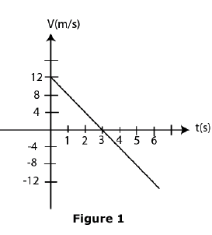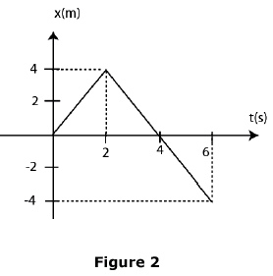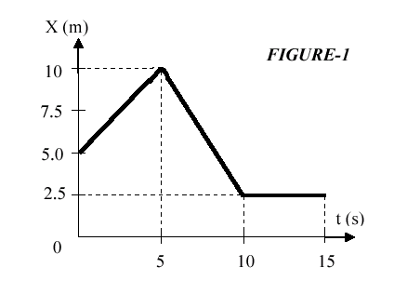
Fig.1-T041 Fig.2.T041 Fig.1-T031
T031
Q2 Fig. 1 shows a graph of position versus time for a particle moving along the x axis. What is the total distance travelled by the particle in 15 s? (Ans: 12.5 m ).
Q3 An object starts from rest at the origin and moves along the x-axis with a constant acceleration of 5.0 m/s**2. Find its average velocity as it goes from x = 0 m to x = 10 m. (Ans: 5.0 m/s.)
Q4. Starting at time t = 0, an object moves along a straight line with a velocity in m/s given by v = 72 - 2 t**2, where t is in seconds. Find its acceleration when it stops momentarily. (Ans: -24 m/s**2 )
Q5 A stone is thrown vertically upward with an initial speed of 15 m/s. What is its speed at a height of 10 m from its release point? ( Ans: 5.4 m/s)
T022
Q6 A car travels in a straight road with a velocity of v1=15 m/s for half the distance between two cities and with a velocity v2=30 m/s for the other half. What is the average velocity of the car for the entire trip? (Ans: 20.0 m/s.)
Q7 An object moving along the x axis has a position given by x = (3 t - t**3) m, where t is measured in s. What is the acceleration of the object when its velocity is zero? (Ans: -6.0 m/s**2 )
Q8 A particle moving with a constant acceleration has a velocity of 10 cm/s when its position is x0 =10 cm. Its position 4.0 s later is x= -14 cm. What is the acceleration of the particle? (Ans: -8.0 cm/s**2).
Q9 A stone is thrown vertically upward such that it has a speed of 9.0 m/s when it reaches one half of its maximum height above the launch point. Determine the maximum height. (Ans: 8.3 m).

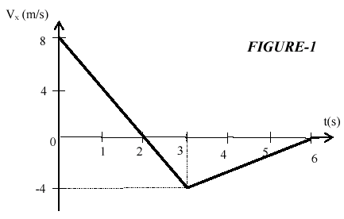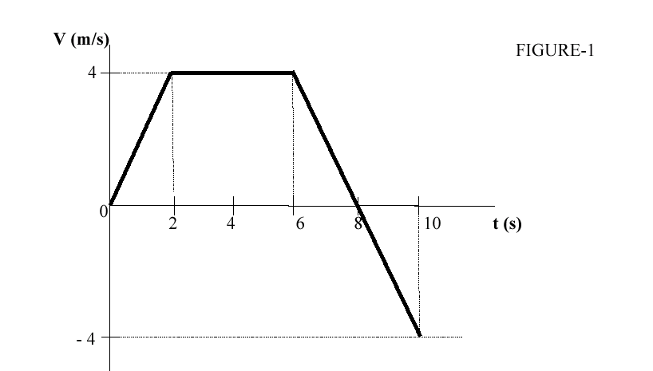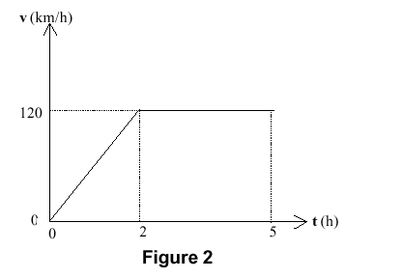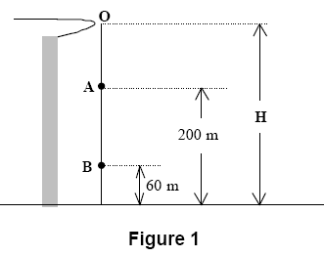
Fig. 1 T-021 Fig. 1 T011 Fig.2 T992 Fig. 1 T992
T021
Q2) Fig (1) shows the velocity (Vx) of a particle moving along x axis as a function of time (t). What is the acceleration of the particle at t= 2.0 s? (Ans: -4 m/s**2 ).
Q4)A particle moving along the x axis has a position given by x =(24 t - 2 t**3) meters, where t is measured in seconds. How far is the particle from the origin (x=0) when the particle stops momentarily? ( Ans: 32 m.)
Q5) In 2.0 seconds, a particle moving with constant acceleration along the x axis goes from x=10 m to x=50 m. The velocity at the end of this time interval is 10 m/s. What is the acceleration of the particle? (Ans: -10 m/s**2)
Q6)A stone is thrown downward from height (h) above the ground with an initial speed of 10 m/s. It strikes the ground 3.0 seconds later. Determine h. (Ans:74 m.)
T012
Q2 The position of an object moving along an X-axis is given by x = 3 + 12*t - t**3, where x is in meters and t is in seconds. At what time is the particle momentarily at rest? (Ans: 2 s ) .
Q3 A rock is dropped (Vo =0) from a 100-m high cliff. It takes the rock 3.2 s to fall the first 50 m. How long does it take to fall the second 50 m? (A1) 1.3 s
Q4 The position-time graph for an object is a straight line with a positive slope. The object has (A1) a constant velocity (A2) a decreasing acceleration (A3) an increasing velocity (A4 )an increasing acceleration (A5) a decreasing velocity.
Q5 A balloon is going up with a speed of 10 m/s and is 100 m above the ground when a package is dropped from the balloon. How long does the package take to reach the ground? (Ans: 5.7 s)

T011
Q3 How far does the runner whose velocity - time graph is shown in Fig.1 travel in 10 s? (Ans: 20 m )
Q4 A car traveling 20.0 m/s is 30.0 m from a wall when the driver slams on the brakes. The car hits the wall 2.00 s later. How fast is the car traveling when it hits the wall? (Ans: 10.0 m/s )
Q5 The position of a particle moving along the x axis is described by the equation x(t) = 5.0 + 2.0t + t**3. Find its average acceleration for the time interval t = 1.0 s to t = 2.0 s. (Ans: 9.0 m/s**2)
Q6 A ball is thrown vertically upward with an initial velocity vo and reaches its maximum height in 6.0 s. After how many seconds will it have a velocity -vo/2? (Ans: 9.0 s)
T-992
Q3 A car starts a trip from Dammam, goes 480 km in a straight line to Riyadh in 4.0 hours. Immediately, the car is turned around, and returns to Dammam in 6.0 hours. Find the average speed of the car for the whole trip. (Ans: 96 km/h)
Q4 An object is released from rest at a height H. It takes 2.00 s for the object to fall from point A to point B (see Figure 1). What is the initial height H? (Ans: 385 m)
Q5 Figure 2 represents the straight line motion of a car. What is the distance traveled by the car from t = 0 to t = 5 h? (h stands for hours) (Ans: 480 km)
T991
Q5 A particle moves along the x-axis according to the equation: x = 50*t + 10*t**2 where x is in m and t is in s. Calculate the instantaneous velocity of the particle at t = 3s. (Ans: 110 m/s)
Q6 A baloon carrying a package is ascending (going vertically upward) at the rate of 12 m/s. When it is 80 m above the ground the package is released. How long does it take the package to reach the ground? (Ans: 5.4 s)

