Old-Exam.Questions-Ch-14 (Dr. Gondal, Phys101)

T082
Q9. A penguin (bird) floats first in a fluid of density ρ1 = 1.0 ρ, then in a fluid of density ρ2 = 0.95 ρ, and then in a fluid of density ρ3 = 1.1 ρ. Rank the densities of the fluids according to the amount of fluid displaced by the penguin, GREATEST first. A) ρ2, ρ1, ρ3
Q10. A plastic sphere floats in water with 0.50 of its volume submerged. This same sphere floats in oil with 0.40 of its volume submerged. Determine the density of the oil.
Q11. The open vertical tube in Fig. 3 contains three fluids of densities ρ1 = 300 kg/m3, ρ2 = 400 kg/m3 and ρ3 = 500 kg/m3, which do not mix. Find the pressure at point B. A) 1.03 x 105 Pa
Q12. Fig. 4 shows an ideal fluid flowing in a horizontal tube. The pressure, velocity, and tube cross section area at point 1 and 2 are (P1, v1, A1) and (P2, v2, A2), respectively. If P1=8.0 x 104 Pa, A1=4A2, P2 = 6.0 x104 Pa and A2= 2.0 x 10-3 m2, at what volume rate does water flow through point 2? [Take density of water to be 1000 kg/m3] (A) 0.013 m3/s

T081 Q23. : A uniform block of wood floats in water with two-thirds of its volume submerged. What is the density of the wood? A) 0.67 g/cm³
Q24. On a standard day (atmospheric pressure), a pressure gauge instrument below the surface of the ocean (Specific Gravity = 1.025) reads an absolute pressure of 1.4 x 10⁶ Pa. How deep underwater is this instrument? A) 129 m
Q25. A vertical cross section of a simple geological model of the earth that requires mountains to have roots is shown in Figure 10. At some horizontal level in the fluid mantle (called the level of compensation), the pressure has a constant value (the pressures at points A and B in the figure are equal). How deep must the root (d) of the mountain approximately be? A) 13 km

Fig. 3, T082 Fig. 4, T082 Fig. 10, T081

T072

T072
Q23.: Water is pumped out of a swimming pool at a speed of 5.0 m/s through a uniform hose of radius 1.0 cm. Find the mass of water pumped out of the pool in one minute. (Density of water = 1000 kg/m³).(Ans: 94 kg)
Q24. A large tank open to atmosphere is filled with water. Fig 6 shows this tank with a stream of water flowing through a hole (open to atmosphere) at a depth of 4.00 m. The speed of water, v₂, leaving the hole is: ( Ans: 8.85 m/s)
Q25.A 10 kg spherical object with a volume of 0.10 m³ is held in static equilibrium under water by a cable fixed to the bottom of a water tank. What is the tension T in the cable? (See Fig. 7) (Ans: 880 N)
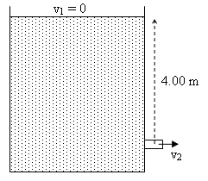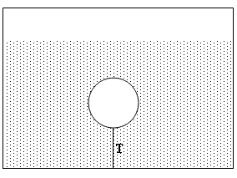

Fig. 6, T072 Fig. 7, T072 Fig. 5, T071 Fig. 6, T071

T071
Q8.The pressure of a gas in a tank is measured with a mercury manometer (Fig. 5). The mercury is 36.2 cm higher in the outside arm than in the arm connected to the gas cell. Find the gauge pressure of the gas cell. (Density of mercury is 13.6 g/cm3) (Ans: 4.82 × 10⁴ Pa)
Q9.: A cube of wood of side = 10 cm has a density of 700 kg/m3. As shown in Fig. 6, the cube is held in equilibrium under water by a string tied to the BOTTOM of a container. Find the tension in the string. (Ans: 2.94 N)
Q10. A garden hose has an inner diameter of 16 mm. The hose can fill a 10 liter bucket in 20 s. Find the speed of the water at the end of the hose (1 Liter = 10-3 m3).(Ans: 2.5 m/s)
Q11.Water flows through a pipe as shown in Fig. 7. At the lower elevation, the water’s speed (vA) is 5.0 m/s and the gauge pressure (PA) is 7.5 × 104 Pa. Find the gauge pressure at the higher elevation (PB). (Diameter at A = 6.0 cm, diameter at B = 4.0 cm and the elevation of B relative to A is 2.0 m) (Ans: 4.60 kPa)

Fig. 7, T071

T062
Q7. Fig. 4 shows an ideal fluid flow in a horizontal tube. The pressure, velocity, and cross sectional area of fluid at point 1 and 2 are (P₁, v₁, A₁) and (P₂, v₂, A₂) respectively with A₁>A₂. Which one of the following statements is correct? A) v₁ < v₂ & P₁> P₂
Q8. A wooden box has been found to floats in three different fluids of densities: ρ₁ (fluid 1) = 0.9 g/cm³, ρ₂ (fluid 2) = 1.0 g/cm³, ρ₃ (fluid 3) = 1.1 g/cm³. Which one of the following statements is true? (A) the three fluids exert the same buoyant force
Q9.A U-tube of constant cross sectional area, open to the atmosphere, is partially filled with Hg (ρ_{Hg}=13.6 g/cm³). Water (ρ_{w}=1.00 g/cm³) is then poured into both arms. If the equilibrium configuration of the tube is as shown in the Fig. 5 with h₃= 1.00 cm, determine the value of h₁. (Note that h₁, h₂ and h₃ are not drawn to scale). A) 12.6 cm
Q10. The open end of a cylindrical pipe has a radius of 1.5 cm. Water (density = 1.0×10³ kg/m³) flows steadily out of this end at a speed of 7.0 m/s. The rate at which mass is leaving the pipe is: A) 4.9 kg/s

T061
Q23. The open vertical tube in Fig. 13 contains two liquids of densities ρ₁ = 1000 kg/m³ and ρ₂ = 800 kg/m³, which do not mix. Find the gauge pressure (pressure due to the liquids only) at the bottom of the tube. (A: 9000 Pa )
Q24. An Aluminum block of density 2.70 g/cm³ has a weight W in air and has a weight W_{app} in water when completely submerged. If (W- W_{app}) is equal to 196 N, the volume of the block is: A) 0.020 m³
Q25. Water is pumped through a hose of uniform cross-section as shown in Fig. 14, from the lower level (1) to the upper level (2). Which of the following expresses the correct relationship between velocity and pressure at the two levels? A) v₁ = v₂ and p₂ < p₁
Q26. Water flows through a horizontal tube from point 1 (cross sectional area A₁) to point 2 (cross sectional area A₂), as shown in Fig. 15. If A₁ = 2A₂ and v₁ = 10 m/s, the change in the kinetic energy (ΔK) of 1.0 m³ of water in moving from point 1 to point 2 is: A) 1.5 x 10⁵ J )

Fig. 4, T062 Fig. 5, T062 Fig. 13, T061 Fig. 14, T061 Fig. 15, T061

T052
Q#23: A uniform U-tube is partially filled with water. Oil, of density 0.75 g/cm³, is poured into the right arm until the water level in the left arm rises 3.0 cm (see Fig 8). The length of the oil column (h) is then: (Ans: 4.0 cm)
Q#24: The dimensions of a boat (ρ_{boat}= 150 kg/m³) is 3.00 m x 3.00 m x 1.00 m. What maximum load can it carry in sea water (ρ_{sea water}= 1020 kg/m³) without sinking? (Ans: 7830 kg)
Q#25: A water line enters a house 2.0 m below ground. A smaller diameter pipe carries water to a faucet 5.0 m above ground, on the second floor. Water flows at 2.0 m/s in the main line and at 7.0 m/s on the second floor. If the pressure in the main line is 3.0 x 10⁵ Pa, then the pressure on the second floor is: (Take the density of water to be 1.0 x 10³ kg/m³) (Ans: 2.1 x 10⁵ P)
Q#26: The rate of flow of water through a horizontal pipe is 2.00 m³/min. Calculate the speed of flow at a point where the diameter of the pipe is 10.0 cm. (Ans: 4.24 m/s).
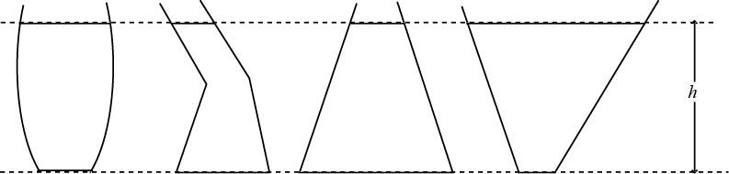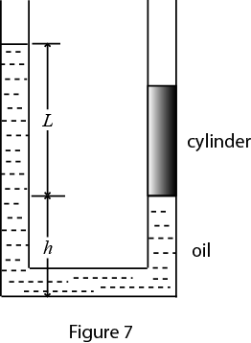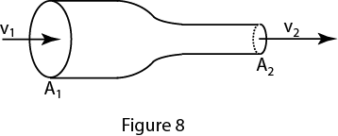
Fig. 8, T052 Fig. 6, T051 Fig. 7, T051 Fig. 8, T051
T051:
Q#23: Several cans of different sizes and shapes are all filled with the same liquid to the same height h (See Fig. 6). Then: (Ans: the pressure on the bottom of each can is the same)
Q#24: Fig. 7 shows a U-tube with cross-sectional area A and partially filled with oil of density . A solid cylinder, which fits the tube tightly but can slide without friction, is placed in the right arm. The system is in equilibrium. The weight of the cylinder is: (Ans: ALg)
Q#25: An object hangs from a spring balance The balance indicates 30N in air and 20N when the object is submerged in water. What does the balance indicate when the object is submersed in a liquid with a density that is half that of water? (Ans:25N)
Q#26: An incompressible liquid flows along the pipe as shown in Fig. 8 with A₁=2A₂. The ratio of the mass flow rate R₂/R₁ is: (show v₁ and v₂ in fig) (Ans: 1)
T042: Q8 A water hose of 1.00 cm radius is used to fill a container of volume 20.0*10**3 cm**3. It takes 60 s to fill the container. What is the speed at which the water leaves the hose? (Ans: 106 cm/s)
Q9 Water enters a house through a pipe with a velocity of 4.0 m/s at a pressure of 4*10**5 Pa. The water in a narrower pipe at the second floor bathroom 5.0 m above has a velocity of 16 m/s.What is the pressure of water in the bathroom? (Density of water = 1.0*10**3 kg/m**3) (Ans 2.3*10**5 Pa)
Q10 A block of metal has mass of 0.50 kg and density of 8.0*10**3 kg/m**3. It is suspended from a string and completely submerged in water. Find the tension in the string. (Density of water = 1.0*10**3 kg/m**3) (Ans: 4.3 N)
Q11 A piston of radius R1= 5.0 cm is used in a hydraulic press to exert a force F1 on the enclosed liquid to raise a car of weight F2=13,500 N (see Fig 4). If the radius of the larger piston is R2 = 15 cm, Find F1. (Ans: 1.5*10**3 N)
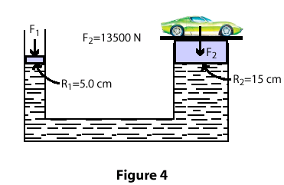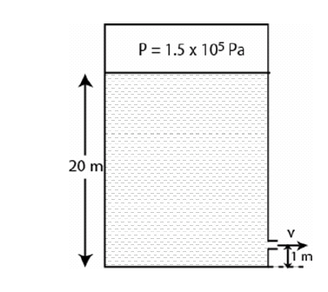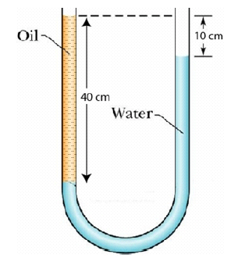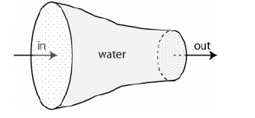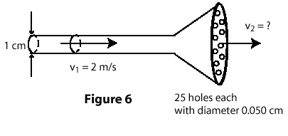
Fig. 4, T041 Fig. 5, T042 Fig. 2, T041 Fig. 3, T041 Fig. 6, T032
T041: Q8 A solid sphere of mass 5.0 kg is floating in water with half of its volume submerged. The density of water is 1000 kg/m**3. The buoyant force on the sphere is (Ans: 49 N)
Q9 Fig 5 shows a very large, closed, oil tank with a hole at a height of 1.0 m from the bottom of the tank. The oil vapor pressure in the tank is maintained at 1.5*10**5 Pa. Find the speed at which oil leaves the hole, when the oil level is 20 m from the bottom of the tank. The density of oil is 850 kg/m**3. (Ans: 22 m/s )
Q10 A U-tube of uniform cross-section, open at both ends, is filled with water (density 1000 kg/m**3) and oil as shown in Fig 2. Water and oil do not mix. Find the density of oil. (Ans: 750 kg/m**3)
Q11 Water flows through a horizontal pipe. The diameter of the pipe is reduced gradually as shown in Fig 3. Assume water is an ideal fluid. Which of the following statements is true? (Ans: The water flow rate is constant everywhere.)
T032: Q23 The density of oil is 0.8 g/cm**3. The height h of the column of oil as shown in Fig 8 is: (The density of water is 1.0 g/cm**3) (Ans; 10 cm)
Q24 An object hangs from a spring balance. The balance indicates 30 N in air, 20 N when the object is completely submerged in water, and 24 N when the object is completely submerged in a liquid. The density of the liquid in g/cm**3 is: (Ans: 0.6)
Q25 A sprinkler is made of a 1.0 cm diameter garden hose with one end closed and 25 holes, each with a diameter of 0.050 cm, cut near the closed end (see Fig 6). If water flows at 2.0 m/s in the hose, the speed of the water leaving a hole is: (Ans: 32 m/s)
Q26 Fig 10 shows a water pipe enters a house and carries water to the second floor 7.0 m above ground. Water flows at 2.0 m/s in the ground level and at 7.0 m/s on the second floor. Take the density of water to be 1.0*10**3 kg/m**3. The pressure in the ground level is 2.0*10**5 Pa. Find the pressure on the second floor. (Ans: 1.1*10**5 Pa )
T031: Q8 Two different solid metal pieces experience the same buoyant force when completely submerged in the same liquid. Which of the following statements is CORRECT? (Ans: Their volumes are equal.)
Q9 How deep into a lake would you have to dive so that the increase in pressure you experience is one atmosphere? (The density of water = 10**3 kg/m**3). (1 atmosphere = 1.01 * 10**5 N/m**2) (Ans: 10.3 m )
Q10 A pipe 16 cm in diameter is used to fill a tank of volume 5000 liters in 5 minutes. What is the speed at which the water leaves the pipe? (1 liter = 10**-3 m**3) (Ans: 50 m/min)
Q11 Consider a large, closed, cylindrical tank with oil inside it. There is a small hole at a height of 1 m from the bottom of the tank. The air above the oil is maintained at a pressure 1.5 x 10**5 Pa (see Fig 7). Find the speed at which oil leaves the hole, when the oil level is 20 m above the bottom of the tank. (The density of oil is 850 kg/m**3). (Ans: 22 m/s)
T022: Q22 The density of water and oil are 1.0 g/cm**3 and 0.80 g/cm**3 respectively. The height h of the column of oil, shown in Fig.5, is: (Ans: 10 cm)
Q23 An incompressible ideal liquid flows along the pipe as shown in Fig.6. The ratio of the speeds v2/v1 is: A1 A1/A2
Q24 Bernoulli's equation can be derived from the conservation of: ( Ans: energy )
Q25 A liquid of density 791 kg/m**3 flows smoothly through a horizontal pipe (see Fig. 6). The area A2 equals A1/2. The pressure difference between the wide and the narrow sections of the pipe (P1-P2) is 4120 Pa. What is the speed v1? (Ans: 1.86 m/s)
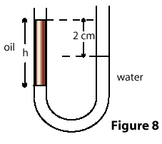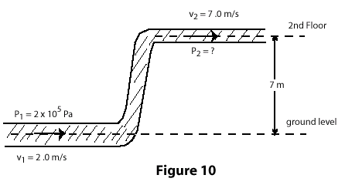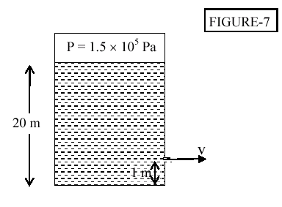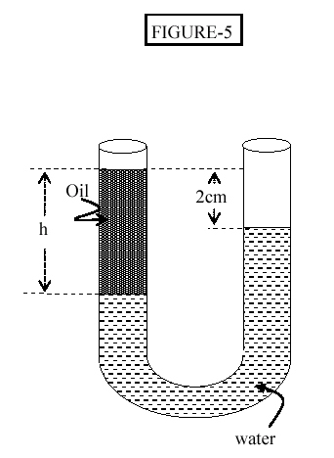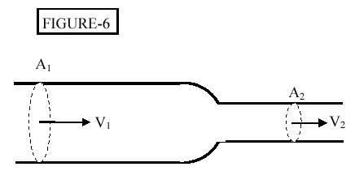
Fig. 8, T032 Fig. 10, T032 Fig. 7, T031 Fig. 5, T022 Fig. 6, T022
T021: Q9 A uniform U-tube is partially filled with water. Oil, of density 0.75 g/cm**3, is poured into the left arm until the water level in the right arm rises 3 cm (see Fig. 3). The length of the oil column, L, is then: (Ans: 8 cm )
Q10 An object hangs from a spring balance. The balance indicates 30 N in air, 20 N when the object is completely submerged in water, and 24 N when the object is completely submerged in an unknown liquid. The density of the unknown liquid equals : (Ans: 0.6 g/cm**3 )
Q11 A large open tank filled with water has two small holes in its bottom, one with twice the radius of the other (see Fig. 4). In steady flow, the speed of water leaving the larger hole is and the speed of the water leaving the smaller hole is Which of the following statements is correct? (Ans: v1 = v2 )
Q12 Water flows from a 6.0-cm diameter pipe into an 8.0-cm diameter pipe. The speed in the 6.0-cm pipe is 5.0 m/s. The speed in the 8-cm pipe is: (Ans: 2.8 m/s)
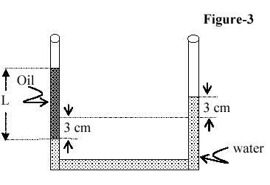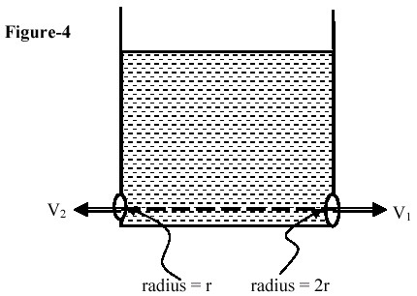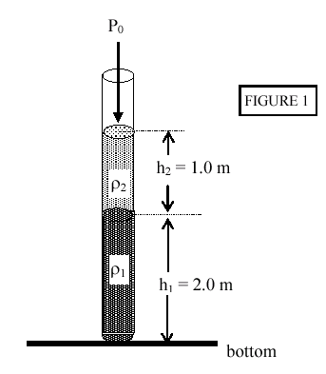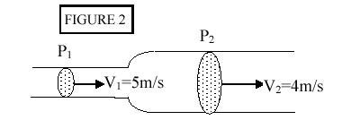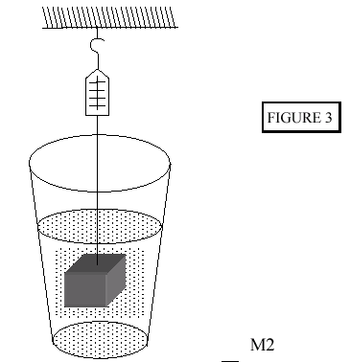

Fig. 3, T021 Fig. 4, T021 Fig. 1, T012 Fig. 2, T012 Fig. 3, T012
T012: Q6 The open vertical tube in FIGURE 1 contains two liquids of densities Rho1 = 1000 kg/m**3 and Rho2 = 600 kg/m**3, Which do not mix. Find the PRESSURE (in N/m**2) at the bottom of the tube. (Ans: 1.3* 10**5 Pa)
Q7 Water (density = 1.0 x 10**3 kg/m**3) flows through a horizontal pipe as shown in FIGURE 2. At the wider end its speed is 4.0 m/s and at the narrow end its speed is 5.0 m/s. The DIFFERENCE in pressure,P2 - P1, between the two ends is: (Ans: +4.5 x 10**3 Pa)
Q8 A 3.20-kg block of metal measuring 15 cm X 10 cm X 10 cm is suspended from a scale and totally immersed in water as shown in FIGURE 3. What is the READING of the spring scale (in N)? (density of water = 1.0* 10**3 kg/m**3) A1 16.7
Q9 A block of wood floats in water with two-third of its volume submerged. Find the DENSITY of the wood (in kg/m**3). ( Density of water is 1.0* 10**3 kg/m**3). (Ans: 667 kg/m**3)
Q10 The rate of flow of water through a horizontal pipe is 2.0 m**3/minute. Determine the SPEED of flow at a point where the radius of the pipe is 5.0 cm. (Ans: 4.2 m/s.)

