Old-Exam-Questions- Ch-11 - Dr. Gondal (Phys101)
T082: Q17. A sphere of mass 1.40 x102 kg rolls on a horizontal floor so that its center of mass has a speed of 0.150 m/s. How much work must be done on the sphere to stop it? (Ans: – 2.21 J)
Q18. Two cylinders made of the same material roll down a plane inclined at an angle θ with the horizontal. Each travels the same distance. The radius of cylinder B is twice the radius of cylinder A. If they start from rest at the same height, in what order do they reach the bottom. (Ans: They both reach the bottom at the same time, because each has the same linear acceleration. )
Q19. A 2.0-kg particle has a velocity v = (2.0 i + 4.0 j) m/s at the point (2.0, -2.0) m. Find its angular momentum relative to the point (- 2.0, - 2.0) m at this moment. (Ans: + 32 k )
Q20. A student holding two weights close to his chest is sitting on a frictionless chair; the student and chair are rotating with an angular speed of 10 rad/s. The moment of inertia of Student + Weights + Chair system about the axis of rotation is 20 kg.m2. Now the student extends his arms horizontally to increase the moment of inertia by 10 %. Find the new angular speed of the system? (Ans: 9.1 rad/s )
T081 Q17.: A uniform disk of mass M and radius R rolls smoothly from rest down a 40⁰ incline as shown in Figure 6. Find the speed of the disk after it has moved a distance of 3.0 m down the incline.(Ans: 5.0 m/s)
Q18.: A 4.0 kg particle moves in an x-y plane. At the instant when the particle’s position relative to the origin is , its acceleration is , where is in meters and is in m/s². Find the torque acting on the particle about the origin.(Ans: )
Q19.: A uniform thin rod of length 1.0 m and mass 3.0 kg can rotate freely in a vertical plane about a horizontal axis through one end. The rod is at rest when a 10 g bullet is fired into the free end of the rod as shown in Figure 7. The speed of the bullet just before impact is 250 m/s. If the bullet is embedded into the rod, what is the angular speed just after the collision?( Ans: 2.5 rad/s)
Q20.: Figure 8 shows the position vector of a particle at a certain instant, and three forces that act on the particle. All three forces are equal in magnitude and lie in the x-y plane. Rank the forces according to the magnitude of the torque they produce on the particle about the origin O, the greatest first.(Ans: F2, F3, F1)

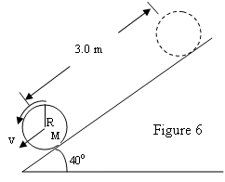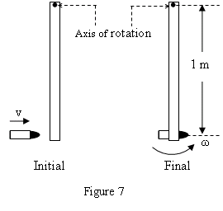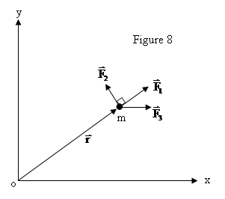
Fig. 6, T081 Fig. 7, T081 Fig. 8, T081
T072
Q18: A uniform solid disk of mass 3.0 kg and radius 0.20 m rotates about a fixed axis perpendicular to its face. The axis passes through a point midway between the center and the edge of the disk. The angular speed of rotation is 6.0 rad/s. What is the magnitude of the angular momentum (in kg.m²/s) of the disk about this axis? ( Ans: 0.54)
Q19. A merry-go-round of radius R = 2.0 m has a rotational inertia I = 200 kg.m² and is rotating at 10 rev/min, about a frictionless vertical axle. A 50 kg boy jumps onto the edge of the merry-go-round and sits down on the edge. Considering the boy to be a point mass, the new angular speed of the merry-go-round is: (Ans: 5.0 rev/min)
Q20. A uniform hoop (ring) is smoothly rolling from the top of a 30° inclined plane of height 5.0 m, starting from rest. Find the speed of its center of mass when it reaches the bottom of the incline. (Ans: 7.0 m/s)
T071
Q17. A uniform ball, of mass M = 80.0 kg and radius R = 0.250 m, rolls smoothly from rest down a 30° incline. The ball descends a vertical height h to reach the bottom of the incline with a speed of 9.80 m/s. Find the value of h. (Ans: 6.86 m)
Q18. A horizontal disk has a radius of 3.0 m and a rotational inertia of 600 kg·m² about its axis. It is initially spinning at 0.80 rad/s when a 20 kg child is at the center of the disk. The child then walks to the rim (edge) of the disk. When the child reaches the rim, the angular velocity of the disk is (Treat the child as a point mass): (Ans: 0.62 rad/s )
Q19. At an instant, a particle of mass 2.0 kg has a position of ()ˆˆ9.015.0 mrij=+􀁇and acceleration of . What is the net torque on the particle at this instant about the point having the position vector: ? ()2ˆ3.0 m/sai=−􀁇ˆ9.0 mori=􀁇 (Ans: ()ˆ90Nmk⋅
Q20. A thin rod of mass M = 2.0 kg and length L = 1.0 m is rotating about an axis O located a 25 cm from one end. Find the angular momentum of the rod about O, if its angular velocity is 120 rev/min. (Ans: 3.7 kg·m²/s )
T062
Q17. A mass, m₁ = 5.0 kg, hangs from a string and descends with an acceleration = a. The other end is attached to a mass m₂ = 4.0 kg which slides on a frictionless horizontal table. The string goes over a pulley (a uniform disk) of mass M = 2.0 kg and radius R = 5.0 cm (see Fig. 6). The value of a is: (Ans: 4.9 m/s²)
Q18. Fig. 7 shows an overhead view of a thin rod of mass M (=2.0 kg) and length L = 2.0 m which can rotate horizontally about a vertical axis through the end A. A particle of mass m = 2.0 kg traveling horizontally with a velocity v_{i} =10.0 j m/s strikes the rod (which was initially at rest) at point B. The particle rebounds with a velocity v_{i} = - 6.0 j m/s Find the angular speed (ω_{f} ) of the rod just after collision. ( Ans: 24 rad/s )
Q19. A string is wrapped around a solid disk of mass m, radius R. The string is stretched in the vertical direction and the disk is released as shown in Fig. 8. Find the tension (T) in the string. (Ans: 1/3 mg )
Fig. 6, T062 Fig. 7, T062 Fig. 8, T062 Fig. 6, T061
T061
Q17. A particle, held by a string whose other end is attached to a fixed point C, moves in a circle on a horizontal frictionless surface. If the string is cut, the angular momentum of the particle about the point C: (Ans: does not change )
Q18. What is the net torque about the origin on an object located at (0, -5.0, 5.0) m when forces and F₁= -3.0 k N and F₂= 2.0 j N act on the object? (Ans: 5i N.m)
Q19. : A thin uniform rod of mass M = 3.0 kg and length L = 2.0 m is suspended vertically from a frictionless pivot at its upper end. An object of mass m = 500 g, traveling horizontally with a speed v = 45 m/s strikes the rod at its center of mass and sticks there (See Fig 6). What is the angular velocity of the system just after the collision? (Ans: 5.0 rad/s )
Q20. A thin hoop rolls without sliding along the floor. The ratio of its translational kinetic energy of the center of mass to its rotational kinetic energy about an axis through its center of mass is: (Ans: 1 )
T052
Q#17: A ring is given an initial speed of 7.0 m/s at its center of mass (see Fig 5). It then rolls smoothly up the incline. At the height 5.0 m the speed of the center of mass of the ring is: (Ans: 0 m/s)
Q#18: The angular momentum of an object about the origin is given as functions of time as follows: L=(2t-1)i kg.m².s where t is in s. The torque about the origin at t = 2.0 s is:.(Ans: (2.0 i) N.m)
Q#19: Two identical thin rods of mass M and length d are attached together in the form of a plus sign “+” (see Fig 6). The whole structure is rotating counterclockwise with angular velocity of ω about the z axis (which is at the point of attachment). The angular momentum about the z axis is: (Ans: (1/6) M ω d2 counterclockwise )
Q#20: A solid sphere of mass M=1.0 kg and radius R=10 cm rotates about a frictionless axis at 4.0 rad/s (see Fig 7). A hoop of mass m=0.10 kg and radius R =10 cm falls onto the ball and sticks to it in the middle exactly. The angular speed of the whole system about the axis just after the hoop sticks to the sphere is: (Ans: 3.2 rad/s )

T051
Q#17. A wheel is 60 cm in diameter and rolls without slipping on a horizontal floor. The speed of the center of mass of the wheel is 20 m/s. The speed of a point at the top edge of the wheel is: (Ans: 40 m/s)
Q#18: A stone attached to a string is whirled at 3.0 rev/s around a horizontal circle of radius 0.75 m. The mass of the stone is 0.15 kg. The magnitude of the angular momentum of the stone relative to the center of the circle is: (Ans: 1.6 kg.m²/s )
Q#20. A monkey of mass = M stands on the rim of a horizontal disk. The disk has a mass of 4 M and a radius R=2.0 m and is free to rotate about a frictionless vertical axle through its center. Initially the monkey and the disk are at rest. Then the monkey starts running around the rim clockwise at a constant speed of 4.0 m/s relative to the ground. The angular velocity of the disk becomes: (Ans: 1.0 rad/s counterclockwise)

T042
Q18: A 3.0 kg wheel, rolling smoothly on a horizontal surface, has a rotational inertia about its axis= M*R**2/2, where M is its mass and R is its radius. A horizontal force is applied to the axle so that the center of mass has an acceleration of 2.0 m/s**2. The magnitude of the frictional force of the surface is : (Ans: 3.0 N)
Q19: Fig 7 shows two disks mounted on bearings on a common axis . The first disk has rotational inertia I and is spinning with angular velocity w. The second disk has rotational inertia 2I and is spinning in the same direction as the first disk with angular velocity 2w. The two disks are slowly forced toward each other along the axis until they stick and have a final common angular velocity of: (Ans: 5*w/3)
Q20: A hoop has a mass of 200 grams and a radius of 25 cm. It rolls without slipping along a level ground at 500 cm/s. Its total kinetic energy is : (Ans: 5 J)
Fig.5, T061 Fig. 5, T052 Fig. 6, T052 Fig. 7, T052 Fig. 7, T042

T041
Q15: Consider two thin rods each of length (L = 1.5 m) and mass 30 g, arranged on a frictionless table as shown in Fig 5. The system rotates about a vertical axis through point O with constant angular speed of 4.0 rad/s. What is the angular momentum of the system about O? (Ans: 0.18 kg*m**2/s ).
Q18: A uniform solid sphere of radius 0.10 m rolls smoothly across a horizontal table at a speed 0.50 m/s with total kinetic energy 0.70 J. Find the mass of the sphere. (Ans: 4.0 kg )
Q30: Fig 7, shows two particles of mass m1 and m2 having velocities 5.0 m/s in the +x-direction and 2.0 m/s in the -x-direction. Find the total angular momentum of this system of particles about the origin. (Ans: -50 k (kg.m**2/s)
T032
Q17: A uniform wheel of radius 0.5 m rolls without slipping on a horizontal surface. Starting from rest, the wheel moves with constant angular acceleration 6.0 rad/s**2. The distance traveled by the center of mass of the wheel from t = 0 to t = 3 s is: (Ans: 13.5 m )
Q14: A 6.0 kg uniform solid cylinder is rolling without slipping on a horizontal surface. A horizontal force (F) is applied to the axle at its center of mass and gives the center of mass an acceleration of 4.0 m/s**2. Find the magnitude of the frictional force of the surface. (Ans: 12 N)
Q20: A disk (rotational inertia = 2*I) rotates with angular velocity Wo about a vertical, frictionless axle. A second disk (rotational inertia = I) and initially not rotating, drops onto the first disk (see Fig 5). The two disks stick together and rotate with an angular velocity W. Find W. (Ans: (2/3)*Wo )

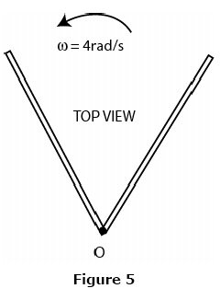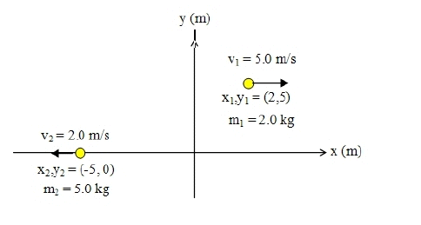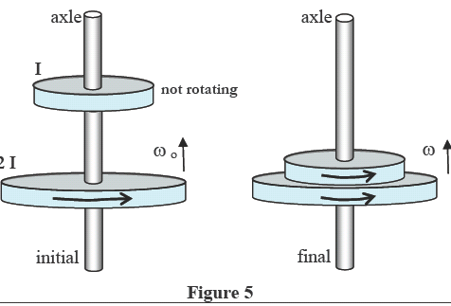
Fig. 5, T041 Fig. 7, T041 Fig. 5, T032 Fig. 7, T032 Fig. 7, T022
T031
Q29 A merry-go-round, of radius R=2.0 m and rotational inertia I = 250 kg.m**2, is rotating at 19 rev/min about its axle. A 25 kg boy jumps onto the edge of the merry-go-round. What is the new angular speed of the merry-go-round? (Ans: 13.6 rev/min)
Q30 A wheel of radius 0.5 m rolls without slipping on a horizontal surface as shown in Fig 5. Starting from rest, the wheel moves with constant angular acceleration of 6.0 rad/s**2. The distance traveled by the center of the wheel from t=0 to t=3.0 s is: (Ans: 13.5 m)
Q18: A star of radius R is spinning with an angular velocity w. If it shrinks till its radius becomes R/2, find the ratio of the final angular momentum to its initial angular momentum. (Ans: 1 )
Q19: Mohammed (M) and Salim (S) (have the same mass) are riding on a merry-go-round rotating at a constant rate. Salem is half way in from the edge, as shown in Fig 7. The angular moment of Salem and Mohammed about the axis of rotation are Ls and Lm respectively. Which of the following relations is correct?(Ans: Lm = 4 Ls )

T022
Q18: A 2-kg particle moves in the xy plane with constant speed of 3.0 m/s in the +x-direction along the line y = 5 m (see Fig.7). What is its angular momentum (in kg.m**2/s) relative to the origin? (i, j, k are the unit vectors in x, y, z axes) (Ans: -30 k )
Q19: A solid sphere rolls without slipping along the floor. The ratio of its transnational kinetic energy to its rotational kinetic energy (about an axis through its center of mass) is: (Ans: 5/2 )
Q20: A man, with his arms at his sides, is spinning on a light frictionless turntable. When he extends his arms: (Ans: his angular momentum remains the same)

T021
Q18.: A solid ball, whose radius R is 10 cm and whose mass M is 8.5 kg, rolls smoothly from rest down a 25 deg inclined plane whose length L is 5.0 m. What is the speed of the center of mass of the ball when it reaches the bottom of the inclined plane? (Ans: 5.4 m/s )
Q19:. A 2.5 kg block travels around a 0.50 m radius circle with an angular velocity of 12 rad/s. Find the magnitude of the angular momentum of the block about the center of the circle. (Ans: 7.5 kg.m**2/s)
Q20: Fig (7) shows an object of mass m=100 g and velocity =Vo is fired onto one end of a uniform thin rod (L=0.4 m, M = 1.0 kg) initially at rest. The rod can rotate freely about an axis through its center (O). The object sticks to the rod after collision. The angular velocity of the system (rod + object) is 10 rad/s immediately after the collision. Calculate Vo. (Ans: 8.7 m/s )
Q9 A 1.0 m mass less rod with a mass m1 = 100 g at the lower end is pivoted at O. The rod is at rest when a mass m2 = 100 g moving with velocity Vo strikes the top end and stick to it (see Fig.2). If the angular velocity of the system just after this collision is 32 rad/s, find Vo. (Ans: 32 m/s .)
Q10: A uniform solid sphere is rolling smoothly up a ramp that is inclined at 10 degrees. What is the acceleration of its center of mass? (Ans: 1.2 m/s**2 down the ramp.)
T012
Q16: A student in a class demonstration is sitting on a frictionless rotating chair with his arms by the side of his body. The chair-student system is rotating with an angular speed w. The student suddenly extends his arms horizontally. The angular velocity of the system: (Ans: decreases )
Q17: A solid cylinder of mass M and radius R starts from rest and rolls down an incline plane making an angle of 30 degrees with the horizontal. The linear speed of its center, after it has traveled 5 m down the incline, is: ( Icm = 1/2* M* R**2) (Ans: 5.7 m/s )
Q18 As shown in FIGURE 5 a disk rotates about a vertical, frictionless axle with angular velocity 50 rad/s. A second identical disk, initially NOT rotating, drops onto the first disk and the two disks eventually reach an angular velocity W. Calculate W (in rad/s). (Ans: 25)
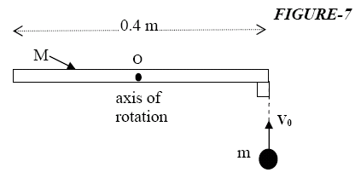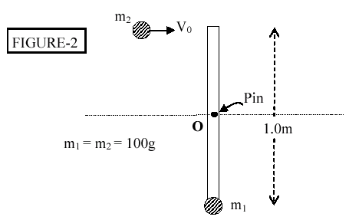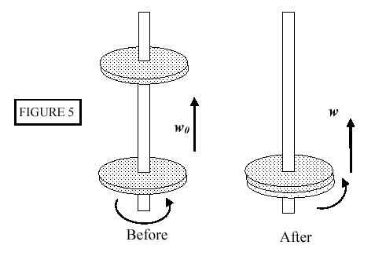
Fig. 7, T021 Fig. 2, T021 Fig. 5, T012

