Old-Exam-Questions-Ch-10-(Dr. Gondal -Phys101)
T082
Q13.: An object whose moment of inertia is 4.0 kg.m² experiences the net torque shown in Fig.2. What is the angular speed of the object at t = 3.0 s if it starts from rest? (A) 0.75 rad/s
Q14: A uniform rod of length L = 10.0 m and mass M = 2.00 kg is pivoted about its center of mass O. Two forces of 10.0 and 3.00 N are applied to the rod, as shown in Fig.3. The magnitude of the angular acceleration of the rod about O is (A) 1.02 rad/s2
Q15: A horizontal disk with a radius of 0.10 m rotates about a vertical axis through its center. The disk starts from rest at t = 0.0 s and has a constant angular acceleration of 2.1 rad/s2. At what value of t will the radial and tangential components of the linear acceleration of a point on the rim of the disk be equal in magnitude? (A) 0.69 s
Q16.: The average power needed to spin ( rotate about its axis) a uniform, solid disk of mass 5.0 kg and radius 0.50 m from rest to a final angular velocity ωf in 3.0 s is 2.6 W. The final angular speed is: (A) 5.0 rad/s
T081 Q13.: A disk is rotating about an axis perpendicular to the disk and passing through its center of mass. The angular position of a reference line on the disk is given by, where t is in seconds and  in radians. Find the average angular acceleration of the disk during the time interval t = 2.0 s and t = 4.0 s. (Ans: 27.0 rad/s²
Q14.: Figure 5 shows two masses m and 3m that are initially held at rest and then released. If the pulley has mass m and radius R, what is the angular acceleration of the pulley? ( Ans: )
Q15: A disk of mass M and radius R is free to rotate about an axis through its center. A tangential force F is applied to the rim (edge) of the disk. What must one do to maximize the angular acceleration of the disk? (Ans: Make F as large as possible and M and R as small as possible)
Q16.: Consider a square plate of mass M = 2.0 kg and side L = 2.0 m. Calculate the kinetic energy of the plate if it is rotated with an angular speed of 10 rad/s about an axis passing through one of the corners of the plate and perpendicular to it. The rotational inertia of the plate about an axis passing through the center of mass of the plate and perpendicular to it is ML²/6. (Ans: 267 J)

T072 : Q13. Assume that a disk starts from rest and rotates with an angular acceleration of 2.00 rad/s². The time it takes to rotate through the first three revolutions is: (Ans: 4.34 s)
Q14. A uniform slab of dimensions: a = 60 cm, b = 80 cm, and c = 2.0 cm (see Fig. 6) has a mass of 6.0 kg. Its rotational inertia about an axis perpendicular to the larger face and passing through one corner of the slab is: (Ans: 2.0 kg.m² )
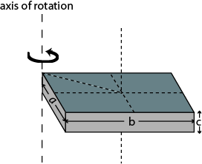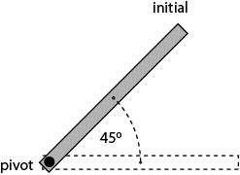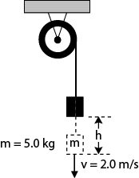

Fig. 6, T072 Fig. 7, T072 Fig. 8, T072

Q15. A thin rod of mass 0.50 kg and length 2.0 m is pivoted at one end and can rotate in a vertical plane about this horizontal frictionless pivot (axis). It is released from rest when the rod makes an angle of 45° above the horizontal (Fig. 7). Find the angular speed of the rod as it passes through the horizontal position. (Ans: 3.2 rad/s)
Q#16: A wheel of radius R = 0.20 m is mounted on a fixed frictionless horizontal axis. The rotational inertia I of the wheel about this axis is 0.50 kg.m². A massless cord wrapped around the circumference of the wheel is attached to a m = 5.0 kg box (Fig. 8). The box is then released from rest. When the box has a speed of v = 2.0 m/s, the distance (h) through which the box has fallen is:
Q17. A force is applied to an object that is pivoted about a fixed axis aligned along the z-axis. If the force is applied at the point of coordinates (4.0, 5.0, 0.0) m, what is the applied torque (in N.m) about the z axis? (Ans: )
T071
Q14. A rigid body consists of two particles attached to a rod of negligible mass. The rotational inertia of the system about the axis shown in Fig. 3 is 10 kg m². What is x₁? (Ans: 1.4 m )
Q15. A 5.00 kg block hangs from a cord which is wrapped around the rim of a frictionless pulley as shown in Fig. 4. What is the acceleration, a, of the block as it moves down? (The rotational inertia of the pulley is 0.200 kg·m² and its radius is 0.100 m.) (Ans: 1.96 m/s² )
Q16. Fig. 5 shows a 1.0 m thin uniform rod of mass 2.0 kg, which is free to rotate about a frictionless pin passing through one end O. The rod is released from rest in the horizontal position. As the rod swings through its lowest position, its kinetic energy is: (Ans: 9.8 J )

Fig. 3, T071 Fig. 4, T071 Fig. 5, T071

T062: Q13. : A torque of 0.80 N·m applied to a pulley increases its angular speed from 45.0 rev/min to 180 rev/min in 3.00 s. Find the moment of inertia of the pulley. (Ans: 0.17 kg·m² ⁾
Q14. : A thin rod of mass 0.23 kg and length 1.00 m is rotated in a horizontal circle about a fixed axis passing through a point 20.0 cm from one of the edges of the rod. If it has a constant angular acceleration of 3.0 rad/s², find the net torque acting on the rod? (Ans: 0.12 N·m)
Q15. A disk starts from rest at t = 0, and rotates about a fixed axis (moment of inertia = 0.030 kg·m²) with an angular acceleration of 7.5 rad/s². What is the rate at which work is being done on the disk when its angular velocity is 32 rad/s? (Ans: 7.2 W)
Q16: A disk has a rotational inertia of 4.0 kg·m² and a constant angular acceleration of 2.0 rad/s². If it starts from rest the work done during the first 5.0 s by the net torque acting on it is: (Ans: 200 J)
Q17. A mass, m₁ = 5.0 kg, hangs from a string and descends with an acceleration = a. The other end is attached to a mass m₂ = 4.0 kg which slides on a frictionless horizontal table. The string goes over a pulley (a uniform disk) of mass M = 2.0 kg and radius R = 5.0 cm (see Fig. 6). The value of a is: (Ans: 4.9 m/s² )
T061: Q13. : A string (one end attached to the ceiling) is wound around a uniform solid cylinder of mass M = 2.0 kg and radius R = 10 cm (see Fig 3). The cylinder starts falling from rest as the string unwinds. The linear acceleration of the cylinder is: (Ans: 6.5 m/s²)
Q14. : A 16 kg block is attached to a cord that is wound around the rim of a flywheel of radius 0.20 m and hangs vertically, as shown in Fig 4. The rotational inertia of the flywheel is 0.50 kg·m². When the block is released and the cord unwinds, the acceleration of the block is: (Ans: 5.5 m/s² )
Q15. : A particle of mass 0.50 kg is attached to one end of a 1.0 m long rod of mass 3.0 kg (Fig 5). The rod and the particle are rotating around the other pivoted end of the rod with 2.0 rad/s. The kinetic energy of the system about the pivot is: (Ans: 3.0 J)
Q16. A disk starts from rest and rotates around a fixed axis, subject to a constant net torque. The work done by the torque during the time interval from t = 0 to 2 s is W₁ and the work done during the time interval from t = 0 to 6 s is W₂. The ratioW₂/W₁ = (Ans: 9)

Fig.6-T062 Fig.3-T061 Fig. 4-T061 Fig.5-T061
T052: Q#13: The angular position of a particle is given as θ = 2 + t – t³ where θ is in rad and t is in s. The angular acceleration when the particle is momentarily at rest is (Ans: 3.5 rad/s² clockwise)
Q#14: A disk of rotational inertia 5.0 kg m² starts rotating from rest and accelerates with a constant angular acceleration of 1.0 rad/s². During the first 4.0 s, the work done on the disk is: (Ans: 40 J)
Q#15: The rotational inertia of a solid sphere (mass M and radius R₁) about an axis parallel to its central axis but at a distance of 2R₁ from it is equal to I₁. The rotational inertia of a cylinder (same mass M but radius R₂) about its central axis is equal to I₂. If I₁=I₂, the radius of the cylinder R₂ must then be: (Ans: 3.0 R₁)
Q#16: A rope pulls a 1.0-kg box on a frictionless surface through a pulley as shown in Fig 4. The pulley has a rotational inertia of 0.040 kg.m² and radius of 20 cm. If the force F is 10 N, then the acceleration of the box is: (Ans: 5.0 m/s²)

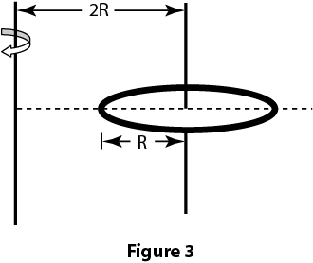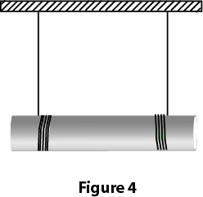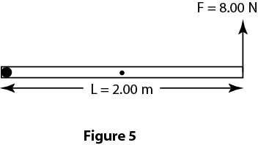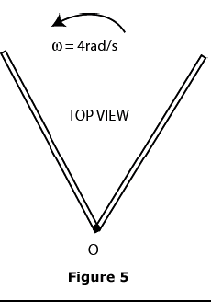
Fig.4-T052 Fig.3-T051 Fig. 4-T051 Fig.5-T051 Fig. 5-T042 Fig. 6, T042 Fig. 5-T041

T051: Q#13. A car engine is idling at ω₀= 500 rev/min at a traffic light. When the light turns green, the crankshaft rotation speeds up at a constant rate to ω= 2500 rev/min over an interval of 3.0 s. The number of revolutions the crankshaft makes during these 3.0 s is: (Ans: 75)
Q#14: Find the moment of inertia of a uniform ring of radius R and mass M about an axis 2R from the center of the ring as shown in the Figure 3. (Ans: 5M R²)
Q#15: A uniform 2.0 kg cylinder of radius 0.15 m is suspended by two strings wrapped around it, as shown in Figure 4. The cylinder remains horizontal while descending. The acceleration of the center of mass of the cylinder is: (Ans: 6.5 m/s²)
Q#16. A uniform thin rod of mass M = 3.00 kg and length L = 2.00 m is pivoted at one end O and acted upon by a force F = 8.00 N at the other end as shown in Figure 5. The angular acceleration of the rod at the moment the rod is in the horizontal position as shown in this figure is: (Ans: 3.35 rad/s² clockwise)
Q#19. Force F = (-8.0 N) i+ (6.0 N) j acts on a particle with position vector r = (3.0 m) i+ (4.0 m)j. What is the torque on the particle about the point P = (0, 4.0 m)? (Ans: 18k N.m)
T042: Q14: A wheel initially has an angular velocity of 18 rad/s but it is slowing at a constant rate of 2.0 rad/s**2. The time it takes to stop is (Ans: 9.0 s)
Q15: Two wheels A and B are identical. Wheel B is rotating with twice the angular velocity of wheel A. The ratio of the radial acceleration of a point on the rim of B (a2) to the radial acceleration of a point on the rim of A (a1) is (a2/a1 : (Ans: 4)
Q16: Four identical particles, each with mass m, are arranged in the x, y plane as shown in Fig 5. They are connected by light sticks of negligible mass to form a rigid body. If m = 2.0 kg and a = 1.0 m, the rotational inertia of this system about the y-axis is: (Ans: 12 kg*m**2)
Q17: Fig 6 shows a pulley (R=3.0 cm and Io= 0.0045 kg*m**2 ) suspended from the ceiling. A rope passes over it with a 2.0 kg block attached to one end and a 4.0 kg block attached to the other. When the speed of the heavier block is 2.0 m/s the total kinetic energy of the pulley and blocks is : (Ans: 22 J)
T041: Q14: A uniform rod (M = 2.0 kg, L = 2.0 m) is held vertical about a pivot at point P, a distance L/4 from one end (see Fig 7). The rotational inertia of the rod about P is 1.17 kg*m**2. If it starts rotating from rest, what is the linear speed of the lowest point of the rod as it passes again through the vertical position (v)? (Ans: 8.7 m/s).
Q16: At t=0, a disk has an angular velocity of 360 rev/min, and constant angular acceleration of -0.50 rad/s**2. How many rotations does the disk make before coming to rest? (Ans: 226)
Q17: In Fig 6, m1 = 0.50 kg, m2 = 0.40 kg and the pulley has a disk shape of radius 0.05 m and mass M = 1.5 kg. What is the linear acceleration of the block of mass m2? (Ans: 0.59 m/s**2)

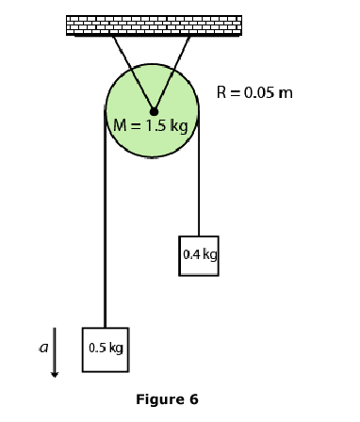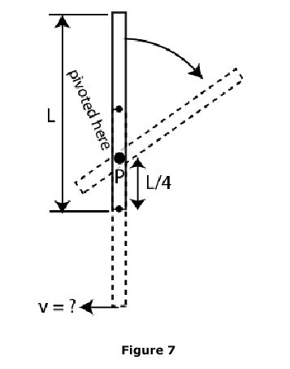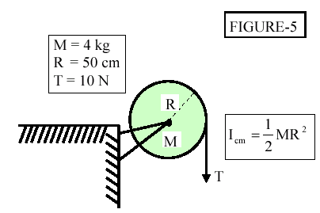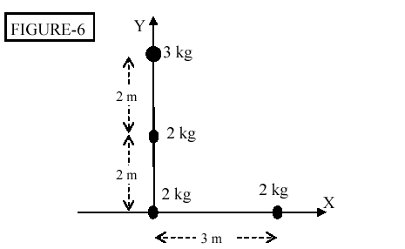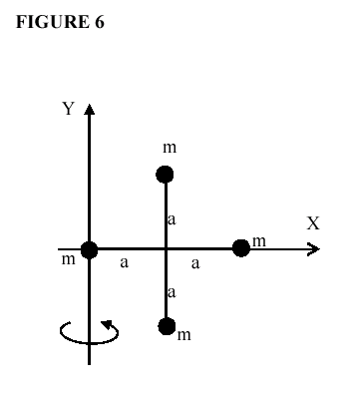
Fig.6-T041 Fig.7-T041 Fig. 5-T041 Fig. 6-T031 Fig. 6-T022 Fig. 7-T022

T032: Q14 A wheel, initially at rest, has a constant angular acceleration. The wheel completes 71 revolutions in 9.0 s. Its angular acceleration in rad/s**2 is: (Ans: 11).
Q15 The rotational inertia of a solid object rotating about an axis Q0 DOES NOT DEPEND UPON ITS: (Ans: angular speed.)
Q16 A disk has a rotational inertia of 6.0 kg*m**2 and a constant angular acceleration of 2.0 rad/s**2. If it starts from rest the work done during the first 5.0 s by the net torque acting on it is: (Ans: 300 J)
Q18 A 2.0 kg stone is tied to a 0.50 m string and swung around a circle at a constant angular velocity of 12 rad/s. The net torque on the stone about the center of the circle is: (Ans: 0 N*m)
T031: Q14 A uniform disk of radius 50 cm and mass 4 kg is mounted on a frictionless axle, as shown in Fig 5. A light cord is wrapped around the rim of the disk and a steady downward pull of 10 N is exerted on the cord. Find the tangential acceleration of a point on the rim of the disk. (Ans: 5.0 m/s**2).
Q15: At t=0, the motor of a turntable (radius = 10 cm) rotating at 33.33 rev/ min is turned off. It slows down uniformly and stops at t=2 min. What is the magnitude of the angular acceleration of the turntable? (Ans 0.029 rad/s**2) .
Q16 The angular position of a point on the rim of a rotating wheel is given by THETA = 4.0t -3.0t**2 + t**3, where THETA is in radians and t is in seconds. What is the average angular acceleration for the time interval that begins at t = 0 s and ends at t = 1.0 s? (Ans: -3.0 rad/s**2) .
Q17: The four particles in Fig. 6 are connected by rigid rods of negligible mass. Find the rotational inertia of the four particles about the y-axis. (Ans: 18 kg.m**2)
T022: Q14: The angular speed in rad/s of the minute hand of a watch is: (Note that PI = 3.14159..) : (Ans: PI/1800)
Q15 A wheel of radius 0.10 m has a 2.5 m cord wrapped around its outside edge. Starting from rest, the wheel is given a constant angular acceleration of 2.0 rad/s**2. The cord will unwind in: (Ans: 5.0 s)
Q16 A disk starts from rest and rotates around a fixed axis, subject to a constant net torque. The work done by the torque from t=0 to t=3.0 s is W1 and the work done from t=0 s to t=6 s is W2. The value of W1/W2 is: (Ans: 1/4 ).
Q17: Four identical particles, each with mass m, are arranged in the x, y plane as shown in Fig. 6. They are connected by mass less rods to form a rigid body. If m =2.0 kg and a =1.0 m, the rotational inertia of this array about the y-axis is: (Ans: 12 kg.m**2)

