KING FAHD UNIVERSITY of PETROLIUM and MINERALS
Physics Department
Atomic and Molecular Physics (Phys-551)
Spring 2014

Issued: 29-1-2014 Assignment # 1 Due date 5-2-2014

- Which spectral lines in the emission spectrum of hydrogen atoms can be observed if the atoms are excited by electrons with kinetic energy E_{kin} = 13.3eV?
Answer: The Hydrogen atom is degenerate, so the transit electron will see only the n-value
So the transition will be:

2- By what factor does the radius of the Bohr orbit increases if the H atom in its ground state is excited by (a) 12.09 eV and (b) 13.387 eV?
a- same as the previous problem, which gives
b- same as the previous problem, which gives

3- A hydrogen wave function in the form: ;
- Determine : By inspection, we know
For l, use
For m, use
- Determine the most probable value of r for an electron in the state specified by .
Ans:
Note that: number of peaks = (n-l) =3-1=2. Plot the radial distribution to visualize the results.

c- What is the probability that an electron in the 1s orbital will be within a radius of 6.0 , 1.0 ?
4- Determine the most probable value of r for an electron in the ground state when Z=1.
[Ans:

5- For an electron in the ground state of Hydrogen atom, find
use ,
Ans:
comment:

5- Find for the state
Ans:

- Calculate the normalization constant “N” in the wave-function:
.
Hint: use the standard integrals: and the spherical coordinates, in which .
Ans:
then
8- For the Gaussian wave-function:
,
find . Hint: use the standard integrals:
Ans:

Using the standard integral$\int_{−∞}^{∞}{x^{2n+1}e^{ −{\text{ax}}^{2}}\text{dx}=\frac{n!}{2a^{n+1}}, n=0,1,2,\text{.}\text{.}}$.
6- For the Hamiltonian:
- Calculate the first order correction to the energy for the Hydrogen like atom. Treat the last term as a perturbation.
- For n = 2, calculate the shift in energy.

7- A helium atom is excited from the ground state to the autoionizing state 2s4p by absorption of ultraviolet light. Assume that the 2s electron moves in the unscreened Coulomb field of the nucleus and the 4p electron in the fully screened Coulomb potential
a) Obtain the energy of this autoionizing level and the corresponding wavelength of the ultraviolet light required to effect this excitation. Make an energy level diagram showing this level together with the ground states of neutral, singly ionized and doubly ionized helium atoms.
b) Find the velocity of the electron emitted in the autoionizing process in which the 2s4p state decays into a free electron and a He⁺ ion in the ground state.
Solution:
a) 2s is unscreened. Therefore, (in atomic units) $E_{2s}=−\frac{Z^{2}}{2n^{2}}=−\frac{2^{2}}{2⋅2^{2}}=−\frac{1}{2}$. Since the 4p is fully screened the effective nuclear charge is 1 and $E_{4p}=−\frac{Z^{2}}{2n^{2}}=−\frac{1^{2}}{2⋅4^{2}}=−\frac{1}{\text{32}}$. Therefore,
$E_{2s4p}=−\frac{1}{2}−\frac{1}{\text{32}}=−\frac{\text{17}}{\text{32}} \text{au} =−\text{14}\text{.}5 \text{eV}$. Graphically, we have
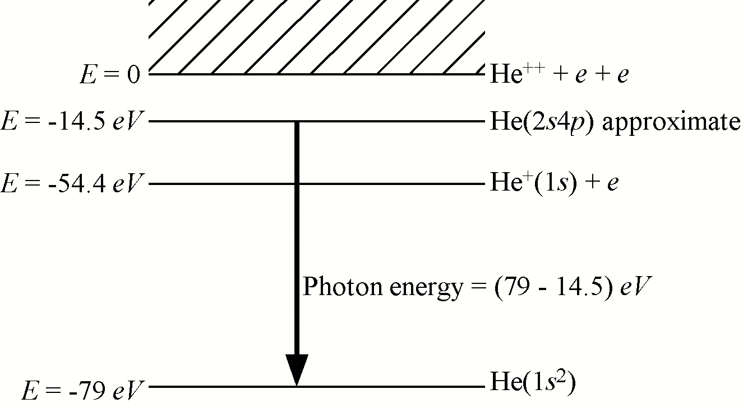

Since the photon energy is 64.5 eV, the wavelength is $λ=\frac{\text{12},\text{400}}{\text{64}\text{.}5}=\text{192} Å$
b) The electron kinetic energy is the difference between the autoionizing level and He⁺(1s):
${\text{KE}}_{\text{electron}}=\text{54}\text{.}4−\text{14}\text{.}5=\text{39}\text{.}9 \text{eV}$ so $\frac{1}{2}{\text{mv}}^{2}=\frac{1}{2}\left({\text{mc}}^{2}\right)\frac{v^{2}}{c^{2}}=\text{39}\text{.}9 \text{eV}$. Therefore,
$\frac{v^{2}}{c^{2}}=2⋅\frac{\text{39}\text{.}9 \text{eV}}{5\text{.}1×{\text{10}}^{5} \text{eV}}=1\text{.}6×{\text{10}}^{−4}$ so

8- For helium atom calculate the following integrals:

- Apply the variational method to the determination of the ground state energy of the hydrogen atom, using as a trial function. Here, is the normalization constant and is the variational parameter.
  - calculate
  - calculate
  - calculate
  - calculate
  - calculate
  - calculate
Discuss your final result, for example: compared with the exact, the behavior of the wave function. [Hint: ]
Answer:
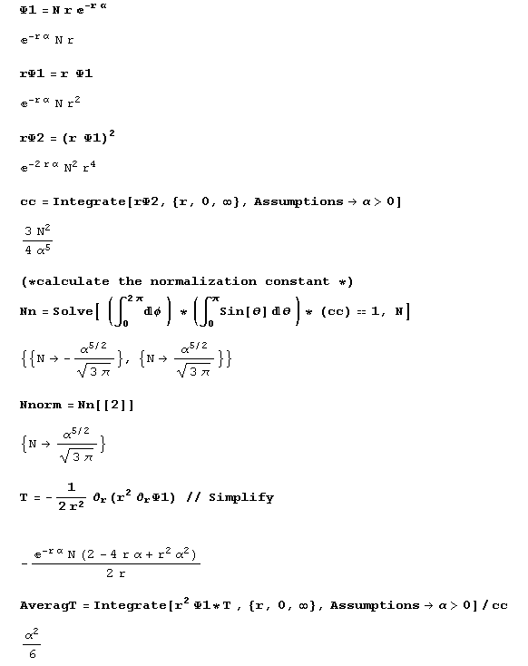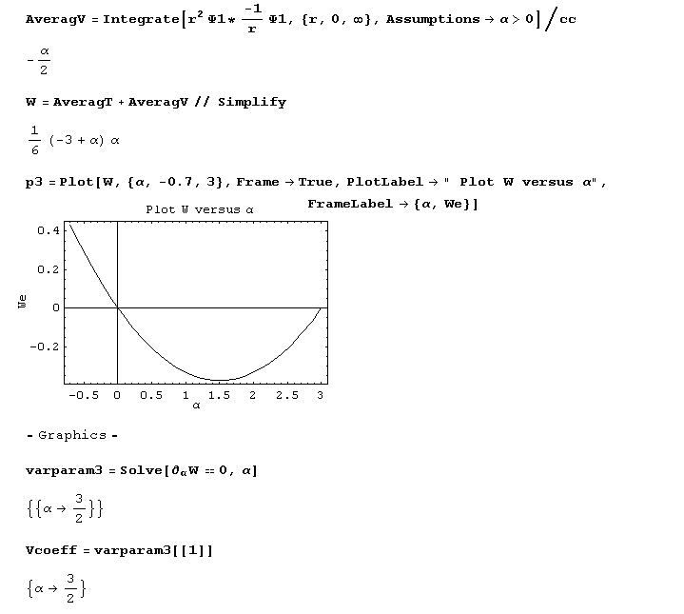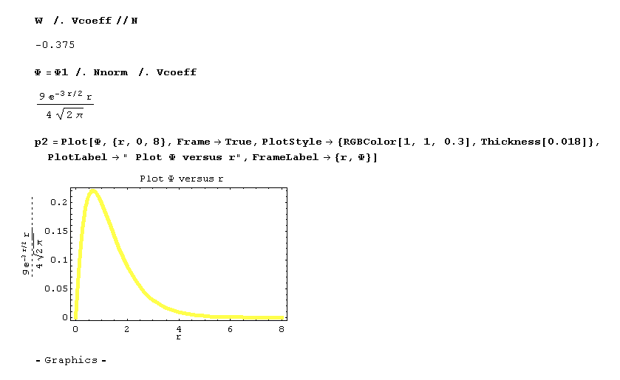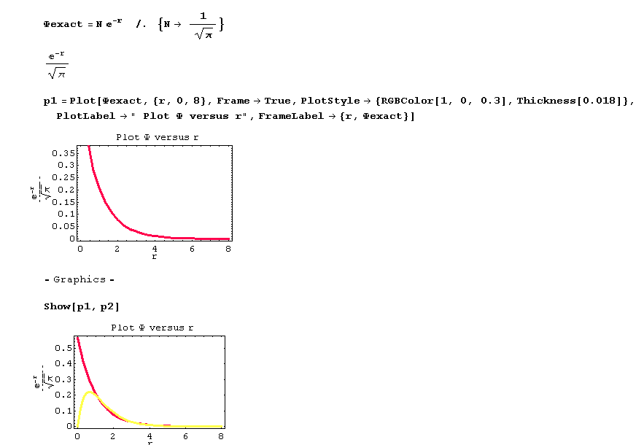

Comment:
-0.375 > -0.5 which satisfy the variational approximation claim. The difference is mainly due to the behavior of the wave function at the origin.

1- (Do it with MATHEMATICA) Use the variational principle to calculate the ground state energy of a hydrogen atom (in atomic units) using the normalized trial functions:
A)
B)
C)
D)
is a variational parameter and N is the normalization constant.

Fill the Table
Wave function | N |  | E | %
A
B
C
D

