LANDAU MEAN FIELD THEORY

Qualitative description of phase transition
We know that for an isolated system in two phases (denoted by subscripts 1 and 2) in equilibrium,
(a) the temperatures of the two phases are equal, i.e.
(b) the pressures of the two phases are equal, i.e.
(c) the chemical potential of the two phases are equal, i.e.
This results because the chemical potential is defined as a function of pressure and temperature (in the absence of any external field) only and the commonality of the pressure and the temperature in the two phases gives equal chemical potential.
Let and be the Gibbs potential (free energy) of the two phases per unit mass (they may be taken as chemical potentials in the two phases). If the composition of the mixture changes, the loss of mass in one phase is equal to the gain of mass in the other phase and the change in Gibbs potential of the system is
Which gives
In each phase, the derivative of the Gibbs potential with temperature at constant pressure is negative of the entropy and the derivative of the Gibbs potential with pressure at constant temperature is the volume; we have
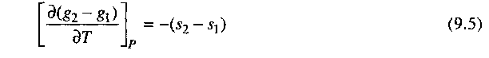
and
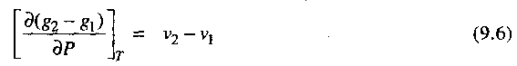
where s₂ and s₁, and v₂ and v₁ are entropies per unit mass and volume per unit mass in the two phases. The behavior of g₁ and g₂ in the two cases is shown in Fig. 9.3 and Fig. 9.4. at the transition point but their first derivatives are discontinuous.
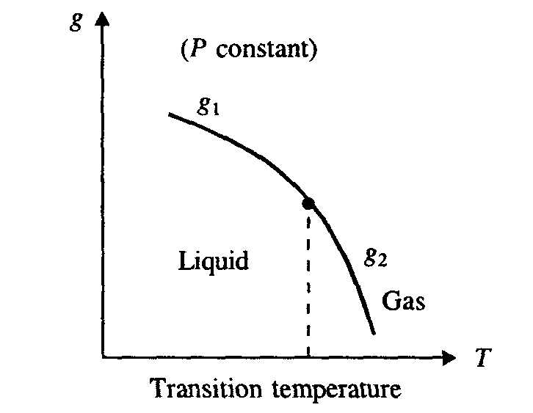
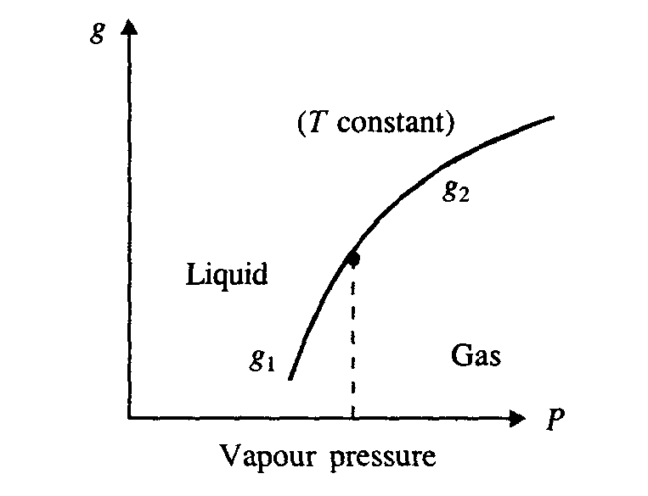

Figure 9.3 Variation of Gibbs potential with temperature. Figure 9.4 Variation of Gibbs potential with vapor pressure.

Thus, this phase transition of the first kind, also called the first order phase transition, has discontinuous entropy and specific volume at the transition point.
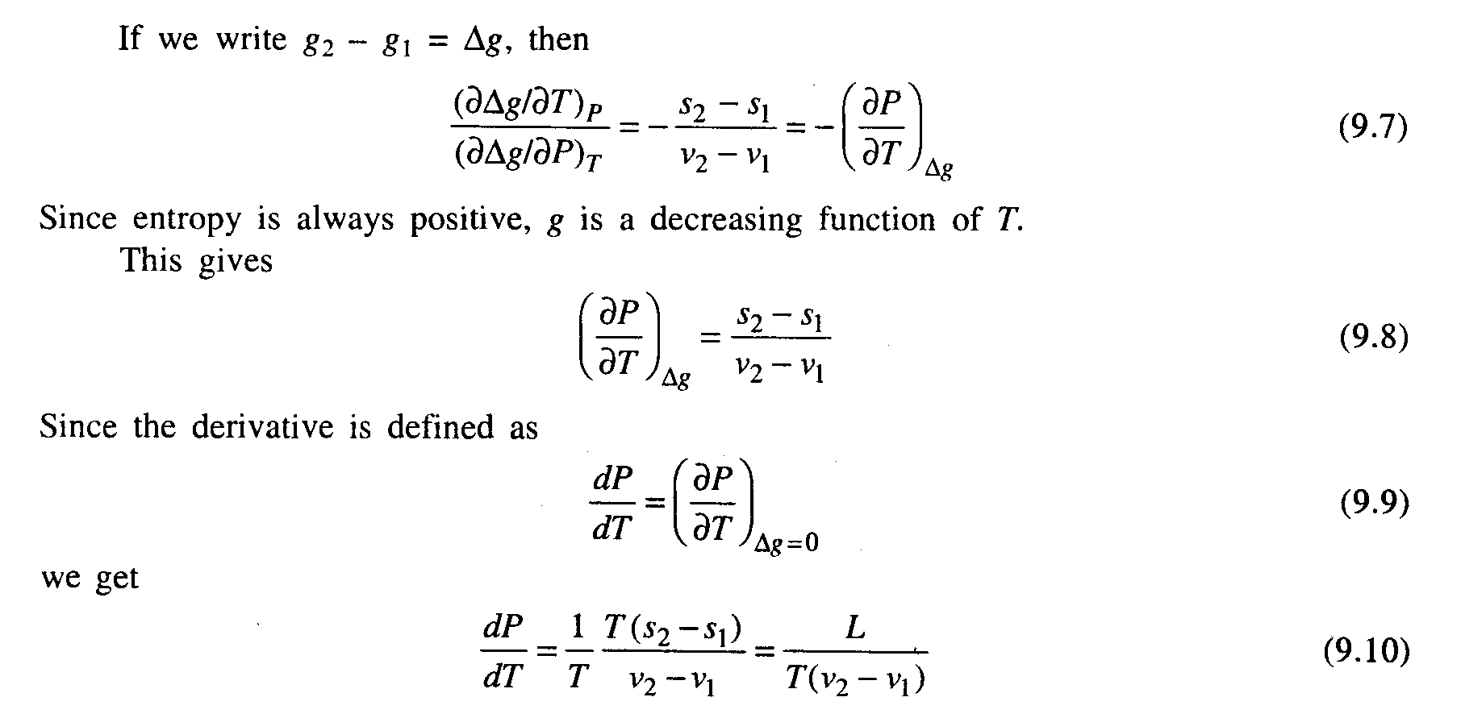
where is called the latent heat of transition. This is known as Clausius-Clapeyron equation that gives the change of vapor pressure with temperature.

In addition to this, there is a phase transition of second order in which the first derivatives of Gibbs potential at transition point is equal, i.e. and v₂ = v₁. Ehrenfest defines a phase transition to be of n^{th} order if at the transition point
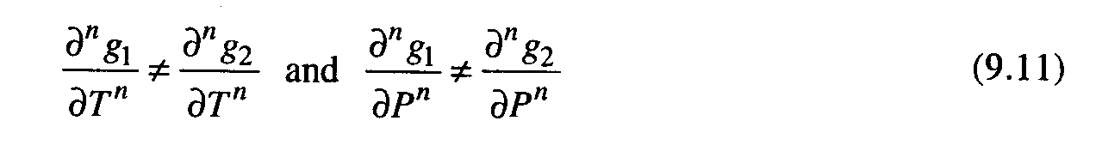
whereas all lower derivatives are equal.

No discontinuous change of state at the phase transition of second kind implies that the thermodynamic functions like energy, entropy and volume vary continuously as the transition point is passed. Hence there is no absorption or evolution of heat at the transition. But the derivatives of the thermodynamic quantities like the specific heat, the thermal expansion coefficient, the compressibility, etc. are discontinuous at the transition point.

We have seen that in the second order phase transition, the symmetry of one phase is higher than the other. The more symmetrical phase corresponds to higher temperature. Next, we define an order parameter such that it takes non-zero values in the phase with less symmetry (ordered phase) and zero in the phase with more symmetry (disordered phase). The phase transition of the second kind has a continuous change of to zero in contrast to discontinuous change of in the phase transition of the first kind.

Landau and the order parameter
It is difficult to trace the beginning of research in the field of phase transition physics. It might have been started by the experimental work by Andrew (1869) in which he studied the liquid-vapor critical point. That study motivated van der Waals theory (1873). At about the same time, a systematic study of magnetic ordering was undertaken. A cornerstone of that research was the molecular field theory (mean field theory) by Weiss (1907).

Mean field theory correctly describes the qualitative features of most phase transitions and, in some cases, the quantitative features. Since mean-field theory replaces the actual configurations of the local variables (e.g. spins) by their average value, it neglects the effects of fluctuations about this mean. These fluctuations may or may not be important. The more spins that interact with a particular test spin, the more the test spin sees an effective average or mean field. If the test spin interacts with two neighbors, the averaging is minimal and the fluctuations are large and important. The number of spins producing the effective field increases with:
- the range of the interaction and
- with the dimension.
Thus the mean field theory is a good approximation in high dimensions but fails to provide a quantitatively correct description of second-order critical points in low dimensions.

Landau was the first to notice (1937) that all second-order phase transition have an important constituent. At the transition point a new element of symmetry first appears. As the symmetry is a qualitative feature, the new element can appear only abruptly at some fixed values of thermodynamics variables. The latter means that the second-order phase transition breaks symmetry spontaneously and the symmetry of the system in the ordered state is lower than symmetry of the Hamiltonian. To describe such a phenomenon Landau introduced a new entity, , which is called an order parameter. This parameter has the following properties:
- in the high-temperature (disordered, high symmetry) phase (i.e. at temperatures above some critical value ).
- below the critical temperature(ordered and low symmetry phase).
- Close to the critical point of a continuous phase transition, the order parameter is small.

For instance, in the case of a magnetic transition into a ferromagnetic state, the magnetization of this state can serve as an order parameter; the liquid-vapor transition order parameter can be characterized by the difference in the densities of the liquid and gas phases. From these examples it is seen that the order parameter is not always a scalar entity but can be a vector or even a tensor quantity. In the most general case, one may consider it as some macroscopic quantity having several components n.

So, mean-field theory is an approximation for the thermodynamic properties of a system based on treating the order parameter as spatially constant. It is a useful description if spatial fluctuations are not important. It becomes an exact theory only when the range of interactions becomes infinite. It, nevertheless, makes quantitatively correct predictions about some aspects of phase transitions (e.g. critical exponents) in high spatial dimensions where each particle or spin has many nearest neighbors, and it makes qualitatively correct predictions in physical dimensions. Mean-field theory has the enormous advantage of being mathematically simple, and it is almost invariably the first approach taken to predict phase diagrams and properties of new experimental systems.

Sometimes, it is convenient to treat the order parameter as a vector in some isotropic space, not related to real configurational space. Landau theory is based on a power series expansion of the free energy in terms of the order parameter (or order parameters) for the transition of interest. It assumes the order parameter is small so that only the lowest order terms required by symmetry (and to keep the energy from diverging) are kept. The form of a Landau phenomenological free energy is determined entirely by the nature of broken symmetry of the ordered phase, i.e. by combinations of the order parameters that are left invariant under symmetry operations of the interaction Hamiltonian. The undisputed usefulness of Landau theory rests in its simplicity. It is, of course, most useful in the vicinity of second-order phase transitions, where the order parameter is guaranteed to be small. It, however, can be used with care to treat first-order transitions, where there are discontinuous changes in order parameters, or to determine properties of ordered phases rather than of phase transitions themselves.
There are two important points to the nature of this approach
- It is a phenomenological approach dealing only with macroscopic quantities.
- It is spatially independent.
- It is only meaningful in the vicinity of a critical point of a continuous phase transition where the order parameter is small.
LANDAU THEORY

Let us consider a physical system in -dimensional space undergoing a phase transition in which there is only one order parameter and its conjugated field. Landau theory assumes that
- The order parameter can be defined such that:
- and ii- ,
which is the natural condition for minima of the free energy near the critical temperature.
- Based on the fact that at the phase transition . Therefore, close to the phase transition point he assumed that the thermodynamic potential (generalized free energy density) can be expanded as a power series in ,

For example, for a simple ferromagnet in external field
(1)
The even terms only are included because it is assumed they are invariant under a reversal in the sign of the magnetization, i.e. . is weakly temperature dependent, and are assumed to be constant or weakly temperature dependent coefficients. We can distinguish two cases:

CASE 1: vanishing field
Also we will consider is uniform; i.e. , which implies . Thus at equilibrium we have the conditions (i) and (ii). The condition (i) gives:
(2)
Taking into account that the higher order coefficient must be positive, such that for for to be stable at higher values of . From Eq.2, we conclude that at
And at
The question mark,, indicates that we do not know in advance the sign of at , but we can investigate what constraints are put on it by the different possible signs in . Now, we distinguish three different possibilities for .

(i) Ordinary Critical Point
The above condition gives:
Take , then
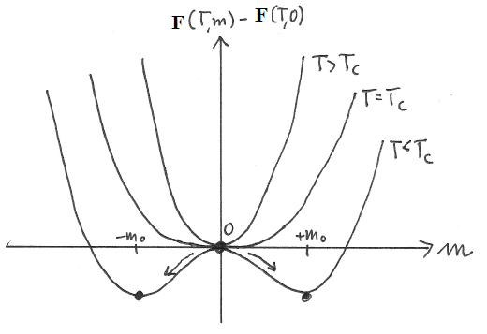
Figure: Shapes of the free energy versus order parameter m in Landau theory (scenario for a continuous phase transition): above Tc, there is one global minimum at m = 0. Positive prefactors of the higher powers of m ensure stability, i.e. prevent a minimum of the free energy at some unphysical diverging value of m. At Tc, the free energy becomes flat at m = 0, i.e. the derivative develops three zeros. Two of the extrema separate away at T < Tc and are minima due to symmetry and the stability requirement. Their positions give the new values of the order parameter m0.

(ii) Tri-Critical Point
The above condition gives:
Take , then
This case is a borderline between a continuous transition (second order phase transition, case i) and a discontinuous transition (first order phase transition, case iii).
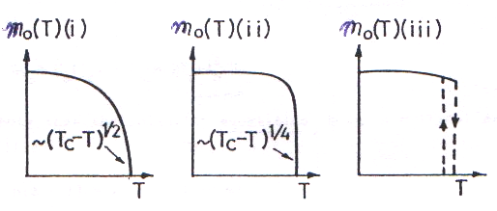
Figure: Temperature dependence of the order parameter in the three cases of (i) ordinary critical point, (ii) tricritical point, (iii) discontinuous (first order) phase transition.

(iii) Discontinuous Point

(3)
Eq. 3 has a real solution only for and this is possible only for , such that:
Therefore goes over from
To
in a discontinuous manner. That is the discontinuity or first order phase transition occurs at a given temperature.
We conclude that the sign of is very important in determining the character (continuous or discontinuous) of the phase transition. The mean field critical exponents are summarized in the following table.
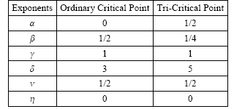

H.W. do CASE 2 for nonvanishing field

LANDAU THEORY OF SECOND ORDER PHASE TRANSITION

By introducing the order parameter , to distinguish the phase of the system, the Gibbs free energy G is now a function of three parameters, G = G(P, T, η). The variables P and T can be specified arbitrarily but the variable must be determined from the condition that for a given P and T, G must be minimum in thermal equilibrium. Since the free energy of the system in equilibrium is uniquely determined by P and T, this order parameter must be a function of them, .
The theory based in two assumptions:
- The order parameter can be defined such that:
and ,
which is the natural condition for minima of the free energy.
- Based on the fact that at the phase transition . Therefore, close to the phase transition point he assumed that G can be expanded as a power series in ,

Since the change of state is continuous in second order phase transition, takes arbitrarily small values near the transition point. In the neighborhood of the transition point, we expand G (P, T, ) in powers of
the coefficients , A, D, B, ... are functions of P and T.
The expansion of the type given by Eq. (9.12) does not take into account that the transition point is a singularity of free energy. The first assumption, ∂G/∂η = 0, can only be satisfied for all if α = 0. In other words, since the states of and are of different symmetry, the first order term in the expansion is zero, i.e..

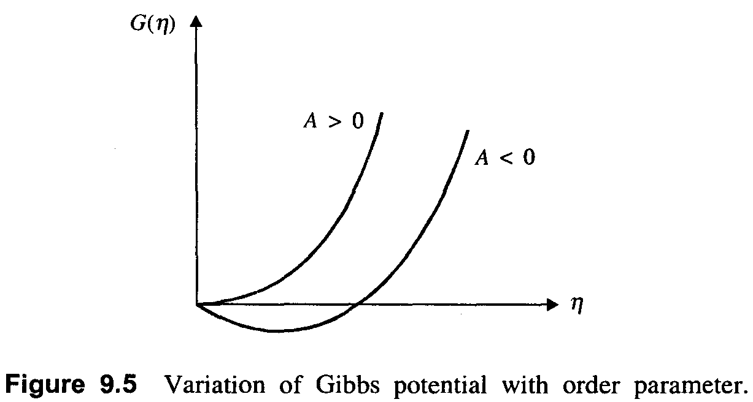
At the transition point, in the phase with more symmetry, should correspond to a minimum of G, hence . Looking from the other side of the transition, i.e., the phase with less symmetry, the non-zero values of correspond to the stable state, i.e. G is minimum. This is possible only if . Hence A is positive on one side of the transition point and negative on the other side; it must vanish at the transition point itself. A plot of G() is shown for and in Fig. 9.5.

At the transition point, which is a stable state, G as a function of , is a minimum at . Hence necessarily we have at transition point
The coefficient of the third term is identically zero due to the symmetry of the body. However, if is not identically zero, continuous phase transitions can occur only at isolated points and in such cases Landau has shown that the expansion of G contains no odd order terms, and hence we take . The expansion of G then has the form
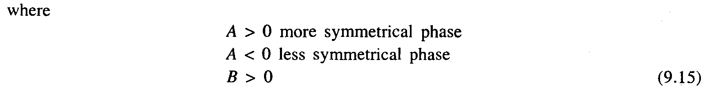
and the transition points are determined by the condition .

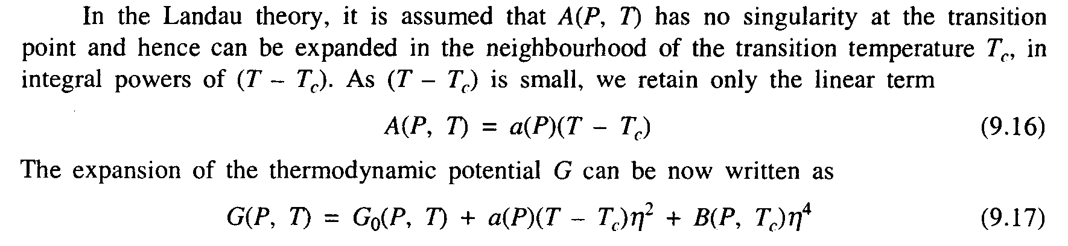
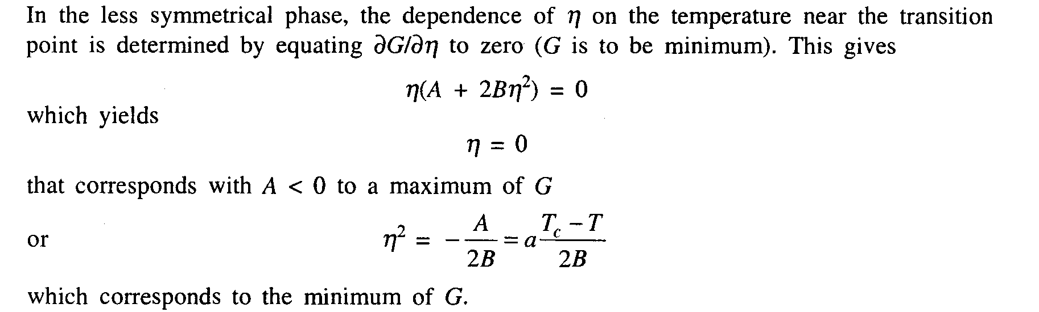
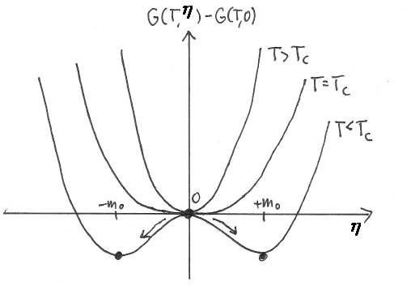
Figure: Shapes of the free energy versus order parameter in Landau theory (scenario for a continuous phase transition): above Tc, there is one global minimum at . Positive prefactors of the higher powers of ensure stability, i.e. prevent a minimum of the free energy at some unphysical diverging value of . At Tc, the free energy becomes flat at , i.e. the derivative develops three zeros. Two of the extrema separate away at T < Tc and are minima due to symmetry and the stability requirement. Their positions give the new values of the order parameter .

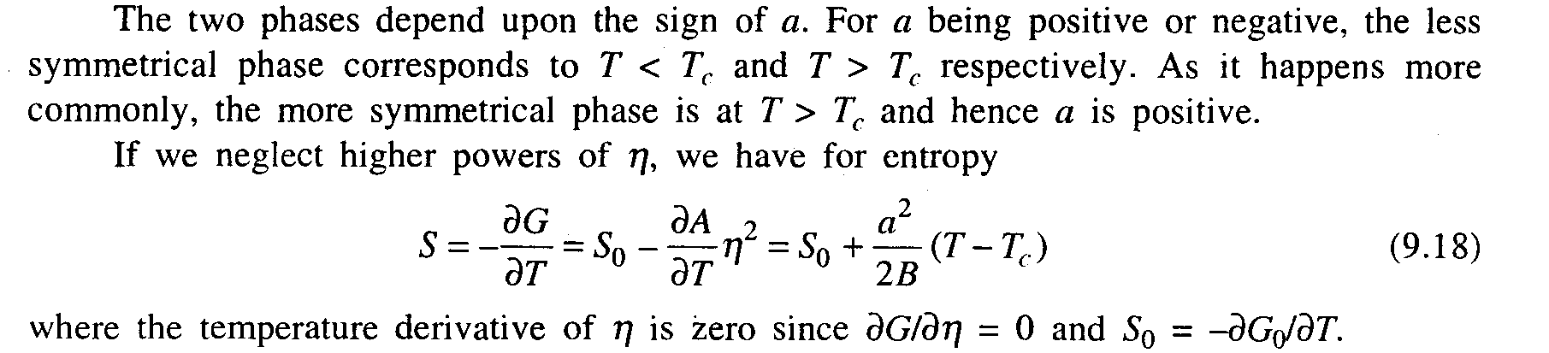
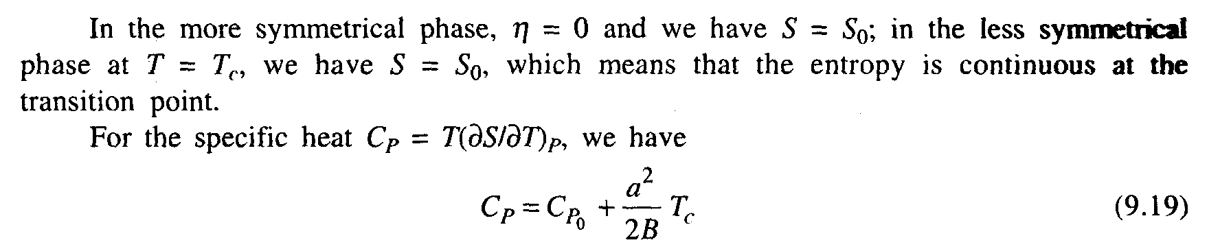
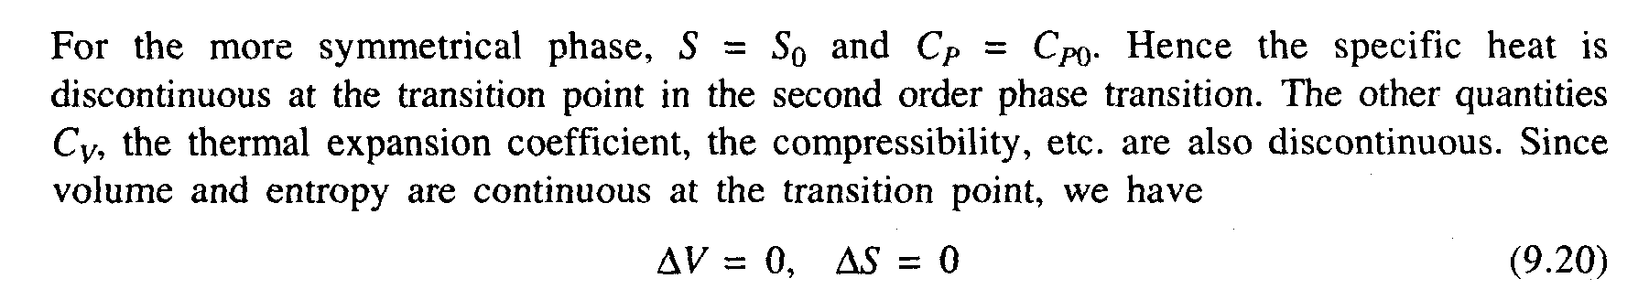
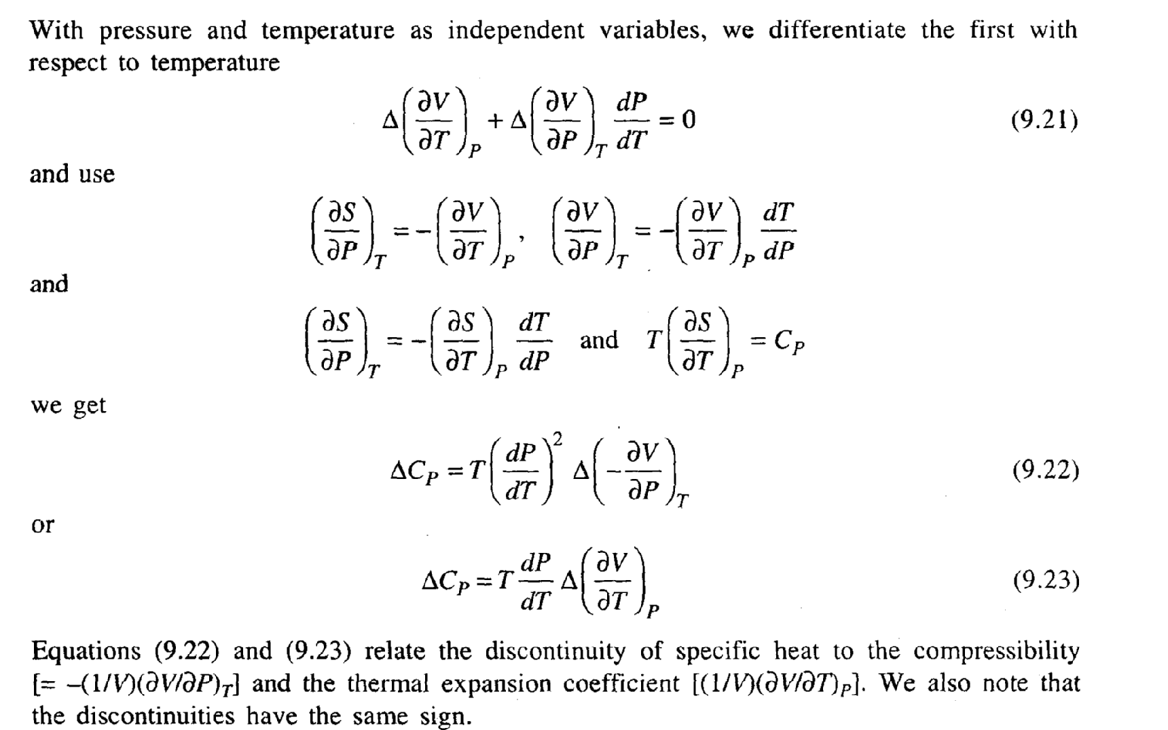
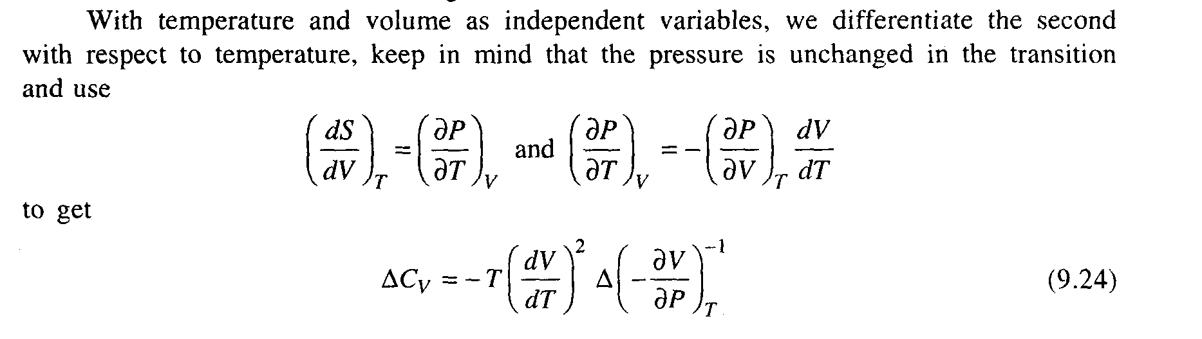
We observe that the compressibility decreases discontinuously in going from less symmetrical to more symmetrical phase.
The transition between phases of different symmetry (different crystal modifications) does not occur in a continuous manner. The body has one symmetry or the other in every state and hence can be assigned to one phase or the other. The transition between different crystal modifications is brought about by phase transition in which there is an abrupt rearrangement of the crystal lattice. We take the example of BaTiO₃, which has cubic lattice at high temperatures. As the temperature is lowered below a certain value, the titanium and oxygen atoms begin to move relative to the barium atoms affecting the symmetry of the lattice and it becomes tetragonal in place of cubic. The change in symmetry also may occur due to a change in the ordering of the crystal. Increase of symmetry means disordered (less ordered) state. For example, a completely ordered alloy of CuZn (brass) has a simple cubic Braves lattice with zinc atoms at the vertices and copper atoms at the centers of the cubic cells, the probabilities of these sites for occupancy by either type of atom is not equivalent. When the alloy becomes disordered, the probabilities of finding an atom of one kind or the other becomes equal at all the sites and the symmetry is raised. Both of these are phase transitions of the second kind. This kind of transition may bring about the change in son other property of symmetry, as is the case in the ferromagnetic substances at Curie point. In this case, the symmetry of the arrangement of elementary magnetic moments in the body is changed. The other examples of the second order phase transition are of liquid helium to super-fluid state and that of metal to superconducting state. In both these cases, the body acquires a new property at the transition point.

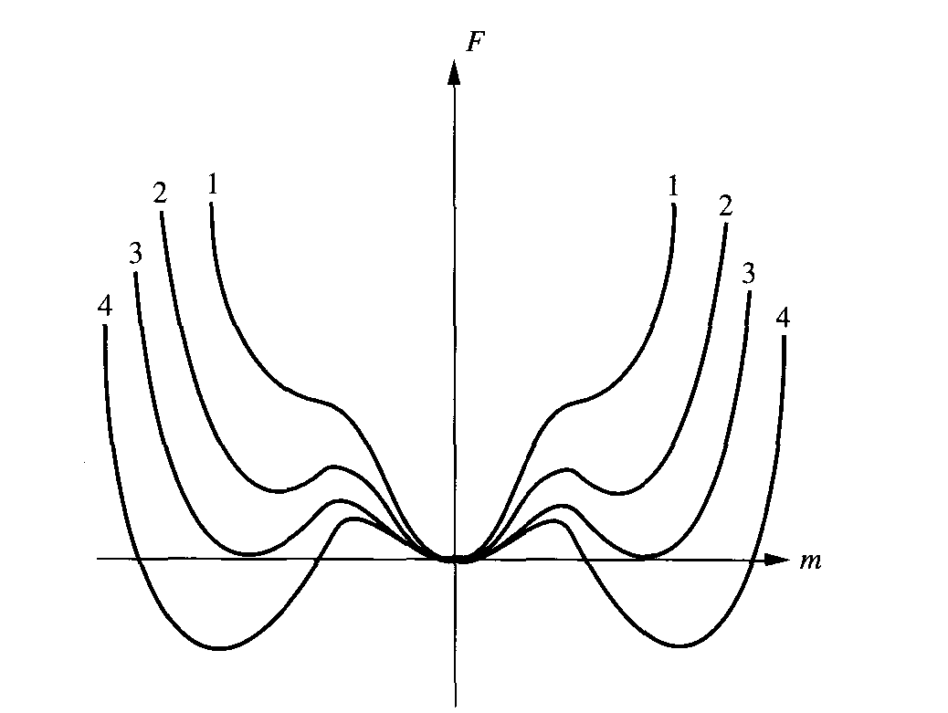

The different behaviors of the function are as follows:

1-

3- Ordinary Critical Point, , .

