Overview of phase transition and critical phenomena

Aims: Phase transitions are defined, and the concepts of order parameter and spontaneously broken symmetry are discussed. Simple models for magnetic phase transitions are introduced, together with some experimental examples. Critical exponents and the notion of universality are defined, and the consequences of the scaling assumptions are derived.

Different phases of matter, e.g. solid, liquid and gasses can be distinguished by observing various physical quantities. In standard, thermal phase transitions, these are thermodynamic quantities such as the volume, pressure, magnetization, dielectric polarization, superfluid density. Some of these quantities are familiar to everyone, and the corresponding phases can be easily distinguished just by taking a look at them. And phase transitions between these phases are familiar from everyday life!
Consider the phase diagram of a typical substance:
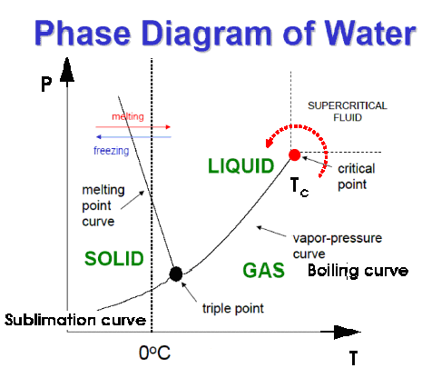
Fig. 1. Liquid-gas critical Point: Critical Opalescence
It is interesting to note that the density jump at the liquid-gas transition decreases at higher pressures and temperatures. The first-order line ends at the liquid-gas critical point. The approach to this point is a second-order phase transition. In its vicinity, the fluid cannot seem to “decide” what to become: a liquid or a gas. Large density fluctuations emerge leading to a “milky” appearance of the fluid: the critical opalescence. It is important to note that one can smoothly go from a liquid to a gas by traveling “around” the critical point (see figure 1). At higher temperature and pressure, there is no distinction between the liquid and the gas: this is the supercritical fluid. The fluid is very compressible in this region.

In Summary: Phase transitions are defined as points in the parameter space where the thermodynamic potential becomes non-analytic. Such a non-analyticity can arise only in the thermodynamic limit, when the size of the system is assumed to be infinite, i.e.,. In a finite system the partition function of any system is a finite sum of analytic functions of its parameters, and is therefore always analytic. A sharp phase transition is thus a mathematical idealization; albeit one that describes the reality extremely well. Macroscopic systems typically contain 10²³ degrees of freedom, and as such are very close to being in the thermodynamic limit. The phase boundaries in Fig. 1, for example, for this reason represent reproducible physical quantities. Simple A phase transition is a thermodynamically reversible cross-over between two different phases or states of matter as function of an external control parameter such as temperature, pressure, magnetic field, stress etc. In general, it is associated with a change of order which is viewed as symmetry breaking (All will be defined in the next discussion).

Phase: A portion of the system under consideration that is sub-macroscopically homogeneous and is separated from other such portions by definite physical boundary.

Coexistence lines: The boundary lines between phases.

Phase Transition (PT):- Transition between two equilibrium phases of matter whose signature is a singularity or discontinuity in some observable quantity.

Classification of the Phase Transition:

- first-order PT: Discontinuous change of order parameter.
Crossing a coexistence line (e.g. melting, vaporization, sublimation) leads to a first order phase transition, which is characterized by a discontinuous change in some thermodynamic quantity such as volume, enthalpy, and magnetization. Generally is defined to be those that involve a non-zero latent heat. For example at fixed pressure and temperature one can find the volume and entropy are changed.

- Second-order PT (continuous PT ): order parameter grows continuously

Notice that, while the melting curve, in principle, can be extended to infinity, the gas-liquid/boiling curve terminates at a point, beyond which the two phases cannot be distinguished. This point is called a critical point and beyond the critical point, the system is in a supercritical fluid state. The temperature at which this point occurs is called the critical temperature . At a critical point, thermodynamic quantities such as given above remain continuous (for example ), but derivatives of these functions may diverge .
First derivatives of thermodynamic potentials are continuous. Close to a critical point (i.e. to a second-order transition) one observe quantities obeying power laws with exponents that are not integers. All, the pressure, temperature, volume and entropy are fixed. (e.g. Ferromagnetic materials at Curie’s point, superconductor materials, etc.)
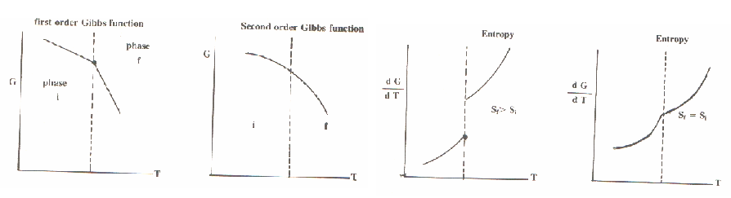
Note: Not all the quantities must change continuously near a critical point; in rare instances some may actually be discontinuous, like the superfluid density at the Kosterlitz-Thouless transition. Also, there are a few examples of a weak first-order transition preempting a critical point, as in the type-I superconductors, which is also be considered as critical phenomena.
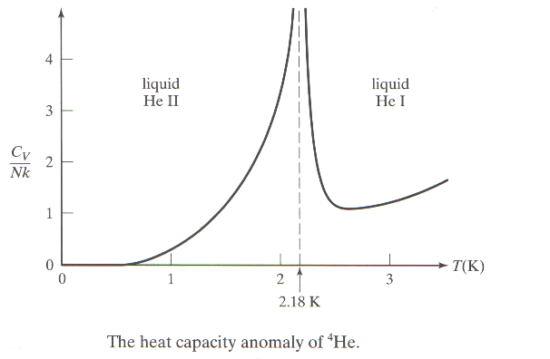
Properties of the Phase Transition

- Power-Law:- The critical phenomena (CP), exhibit scaling, i.e. two measurable quantities depend upon each other in a power-law fashion, with critical exponent. It was believed that: the power law or exponent is rational fraction , after deduce from dimensional consideration, but this is not usually the case in (CP). The critical exponents describe the nature of the singularities in various measurable quantities at the critical point. Denote the critical temperature by and introduce the quantity and as and one finds:

The last two equations have been derived from the correlation function as . As and one finds

We suppose that, in the limit of , any thermodynamic quantity can decompose into a ''regular'' part, which remains finite (but not necessary continuous), plus a ''singular'' part that may be divergent, or have divergent derivatives. The singular part is assumed to be proportional to some power of t, generally fractional.

Only two of the six critical exponents defined before are independent, because of the following '' scaling laws'':
where d is the dimensionality of space.

- Symmetry breaking: Above the critical temperature (), where there is no magnetization (paramagnetic phase), i.e., the system is rotationally invariant (isotropic). Below the critical temperature, when spontaneous magnetization occurs (ferromagnetic phase), i.e., the magnetization vector defines a preferred direction in space, destroying the rotational invariance. (This is not the case in liquid-gas phase transitions only a huge change in volume).
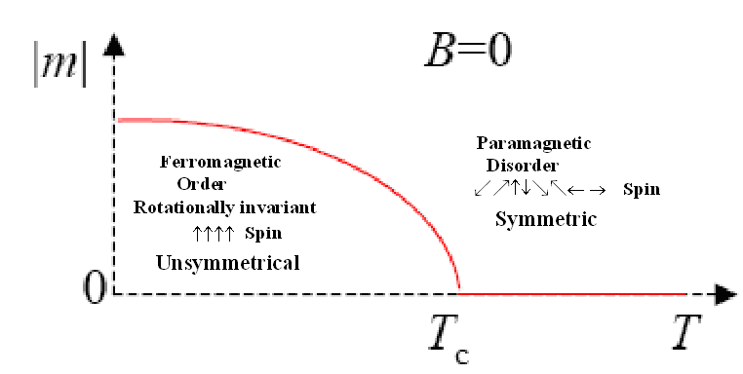
Spontaneous magnetization as a function of temperature and B = 0.

- Order Parameter: Since symmetry is either present or absent, the two phases must described by different function of thermodynamic variable (order parameter), which can not be continued analytically across the critical point. The order parameter is usually an extensive thermodynamic variable (i.e. depend on the amount of substance present (mass). Examples include the volume, internal energy, enthalpy, entropy, and heat capacity) accessible to measurements. The choice of the order parameter is a phenomenological matter and is not always obvious.

Table 1.1 Examples of phase transitions and the corresponding order-parameters.
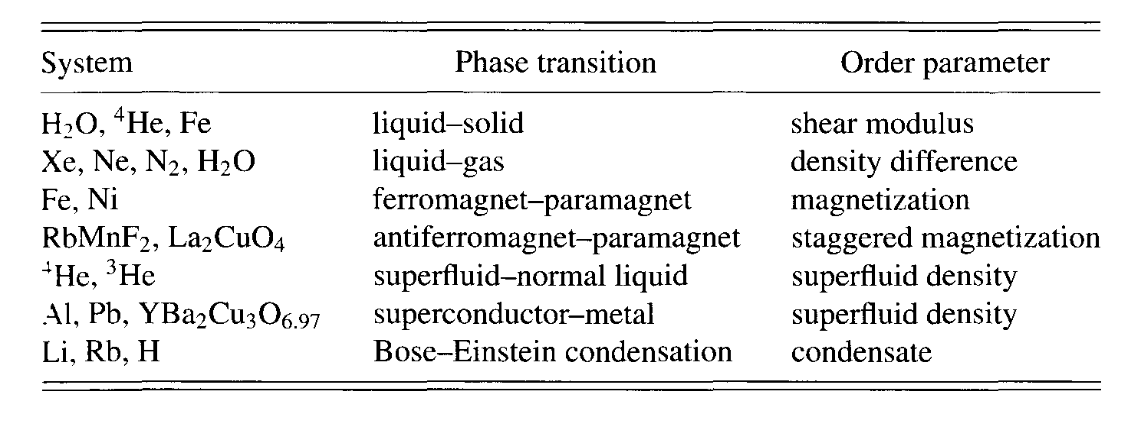
- Scale Invariance: Intuitively speaking, scale invariance means that if part of a system is magnified until it is as large as the original system; one would not be able to tell the difference between the magnified part and the original system (see Fig). At critical point, the correlation length is infinite and that the critical system is invariant on all length scale. The essential ingredient in critical behavior is the divergence of the correlation length at the critical point. The correlation length can be though of as the distance over which fluctuations in the order parameters are correlated, and it sets a natural scale in the system. At the critical point the correlation length is infinite and fluctuations in the order parameter are strong on all length scales.

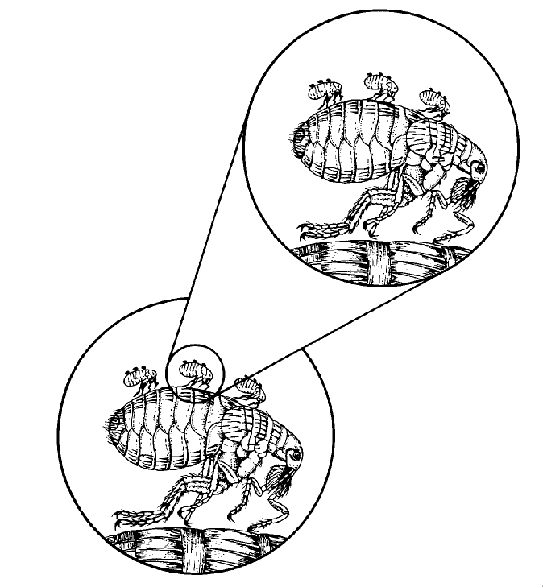
Scale invariance.
Great fleas have lesser fleas
Upon their backs to bite ‘em.
And lesser fleas have lesser still
And so ad infinitum
Johnathan Swift

- Universality: experiments have shown, widely different systems, with critical temperature differing by orders of magnitudes and different order parameter, approximately share the same critical exponents. Generally speaking, the properties depend only on very general features (like the spatial dimension d, the dimension, n, of the order parameter, and the symmetries of the local coupling and order parameter), but not on the details of the interactions. Systems belonging to the same universality class will exhibit the same behavior about their critical points, as manifested by their having the same set of critical exponents.

- Critical Dimension: The upper critical dimension is the spatial dimension, d_{c}, below which fluctuations become dominant and mean-field theory breaks down. The lower critical dimension is that below which the fluctuations become so large that no transition occurs.

The primary critical exponents.

1. The heat capacity at constant volume defined by
diverges with temperature as the critical temperature is approached according to
2. The isothermal compressibility defined by
diverges with temperature as the critical temperature is approached according to
.
The isothermal compressibility conjugate to the order parameter (density ) diverges at the critical point
.
Similar behavior is found also for the specific heat

3. On the critical isotherm, the shape of the curve near the inflection point at is given by
4. The shape of the coexistence curve in the -T plane near the critical point for is given by

These are the primary critical exponents.

