**KING FAHD UNIVERSITY OF PETROLEUM AND MINERALS**



**DEPARTMENT OF PHYSICS**

**PHYS-503: GRADUATE LABORATORY (TERM 152)**

**CHLORINE CONCENTRATION MEASUREMENT IN SALINE SAMPLE USING A CeBr3 BASED PROMPT GAMMA NEUTRON ACTIVATION ANALYSIS SET-UP**

**Supervisor: Prof. A.A Naqvi**

**By**

**YAKUBU SANI WUDIL**

**g201409180**

**March 28th, 2016**

**Abstract**

The chlorine concentration in saline sample was measured for 517 keV chlorine Prompt Gamma rays using a portable neutron generator based Prompt Gamma Activation Analysis (PGNAA) system. The gamma rays were measured from water samples containing 2.0, 4.0, 6.0 and 8.0 wt% chlorine. From the difference between the chlorine sample spectrum and the detector’s background spectrum, the difference spectra were generated. A linear regression was fitted between chlorine peak integrated yield and the corresponding chlorine concentration in water sample to extract concentration calibration curve.

**Table of Contents**

Abstract .......................................................................................................................................... 2

1. Introduction .............................................................................................................................. 4

1.1 Prompt Gamma Neutron Activation Analysis (PGNAA) Principle......................................... 4

2. Objectives of the study .............................................................................................................6

3. Experimental setup ...................................................................................................................6

3.1 CeBr3 Detector Intrinsic spectrum ..........................................................................................7

3.2 CeBr3 Activation spectrum .....................................................................................................10

3.3 Prompt Gamma ray measurement of chlorine from saline sample…..................................... 11

4. Results and Discussion ...........................................................................................................13

5. Conclusion .............................................................................................................................15

6. Acknowledgements ................................................................................................................15

References ……............................................................................................................................16

**1. Introduction**

The Prompt Gamma Neutron Activation Analysis (PGNAA) technique is a novel technique for elemental analysis of a sample and various concentrations of the constituent elements [1]. It is used to characterize bulk samples with mass ranging from micrograms to kilograms. The basic application of PGNAA is in nondestructive elemental analysis of matter. It is essential to know what the composition of a sample is. Such situations often arise in testing samples for toxic contaminants in food, soil or even bricks [2]. PGNAA is a swift and efficient technique in such situations. Nonetheless, the technique is exceptional for medical, environmental and industrial applications. The detection capacity of the PGNAA setup depends upon many factors including but not limited to the energy resolution and efficiency of the detector [3]. The significant impact of chlorine both to human health and to the immediate environment is the motivation behind this study.

In this regard, a neutron generator based PGNAA was employed to test the performance of the CeBr3 detector in measuring the chlorine concentration in the saline sample and later to obtain the concentration calibration curve for the chlorine using its 517 keV gamma rays. The detail of the work comes in the report.

**1.1 Prompt Gamma Neutron Activation Analysis (PGNAA) Principle**

The basic principle is demonstrated in Fig.1. The sample is bombarded with an incident neutron beam. The constituent elements absorb these neutrons to form a short lived excited metastable nuclide which instantaneously decays to the ground state through the emission of gamma rays. The rays are measured using a detector known as gamma ray spectrometer which gives spectral graph output. The remaining is the ground state radioactive nucleus which decays over its characteristic half life by beta and delayed gamma emission creating a stable daughter nucleus [4].



**Figure 1: PGNAA and NAA decay scheme**

It is essential to note the difference between the PGNAA and the NAA. Reference to figure 1, the former studies the prompt gamma ray while the later studies the decay gamma ray [5]. This hints some advantages of the PGNAA over the NAA in that the former is non destructive. Also, the recording time for PGNAA is shorter than the NAA [2].

Within PGNAA set-up, the neutrons are produced by a neutron generator that uses nuclear fusion of two deuterium atoms as:

D + D → n + 3He En = 2.5 meV

where by accelerating a deuteron to a few hundred keV of energy and hitting onto a deuterium target, fusion of deuterium atoms (D + D) results in the above reaction with the production of a neutron with a kinetic energy of approximately 2.5 meV.

Worthy to note is that, these neutrons are fast neutrons with low capture cross-section so a polyethylene moderator (having high density of atomic hydrogen) slows them down until they become slow-moving thermal neutrons which have very high capture cross section. Hydrogen has almost the same mass as neutrons so linear momentum conservation ensures maximum energy loss from and slowing down of the neutrons, and thus high thermal neutron generation rate [6].

**2. Objectives of the Experiment**

The objective of this work is to measure chlorine concentration in the saline sample using 517 keV chlorine gamma ray through the use of portable neutron generator based PGNAA setup. A cylindrical 76mm x 76mm (diameter x height) CeBr3 detector will be used to detect 517 keV gamma ray.

**3. Experimental Setup Details**

The prompt gamma ray yields emitted from saline sample was measured using Portable Neutron generator based PGNAA setup available at the nuclear research laboratory of KFUPM [3]. The setup consist a cylindrical hole made of a high density polyethylene moderator which houses the specimen under study. The diameter of the sample cylinder therefore depends on the size of the cylindrical hole of the moderator [1]. The neutron generator modeled MP320 radiates a stream of 2.5 meV neutrons through D+D fusion reaction. A (70keV, 70 μA) deuteron beam is irradiated against a stationary deuterium target to carry out the fusion. At 2.5 MeV, the neutrons are fast neutrons, with small neutron capture cross-section. These fast neutrons from the generator are slowed down by polyethylene (high atomic hydrogen density) moderator to yield thermal neutrons, which have large neutron capture cross-section. A cylindrical cavity of diameter 106 mm has been drilled through the moderator so that a cylindrical sample can be tested by PGNAA. Unwanted neutrons and stray gamma-rays is obstructed from entering the detector using 3 mm thick lead shielding and 50 mm thick paraffin shielding. The detector is high-sensitivity CeBr3 gamma-ray spectrometer supplied by Scionix Holland BV. Fig. represents the PGNAA setup attached with the moderator and the neutron generator.



**Figure 2: The schematic diagram of the PGNAA experimental setup used in the study**

The chlorine contaminated water sample was prepared using four bottles of standard chlorine solution present in our laboratory. The samples were prepared at varying concentrations of 2.0, 4.0, 6.0 and 8.0 wt% conc. The bottles of 106 mm x 125 mm size (diameter x height) were then dried with tissue paper to avoid contamination.

**3.1 CeBr3 Detector Intrinsic spectrum:**

The detector contains naturally radioactive isotopes which emit gamma rays on their own; these rays form the intrinsic spectrum. For the purpose of measuring the intrinsic gamma yield, the neutron beam was switched off and the gamma yield was recorded in the absence of any specimen inside the sample surface. Hence, the detector only detected the presence of naturally-occurring radioisotopes present in the detector. The run time was approximately 1500s.

The intrinsic spectrum for the CeBr3 detector with the (coarse gain 20 and fine gain 8.0) in the low energy range is shown in Fig. 3. In general, it shows an exponentially-decreasing intensity profile modulated with impurity radioisotope peaks, which is in agreement with theoretical predictions since there is generally less random background radiation at higher energies than lower energies. However, this smoothly-decaying profile is interrupted by prominent intrinsic peaks that correspond to the decay energies of various natural radioisotopes present in the detector. From the literature [7], we learn that Ce and Br elements do not present any naturally occurring radioisotopes, and the reason for intrinsic activity is the 227Ac radioactive impurities present in the raw materials used for the detector. They attribute this contamination to the homologous nature of Ac and Ce, which makes it extremely difficult to separate them from one another, hence the cerium would be contaminated with trace amounts of actinium.

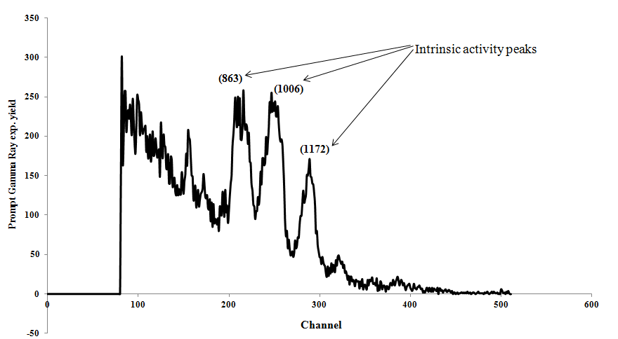

**Fig 3: Full CeBr3 Intrinsic Activity Spectrum for LE and initial amplification settings**

In Figure 4 we have shown the full spectrum of bismuth with its characteristic peak for calibration purpose.

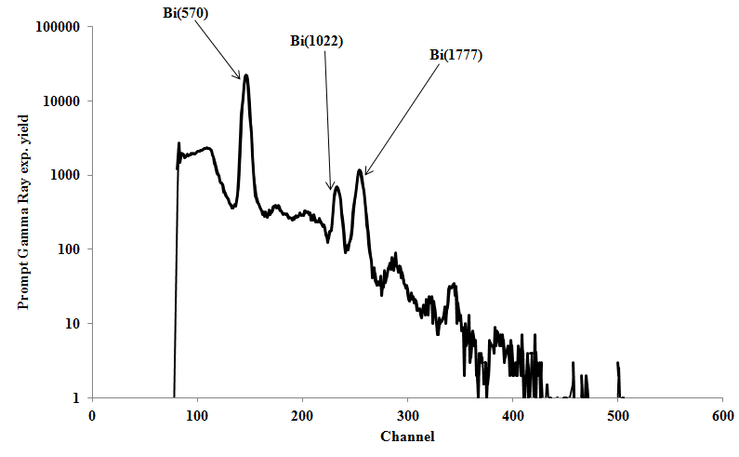

**Fig. 4: Full spectrum of Bismuth taken with the CeBr3 detector**

We later adjusted the coarse and fine gains to 100 and 9.0 respectively and shifted to very low energy range setting (VLE) to record the intrinsic characteristic for the detector and also the Bismuth spectrum as displayed in Fig. 5 and Fig. 6.

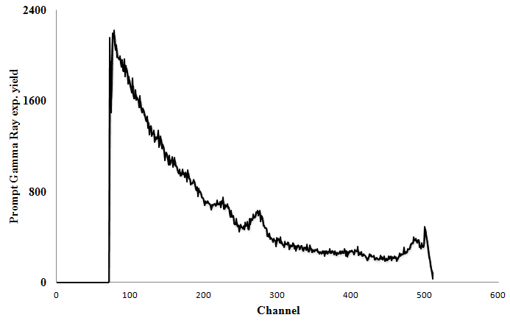

**Fig 5: CeBr3 Intrinsic Activity Spectrum for VLE setting**

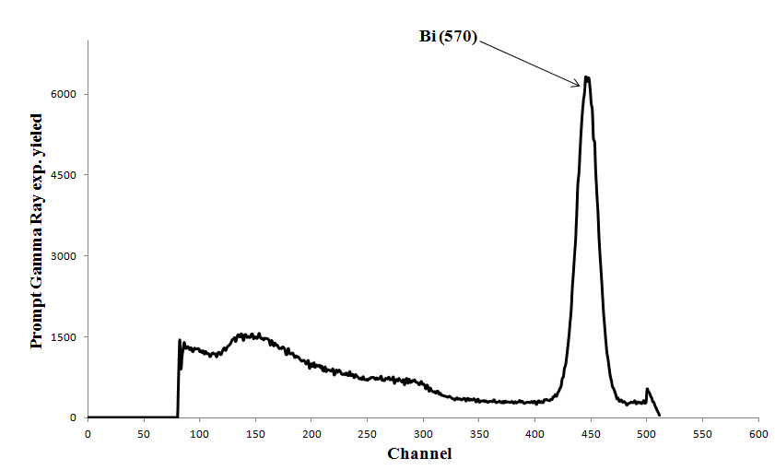

**Fig 6: Bismuth spectrum taken with the CeBr3 detector for VLE setting**

**3.2 CeBr3 Activation Spectrum**

In the PGNAA set-up, the detector also gets exposed to the applied neutron beam which stimulates the production of gamma rays. When the chlorine-contaminated water sample is exposed to the neutron beam, the detector emits its own prompt gamma rays due to thermal neutron capture of the detector material. The thermal gamma rays from the detector material is known as activation spectrum.

To measure the activation spectrum of the CeBr3 detector, the neutron generator was operated at (70 keV, 70 μA), and no sample was placed in the cavity. Again, a run time of approximately 3000s was spent. In this instance, the detector and hydrogen in the moderator get activated and emit prompt gamma rays which is displayed on the PC. This gives the detector activation spectrum, which includes the intrinsic spectrum and is basically the total background spectrum. The activation spectrum of our CeBr3 detector is shown in Figure 6. This spectrum was taken with higher amplifier gain settings (coarse gain = 100, fine gain = 9) to amplify the region of 0 – 600 keV energy gamma rays. It shows capture gamma ray peaks of Br (196), Br (271), Br (367), and Br (512) from bromine and Ce (476) from cerium [8]. The emission from activated hydrogen is in the high-energy range, hence not visible in the low-energy gamma rays we used.

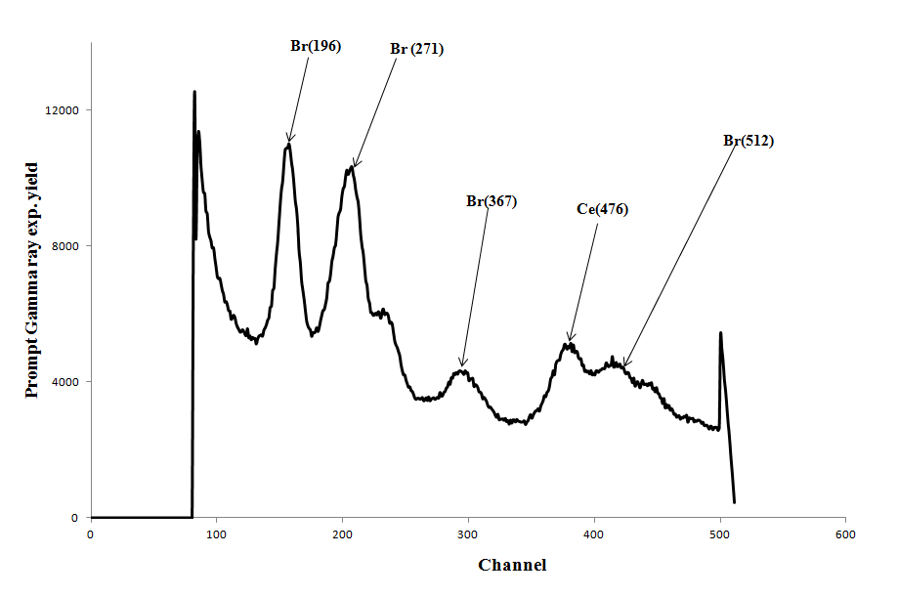

**Fig.7: Prompt gamma-ray spectrum due to activation of the CeBr3 detector**

**3.3 Prompt Gamma ray measurement of chlorine from saline sample**

To measure the sample spectrum of the chlorine contaminated water sample, the sample was inserted into the moderator cavity. The neutron beam was switched ON. The prompt gamma ray data from chlorine containing saline sample were recorded through multi channel buffer acquisition system. For the four chlorine samples of 2.0, 4.0, 6.0 and 8.0% concentrations each was exposed to the thermal neutron beam for more than an hour each.

Sample spectrum was superimposed upon background spectrum to show the effect of chlorine contamination in water sample. The difference between the detector background spectrum and the sample spectrum gives the chlorine peak spectrum, whose area is proportional to the concentration of the chlorine-containing water. Performing linear regression of chlorine concentration against net chlorine counts under the peak gives a straight line which depicts proportional relationship between the 2 variables that can be exploited for elemental composition analysis.

Figure 7 shows the background activation spectrum (solid line) superimposed on chlorine sample spectrum (dotted line). The effect of the chlorine is visible.

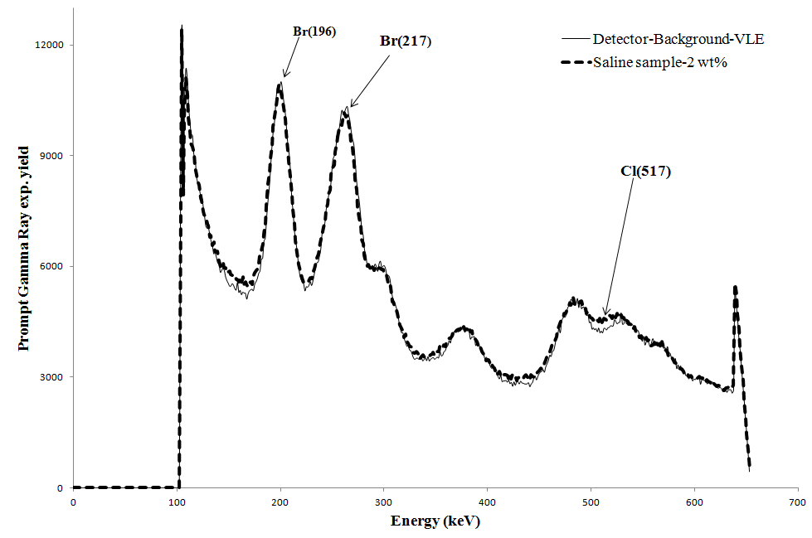

**Fig.8: CeBr3 detector background spectrum (solid line) and chlorine spectrum (dotted line)**

Subsequently, the four chlorine contaminated samples (2, 4, 6 and 8 wt.%) gamma ray spectra were recorded in the multichannel buffer based data acquisition system and superimposed on the background as depicted in figure 8.

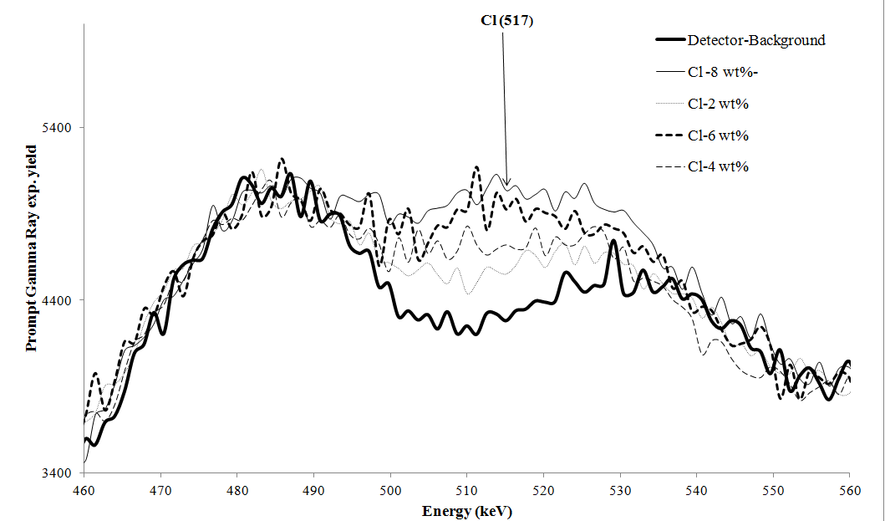

**Fig. 9: Sample spectra for 4 chlorine samples superimposed upon each other with the background**

**4. Results and Discussion**

To analyze the difference spectra, the detector background spectrum was subtracted from the sample spectrum. From the difference between the sample spectra and the background spectrum, the difference spectra were generated as shown in Figure 10.

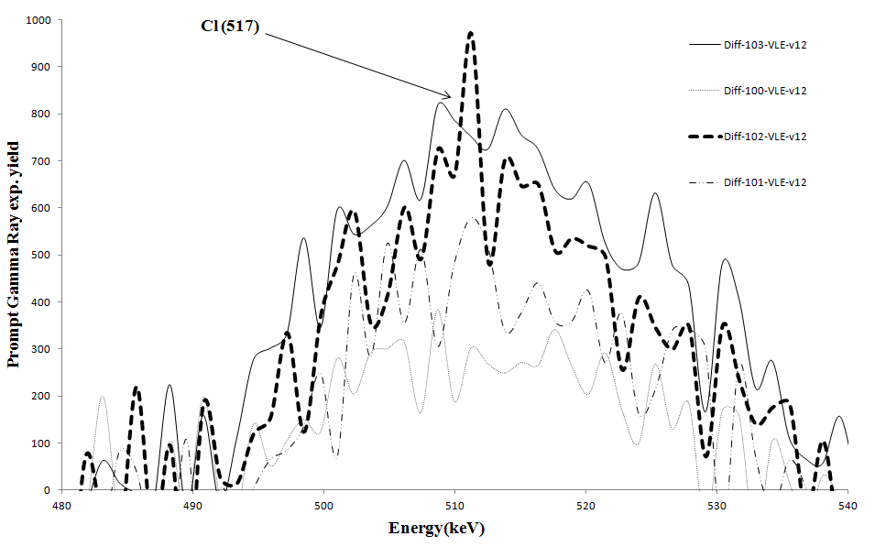

**Fig.10: Chlorine prompt gamma-ray difference spectra for four samples**

The area under these 4 difference spectra gives the integrated yield which is theoretically proportional to the chlorine concentration of the water samples. We next plot the integrated yield against chlorine concentration in Figure 11.

The least-squares regression line of integrated yield against chlorine concentration is illustrated in Figure 10 with a regression equation of y = 1811.2x + 2319.3 and a correlation coefficient of R = 0.9956.

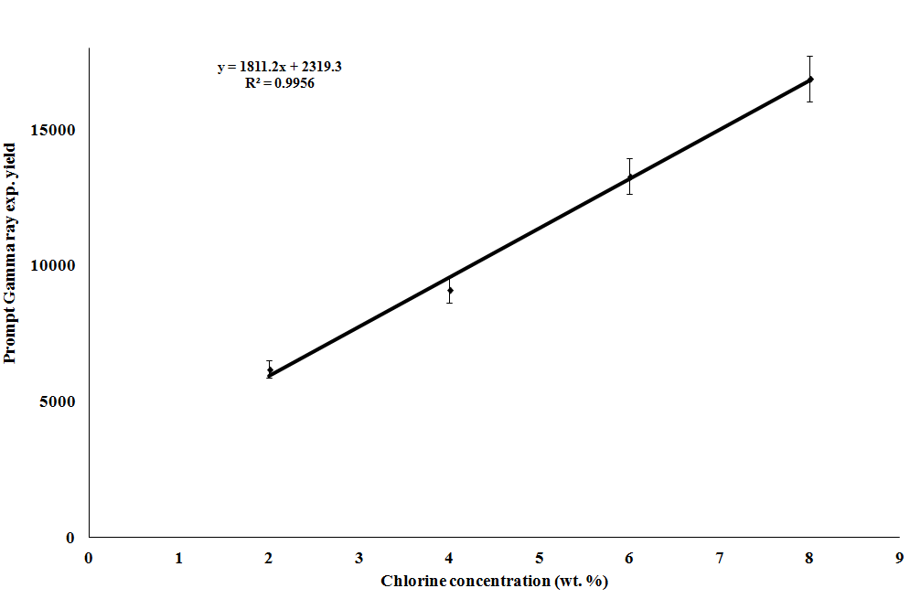

**Figure 11: Plot of gamma-ray intensity vs chlorine wt% concentration**

To discuss the application of the data obtained, one sees that the best fit line is basically the concentration calibration curve for chlorine. Having obtained this, we can systematically determine the concentration of the dissolved chlorine in unknown sample knowing the integrated yield of the difference spectrum. For instance, the world health organization (WHO) may require that polluted water to be tested for compliance to environmental legislation to ensure that its chlorine concentration does not exceed safety limits. We can simply test the unknown sample for its unknown chlorine concentration: Cl (wt%) = (𝑌−2319)/1811. where 𝑌 is the integrated yield of Cl peak from chlorine sample. Similar graphs and equations can be built up for other known pollutants and thus the techniques we have learnt in this experiment can be utilized as a strategic asset to minimize pollutant levels and optimize public health and safety.

Thorough analysis of Figure 10 depicts that the data points display a good scatter about the best-fit line, as evidenced by the points being close to the best fit regression line. This is an indication that only random errors (which are uncontrollable and cannot be totally eliminated) are affecting the data.

Moreover, the best-fit line clearly passes through the error bars, implying the data acquired is accurate to within the limits of experimental uncertainty. It is certainly impossible to obtain data of infinite precision, so the next best alternative is to obtain data that is as accurate as possible within the limits imposed by experimental uncertainties. Having the best fit line pass close to the error bars is an indication that this has been achieved.

**5. Conclusion**

In this experiment, we have measured the chlorine concentration in saline sample for 517 keV chlorine gamma rays using a portable neutron generator based PGNAA technique in accordance with the principle that the integrated prompt-gamma yield is proportional to the concentration of the sample tested. The chlorine concentration was varied over 2.0, 4.0, 6.0 and 8.0 wt% in water samples. The element chlorine was chosen for testing due to its environmental and industrial significance. Lastly, the technique used in this paper can be exploited for elemental characterization of unknown samples, which is useful in environmental pollutants and illegal materials testing, thereby demonstrating that this technique can have positive impacts to humanity.

**6. Acknowledgements**

My inestimable appreciation goes to my supervisor, Professor A.A Naqvi for sparing his precious time to guide me through the whole process and for his encouragement in the course of doing the work. A packet of gratitude must be extended to Liadi Fatai Ayofe, the tutor whose contribution cannot be overemphasized. The contribution of both the staff and Graduate students in physics department, King Fahd University of Petroleum and Minerals, Saudi Arabia, in various capacities towards my success in the work is worth recognizing.

**References**

[1] Naqvi, A. A., et al. "Detection efficiency of low levels of boron and cadmium with a LaBr 3: Ce scintillation detector." Nuclear Instruments and Methods in Physics Research Section A: Accelerators, Spectrometers, Detectors and Associated Equipment 665 (2011): 74-79.

[2] James, W., et al. "Application of prompt gamma activation analysis and neutron activation analysis to the use of samarium as an intestinal marker."Journal of Radioanalytical and Nuclear Chemistry 83.2 (1984): 209-214.

[3] Naqvi, A. A., et al. "Pulse height tests of a large diameter fast LaBr3:Ce scintillation detector." Applied Radiation and Isotopes 104 (2015): 224-231.

[4] Anderson, D. L., Belgya, T., Firestone, R. B., Kasztovsky, Z., Molnàr, G. L., Révay, Z., & Yonezawa, C. (2004). Handbook of Prompt Gamma Activation Analysis.

[5] A. M. Pollard et al. (2007). NEUTRON ACTIVATION ANALYSIS. In: Analytical Chemistry in Archaeology. pp. 123-136. [Online]. Cambridge Manuals in Archaeology. Cambridge: Cambridge University Press. Available from: Cambridge Books Online [Accessed 11 February 2016].

[6] Knoll, Glenn F. Radiation detection and measurement. John Wiley & Sons, 2010.

[7] Quarati, F. G. A., et al. "Scintillation and detection characteristics of high-sensitivity CeBr3 gamma-ray spectrometers." Nuclear Instruments and Methods in Physics Research Section A: Accelerators, Spectrometers, Detectors and Associated Equipment 729 (2013): 596-604.

[8] Choi, H.D. et al, 2006. Database of Prompt Gamma Rays from Slow Neutron Capture for Elemental Analysis. International Atomic Energy Agency, VIENNA.