Quiz #5 Ch.#12 T121 Phys101.37-39-v1
Student ID:……… …… Student Name:………… …….… Section # ……….
_________________________________________________________
Q1.A uniform horizontal beam of length 6.00 m and mass M = 100 kg is attached to the vertical wall by a rope making an angle θ = 60.0 º with the wall; the beam can rotate about the fixed pivot O as shown in Fig. 1. A mass m = 80.0 kg hangs from P at a distance 4.00 m from O. Find the tension in the rope attached to the wall.
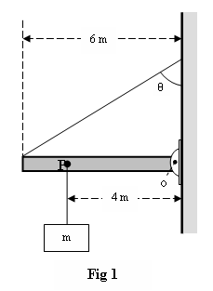

Q2.: A horizontal steel rod of length 81 cm and radius 9.5 mm is fixed at one end. It stretches by 0.90 mm when a horizontal force of magnitude F is applied to its free end. Find the magnitude of F (Young modulus of steel is 20 × 10¹⁰ N/m²).

Q3 : A 5.0 m long uniform ladder (with mass m = 12.0 kg ) leans against a wall at a point 4.0 m above a horizontal floor as shown in Fig 9. Assuming the wall is frictionless (but the floor is not), determine the normal force exerted on the ladder by the wall.

Quiz #5 Ch.#12 T121 Phys101.37-39-v2

Student ID:……… …… Student Name:………… …….… Section # ……….
_________________________________________________________

Q1:A 5.0-m weightless rod (AC), hinged to a wall at A, is used to support an 800-N block as shown in Fig 5.Find the tension T2 in the string

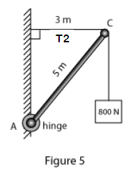

Q2.What increase in pressure is necessary to decrease the volume of a solid aluminum sphere by 0.050 % (Bulk Modulus of Aluminum = 7.00 x 10¹⁰ N/m²)

Q3 A man weighing 720 N stands halfway up a 5.0 m ladder of negligible weight. The base of the ladder is 3.0 m from the wall as shown in Fig. 2. Assume that the wall-ladder contact is frictionless. With what force does the wall push against the ladder?
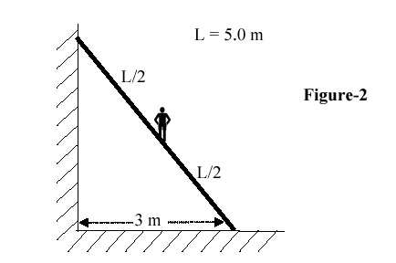
Quiz #5 Ch.#12 T121 Phys101.37-39-v3

Student ID:…………… Student Name:……………….… Section # ……….
_________________________________________________________

Q1: A horizontal uniform beam of weight W = 200 N and length L = 6.0 m is supported by a hinge and a cable as shown in Figure 8. The system is in equilibrium; find the TENSION in the cable.
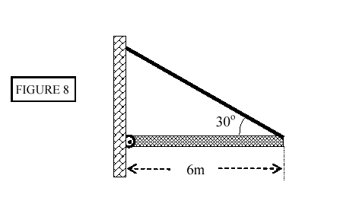

Q2 A steel rod has a radius of 8.5 mm and a length of 100 cm. A force of 6.0 x 10**4 N stretches it along its length. Take Young's modulus for steel as 11 x 10**11 N/m**2. The increase in the length of the rod in mm is:

Q3. A uniform ladder of length L and mass M rests against a smooth, vertical wall. The coefficient of static friction between the ladder and the ground is 0.40. Find the angle θ (in degrees), between the ladder and the ground, at which the ladder is about to slide.

Quiz #5 Ch.#12 T121 Phys101.37-39-v4

Student ID:……… …… Student Name:……… ……….… Section # ……….
_________________________________________________________

Q1. In Fig. 2, PQ is a horizontal uniform beam weighing 155 N. It is supported by a string and a hinge at point P. A 245 N block is hanging from point Q at the end of the beam. Find the tension in the string.

Q2: A horizontal aluminum rod (shear modulus = 2.5*10**10 N/m**2) projects L=5.0 cm from the wall (see Fig 6). The cross sectional area of the rod A =1.0*10**(-5) m**2. A shearing force of 500 N is applied at the end of the rod. Find the vertical deflection delta(x) of the end of the rod.

Q 3: A uniform beam having a mass of 60 kg and a length of 2.8 m is held in place at its lower end by a pin (P). Its upper end leans against a vertical frictionless wall as shown in the Fig. 4. What is the magnitude of the force by the pin on the beam?
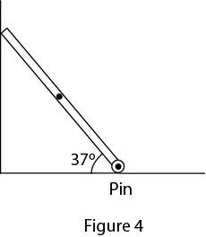
Quiz #5 Ch.#12 T121 Phys101.37-39-v5

Student ID:………… Student Name:………… …….… Section # ……….
_________________________________________________________

Q1 The system in Fig 2 is in equilibrium. A mass (M) of 5.0 kg hangs from the end of the uniform beam of mass = 10.0 kg. The tension in the cable is:

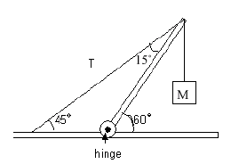

Q#2:A shearing force F = 50 N is applied to an aluminum rod with a length of L =10 m, a cross-sectional area A=1.0 × 10^{–5} m², and a shear modulus G = 2.5 × 10¹⁰ N/m². As a result the rod is sheared through a distance (Δx) of:

Q3: An 800-N man stands half-way up a 5.0-m long ladder of negligible weight. The base of the ladder is 3.0m from the wall as shown in Figure 1. Assuming that the wall-ladder contact is frictionless, then the magnitude of normal force of the wall on the ladder is:
Quiz #5 Ch.#12 T121 Phys101.37-39-v6

Student ID:……… …… Student Name:………… …….… Section # ……….

_________________________________________________________

Q1: A uniform beam of length 6.0 m and mass 150 kg is pivoted to a vertical wall at point O and is suspended horizontally by a rope of negligible mass making an angle θ = 60° with the wall as shown in Figure 2. An unknown mass m is hanged at point P, 4.0 m away from the pivot point O. If the system is in equilibrium as shown with the tension in the rope equal to 2.15 ×10³ N, what is the value of mass m?

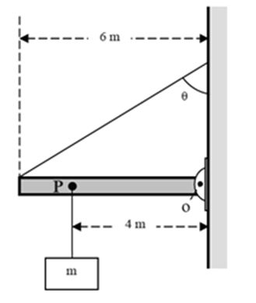

Q2: The volume of a solid Aluminum sphere at the sea level is V = 1.0 m³. This sphere is placed at a depth of about 700 m in the sea where the absolute pressure is P = 7.0 x 10⁶ N/m². The change in the volume ΔV of the sphere is: (the bulk modulus of Aluminum, B = 70 x10⁹ N/m²).

Q3: A uniform ladder of length L and mass M rests against a smooth, vertical wall. The coefficient of static friction between the ladder and the ground is 0.15. Find the angle θ (in degrees), between the ladder and the ground, at which the ladder is about to slide.

