Quiz #3 Ch.#7-8 T121 Phys101.37-39-v1

Student ID:……… …… Student Name:………… …….… Section # ……….
___________________________________________________________
Q#1: A 2.0-kg object moves along the +x-axis with a speed of 5 m/s under the influence of a force F= (3i+4j) N. What is the power delivered by this force? (Ans: 15 W.)
Solution:
V=5i m/s
P=F.v = 3*5=15 W

Q#2.: A 2.2 kg block starts from rest on a rough inclined plane that makes an angle of 30° above the horizontal. The coefficient of kinetic friction is 0.25. As the block moves 3.0 m down the plane, the change in the mechanical energy of the block is: (Ans: –14 J)

Solution
m=2.2 kg; μ_{k}=0.25; d=3.0 m; v_{i}=0.0 m/s
ΔE= ΔK+ΔU_{g} =Wf= -μ_{k}*m*g*cos25*d= -0.25*2.2*9.8*cos30*3=-14.0 J

Q#3: In Fig(1), a block (M = 2.0 kg) slides on a frictionless horizontal surface towards a spring with a spring constant k = 2000 N/m. The speed of the block just before it hits the spring is 6.0 m/s. How fast is the block moving at the instant the spring has been compressed 15 cm? (Ans: 3.7 m/s )
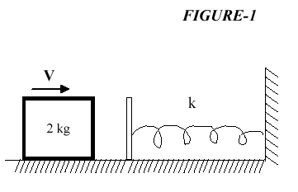

Solution
m=2.0 kg; d= 2.0 m; k=2000 N/m; v_{i}=6.0 m/s; U_{si}=0; x_{f}=15 cm=0.15 m;
ΔK +ΔU_{s} = 0; ΔK = 0.5*m*(v_{f}²-v_{i}²)=-ΔU_{s} =0.5*k*x_{f}*x_{f}
0.5*m*v_{f}²=[0.5*m*v_{i}*vi-0.5*k*x_{f}*x_{f}] ;
v_{f}=√[(0.5*m*v_{i}*vi-0.5*k*x_{f}*x_{f})/0.5*m]=√[(0.5*2*6*6-0.5*2000*0.15*0.15)/0.5*2]=
v_{f}=√(36-22.5)=3.67 m/s
Quiz #3 Ch.#7-8 T121 Phys101.37-39-v2

Student ID:……… …… Student Name:………… …….… Section # ……….
______________________________________________________________
Q#1,v2: Q#2 A force F = (3.00 i +7.00 j) N acts on a 2.00 kg object that moves from an initial position r1=(3.00i - 2.00j) m to a final position r2 = (5.00 i + 4.00 j) m in 4.00 s . What is the average power due to the force during that time interval? (Ans: 12.0 W )
Solution
P=W/t=F.d/t=(Fx*Δx+ Fy*Δy)/t; Δx=5-3=2.0 m; Δy=4+2=6.0 m
P=(3*2+7*6)/4=48/4=12.0 W

Q#2,v2: T022: Q#2: A 2.0-kg block slides 2.0 m down a frictionless incline from point A to point B. A force (magnitude F =3.0 N) acts on the block between A and B, as shown in Fig.2. If the kinetic energy of the block at A is 10 J, what is its kinetic energy at B? (Ans: 24 J) .
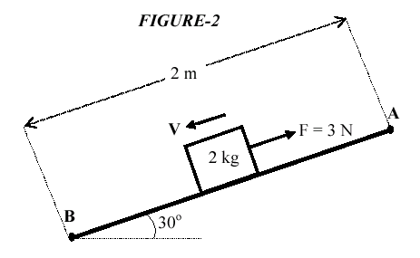
Solution
F= 3 N; m=2.0 kg; d= 2.0 m; K_{i}=10 J; U_{gf}=0.0 J; U_{gi}=m*g*h=m*g*d*sin30
ΔK +ΔU_{g} = Wa; K_{f}-10- m*g*d*sin30= F*d;
K_{f}=10+m*g*d*sin30-F*d=10+2*9.8*2*sin30-3*2= 23.6 J

Q#3: A 3.0 kg block is released from a compressed spring (k=120 N/m). It travels over a horizontal surface (mu =0.20) for a distance of 2.0 m before coming to rest, Fig 1. How far was the spring compressed before being released ? (Ans: 0.44 m.)
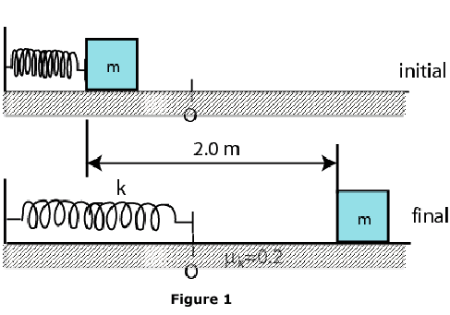
Solution
d =2.0 m; m=3.0 kg; k=120 N/m; μ_{k}=0.20 ; K_{f}= K_{i}=0 J; U_{sf} =0 J; U_{si} =0.5*k*x²
ΔK +ΔU_{s} = W_{f}= - f*d = - μ_{k}*m*g*d ; U_{si}=0.5*k*x²= μ_{k}*m*g*d
x =√[(μ_{k}*m*g*d)/(0.5*k)]= √[(0.2*3*9.8*2)/(0.5*120)]=0.443 m

Quiz #3 Ch.#7-8 T121 Phys101.37-39-v3

Student ID:…………… Student Name:……………….… Section # ……….
___________________________________________________________
Q#1: A 1500 kg car accelerates uniformly from rest to 10 m/s in 3.0 s. The average power delivered by the engine of the car in the first 3.0 s is: (Ans: 25 kW)
Solution
v_{i}=0.0 m/s; v_{f}=10.0 m/s
P=W/t= ΔK/t =K_{f}-K_{i}/t= [(0.5*1500*10*10)-0]/3.0 = 25000 W

Q#2: A 2.2-kg block starts from rest on a rough inclined plane that makes an angle of 25 degrees with the horizontal. The coefficient of kinetic friction is 0.25. As the block goes 2.0 m down the plane, find the change in the mechanical energy of the block. (Ans: –9.8 J)
Solution
m=2.2 kg; μ_{k}=0.25; d=2.0 m; v_{i}=0.0 m/s
ΔE= ΔK+ΔU_{g} =Wf= -μ_{k}*m*g*cos25*d= -0.25*2.2*9.8*cos25*2=-9.8 J

Q#3: Q#4 A 3.00 kg block is dropped from a height of 40 cm onto a spring of spring constant k (see Fig 2). If the maximum distance the spring is compressed = 0.130 m, find k. (Ans:1844 N/m)

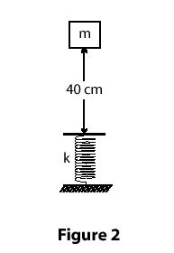

Solution
m=3.0 kg; h=40 cm=0.4 m; x_{f}=0.13 m
K_{i}=K_{f}=U_{si}=U_{gf}=0.0 J
ΔK+ΔU_{g}+ΔU_{s} =0; ΔU_{g}+ΔU_{s} =0; U_{sf}-U_{gi}=0;
U_{sf}=U_{gi}; 0.5*k*(x_{f}+h)*(x_{f}+h)=m*g*h
k=m*g*(h+ x_{f})/ [0.5*x_{f}*x_{f}]=(3*9.8*.53)/[0.5*0.13*0.13]= 1844 N/m
Quiz #3 Ch.#7-8 T121 Phys101.37-39-v4

Student ID:……… …… Student Name:……… ……….… Section # ……….
______________________________________________________________

Q#1: A 20 N force acts horizontally on a 2.0 kg box initially (t = 0) resting on a frictionless floor. The rate at which this force is doing work at t = 2.0 s is: (Ans: 400 W)
Solution
t=2.0 s; m= 2.0 kg; v_{i}=0.0 m/s ; a=F/m= 20/2=10 m/s²; v_{f}=v_{i}+a*t=a*t= 10*2=20 m/s
P=F.v=F*v=20*20=400 W

Q#2: . A man pushes a 50 kg crate a distance of 5.0 m upward along a frictionless slope that makes an angle of 30° with the horizontal. His force is parallel to the slope. The acceleration of the crate is 1.5 m/s 2 and is directed up the slope. The work done by the man is: (Ans:1600 J)
Solution
m= 50 kg; d=5.0 m ; a=1.5 m/s2; Fapp=m*a=50*1.5= 75 N
W_{app=} ΔK+ΔU_{g}= 0.5* m*(v_{f}²-v_{i}²)+(m*g*d*sin30 – 0)
W_{app} =0.5*m*(2*a*d)+m*g*d*sin30=0.5*50*(2*1.5*5)+50*9.8*5*sin30=375+1225= 1600 J

Q#3: A block of mass m=3.0 kg is kept at rest after it has compressed a horizontal massless spring (k=500 N/m) by 0.15 m, as shown in Fig. 2. When the block is released, it travels a distance S on a horizontal rough surface (mu=0.4) before stopping. Calculate the distance S. ( Ans: 0.48 m).
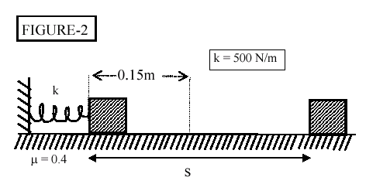

Solution
x =0.15 m; m=3.0 kg; k=500 N/m; μ_{k}=0.4; K_{f}= K_{i}=0 J; U_{sf} =0 J; U_{si} =0.5*k*x²
ΔK +ΔU_{s} = W_{f}= - f*d = - μ_{k}*m*g*d ; U_{si}=0.5*k*x²= μ_{k}*m*g*S
S =(0.5*k*x*x)/ (μ_{k}*m*g)= (0.5*500*0.15*0.15)/(0.4*3.0*9.8)=0.478 m

Quiz #3 Ch.#7-8 T121 Phys101.37-39-v5

Student ID:………… Student Name:………… …….… Section # ……….
___________________________________________________________

Q1: A net horizontal force of 50 N is acting on a 2.0 kg crate that starts from rest on a horizontal frictionless surface. At the instant the object has traveled 2.0 m, the rate at which this net force doing work is: (Ans: 500 W)
Solution:
Vi=0; x=2.0 m; a=F/m=50/2= 25 m/s2; v_{f}²=v_{i}²+2*a*x; v_{f}=√(2*a*x) =√(2*2*25)=10.0 m/s
P=F.v_{f}=F*v_{f}=50*10=500 W

Q2: A 2.2 kg block starts from rest on a rough inclined plane that makes an angle of 25° with the horizontal. The coefficient of kinetic friction is 0.25. As the block slides 2.0 m down the plane, the mechanical energy of the Earth-block system changes by: (Ans: −9.8 J)

Solution
d=2.0 m
ΔE= ΔK+ΔU_{g}=W_{f} =-f_{k}*d=-μ_{k}*m*g*cos(25°)*d=-0.25*2.2*9.8*cos(25)*2=-9.8 J
ΔE=-9.8 J

Q#3: . A 0.50 kg block is attached to an ideal spring with a spring constant of 80 N/m rests on a horizontal frictionless surface. The spring is stretched 4.0 cm longer than its equilibrium length and then released. The speed of the block when it passes through the equilibrium point is(Ans: 0.51 m/s).

Solution
m=0.50 kg; k=80 N/m; xi=4 cm = 0.04 m ; xf=0.0 m ; vi=0. m/s
ΔK+ΔU_{s} =0; K_{f}-U_{si}=0 ; K_{f}= U_{si} ;
K_{f}= 0.5*m*v_{f}²=0.5*k*x_{i}²
v_{f}=√[(k*x_{i}²)/m] =√[(80*0.04*0.04)/0.5]=0.506 m/s

Quiz #3 Ch.#7-8 T121 Phys101.37-39-v6

Student ID:……… …… Student Name:………… …….… Section # ……….
___________________________________________________________
Q#1: A 40-N force is the only force applied on a 2.0-kg crate which is originally at rest. At the instant the object has travelled 2.5 m, the rate at which the force is doing work is: (Ans: 400 W )

Solution:
Vi=0; x=2.5 m; a=F/m=40/2= 20 m/s² ; v_{f}²=v_{i}²+2*a*x; v_{f}=√(2*a*x) =√(2*20*2,5)=10.0 m/s
P=F.v_{f}=F*v_{f}=40*10=400 W

Q#2: . A 0.50 kg block slides down a frictionless 30° incline, starting from rest. The work done by the net force on this block after sliding for 4.0 s is: (Ans:96 J)

Solution:
v_{i}=0.0 m/s; a=g*sinθ; v_{f}=a*t=g*sin30*t=9.8* sin30*4=19.6 m/s
W_{g}=ΔK=K_{f}-K_{i}=K_{f}=0.5*m*v_{f}*v_{f}= 0.5*0.5*19.6*19.6=96 J

Q3: A 0.50 kg block attached to a spring with a spring constant of 100 N/m moves on a horizontal surface having a coefficient of kinetic friction 0.3 (see Fig 2). The spring is initially compressed by 10 cm from the outstretched position O and then released from rest. The speed of the block when it passes through the point O is: (Ans: 1.2 m/s)
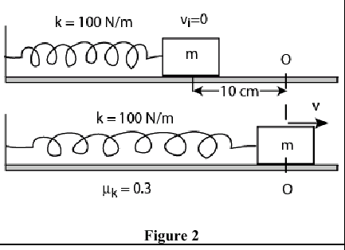

Solution
x =0.10 m; m=0.5 kg; k=100 N/m; μ_{k}=0.3; K_{f}= K_{i}=0 J; U_{sf} =0 J; U_{si} =0.5*k*x²
ΔK +ΔU_{s} = W_{f}= - f*d = - μ_{k}*m*g*d ; K_{f}-U_{si}= - f*d ; K_{f}= U_{si}- f*d = 0.5*k*x²-μ_{k}*m*g*x
v_{f}=√[2*(0.5*k*x²-μ_{k}*m*g*x)/m]= =√[2*(0.5*100*0.1*0.1-0.3*0.5*9.8*0.1)/0.5]
v_{f} = √2*(0.500-0.147)/0.5 = 1.19 m/s

