Old Exam. Questions- Ch. 12-091 (Dr. Naqvi Phys. 101.016-018)

T082
Q1.A uniform horizontal beam of length 6.00 m and mass M = 100 kg is attached to the vertical wall by a rope making an angle  = 60.0 º with the wall; the beam can rotate about the fixed pivot O as shown in Fig. 1. A mass m = 80.0 kg hangs from P at a distance 4.00 m from O. Find the tension in the rope attached to the wall. (Ans: 2.03 x 10³ N)
Q2.What increase in pressure is necessary to decrease the volume of a solid aluminum sphere by 0.050 % (Bulk Modulus of Aluminum = 7.00 x 10¹⁰ N/m²) (Ans: 3.50 x 10⁷ Pa)
Q3: A certain wire stretches 0.90 cm when outward forces with magnitude F are applied to each of its ends. The same forces are applied to a second wire of the same material but with two times the diameter and three times the length. The second wire stretches: (Ans: 0.68 cm)
Q4.A non-uniform meter stick of mass 200 g is pivoted at the 0 cm mark and balances horizontally in a vertical plane. In addition to the reaction at the pivot and weight, two vertical forces are acting on it as shown in Fig. 2. Find the distance of the center of mass of the rod from the pivot. (Ans: 76 cm)

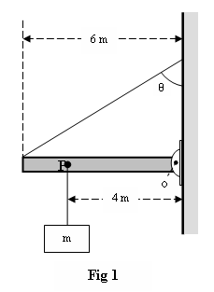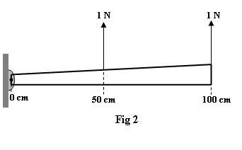

Fig. 1. T082 Fig. 2, T082
T081
Q16. A 90-kg mountain climber is tied to one end of an elastic rope of unstretched length 15 m and diameter 9.6 mm. The climber falls and the rope is stretched by 3 cm. Find Young’s modulus of the rope. (A) 6.1 x 10⁹ N/m² )
Q17. A uniform ladder of length L and mass M rests against a smooth, vertical wall. The coefficient of static friction between the ladder and the ground is 0.40. Find the angle θ (in degrees), between the ladder and the ground, at which the ladder is about to slide. (A) 51.3

T072
Q16. A uniform steel bar of length 3.0 m and weight 20 N rests on two supports (A and B) at its ends. A block of weight W = 30 N is placed at a distance 1.0 m from A (see Fig. 4). The forces on the supports A and B respectively are: (Ans:30 N and 20 N)
Q17. Fig. 5 shows a uniform ball of 600 N weight suspended by a string AB and rests against a frictionless vertical wall. The string makes an angle of 30.0° with the wall. The magnitude of the tension in the string is: ( Ans: 693 N)
Q18.: A horizontal steel rod of length 81 cm and radius 9.5 mm is fixed at one end. It stretches by 0.90 mm when a horizontal force of magnitude F is applied to its free end. Find the magnitude of F (Young modulus of steel is 20 × 10¹⁰ N/m²). (Ans: 63 kN)

T071
Q1.: A uniform meter stick has mass M = 1.25 kg. As shown in Fig. 1, this meter stick is supported by two vertical strings, one at each end, in such a manner that it makes an angle of 20° with the horizontal. Find the tension in each string.( A) T1 = 6.1 N, T2 = 6.1 N)
Q2.: A thin right angled rod is made of a uniform material. The shorter end is half the length of the longer end. It is hanging by a string attached at point O (Fig. 2). At equilibrium, the angle α between the shorter rod and the vertical is: ( Ans: 76°)
Q3. Fig. 3 shows a uniform block of mass m = 100 kg, which is held in a horizontal position by two vertical steel rods at its ends. Each of the rods has length, L = 1.0 m, cross sectional area = 1.0 × 10-3 m2 and young’s modulus, E =2.0×1011 N/m2 . The increase in the length of any one the rods (ΔL), is: (Ans: 2.5×10⁻⁶ m)
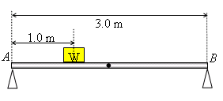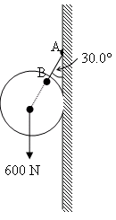
Fig. 4, T072 Fig. 5, T072 Fig. 1, T071 Fig. 2, T071 Fig. 3, T071

T062
Q1. Fig. 1 shows a three boxes of masses m₁, m₂ and m₃ hanging from a ceiling. The crossbars are horizontal and have negligible mass and same length L. If m₃ = 1.0 kg, then m₁ is equal to:(Ans: 12 kg )
Q2. Fig. 2 shows a uniform beam with a weight of 60.0 N and length of 3.20 m is hinged at its lower end and a horizontal force F of magnitude 50.0 N acts at its upper end. The beam is held vertical by a cable that makes an angle θ = 30.0° with the ground and is attached to the beam at a height h = 1.60 m. The tension (T) in the cable is: (A: 115 N)
Q3. A solid copper sphere has a diameter of 85.5 cm. How much stress must be applied to the sphere to reduce its diameter to 85.0 cm? The bulk modulus of copper is 1.4 x 10¹¹ N/m² (Ans: 2.4 × 10⁹ N/m² )
Fig. 1-T062 Fig. 2-T062 Fig. 8, T061 Fig.9, T061

T061
Q16. The volume of a solid Aluminum sphere at the sea level is V = 1.0 m³. This sphere is placed at a depth of about 700 m in the sea where the absolute pressure is p = 7.0 x 10⁶ N/m². The change in the volume ()VΔ of the sphere is: (the bulk modulus of Aluminum, B = 70 x10⁹ N/m²). A) 1.0 x 10⁻⁴ m³
Q17. : A uniform meter stick of mass M is balanced on a knife edge at the 40 cm mark by hanging a 0.50 kg mass at the 20 cm mark (see Fig. 8). Find M (A) 1.0 kg)
Q18. : A 5.0 m long uniform ladder (with mass m = 12.0 kg ) leans against a wall at a point 4.0 m above a horizontal floor as shown in Fig 9. Assuming the wall is frictionless (but the floor is not), determine the normal force exerted on the ladder by the wall. (A) 44 N )
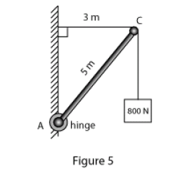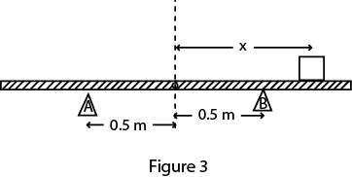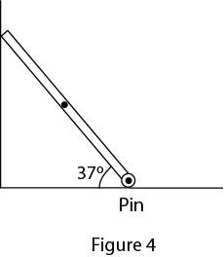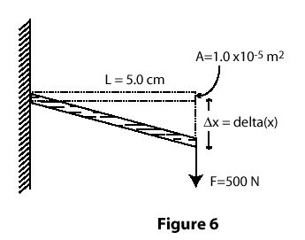
Fig. 5, T052 Fig. 6, T052 Fig. 3, T051 Fig. 4, T051 Fig. 6, T042
T052: Q#16:A 5.0-m weightless rod (AC), hinged to a wall at A, is used to support an 800-N block as shown in Fig 5.The horizontal and vertical components of the force (F_{H}, F_{V}) of the hinge on the rod are: (Ans: F_{H} = 600 N, F_{V} = 800N )
Q#17:A shearing force F = 50 N is applied to an aluminum rod with a length of L =10 m, a cross-sectional area A=1.0 × 10^{–5} m², and a shear modulus G = 2.5 × 10¹⁰ N/m². As a result the rod is sheared through a distance (Δx) of: (Ans: 0.20 cm)
Q#18: A man holds a rod AB of length = 6.0 m and weight = 30 N in equilibrium, by exerting an upward force F₁, with one hand, and a downward force F₂, with the other hand as shown in Fig 6. What are the magnitude of the forces F₁ and F₂? (Ans: F₁ = 90 N, F₂ = 60 N)
T051: Q: 16 . A cube of volume 8.0 cm³ is made of material with a bulk modulus of 3.5×109 N/m². When it is subjected to a pressure of 3.0 × 10⁵ Pa, the change in its volume (V) is(Ans: 6.9 x 10⁻⁴ cm³)
Q: 17. A uniform rigid rod having a mass of 50 kg and a length of 2.0 m rests on two supports A and B as shown in the Fig. 3. When a block of mass 60 kg is kept at point C at a distance of x from the center, the rod is about to be lifted from A The value of x is: (Ans: 0.92 m )
Q: 18. A uniform beam having a mass of 60 kg and a length of 2.8 m is held in place at its lower end by a pin (P). Its upper end leans against a vertical frictionless wall as shown in the Fig. 4. What is the magnitude of the force by the pin on the beam? (Ans: 706 N)
T042: Q2 A horizontal aluminum rod (shear modulus = 2.5*10**10 N/m**2) projects L=5.0 cm from the wall (see Fig 6). The cross sectional area of the rod A =1.0*10**(-5) m**2. A shearing force of 500 N is applied at the end of the rod. Find the vertical deflection delta(x) of the end of the rod. (Ans: 1.0 *10**(-4) m )
Q3 A uniform rod AB is 1.2 m long and weighs 16 N. It is suspended by strings AC and BD as shown in Fig 2. A block P weighing 96 N is attached at point E, 0.30 m from A. The tension in the string BD is: (Ans: 32 N)
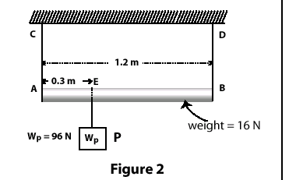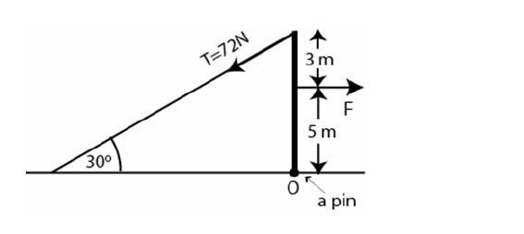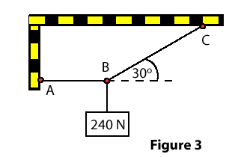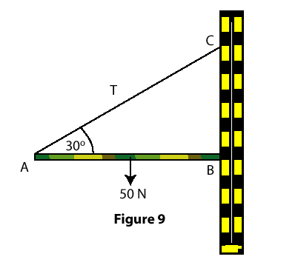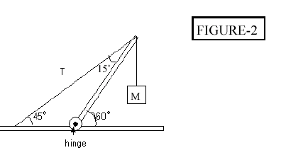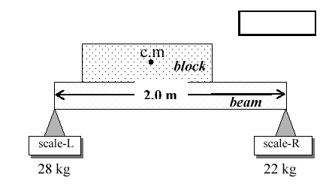

Fig. 2-T042 Fig. 4-T041 Fig. 3-T032 Fig. 9, T032 Fig. 2, T031 Fig. 3-T031
T041: Q1 A 20 kg uniform ladder is leaning against a frictionless wall and makes an angle of 60 degrees with the horizontal. The ladder being at rest find the magnitude of the frictional force exerted on the ladder by the floor ? (Ans: 57 N)
Q2 A uniform beam is held in a vertical position by a pin at its lower end and a cable at its upper end (see Fig 4). The tension in the cable is 72 N. Find the horizontal force F acting on this beam. (Ans: 100 N)
Q3 A certain wire stretches 1.0 cm when a force F is applied to it. The same force is applied to a second wire of the same material but with twice the diameter and twice the length. The second wire stretches: (Ans: 0.50 cm)

T032
Q16 Fig 9 shows a stationary 50 N uniform rod (AB), 1.2 m long, held against a wall by a rope (AC) and friction between the rod and the wall. Find the force (T) exerted on the rod by the rope. (Ans: 50 N)
Q17 A wire stretches 1.0 cm when a force F is applied to it. The same force is applied to a wire of the same material but with twice the diameter and twice the length. The second wire stretches: (Ans: 0.50 cm)
Q18 A 240 N weight is hung from two ropes AB and BC as shown in Fig 3. The tension in the horizontal rope AB is: (Ans: 416 N)

T031
Q1 The system in Fig 2 is in equilibrium. A mass (M) of 5.0 kg 13 hangs from the end of the uniform beam of mass = 10.0 kg. The tension in the cable is: (Ans: 190 N)
Q2 Two scales are 2.0 m apart. A uniform 40 kg beam of the same length is placed on top of them (see Fig 3). A 10 kg block is placed on the beam after which the right scale reads 22 kg and the left scale reads 28 kg. How far from the right scale is the center of gravity of the block located? (Ans: 1.6 m)
Q3 A 500 kg mass is hung from the ceiling with a steel wire. The wire has a length = 45.0 cm, radius = 4.00 mm and has negligible mass. Calculate the change in the length of the wire. (Youngs modulus of steel E = 2.00* 10**11 N/m**2) (Ans: 0.22 mm)

T022
Q14 A uniform 50-kg beam is held in a vertical position by a pin at its lower end and a cable at its upper end. A horizontal force F = 75 N acts as shown in the figure. What is the tension in the cable? (Ans: 54 N)
Q15 A horizontal uniform meter stick is supported at the 50-cm mark. A mass of 0.50 kg is hanging from it at the 20-cm mark and a 0.30 kg mass is hanging from it at the 60-cm mark (see Fig.7). Determine the position on the meter stick at which one would hang a third mass of 0.60 kg to keep the meter stick balanced. (Ans: 70 cm)
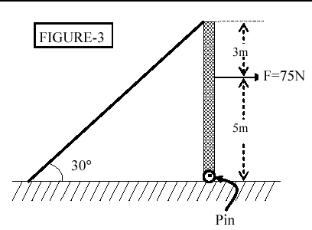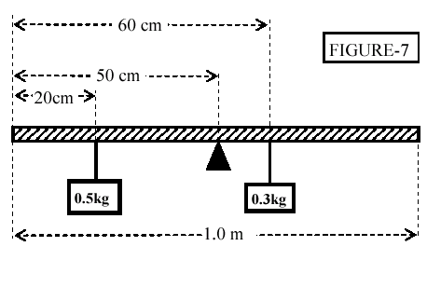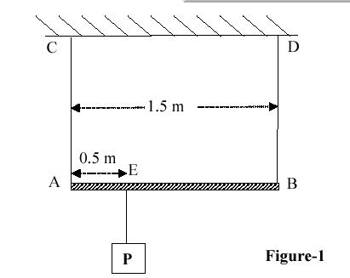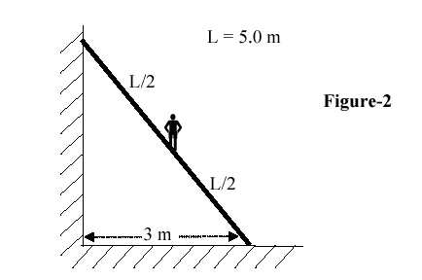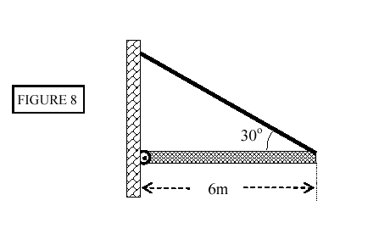
Fig. 3, T022 Fig.7-T022 Fig. 1-T021 Fig. 2-T021 Fig. 8, T012
Q16 A 20-m long steel wire (cross-sectional area 1.0 cm**2, Young's modulus 2.0 x 10**11 N/m), is subjected to a force of 25000 N. How much will the wire be stretched? (Ans: 2.5 cm)

T021
Q1 A uniform rod AB is 1.5 m long and weighs 20 N. It is suspended by wires AC and BD as shown in Fig. 1. A block P weighing 80 N is attached at E, 0.50 m from A. The tension in the wire BD is: (Ans: 37 N)
Q2 A man weighing 720 N stands halfway up a 5.0 m ladder of negligible weight. The base of the ladder is 3.0 m from the wall as shown in Fig. 2. Assume that the wall-ladder contact is frictionless. With what force does the wall push against the ladder? (Ans:270 N)
Q3 A steel rod has a radius of 8.5 mm and a length of 100 cm. A force of 6.0 x 10**4 N stretches it along its length. Take Young's modulus for steel as 11 x 10**11 N/m**2. The increase in the length of the rod in mm is: (Ans: 0.24)

T012
Q25 A horizontal uniform beam of weight W = 200 N and length L = 6.0 m is supported by a hinge and a cable as shown in Figure 8. The system is in equilibrium; find the TENSION in the cable. (Ans: 200 N)

