Old-Exam.Questions-081-Ch-13 (Dr. A. A. Naqvi, Phys101-10-12)

T072
Q19: A spaceship is going from the Earth (mass = M_{e}) to the Moon (mass = M_{m}) along the line joining their centers. At what distance from the centre of the Earth will the net gravitational force on the spaceship be zero? (Assume that M_{e} = 81 M_{m} and the distance from the centre of the Earth to the center of the Moon is 3.8 × 10⁵ km). (Ans: 3.4 × 10⁵ km)
Q20: A 1000 kg satellite is in a circular orbit of radius = 2R_{e} about the Earth. How much energy is required to transfer the satellite to an orbit of radius = 4R_{e}? (R_{e} = radius of Earth = 6.37 × 10⁶ m, mass of the Earth = 5.98 × 10²⁴ kg) (Ans: 7.8 × 10⁹ J.)
Q21: At what altitude above the Earth’s surface would the gravitational acceleration be a_{g}/4 ? (where a_{g} is the acceleration due to gravitational force at the surface of Earth and R_{e} is the radius of the Earth).(Ans: R_{e})
Q22: The gravitational acceleration on the surface of a planet, whose radius is 5000 km, is 4.0 m/s². The escape speed from the surface of this planet is: (Ans: 6.3 km/s)

T071
Q4: At what distance above the surface of Earth (radius = R) is the magnitude of the gravitational acceleration equal to g/16? (Where g = gravitational acceleration at the surface of Earth). (Ans: 3 R)
Q5: A satellite moves around a planet (of mass M) in a circular orbit of radius = 9.4 x 106 m with a period of 2.754 x 10⁴ s. Find M. (Ans: 6.5 × 10²³ kg)
Q6: A rocket is launched from the surface of a planet of mass M=1.90 × 10²⁷ kg and radius R = 7.15 × 10⁷ m. What minimum initial speed is required if the rocket is to rise to a height of 6R above the surface of the planet? (Neglect the effects of the atmosphere). (Ans: 5.51 × 10⁴ m/s)
Q #7: Fig. 4 shows a planet traveling in a counterclockwise direction on an elliptical path around a star S located at one focus of the ellipse. The speed of the planet at a point A is vA and at B is vB. The distance AS = rA while the distance BS = r_{B}. The ratio vA/vB is: (Ans: (r_{B}/r_{A})

T062
Q27. Eight balls of different masses are placed along a circle as shown in Fig. 8 The net force on a ninth ball of mass m in the center of the circle is in the direction of: A) NE
Q28. :The escape velocity of an object of mass 200 kg on a certain planet is 60 km/s. When the object is on the surface of the planet, the gravitational potential energy of the object-planet system is: A) −3.6 x 10¹¹ J
Q29. : A planet has two moons of masses m₁ = m and m₂ = 2m and orbit radii r₁= r and r₂= 2r, respectively. The ratio of their periods T₁/T₂ is: A) 0.35
Q30.: A satellite in a circular orbit around Earth has a kinetic energy of 1.0 x 10⁸ J. The mechanical energy of the stellite-Earth system is: A) −1.0 x 10⁸ J

T061
Q19.: Three identical particles each of mass m are placed on a straight line separated by a distance d as shown in Fig. 10. To remove the particle at the center to a point far away (where U = 0), the work that must be done by an external agent is given by: A) 2Gm²/d
Q20. Two uniform concentric spherical shells each of mass M are shown in Fig. 11. The magnitude of the gravitational force exerted by the shells on a point particle of mass m located a distance d from the center, outside the inner shell and inside the outer shell, is: A) GMm/d²
Q21. Fig. 12 shows five configurations of three particles, two of which have mass m and the other one has mass M. The configuration with the least (minimum) gravitational force on M, due to the other two particles is: A) 2
Q22.: A satellite of mass m and kinetic energy K is in a circular orbit around a planet of mass M. The gravitational potential energy of this satellite-planet system is: A) –2K

T052
Q#19: Three identical particles each of mass m are distributed along the circumference of a circle of radius R as shown in Fig 7. The gravitational force of m₂ on m₁ is 1.0 x 10⁻⁶ N. The magnitude of the net gravitational force on m₁ due to m₂, m₃ is (Ans: 1.4 x 10⁻⁶ N)
Q#20: Calculate the mass of the Sun using the fact that Earth is rotating around the Sun in a circular orbit of radius 1.496 x 10¹¹m with a period of one year (1 year =3.156 x 10⁷s).(Ans: 1.99 x 10³⁰ kg).
Q#21: Calculate the work require to move an Earth satellite of mass m from a circular orbit of radius 2R_{E} to one of radius 3R_{E}. (Consider M_{E} = mass of Earth, R_{E} = radius of Earth, G = universal Gravitational constant) (Ans: G M_{E} m /(12 R_{E})).
Q#22: A 100-kg rock from outer space is heading directly toward Earth. When the rock is at a distance of (9R_{E}) from the Earth's surface, its speed is 12 km/s. Neglecting the effects of the Earth's atmosphere on the rock, find the speed of the rock just before it hits the surface of Earth.(Ans: 16 km/s)

Fig. 4, T071 Fig. 8, T062 Fig. 10, T061 Fig. 11, T061 Fig. 12, T061

T051
Q#19: Calculate the magnitude and direction of net gravitational force on particle of mass m due to two particles each of mass M, where m =1000 kg and M =10000 kg and are arranged as shown in the Fig. 5.(Ans: 4.3 x 10⁻⁵ N directed towards negative x-axis)
Q#20: One of the moons of planet Mars completes one revolution around Mars in 1.26 days. If the distance between Mars and the moon is 23460 km, calculate the mass of Mars.( Ans: 6.45 x 1023 kg)
Q#21: A satellite of is in a circular orbit around a planet. If the kinetic energy of the satellite is 1.87 x 10⁹ J, what is the mechanical energy of the satellite? (Ans: - 1.87 x 10⁹ J)
Q#22: A projectile was fired straight upward from Earth's surface with an initial speed v_{i} such that it reaches a maximum height of 2R_{E} above the Earth surface (take g = 9.80 m/s² and R_{E} = 6.37 x 10⁶ m). The initial speed v_{i} is (Ans: 10.5 km/s)
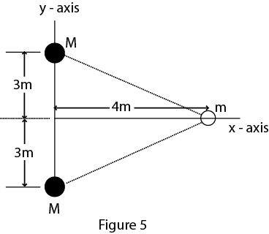
Fig. 7 T052 Fig. 5 T051 Fig. 3 T042

T042
Q4: Four point masses are at the corners of a square whose side is 20 cm long (see Fig 3). What is the magnitude of the net gravitational force on a point mass m5 = 2.5 kg located at the center of the square? (Ans:1 3.3*10**(-8) N)
Q5: An object is fired vertically upward from the surface of the Earth (Radius = R) with an initial speed of (Vesc)/2, where (Vesc = escape speed). Neglecting air resistance, how far above the surface of Earth will it reach? (Ans: R/3)
Q6: What is the escape speed on a spherical planet whose radius is 3200 km and whose gravitational acceleration at the surface is 4.00 m/s**2? (Ans: 5.06 km/s)
Q7 : A planet requires 300 (Earth) days to complete its circular orbit about its sun (mass M = 6.0*10**30 kg). The orbital speed of the planet is: (Ans: 4.6*10**4 m/s)

T041
Q4 Four point masses are at the corners of a square whose side is 20 cm long (see Fig 3). What is the magnitude of the net gravitational force on a point mass m5 = 2.5 kg located at the center of the square?
Q5 An object is fired vertically upward from the surface of the Earth (Radius = R) with an initial speed of (Vesc)/2, where (Vesc = escape speed). Neglecting air resistance, how far above the surface of Earth will it reach?: A1 R/3
Q6 What is the escape speed on a spherical planet whose radius is 3200 km and whose gravitational acceleration at the surface is 4.00 m/s**2?: A1 5.06 km/s
Q7 A planet requires 300 (Earth) days to complete its circular orbit about its sun (mass M = 6.0*10**30 kg). The orbital speed of the planet is: A1 4.6*10**4 m/s
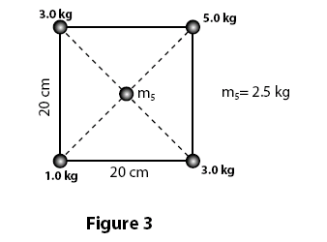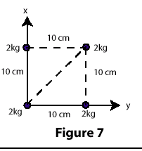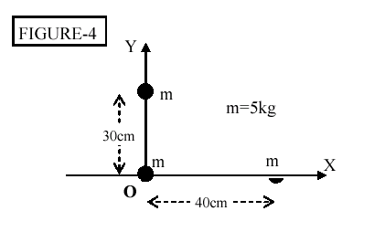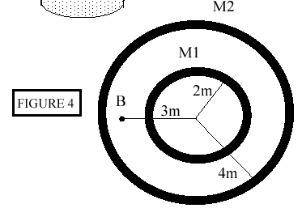
Fig. 3 T041 Fig. 7 T032 Fig. 4 T022 Fig. 4 T012

T032
Q19 Four equal masses, 2.0 kg each, are placed at the four corners of a square of side 10 cm as shown in Fig 7. What is the magnitude of the gravitational force on one of the masses due to the other three? A1 5.1 * 10**-8 N
Q20 The escape speed from a certain planet for an empty spaceship of mass M is 2.0 * 10**4 m/s. What is the escape speed for a fully loaded spaceship which has mass = 3*M ? A1 2.0 * 10**4 m/s.
Q21 The gravitational acceleration at the surface of Earth = 9.8 m/s**2. Find the gravitational acceleration at an altitude equal to 3 times the radius of earth. A1 0.6 m/s**2
Q22 A 1200 kg satellite orbits the Earth (Mass = 5.98 * 10**24 kg and Radius R = 6.37 * 10**6 m) in an orbit of radius = 2*R. How much energy is needed to move the satellite from this orbit to another orbit of radius = 3*R? A1 6.26*10**9 J.

T031
Q4 A space ship is going from the Earth to the Moon along the line joining their centers. At what distance from the center of the Earth will the net gravitational force on the space ship be zero? Assume that Me = 81 Mm, where Me is the mass of the Earth and Mm is the mass of the Moon. (The distance from the center of the Earth to the center of the Moon is 3.8*10**5 km). A1 3.4*10**5 km .
Q5 A satellite circles the Earth at an altitude equal to 3 times the radius of Earth. Find the gravitational acceleration due to Earth at the satellite. ( g on the surface of Earth is 9.8 m/s**2) A1 0.61 m/s**2
Q6 Two moons orbit a planet in circular orbits. Moon (A) has orbital radius R and moon (B) has orbital radius 4R. Moon A takes 20 days to complete its orbit. How long does it take moon (B) to complete its orbit? A1 160 days.
Q7 What is the escape speed from the surface of a planet whose radius is 5000 km, if the gravitational acceleration on its surface is 4.0 m/s**2? A1 6.3 km/s .

T022
Q17 A satellite circles a planet (mass M = 5.0x10**24 kg) every 98 min. What is the radius of the orbit? A1 6.6 x 10**6 m
Q18 Three 5.0 kg masses are located at points in the xy plane as shown in the Fig.4. What is the magnitude of the resultant force caused by the other two masses on the mass at the origin? A1 2.1x10**(-8) N
Q19 A rocket is fired vertically from the surface of a planet (mass = M, radius = R). What is the initial speed of the rocket if its maximum height above the surface of the planet is 2R ? (Assume there is no air resistance) : A1 SQRT(4GM/3R)
Q20 A spaceship (mass = m) orbits a planet (mass = M) in a circular orbit (radius = R). What is the minimum energy required to make the spaceship escape the gravitational force of the planet? : A1 GmM/(2R)

T021
Q5: A satellite circles a planet every 2.8 h in an orbit of radius 1.2 x 10**7 m. If the radius of the planet is 5.0 x 10**6 m, what is the mass of the planet? A1 1.0 x 10**25 kg
Q6: Two stars of masses M and 6M are separated by a distance D. Calculate the distance (measured from M) to a point at which the net gravitational force on a third mass would be zero. A1 0.29 D
Q7: A spaceship of mass m circles a planet (mass = M) in an orbit of radius R. How much energy is required to transfer the spaceship to a circular orbit of radius 3R?
A1 GmM/(3R)
Q8: A planet has a mass of 5.0 x 10**23 kg and radius of 2.0 x 10**6 m. A rocket is fired vertically from the surface of the planet with an initial speed of 4.0 km/s. What is the speed of the rocket when it is 1.0 x 10**6 m from the surface of the planet? A1 2.2 km/s.

T012
Q11 Two concentric shells of uniform density having masses M1 and M2 and Radii R1 =2.0 m, R2 = 4.0 m are situated as shown in FIGURE 4. Find the gravitational FORCE on a particle of mass m placed at point B at a distance of 3.0 m from the center :A1 (G*M1*m)/9.
Q12: Three particles with equal mass M = 2.0 kg are located at (0,0), (4,0) and (0,3) where the x and y coordinates are in meters. Find the magnitude of the gravitational force exerted on the particle located at the origin by the other two particles. A1 3.4* 10**(-11) N
Q13: A moon is moving in a circular orbit around a planet with a period of 2.75* 10**4 s. Find the MASS of the planet if the radius of the orbit is 9.4* 10**6 m. A1 6.5* 10**23 kg
Q14: A 1000-kg rocket is fired vertically from Earth's surface with zero total mechanical energy. With what KINETIC energy was it fired? (Mass of Earth = 6.0* 10**24 kg, Re = 6.4* 10**6 m) A1 6.3* 10**10 J.

