LASER PULSE HEATING

Hussain Al-Qahtani¹ and Bekir Yilbas¹
- Department of Mechanical Engineering, KFUPM, Dhahran 31261, Saudi Arabia, Email: Qahtanih@kfupm.edu.sa
- Department of Mechanical Engineering, KFUPM, Dhahran 31261, Saudi Arabia, Email: Qahtanih@kfupm.edu.sa

ABSTRACT

Laser pulse heating has a wide interest in modification of surface properties of metals. This is because of the rapid processing, low cost, and shallow heat affected zone. Moreover, model studies reduce the experimental cost and time and give insight into the physical processes that take place during the heating process. The numerical studies offer solution to the heating problem, but limits the solutions with certain range of parameters. On the other hand, closed form solutions provides complete information on the heating situation. In laser surface processing, an assisting gas is used to minimize the oxidation effects of the air ambient. In this case, inert assisting gas protects the surface from high temperature oxidation reactions during laser heating. Consequently, when modeling the laser heating process, cooling effect of the substrate surface due to assisting gas, should be accounted for.

Keyword: Laser pulse, temperature, half-space heating

1. INTRODUCTION

Considerable research studies were carried out to examine laser heating process. Ready [1] introduced an analytical solution for temperature rise due to laser pulse heating of metallic surface. His solution was valid for insulated surface and constant intensity pulse. Yilbas et al [2-5] investigated extensively laser pulse heating of metallic surfaces and presented closed form solutions. However, closed form solution obtained for temperature rise was due to less step input pulse with non-convection boundary at the surface. In practical application of laser heating, the cooling effect of the assisting gas should be included in the analysis.
In the present study, laser step input pulse heating of solid surface is considered. In order to account for the cooling effect of the assisting gas, convective boundary is accommodated. A Laplace transformation method is used to obtain the analytical solution for the Fourier conduction equation with appropriate boundary conditions.

2 HEAT TRANSFER ANALYSIS

The laser pulse heating consists of two cycles, namely heating and cooling cycles. The heating cycle starts with initiation of the pulse and ends when the pulse intensity reduces to zero. The first unit step pulse starts at time t = 0 while the second unit step pulse at timeτ.

The heat transfer equation for a laser heating pulse can be written as:

(3)

where: and r_{f} is the reflection coefficient. Note that 1(t) is a special case of Since the heat transfer equation is linear one can consider the half-pulse response; and then apply the superposition principle to obtain the solution for the full pulse. Therefore, one can write:

(4)

By applying the inverse Laplace transformation, the solution can be written in the time domain as:|
(18)
where

(20)
(21)
Recall that we only considered a half-pulse excitation. Since the other half, i.e., 1(t) is a special case of 1(t – Δt), one can get the response due to 1(t) by making Δt = 0 in Eq. (17).
The residues above are:
, , , and

3 RESULTS AND DISCUSSIONS

Figure (1) shows temporal variation of dimensionless temperature at different depths from the surface. The magnitude of maximum temperature is in the order of 1200°C and the pulse length is in the order of 1 nanosecond. The rise of surface temperature is high in the early heating period and as the time increases towards the pulse end, the rate of rise becomes small. This is because of the energy absorbed in the early heating period from the irradiated field. This, in turn, enhances internal energy gain in the surface region of the substrate material. Since the temperature gradient in the surface region is small in the early heating period, diffusional energy transport from surface region to solid bulk becomes less. Moreover, this situation is particularly true in the surface region. As the depth from the surface increases towards the solid bulk, both the rate of temperature rise and decay become gradual. The decay rate of temperature immediately after the laser pulse ending is rapid as compared to the rate of rise of temperature in the early heating period. This can be attributed to the diffusional energy transfer from the surface region to solid bulk due to high temperature gradient, particularly in the surface region.
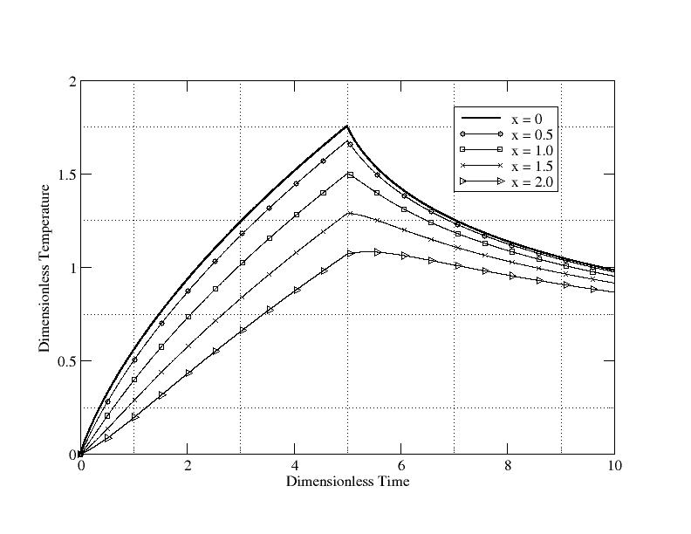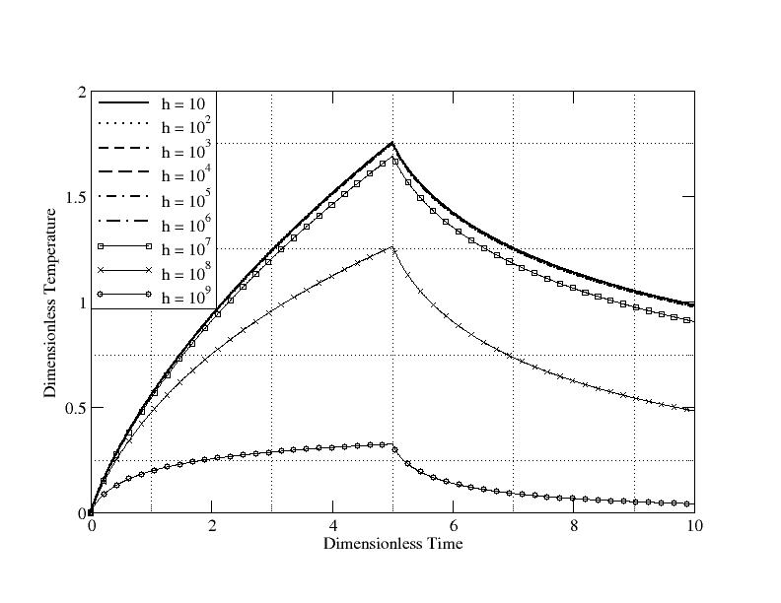
Figure 1 Temporal variations of dimensionless Figure 2 Effects of heat transfer coefficient h* temperature. on the temporal distribution of dimensionless
temperature at the epicenter of the pulse.

Figure (2) shows temporal variation of surface temperature for different heat transfer coefficients. It should be noted that maximum and minimum heat transfer coefficients correspond to 0 W/m²∙K and 10⁹ W/m²∙K. The magnitudes of temperature rise and temperature variation are similar for heat transfer coefficient up to h ≤ 10⁷ W/m²∙k. In this case the convective energy loss from the surface becomes negligible small as compared to energy gain of the substrate material. As heat transfer coefficient increases beyond 10⁷ W/m²∙K, convective loss from the surface becomes important and temperature rise in the surface region is suppressed particularly during the heating period. Consequently, temperature below the surface becomes higher than at the surface. This is more pronounced when heat transfer coefficient increases beyond 10⁸ W/m²∙k. In the cooling cycle, similar effect is also observed. The location of magnitude of maximum temperature gradient moves towards the solid bulk as heat transfer coefficient increases. In this case, convection losses from surface, internal energy gain of the substrate material from the irradiated field and diffusional energy loss from the surface to solid bulk attains a balance and its location at different depths below the surface differs for different heat transfer coefficients. Moreover, the influence of convective loss from the surface on temperature rise becomes significant in the surface region which is limited to a depth corresponding to maximum magnitude of temperature gradient.

CONCLUSION

Laser pulse heating of solid surface is considered, a closed form solution for temperature rise is obtained. A convective boundary condition at the surface is accommodated while a step input laser pulse is employed in the analysis. A Laplace transformation method is used in the analytical solution. It is found that temperature rise in the early heating period is higher than in the late heating durations. This is because of the substantial internal energy gain from the irradiated field and small diffusional energy loss from the surface region to solid bulk. The location of magnitude of maximum temperature gradient moves towards solid bulk as heating period progresses. The diffusional energy transport becomes significant when magnitude of temperature gradient becomes maximum. The influence of heat transfer coefficient on temperature rise in the surface region becomes significant for h ≥ 10⁸ W/m²∙k. In this case, convective loss dominates over energy gain by substrate material from the irradiated field. However, for low heat transfer coefficient h < 10⁸ W/m²∙k, amount of energy gain from the irradiated field is substantial and convective loss from the surface does not influence the temperature rise in the surface region.

REFERENCES

- Ready, J. F. Effects due to absorption of laser radiation. Journal of Applied Physics, 1963, Vol. 36, pp. 462-470.
- Yilbas BS, Kalyon M. Laser repetitive pulse heating with convective boundary condition at the surface. Journal of Physics D: Applied Physics. 2001; Vol. 34, 222-231.
- Yilbas BS. Analytical solution for time unsteady laser pulse heating of semi-infinite solid. International Journal of Mechanical Sciences. 1997; Vol. 39, pp. 671-682.
- Yilbas B.S. and Kalyon M., “Analytical solution for pulsed laser heating: convective boundary condition case”, International Journal of Heat and Mass Transfer, 2002, Vol. 45, pp. 1571-1582.
- Yilbas B.S. and Kalyon M.," Formulation of laser pulse heating: a closed form solution including heating and cooling cycles with pulse parameter variation", Lasers in Engineering, 2004, Vol. 14, pp. 213-228.

ACKNOWLEDGEMENTS

The authors acknowledges the support of KFUPM in Saudi Arabia.

