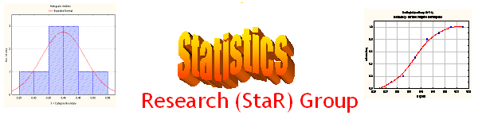
Seminar

Dept of Mathematical Sciences
King Fahd University of Petroleum and Minerals

Presenter | Mr. Mu'azu Ramat Abujiya  Dept of Mathematical Sciences, KFUPM
Title | An Overview of Statistical Analysis Using Excel
Audience | All KFUPM community are cordially Invited
Date | Tuesday, May 17, 2005
Time | 1:00 PM
Location | Building 5, Smart Classroom # 201

Abstract

Microsoft Excel is probably the most commonly used spreadsheet for computers as it’s often packaged with new PCs. The program is almost everywhere and naturally encourages its use for statistical analysis. However, there are recent concerns about the quality of Excel’s statistical computing, owing to the fact that the program is not a statistical package. But the truth remains that due to its easy availability, its use for statistical analysis is at increasing rate even among the statisticians.

This seminar will give an overview of the statistical functions in Microsoft Excel as well as the magnitude of its inaccuracies in handling data analysis.

Tea and Coffee will be provided

