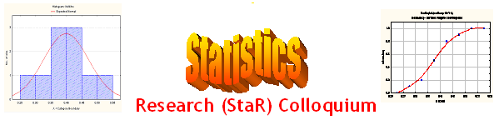
Seminar

Dept of Mathematical Sciences
King Fahd University of Petroleum and Minerals

Presenter | Mr. Esam Al-Sawi  Dept of Mathematical Sciences, KFUPM
Title | Introduction to the SPSS statistical package
Audience | All KFUPM community are cordially Invited
Date | Tuesday, Oct 25, 2005
Time | 1:00 PM
Location | Building 5, Smart Classroom # 203

Abstract

SPSS (Statistical Package for the Social Sciences) is a data management and analysis product. It can perform a variety of data analysis and presentation functions, including statistical analyses and graphical presentation of data. In addition, it is comprehensive and easy-to-use. SPSS is widely used because it is user-friendly for data analyses.

This talk is for a general audience with some knowledge of statistical analyses, but little or no experience using the SPSS statistics software package. Topics covered will include: entering data directly into SPSS, importing data into SPSS from other applications, descriptive statistics, and performing common statistical tests such as t-tests, Chi-Square, and regression analyses.

Ramadan Mubarak

