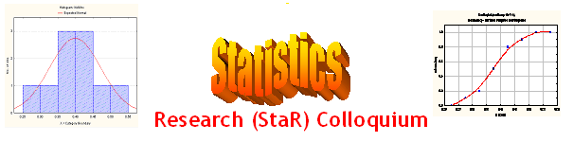
Seminar

Dept of Mathematical Sciences
King Fahd University of Petroleum and Minerals

Presenter | Dr. Walid Abu Dayyeh  Dept of Mathematical Sciences, KFUPM
Title | Estimating Using Ranked Set Sampling in Case of the Exponential Distribution
Topic | Statistical Inference
Audience | All KFUPM community are cordially Invited
Date | Tuesday, Apr 25, 2006
Time | 1:00 PM
Location | Building 5, Smart Classroom # 203

Abstract

The problem of making inference about has been under great investigation in the literature using simple random sampling (SRS) data. This problem arises naturally in the area of reliability for a system with strength X and stress Y. The system fails any time its strength is exceeded by the stress applied to it.
In this study, we will consider making inference about when X and Y are independent random variables and have exponential distributions with parameters and respectively using ranked set sampling (RSS) data. Several estimators are proposed to estimate using RSS including the maximum likelihood estimator (MLE) and modified maximum likelihood estimator (MMLE). The properties of these estimators will be investigated and compared with usual estimators based on SRS data using their biases and MSE’s.
Also, the likelihood ratio test (LRT) and modified likelihood ratio test (MLRT)for the testing a simple hypothesis about against one side alternatives using SRS and RSS data will be considered and compared via their power functions.

Refreshments will be provided

