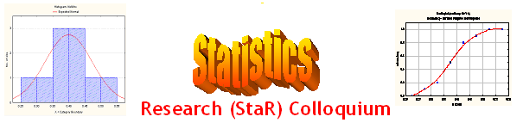
Seminar

Dept of Mathematical Sciences
King Fahd University of Petroleum and Minerals

Presenter | Dr. Ali Sahin  Research Institute, KFUPM
Title | Regionalized Variables and Spatial Correlation
Topic | GeoStatistics
Audience | All KFUPM community are cordially Invited
Date | Tuesday, Apr 11, 2006
Time | 1:00 PM
Location | Building 5, Smart Classroom # 203

Abstract

The term regionalized variable is used to designate any variable distributed in space. Almost all variables encountered in Earth Sciences can be considered as regionalized variables. The theory of regionalized variables forms the basis of geostatistical techniques that have been applied to various fields of Earth Sciences as well as other disciplines during the last four decades. However, the most significant and rapid developments are recorded in the field of mineral deposit evaluation.
After introducing the basic concepts of regionalized variables and spatial correlation, this presentation will focus on the development and applications of geostatistics in mineral deposit evaluation. Considering their profound impact on the development, particular emphasis is given to the statistical techniques practiced in South African gold mines since the beginning of the 20th Century.

Refreshments will be provided

