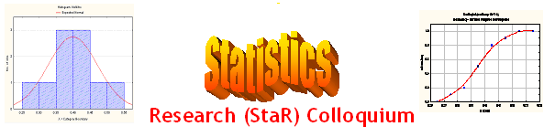
Seminar

Dept of Mathematical Sciences
King Fahd University of Petroleum and Minerals

Presenter | Dr. Ibrahim Rahimov  Dept of Mathematical Sciences, KFUPM
Title | Branching Stochastic Processes in Epidemiology
Topic | Stochastic Process Application
Audience | All KFUPM community are cordially Invited
Date | Tuesday, Nov 22, 2005
Time | 1:00 PM
Location | Building 5, Smart Classroom # 203

Abstract

In the seminar possibility of using of a simple branching process in modeling of epidemics of infectious diseases will be discussed. After a brief historical review we consider simple discrete time branching stochastic process. We will discuss well known Galton’s Puzzle on extinction of families, criticality parameters and their estimation theory. As an example of concrete application, results related to Singapore SARS epidemic propagation will be provided.

Tea and Coffee will be provided

