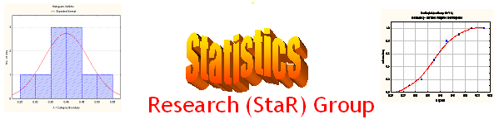
Seminar

Dept of Mathematical Sciences
King Fahd University of Petroleum and Minerals

Presenter | Dr. Ibrahim Rahimov  Dept of Mathematical Sciences, KFUPM
Title | On a Stochastic Model for Continuous Mass Population Growths
Audience | All KFUPM community are cordially Invited
Date | Tuesday, May 10, 2005
Time | 2:15 PM
Location | Building 5, Smart Classroom # 203

Abstract

It is well known that the set of nonnegative integers is the state-space of usual branching stochastic processes. However in many applications one may have situations when it is difficult to count the number of individuals in the population, but some non-negative characteristic, such as volume, energy, weight or product produced by the individuals can be measured. There are many processes in which a random number of new individuals from an external source may immigrate to the population as well. To model this kind of situation, branching stochastic processes with continuous state-space and with immigration are introduced. In this talk, methods for investigation of asymptotic behaviour of the continuous state-space branching process with immigration in varying environments will be discussed. Using these methods a limit distribution for the processes will be obtained. Possible applications in microbiology and in nuclear physics will also be discussed.

Tea and Coffee will be provided

