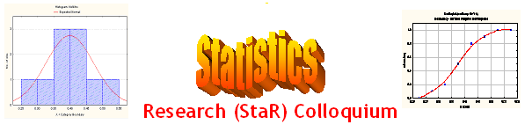
Seminar
Dept of Mathematical Sciences
King Fahd University of Petroleum and Minerals
Presenter | Dr. Raja M. Latif  Dept of Mathematical Sciences, KFUPM
Title | Borel Probability Measures on Metric Spaces and Prokhorov’s Theorem
Topic & (Level) | Probability Theory & Stochastic Process  (Mathematical Statistics, Theoretical)
Audience | All KFUPM community are cordially Invited
Date | Tuesday, Jan 16, 2007
Time | 1:00 PM
Location | Building 5, Smart Classroom # 203

Abstract

Let be a metric space and let be the set of Borel probability measures on . We endow with the Prokhorov matric induced by . In the study of limit behavior of stochastic processes one often needs to know when a sequence of random variables is convergent in distribution or, at least, has a subsequence that converges in distribution. This comes down to finding a good description of the sequences in that have a convergent subsequence or rather of the relatively compact sets of . In this talk we will describe Prokhorov’s Theorem that gives a useful description of the relatively compact sets of in case is separable and complete.

Tea and Coffee will be served

