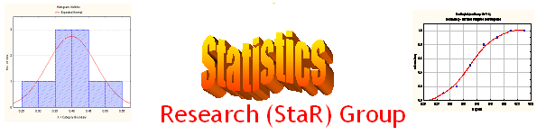
Seminar

Dept of Mathematical Sciences
King Fahd University of Petroleum and Minerals

Presenter | Dr. Hassen A. Muttlak  Dept of Mathematical Sciences, KFUPM
Title | Cumulative Sum Quality Control Charts  using Ranked Set Sampling
Audience | All KFUPM community are cordially Invited
Date | Tuesday, Sept 27, 2005
Time | 1:00 PM
Location | Building 5, Smart Classroom # 203

Abstract

Cumulative sum control charts (CUSUM) are developed using ranked set sampling (RSS), and median ranked set sampling (MRSS) data. These new charts are compared to the usual CUSUM charts using simple random sampling (SRS) data.

Different CUSUM control charts for the sample mean and single observation based on RSS and MRSS are developed. The charts based on RSS or one MRSS are shown to have smaller average run length (ARL) than the classical CUSUM charts based on SRS if the process starts to get out of control and have approximately the same ARL if the process is under control. In this study we are assuming the underlying distribution is normal.

Tea and Coffee will be provided

