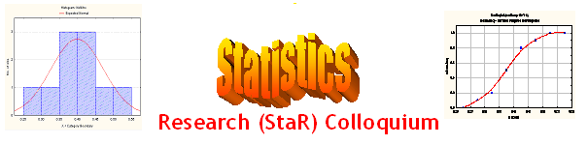
Seminar

Dept of Mathematical Sciences
King Fahd University of Petroleum and Minerals

Presenter | Dr. Anwar H. Joarder  Dept of Mathematical Sciences, KFUPM
Title | An Introduction to the Bivariate T-Distribution
Topic | Statistical Distribution
Audience | All KFUPM community are cordially Invited
Date | Tuesday, Feb 28, 2006
Time | 1:00 PM
Location | Building 5, Smart Classroom # 203

Abstract

The bivariate t-distribution is a natural generalization of the bivariate normal distribution as a derived sampling distribution or as a scale mixture of itself with an inverted gamma distribution. Since it has heavier tails compared to the bivariate normal distribution, it has found applications in business and economics. For broad spectrum of researchers, the paper introduces the bivariate t-distribution as a probable model for population. Some characteristics especially different types of moments are presented.

Refreshments will be provided

