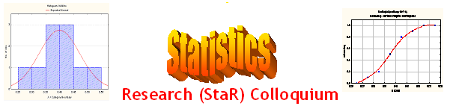
Seminar

Dept of Mathematical Sciences
King Fahd University of Petroleum and Minerals

Presenter | Dr. Anwar H. Joarder  Dept of Mathematical Sciences, KFUPM
Title | On a Bivariate Chisquare Distribution
Topic | Statistical Distribution
Audience | All KFUPM community are cordially Invited
Date | Tuesday, Feb 21, 2006
Time | 1:00 PM
Location | Building 5, Smart Classroom # 203

Abstract

A correlated bivariate chisquare distribution is derived from the bivariate Wishart distribution. A theorem is established that provides elegant expression for infinite sum of the product of several gamma functions. Then it is utilized for deriving product moments of the distribution. Some applications of these moments are outlined.

Refreshments will be provided

