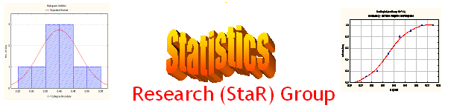
Seminar

Dept of Mathematical Sciences
King Fahd University of Petroleum and Minerals

Presenter | Dr. Anwar H. Joarder  Dept of Mathematical Sciences, KFUPM
Title | The Expectation of Sample Variance:  An Elegant Approach
Audience | All KFUPM community are cordially Invited
Date | Tuesday, Sept 20, 2005
Time | 1:00 PM
Location | Building 5, Smart Classroom # 203

Abstract

The expected value of the sample variance is often calculated by deriving its sampling distribution which is difficult for many distributions. In this note, it is demonstrated that only the distribution of the difference of any two observations is needed for the expected value of sample variance. An alternative method is also presented with some examples.

Tea and Coffee will be provided

