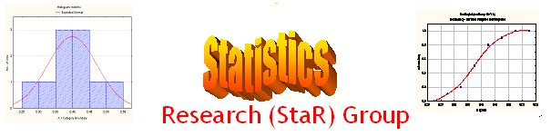
Seminar

Dept of Mathematical Sciences
King Fahd University of Petroleum and Minerals

Presenter | Dr. Anwar H. Joarder  Dept of Mathematical Sciences, KFUPM
Title | The Distribution of Correlation Coefficient  Based on a T-Population
Audience | All KFUPM community are cordially Invited
Date | Tuesday, Oct 11, 2005
Time | 1:00 PM
Location | Building 5, Smart Classroom # 203

Abstract

The distribution of the product moment correlation coefficient based on bivariate normal distribution is well known. Recently in many business and economic data, fat tailed distribution especially t-distributions are considered as a parent population. In this talk we relax the assumption of normality to bivariate t-disribution to derive the distribution of correlation coefficient by a direct approach for broad spectrum of readers.

Tea and Coffee will be provided

