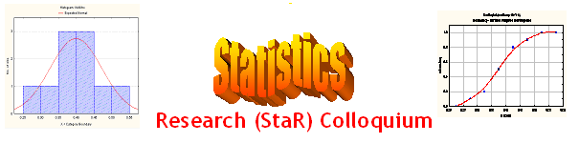
Seminar

Dept of Mathematical Sciences
King Fahd University of Petroleum and Minerals

Presenter | Dr. Walid A. Abu-Dayyeh  Dept of Mathematical Sciences, KFUPM
Title | Exact Bahadur Slope for Combining Independent Tests in case of the Normal Distribution Using Simple Random Sampling and Ranked Set Sampling Data
Topic | Statistical Inference
Audience | All KFUPM community are cordially Invited
Date | Tuesday, Dec 13, 2005
Time | 1:00 PM
Location | Building 5, Smart Classroom # 203

Abstract

The Fisher, logistic, sum of P-values and the inverse normal methods are used to combine an infinite number of independent tests for testing a simple hypothesis against one-sided alternatives about the location parameter of the normal distribution. The Exact Bahadur Slope (EBS) is used as a criterion for comparing these methods. Two well-known sampling methods are used to select data, namely, simple random sampling (SRS) and ranked set sampling (RSS) methods. It turns out that the RSS method dominates the SRS method for all cases considered.

Tea and Coffee will be provided

