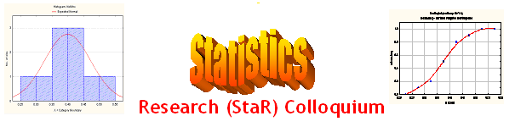
Seminar

Dept of Mathematical Sciences
King Fahd University of Petroleum and Minerals

Presenter | Dr. Anwar H. Joarder  Dept of Mathematical Sciences, KFUPM
Title | A Comparison and Contrast of  Some Methods for Sample Quartiles
Topic & (Level) | Statistics Education  Methodological, Educational
Audience | All KFUPM community are cordially Invited
Date | Tuesday, Sept 26, 2006
Time | 1:00 PM
Location | Building 5, Smart Classroom # 203

Abstract

Currently, there are about a dozen methods to find sample quartiles. The emergence of so many methods is due to non-rigorous definition of quartiles. In this talk we probe the issue, and suggest a new criterion of equisegmentation to determine quartiles. The existing methods have then been checked in the light of this criterion and found that only Shao Method satisfies it. Two new methods have been proposed and illustrated.

.

Ramadan Mubarak

